 | Junior Primary School

Parent Login & Onboarding Manual
Purpose
This guide helps parents create an account, sign in, link their child, and access report cards, statements, and notifications.
Prerequisites
- A valid email address and mobile number
- Your child’s Student ID
- The school portal URL provided by the school i.e. https://sms-apua.vercel.app
Sign Up
- Open the school portal in your web browser
- On the sign‑in page, select “Create Account” or “Sign Up”
- Choose the Parent role if prompted
- Enter your name, email, mobile number, username (if requested) and password
- Submit the form
- If email verification is required, open the link sent to your inbox to complete verification
(Insert screenshot: Sign Up page)
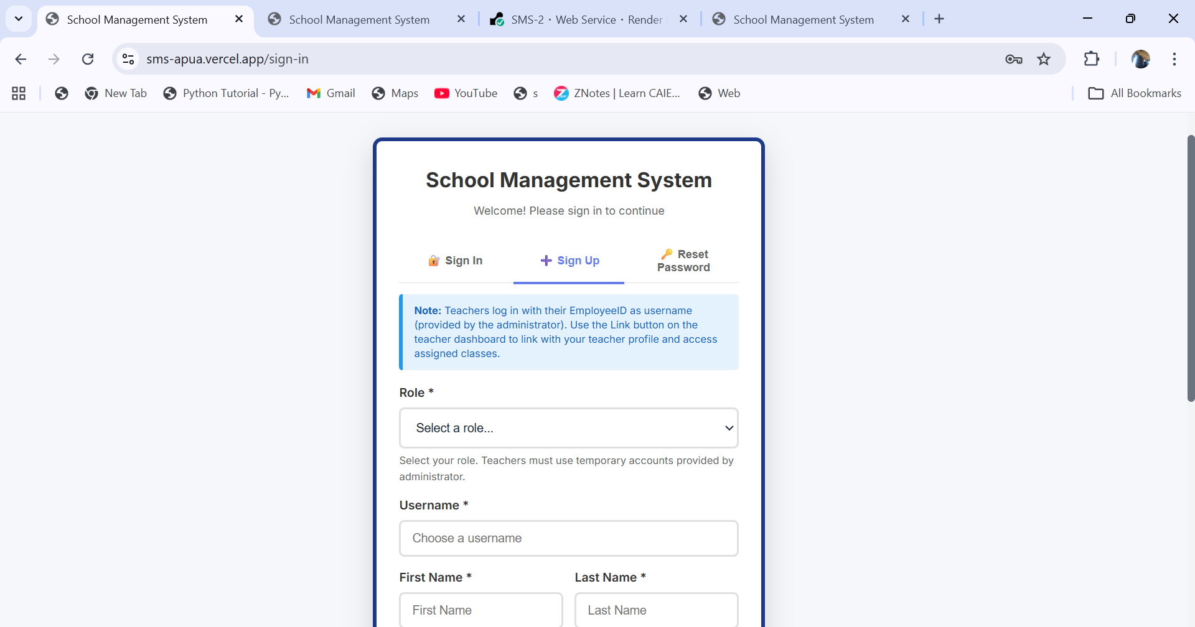

Sign In
- Go to the sign‑in page
- Enter your username or email and your password
- Select “Sign In”
- Forgot your password? Use “Forgot Password”, enter your email, open the reset link, and set a new password
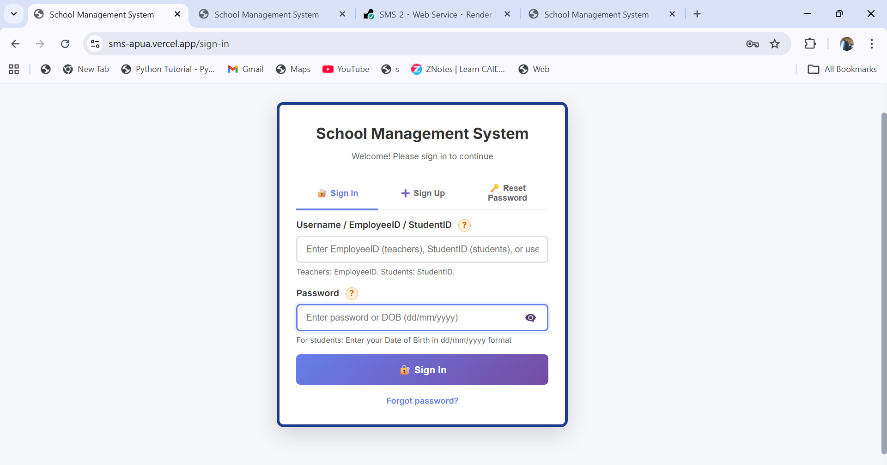
Link Your Child
- Navigate to the Parent area (e.g., “My Students” or “Link Student”)
- Option 1 – Link with Student ID + Date of Birth: Enter both and submit
- Option 2 – Link with Student ID only (if enabled): Enter Student ID and submit
- After linking, your child appears under “My Students”. You can unlink if needed.
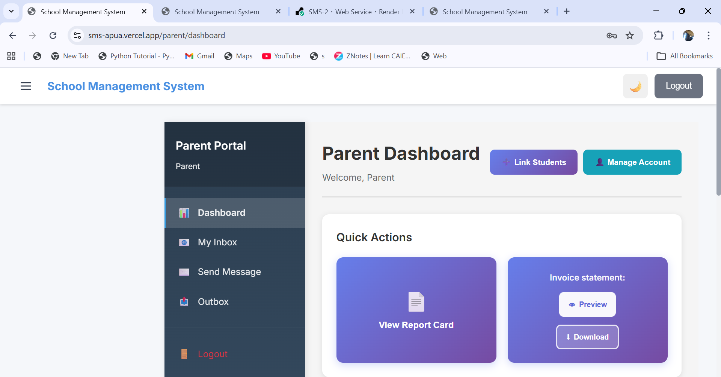

Report Cards
- Open the Student Report Card section
- Select your child and the term/period
- View results and remarks
- Download or print the report (if available)
(Insert screenshot: Report Card view)
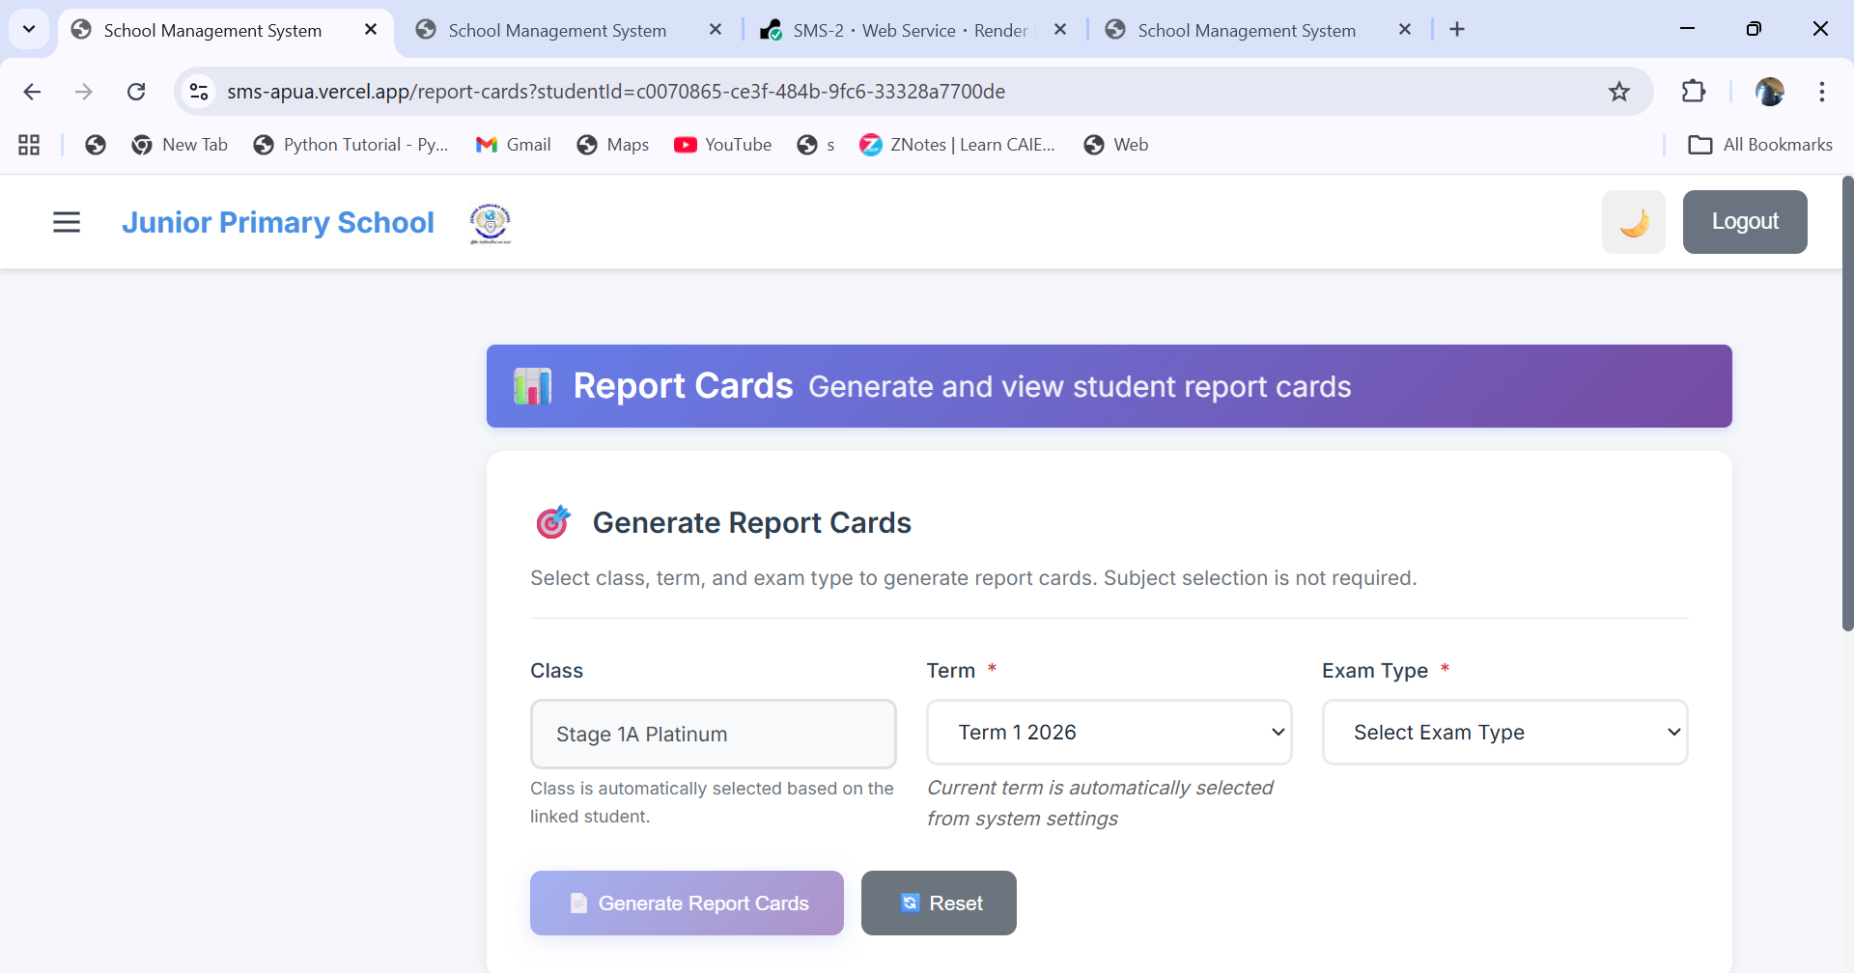
Invoices and Statements
- Open the Student Invoice Statement section
- Select your child and a date range/term if prompted
- Review outstanding balance and transaction history
- Download a PDF copy for your records
(Insert screenshot: Invoice/Statement view)

Notifications and Messages
- Open Messages/Inbox for announcements or direct messages from the school
- Reply where applicable or use the provided contact channels
(Insert screenshot: Messages/Inbox)
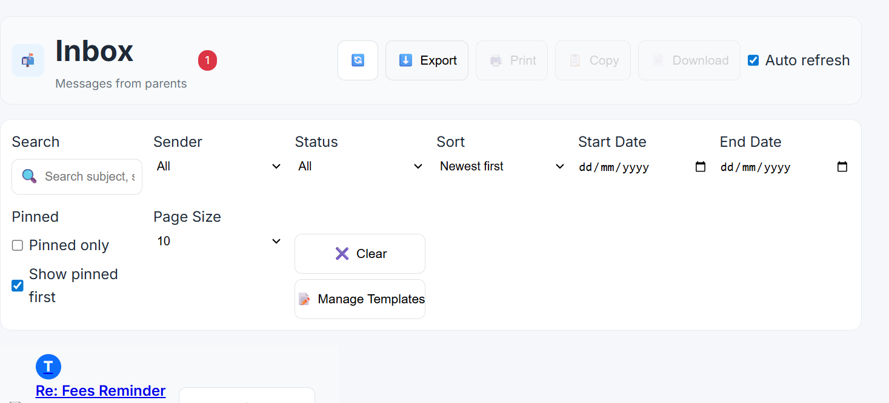

Profile and Security
- Update your name, email, or contact details in “Profile” or “Account”
- Change your password regularly
- Sign out on shared devices
- The system may sign you out after inactivity; sign in again to continue
Troubleshooting
- Can’t sign in: verify credentials, use “Forgot Password”, or try a different browser
- No verification or reset email: check Spam/Junk and confirm your email with the school
- Student not found/can’t link: confirm Student ID and Date of Birth; contact the school if recently enrolled/transferred
- Page errors: check internet connection; try again later (maintenance may be in progress)
Good Practices
- Keep your login details private
- Review report cards and statements regularly
- Keep contact details up to date to receive important notifications
Support
For account issues, contact the school office or portal administrator. Provide your full name, registered email, and (if relevant) your child’s Student ID.

