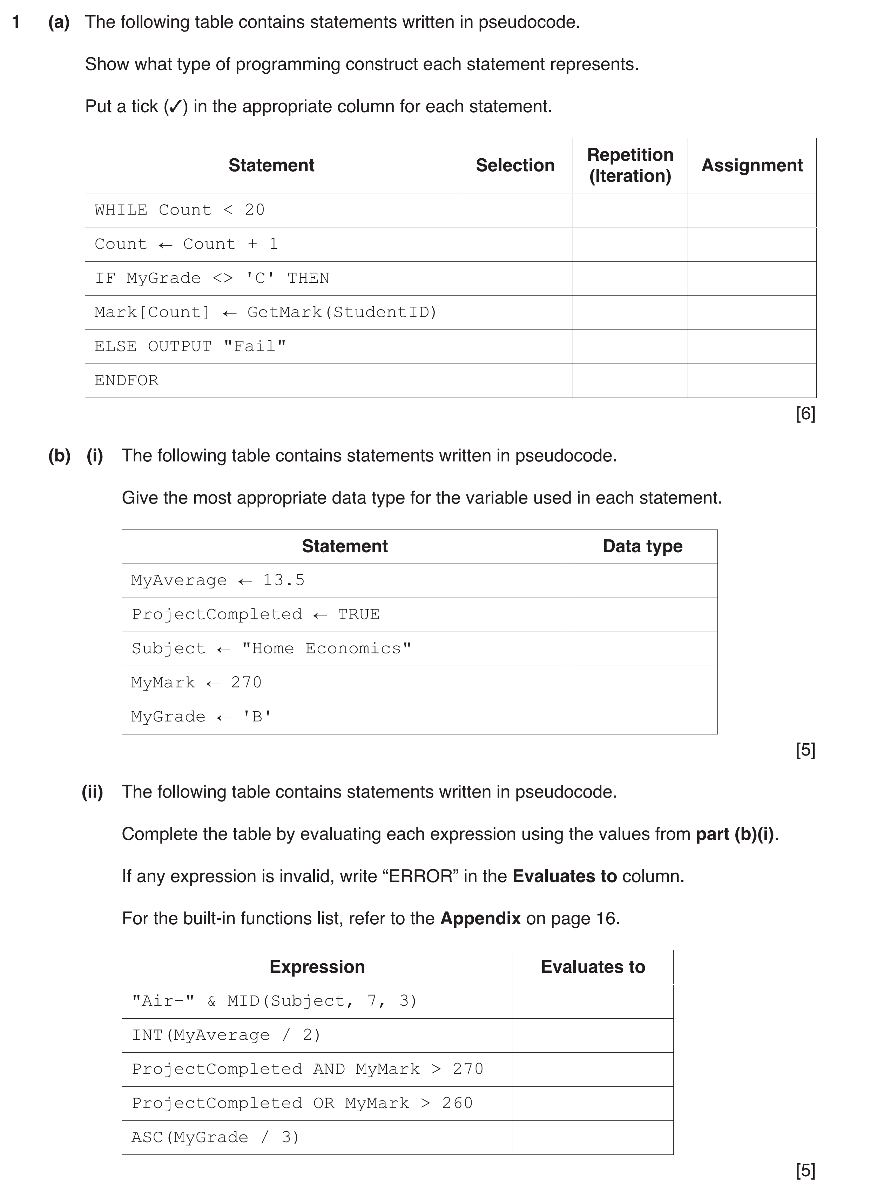
Paper 2 : Algorithms

2 A company keeps details of its product items in a 1D array, StockData. The array consists of 500
elements of type StockRecord. The record fields of StockRecord are:
Field | Typical value
ProductCode | "AGR24-B"
Price | 100.75
NumberInStock | 20
ExpiryDate | 31/12/2025

(a) Write pseudocode to declare the record structure StockRecord.
...................................................................................................................................................
...................................................................................................................................................
...................................................................................................................................................
...................................................................................................................................................
.............................................................................................................................................. [5]
(b) Write pseudocode to declare the StockData array.
...................................................................................................................................................
.............................................................................................................................................. [3]
(c) Write pseudocode to modify the values to element 10 as follows:
• set the price to 106.99
• increase the number in stock by 20
...................................................................................................................................................
...................................................................................................................................................
...................................................................................................................................................
.............................................................................................................................................. [3]

