


NAME……………………………………………………………………….CLASS……………….
COMPUTER SCIENCE
FORM 6 MID TERM EXAMINATION 2025
SYLLABUS CODE 9618 Paper 2 Fundamental Problem-solving and Programming Skills
TIME 2 HOUR 30 MINUTES DATE :
Candidates answer on the question paper

INSTRUCTIONS TO CANDIDATES
1.Write your name and class in the space at the top of this page.
2.Answer all the questions in the spaces provided. If additional space is required, you should use the lined page at the end of this question paper. The question number(s) must be clearly shown.
3.The use of an electronic calculator is not allowed
4.You are reminded of the need for clear presentation in your answers.
5.The number of marks is given in brackets [] at the end of each question or part question.

Total Number of marks : 100

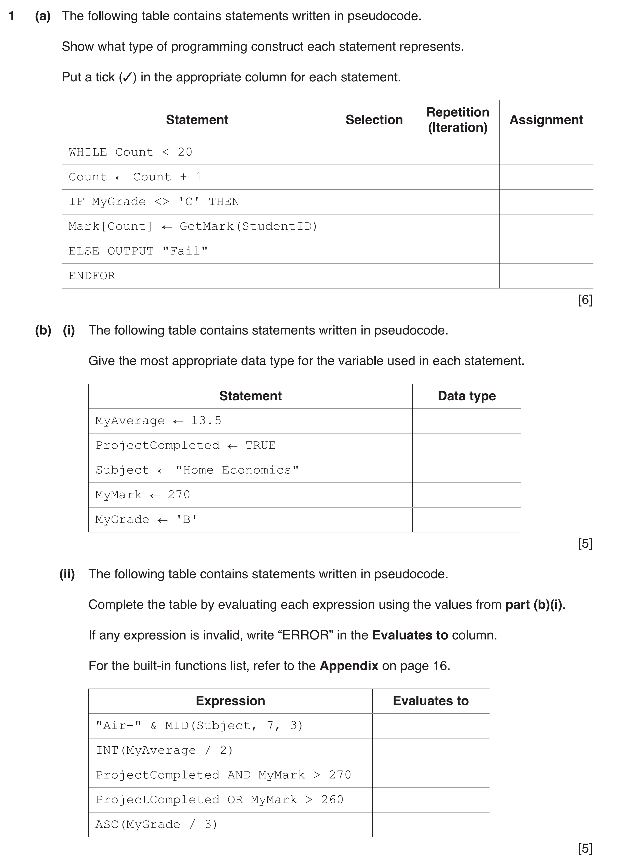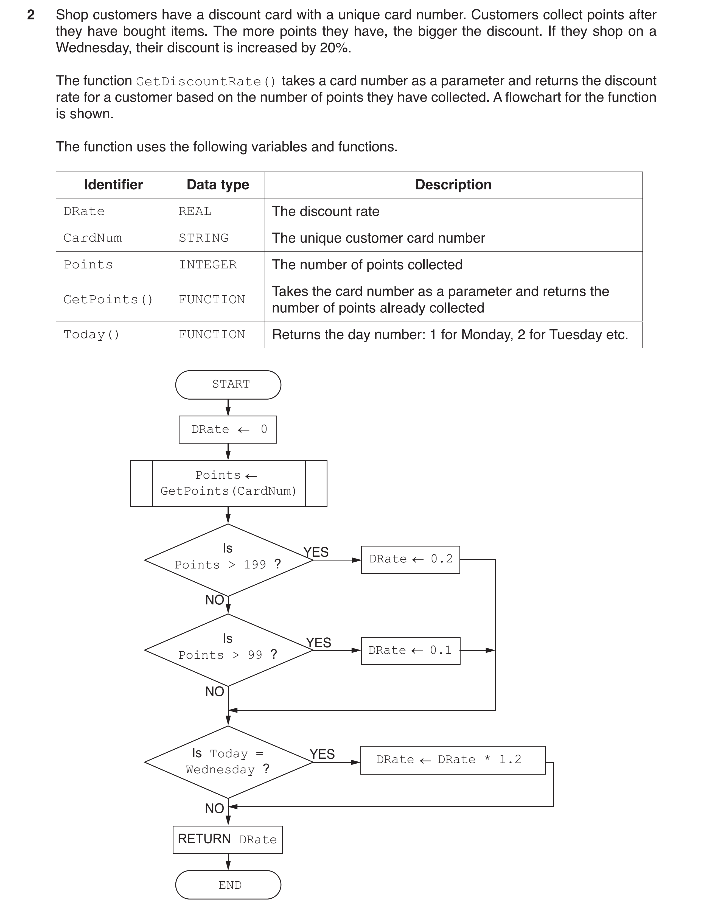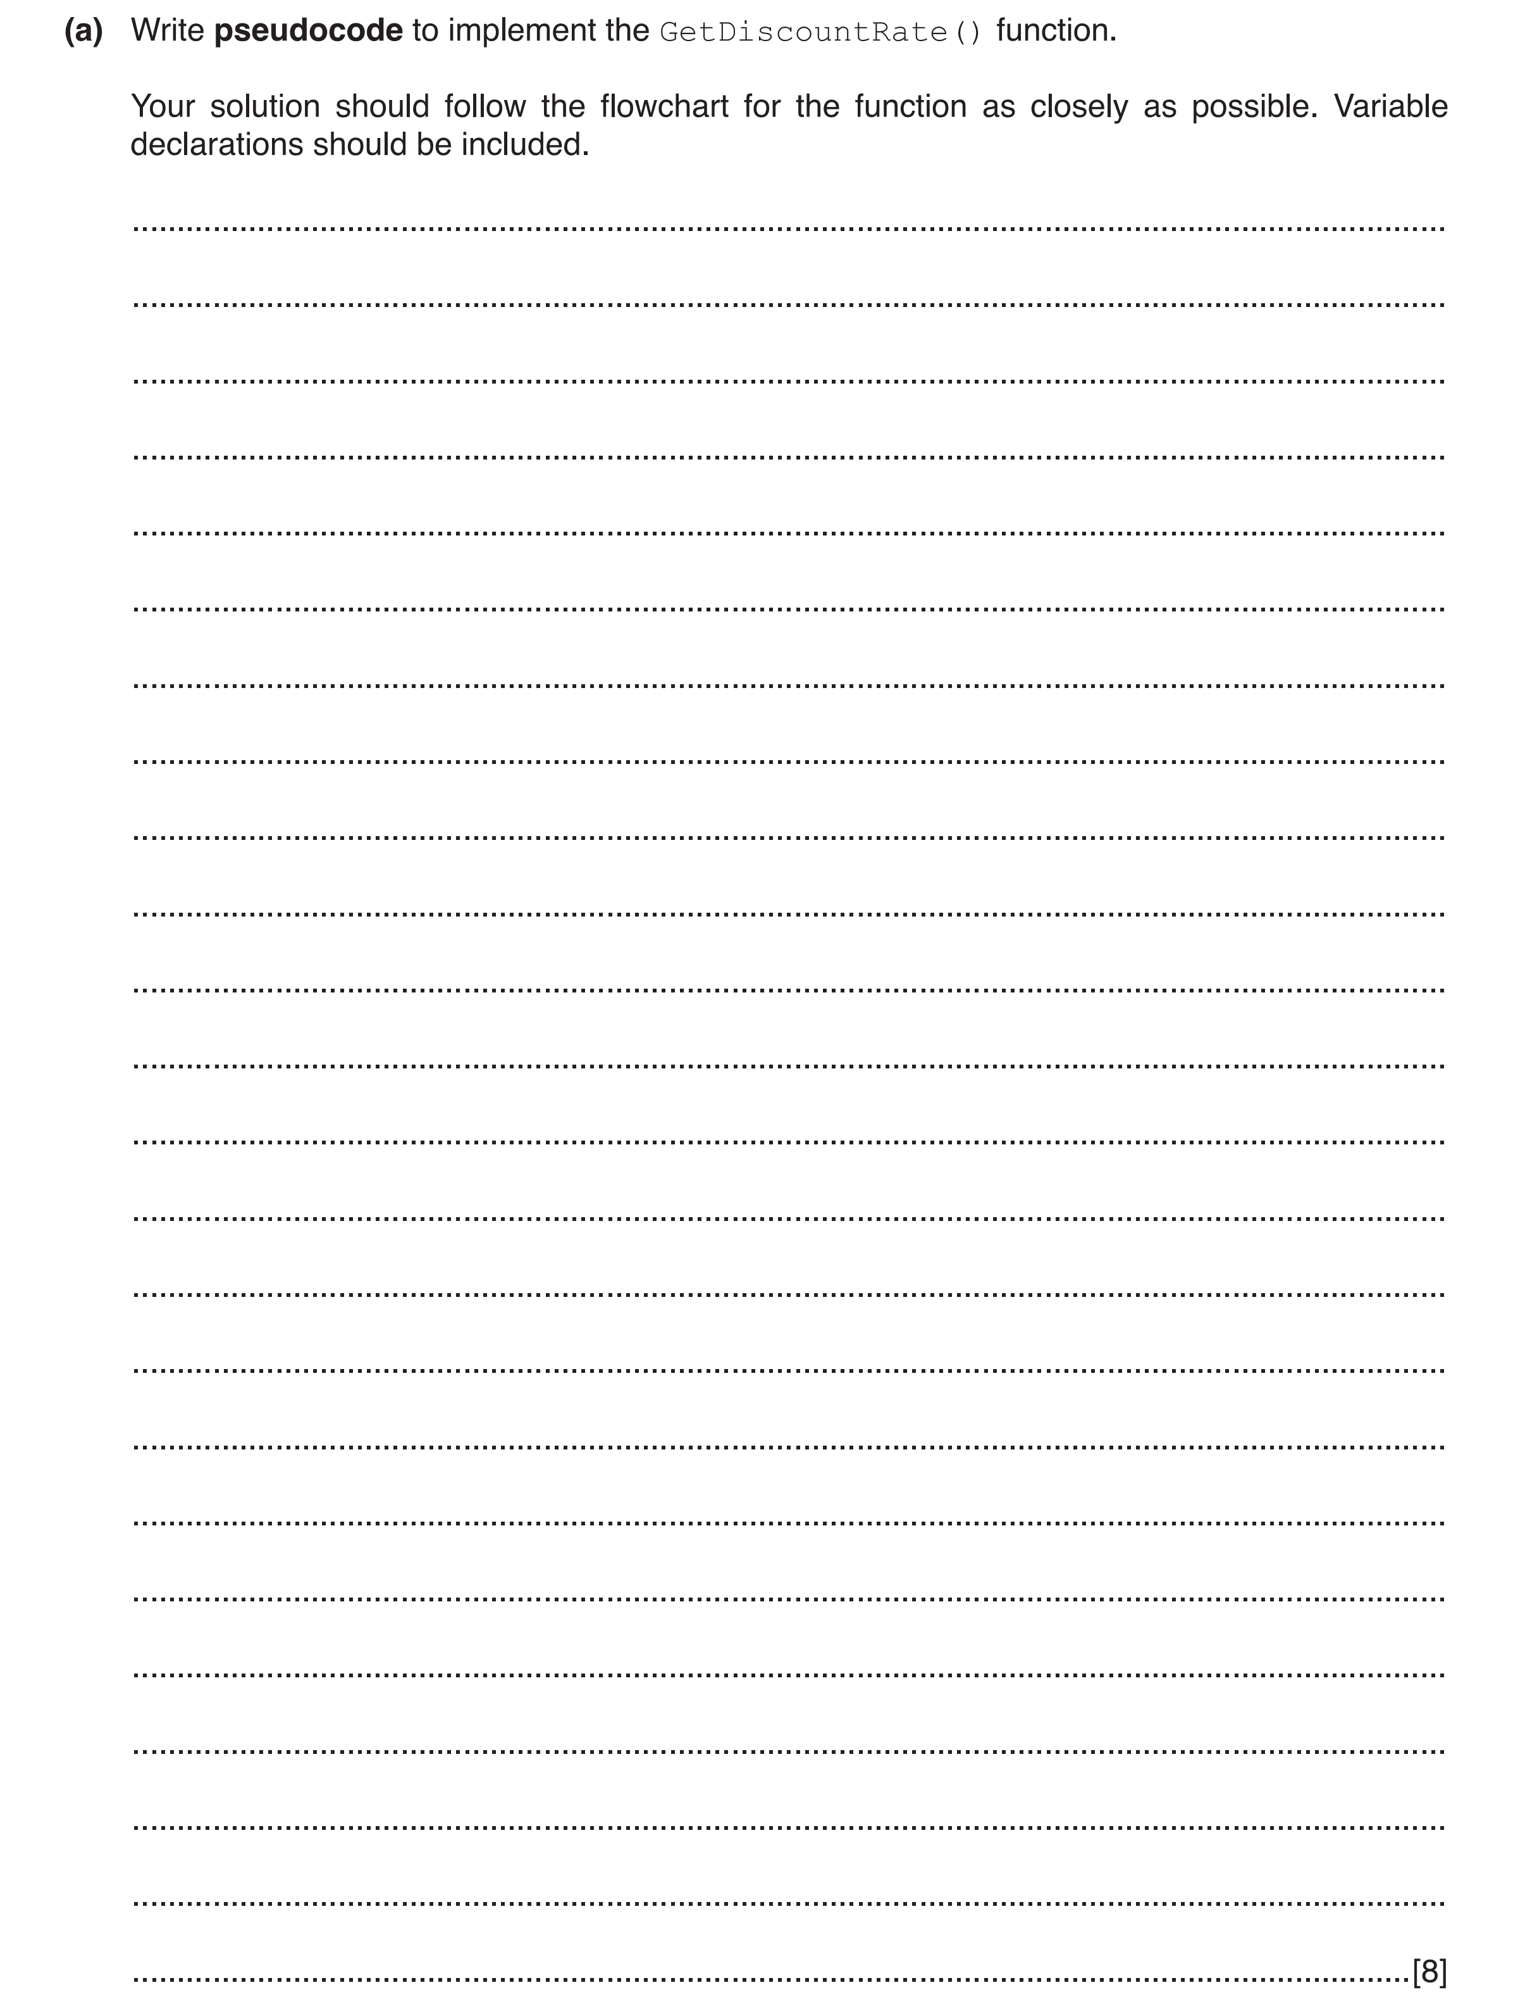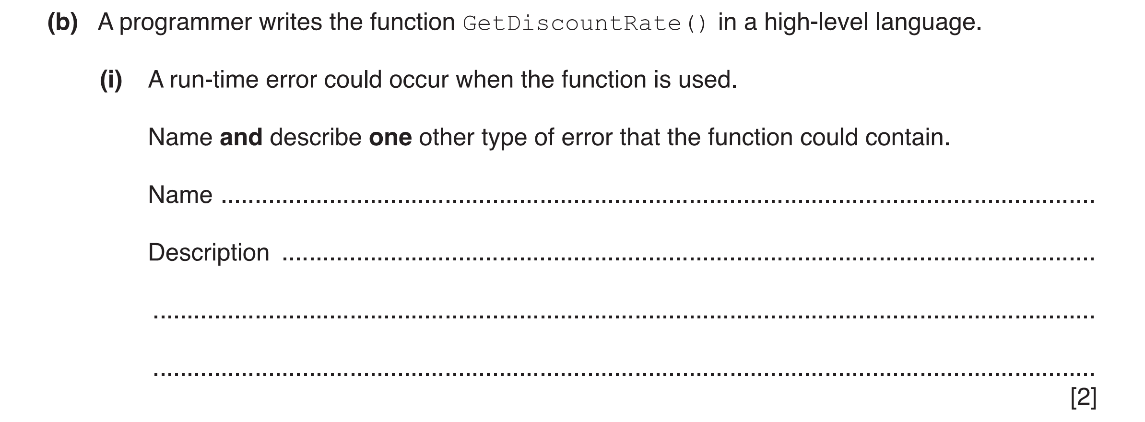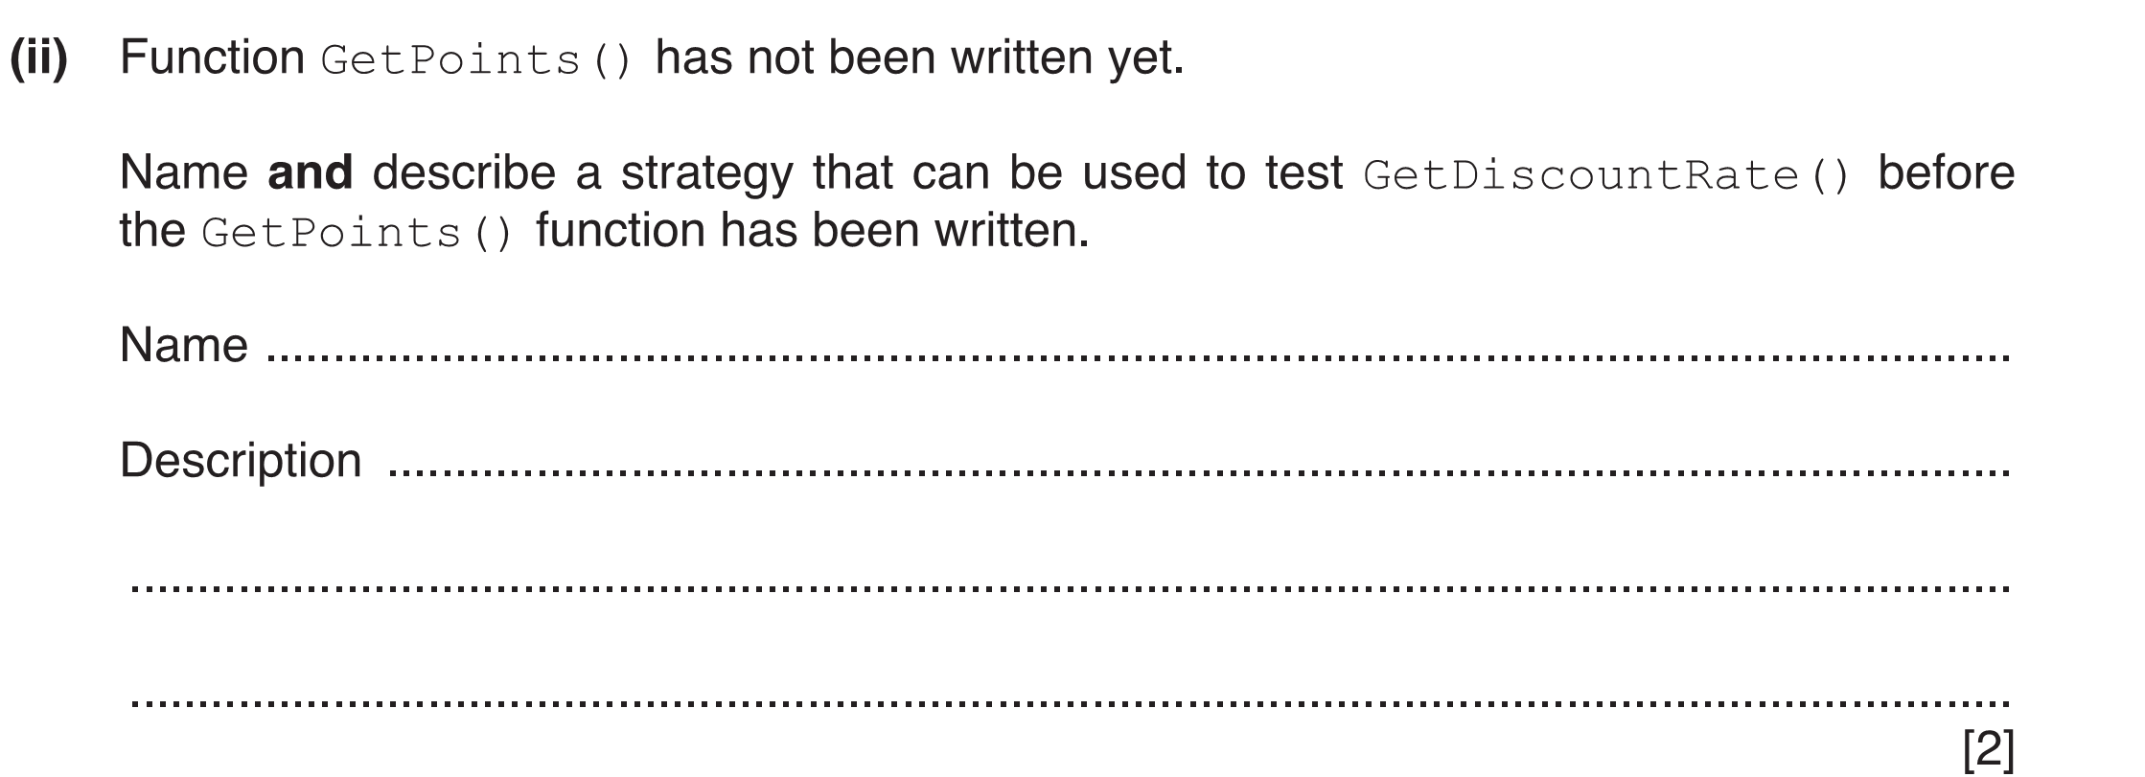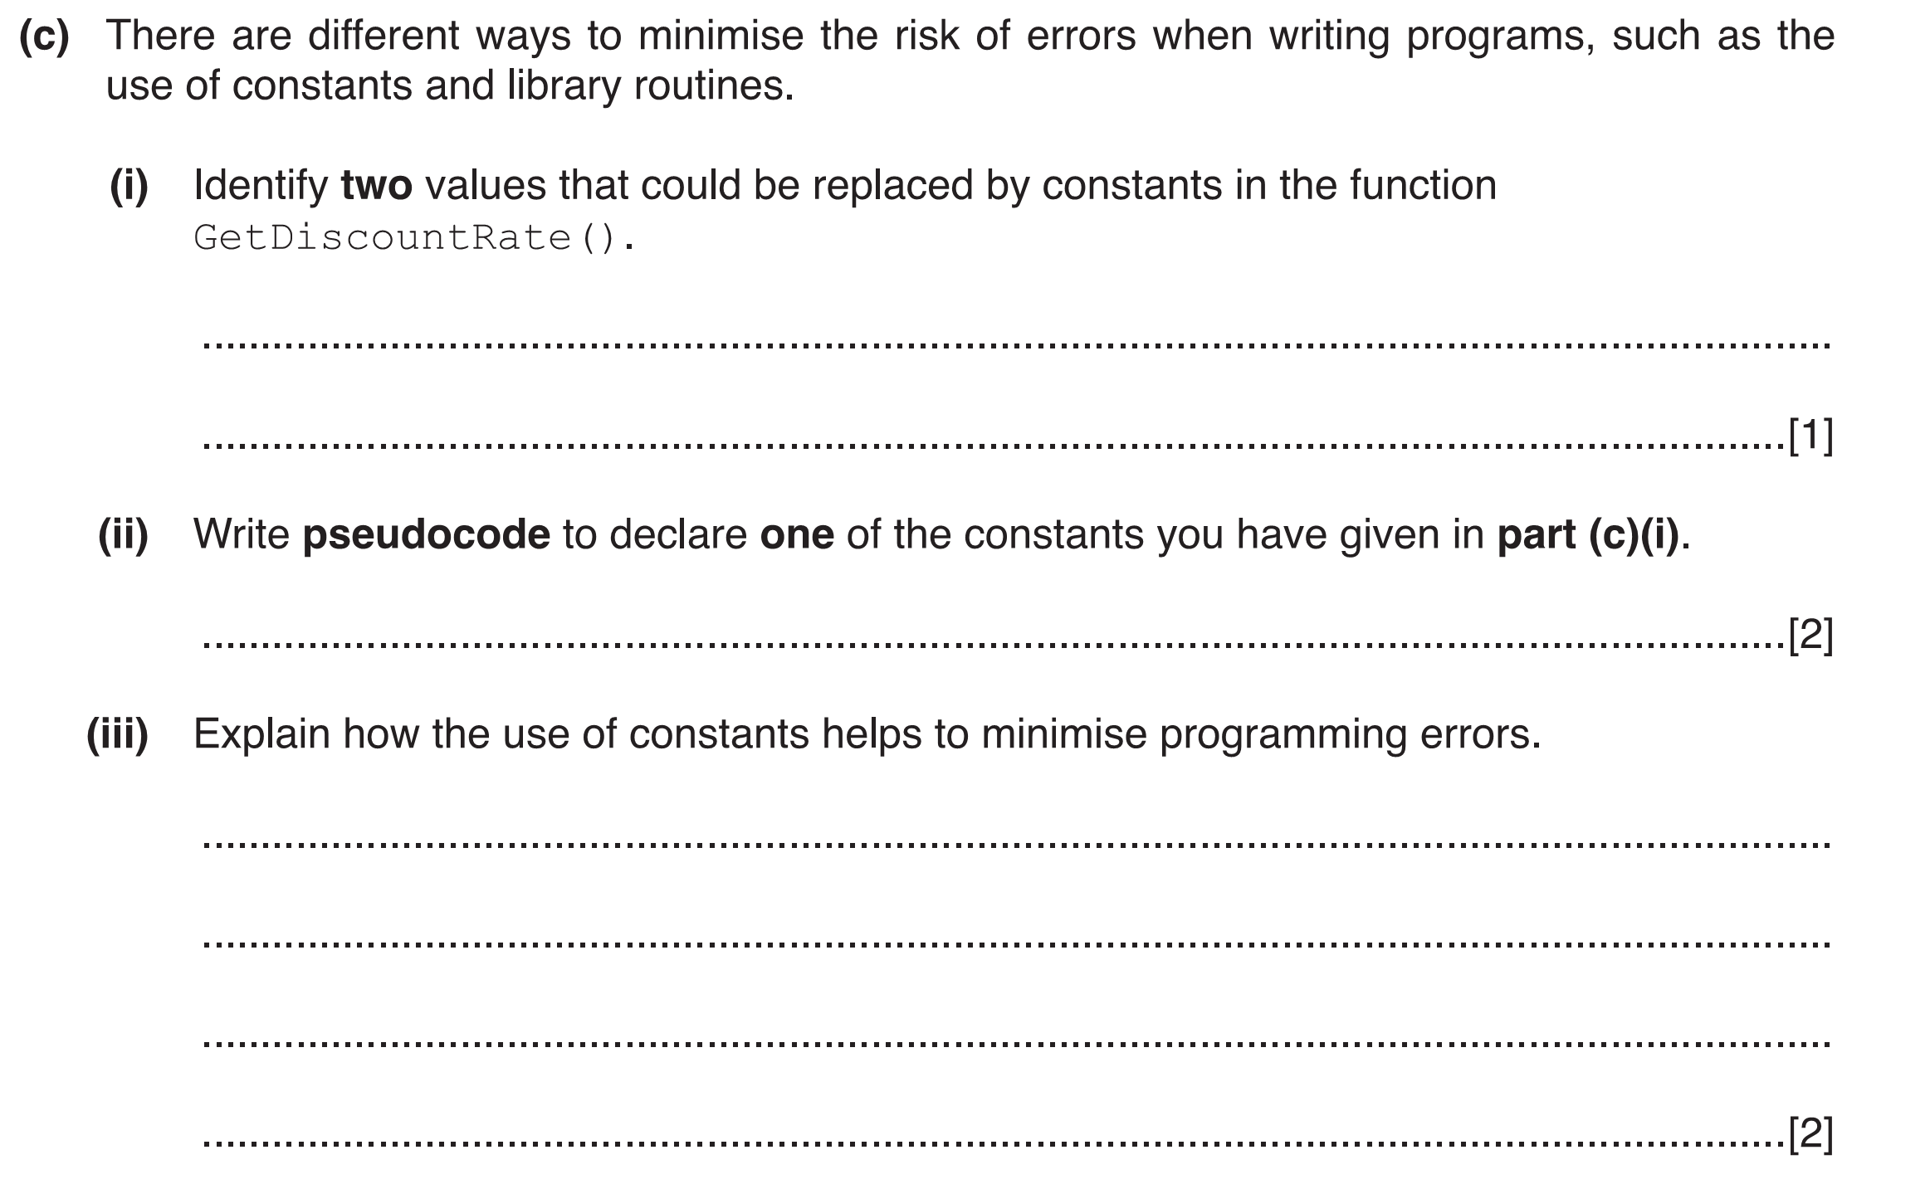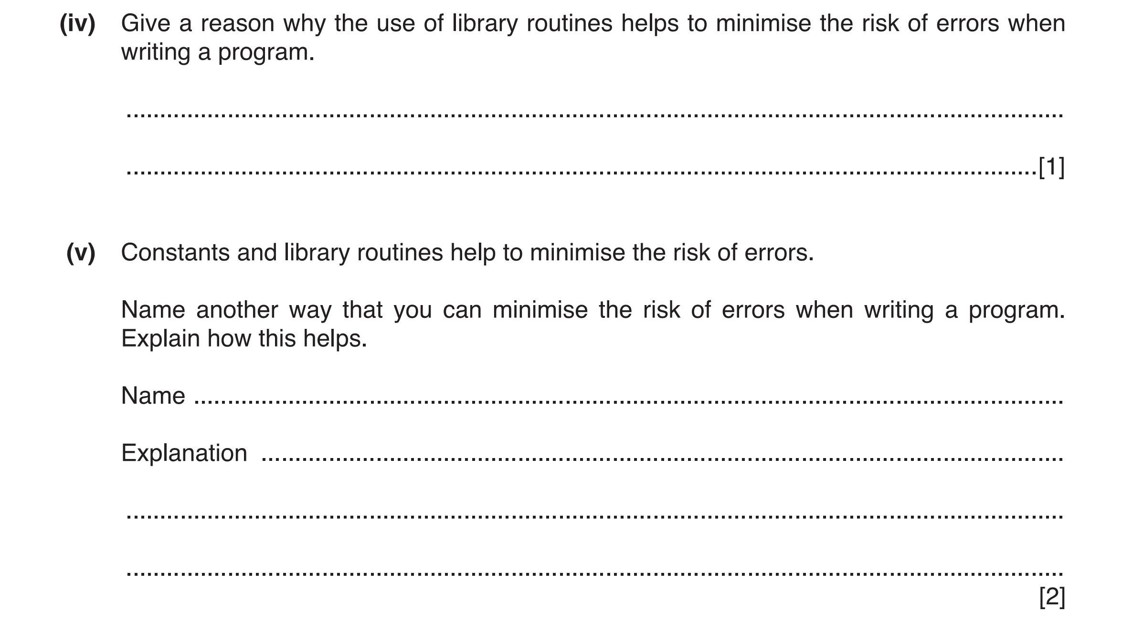
[10]
[3]
[2]
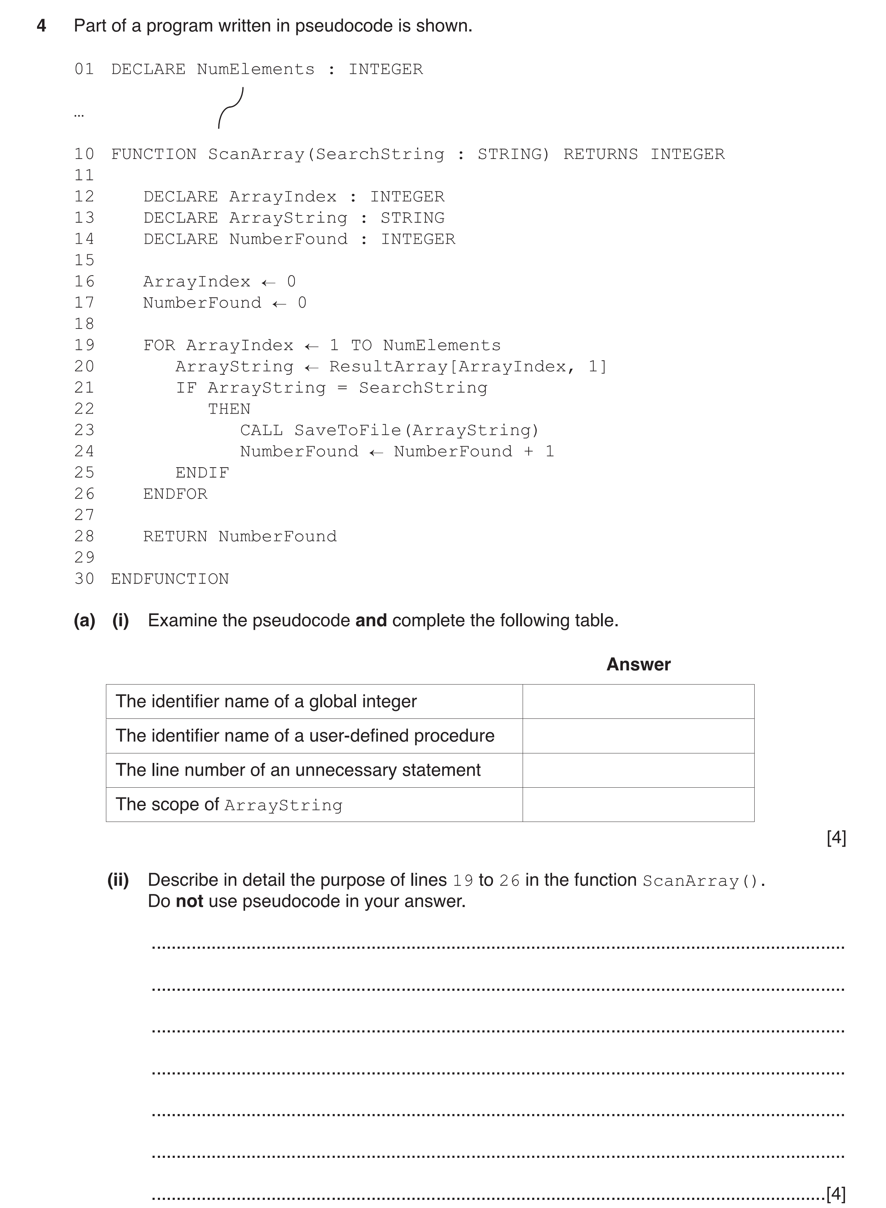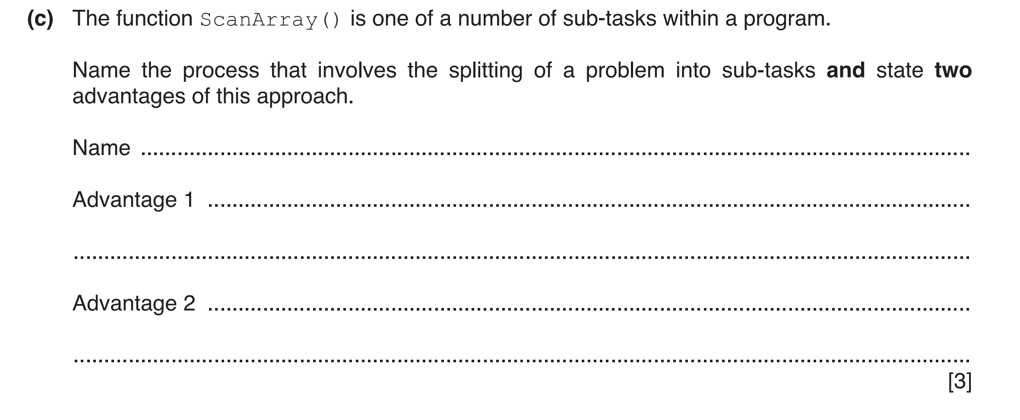(d) ResultArray is a 2D array of type STRING. It represents a table containing 100 rows and
2 columns. Write pseudocode to declare ResultArray and set all elements to the value '*' ....................................................................................................................................................
...................................................................................................................................................
...................................................................................................................................................
...................................................................................................................................................
...................................................................................................................................................
...................................................................................................................................................
...................................................................................................................................................
...............................................................................................................................................[3]
3

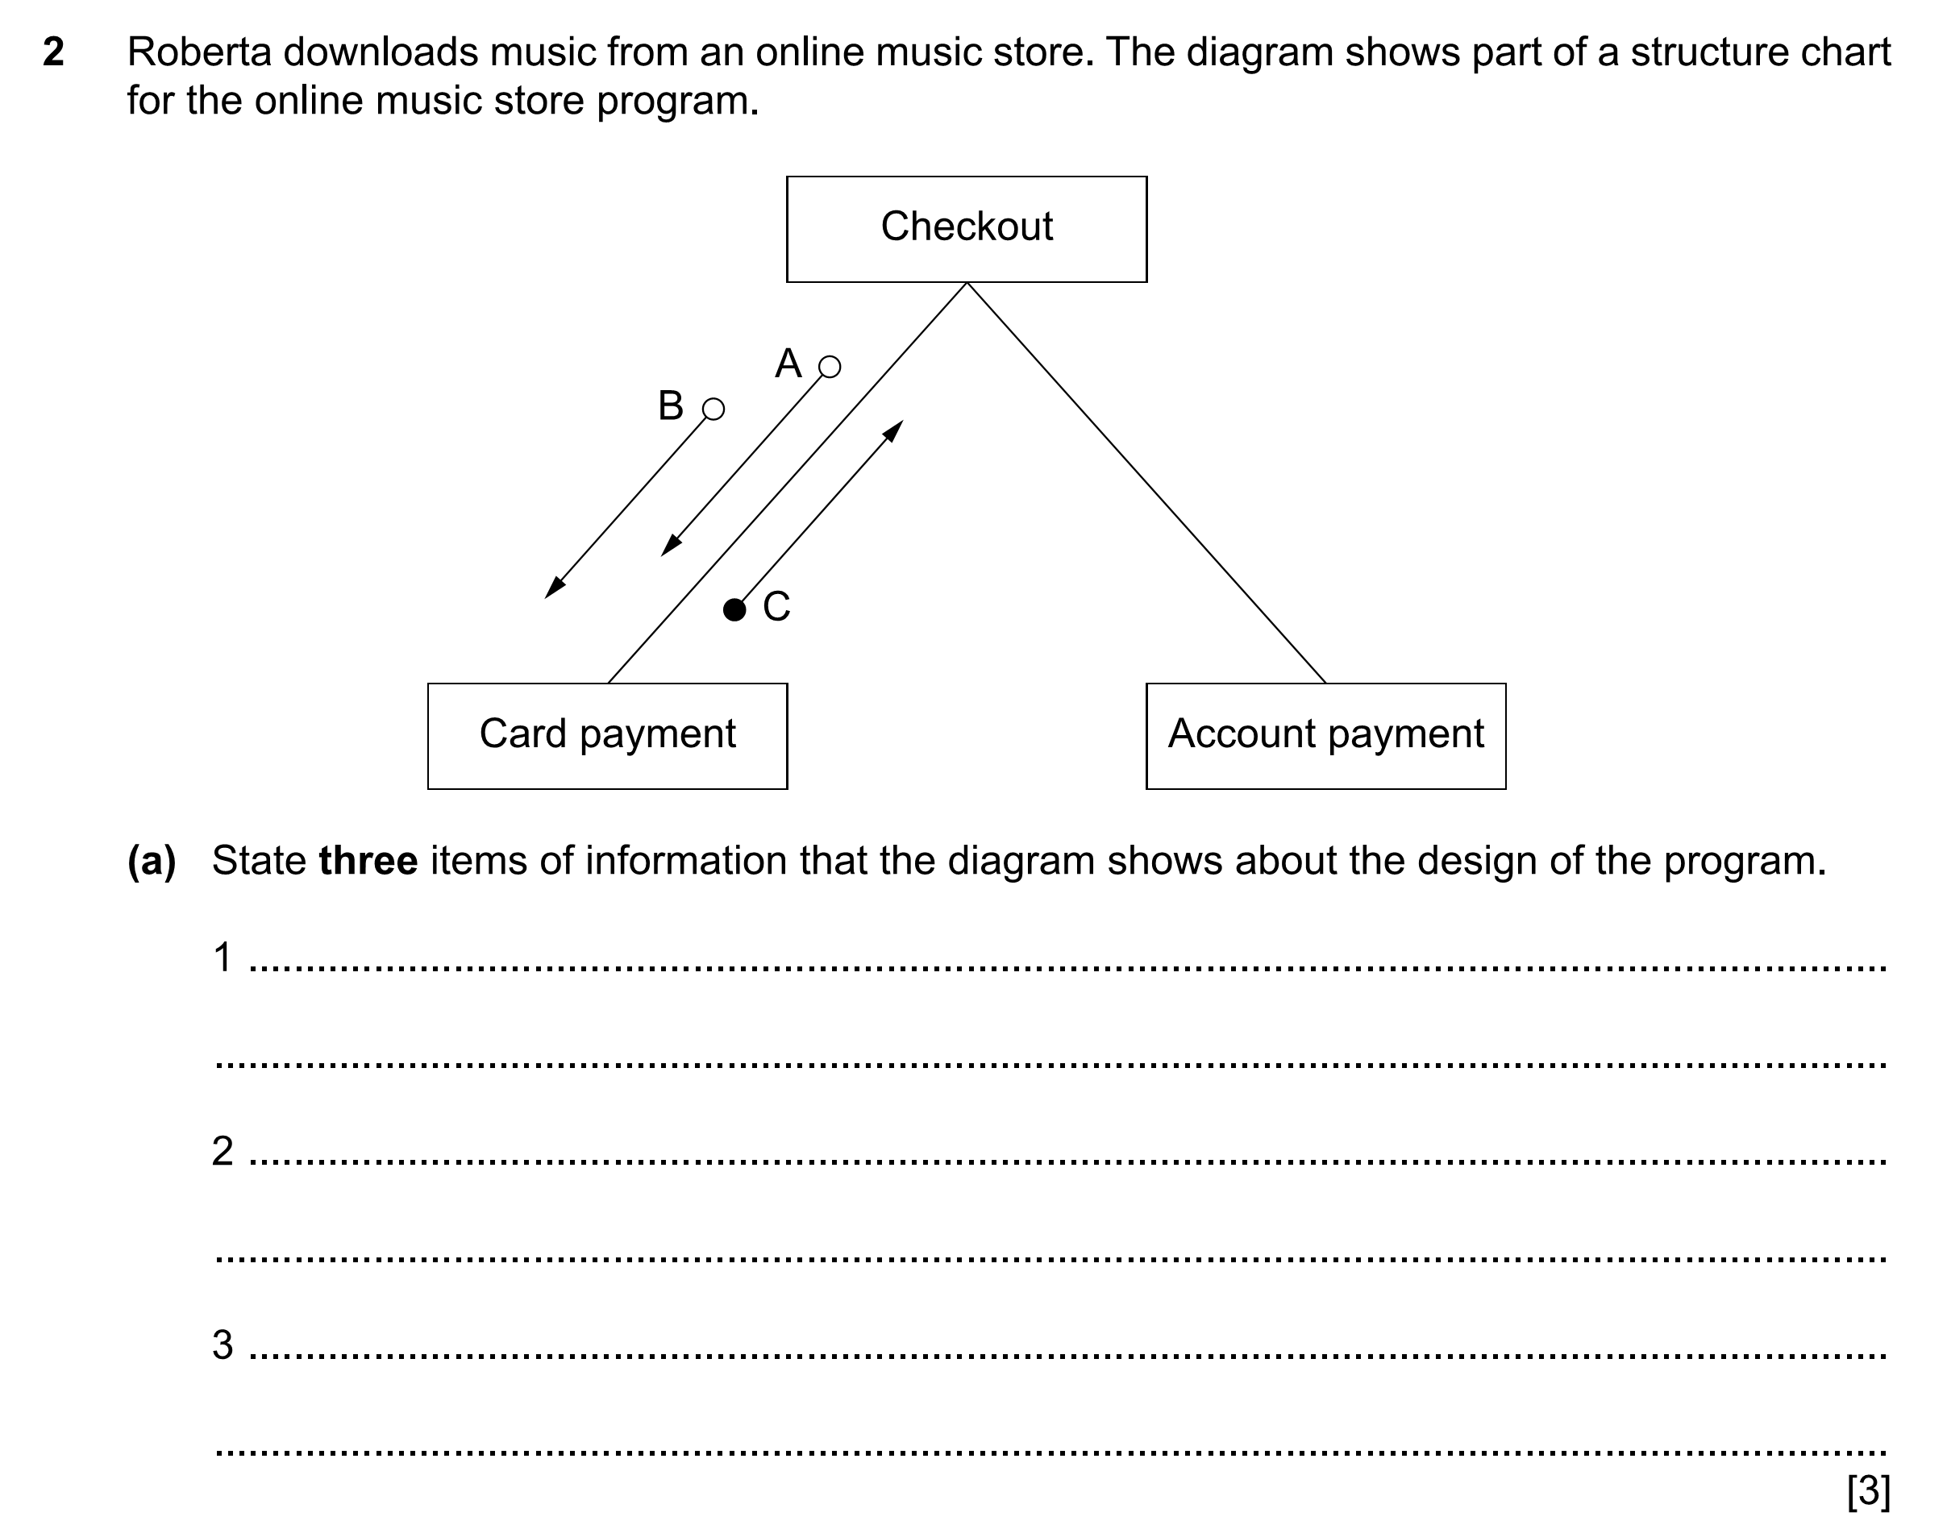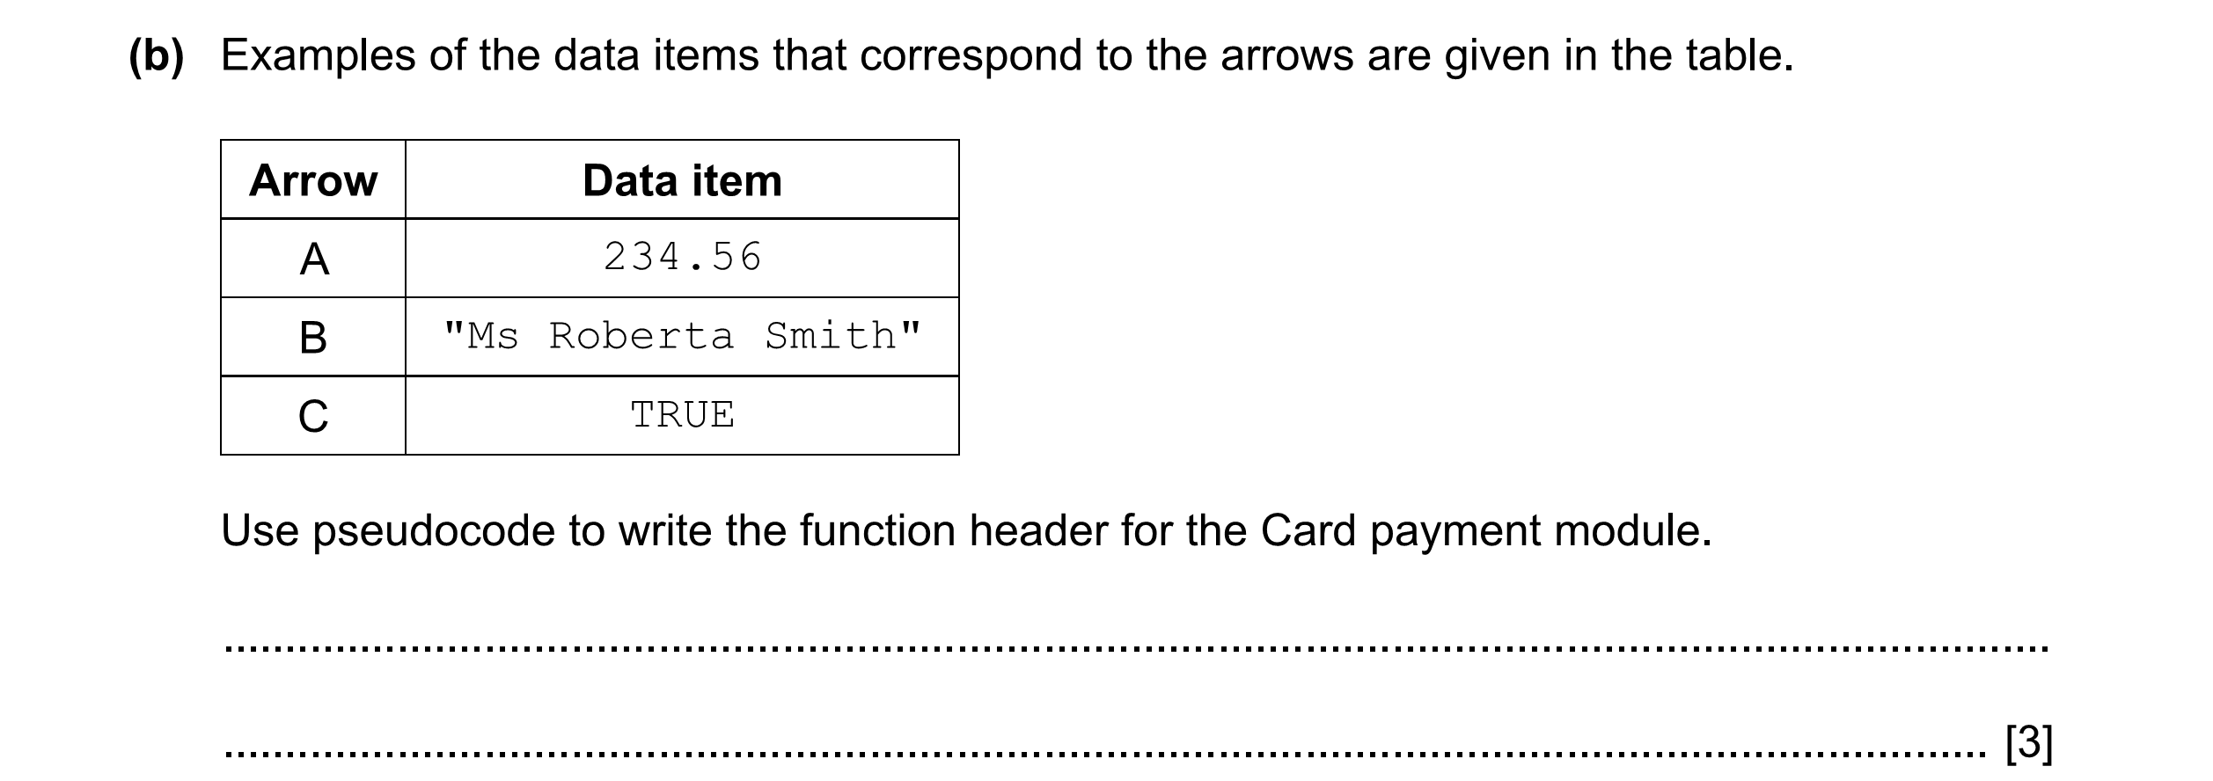
4

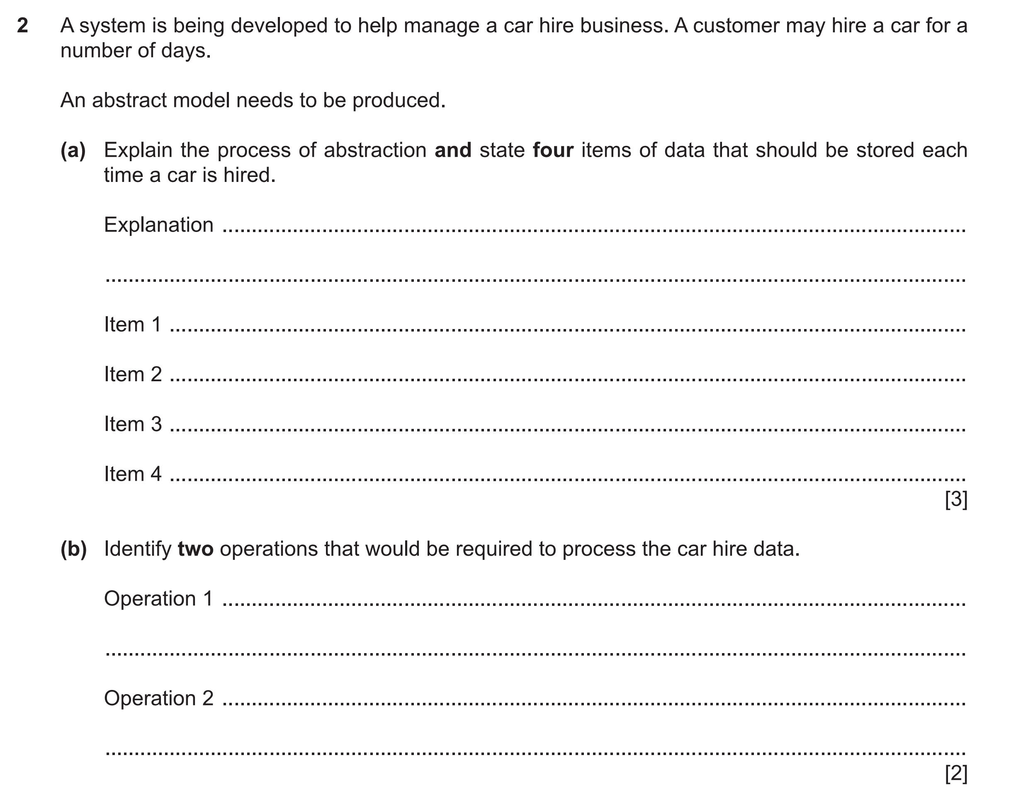
5

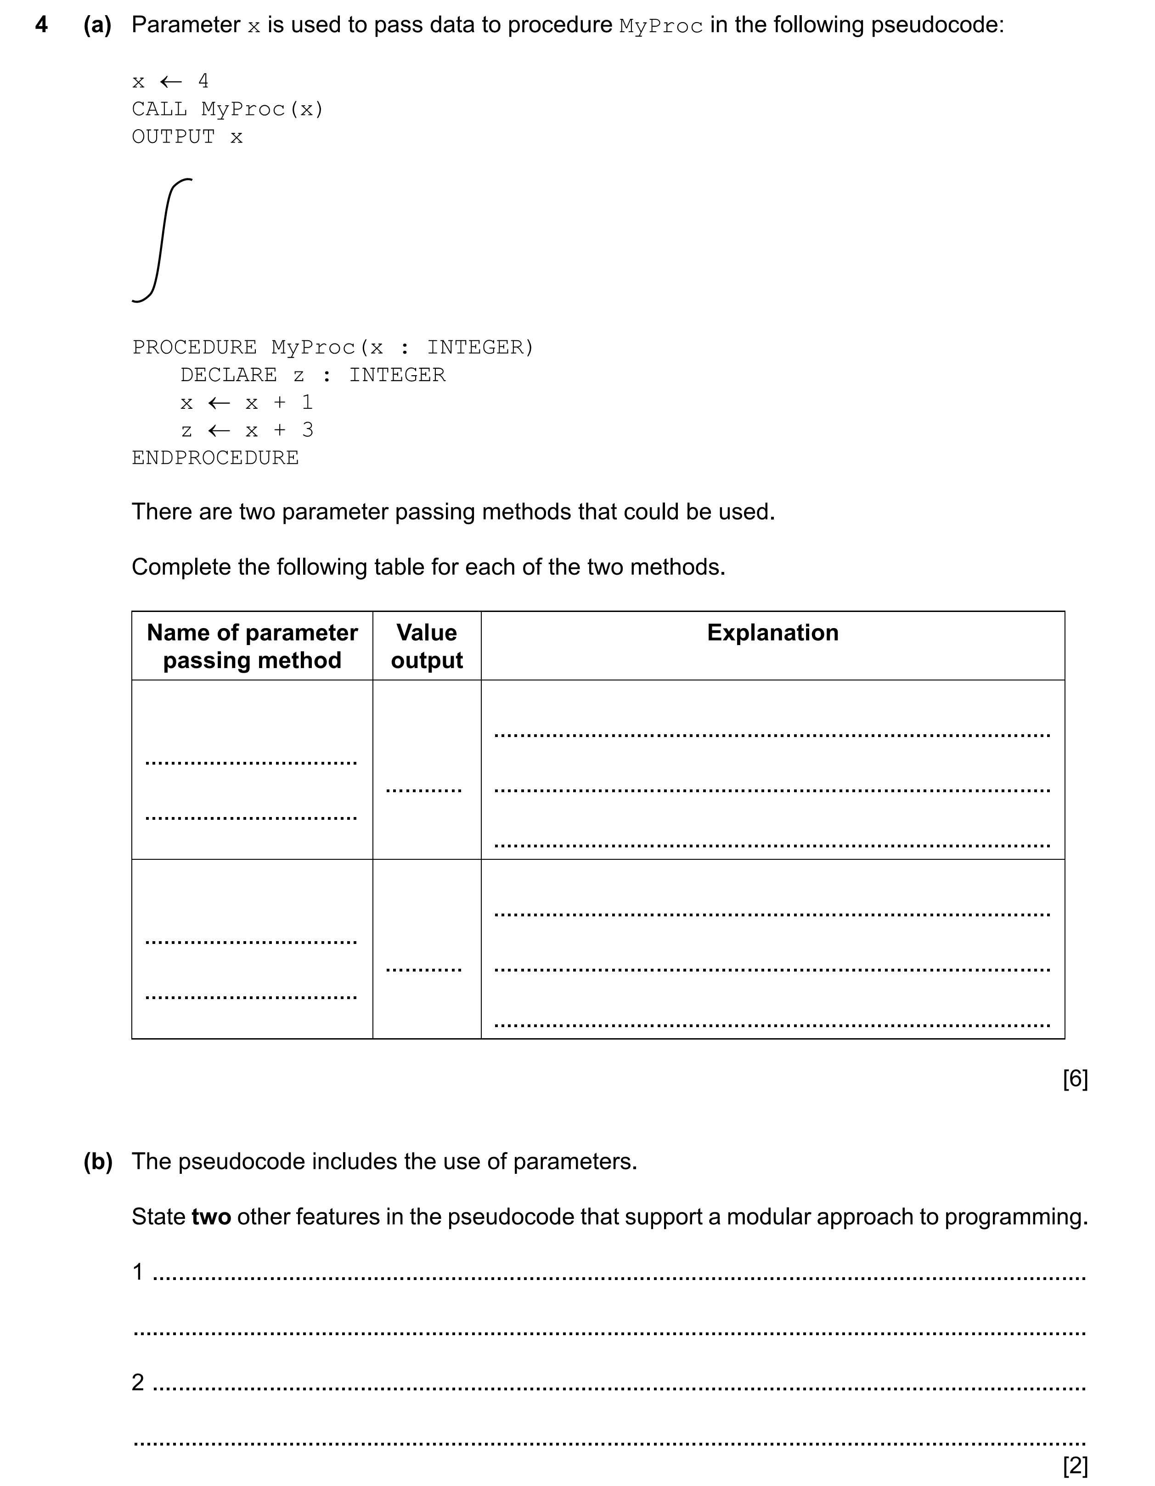
6

7 A company keeps details of its product items in a 1D array, StockData. The array consists of 500
elements of type StockRecord. The record fields of StockRecord are:
Field | Typical value
ProductCode | "AGR24-B"
Price | 100.75
NumberInStock | 20
ExpiryDate | 31/12/2025

(a) Write pseudocode to declare the record structure StockRecord.
...................................................................................................................................................
...................................................................................................................................................
...................................................................................................................................................
...................................................................................................................................................
.............................................................................................................................................. [5]
(b) Write pseudocode to declare the StockData array.
...................................................................................................................................................
.............................................................................................................................................. [3]
(c) Write pseudocode to modify the values to element 10 as follows:
• set the price to 106.99
• increase the number in stock by 20
...................................................................................................................................................
...................................................................................................................................................
...................................................................................................................................................
.............................................................................................................................................. [3]

(d) A stock report program is developed.
Write pseudocode to output the information for each stock item that has a price of at least
100. Output the information as follows:
Product Code: AGR24-B Number in Stock: 20
...................................................................................................................................................
...................................................................................................................................................
...................................................................................................................................................
...................................................................................................................................................
...................................................................................................................................................
...................................................................................................................................................
...................................................................................................................................................
.............................................................................................................................................. [5]

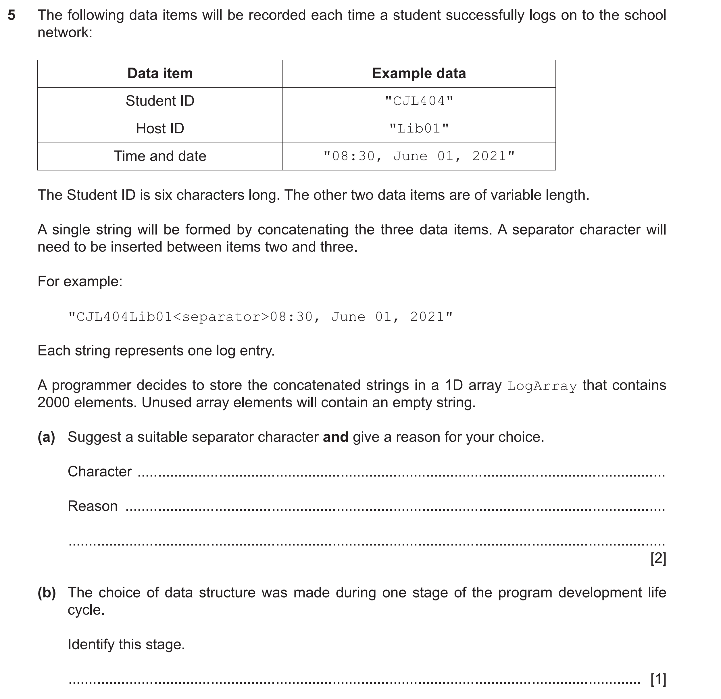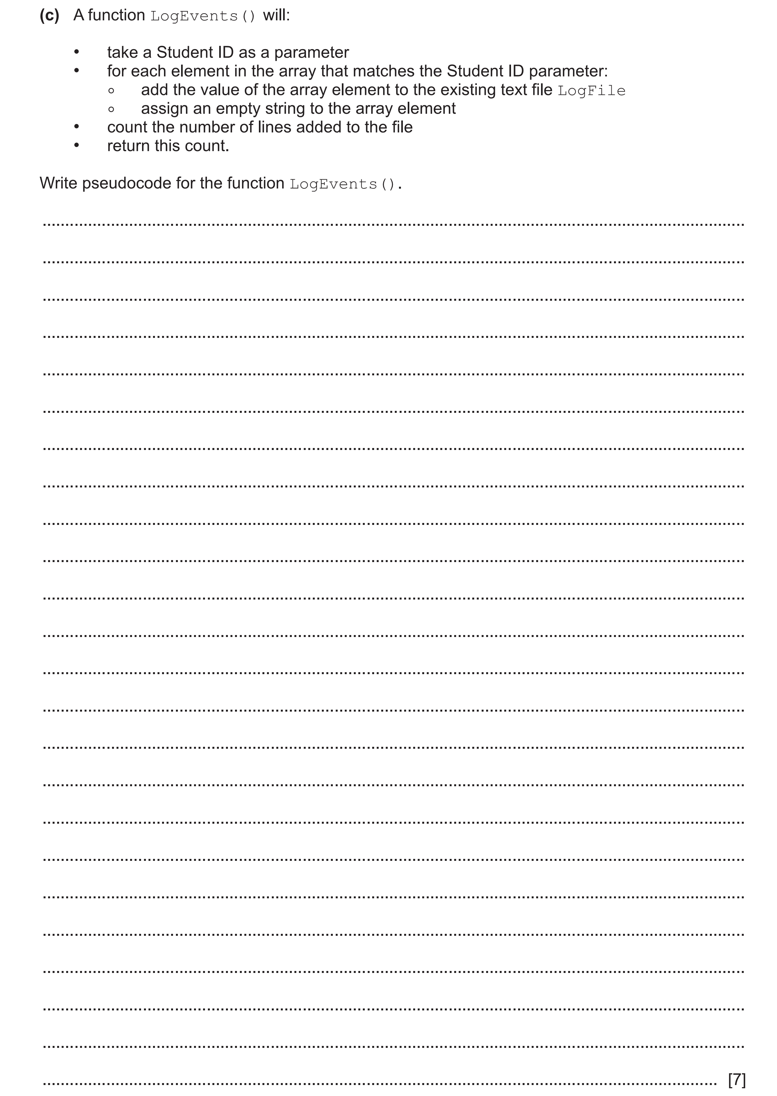
8
[8]

