


NAME……………………………………………………………………….CLASS……………….
COMPUTER SCIENCE
FORM 6 MID TERM EXAMINATION 2025
SYLLABUS CODE 9618 PAPER 1 AND 3 THEORY FUNDAMENTALS
TIME 1 HOUR 30 MINUTES DATE :
Candidates answer on the question paper

INSTRUCTIONS TO CANDIDATES
1.Write your name and class in the space at the top of this page.
2.Answer all the questions in the spaces provided. If additional space is required, you should use the lined page at the end of this question paper. The question number(s) must be clearly shown.
3.The use of an electronic calculator is not allowed
4.You are reminded of the need for clear presentation in your answers.
5.The number of marks is given in brackets [] at the end of each question or part question.

Total Marks : 77

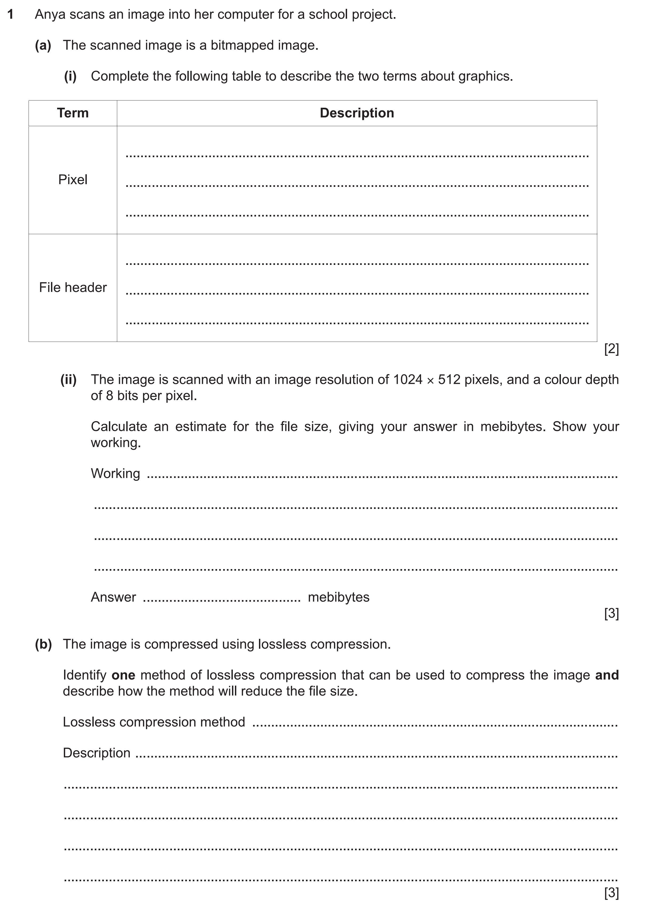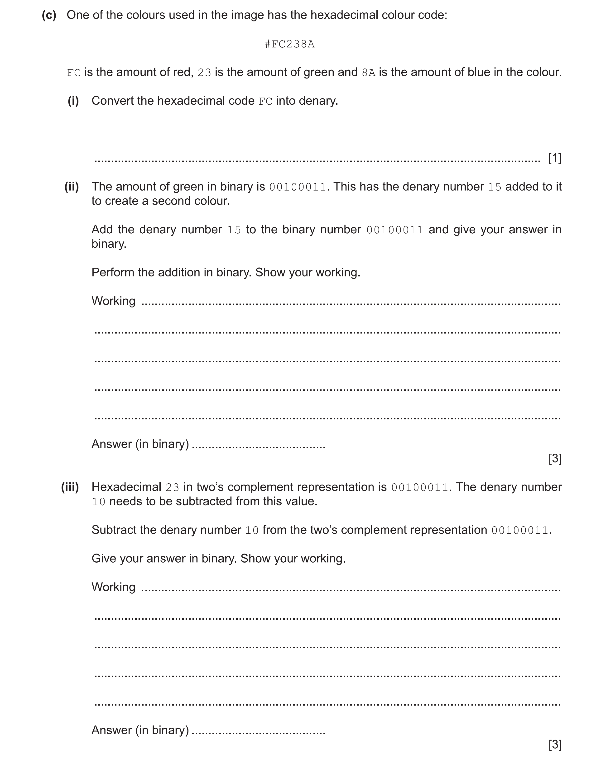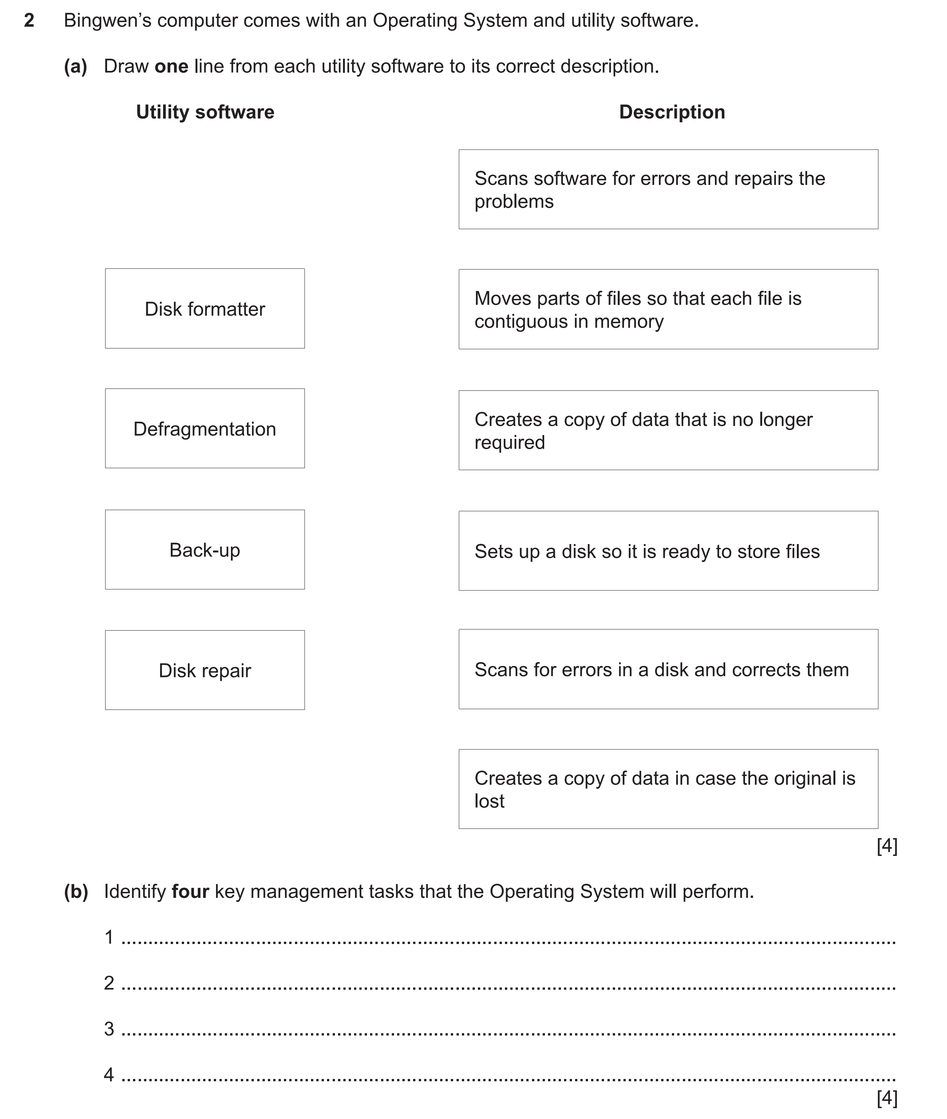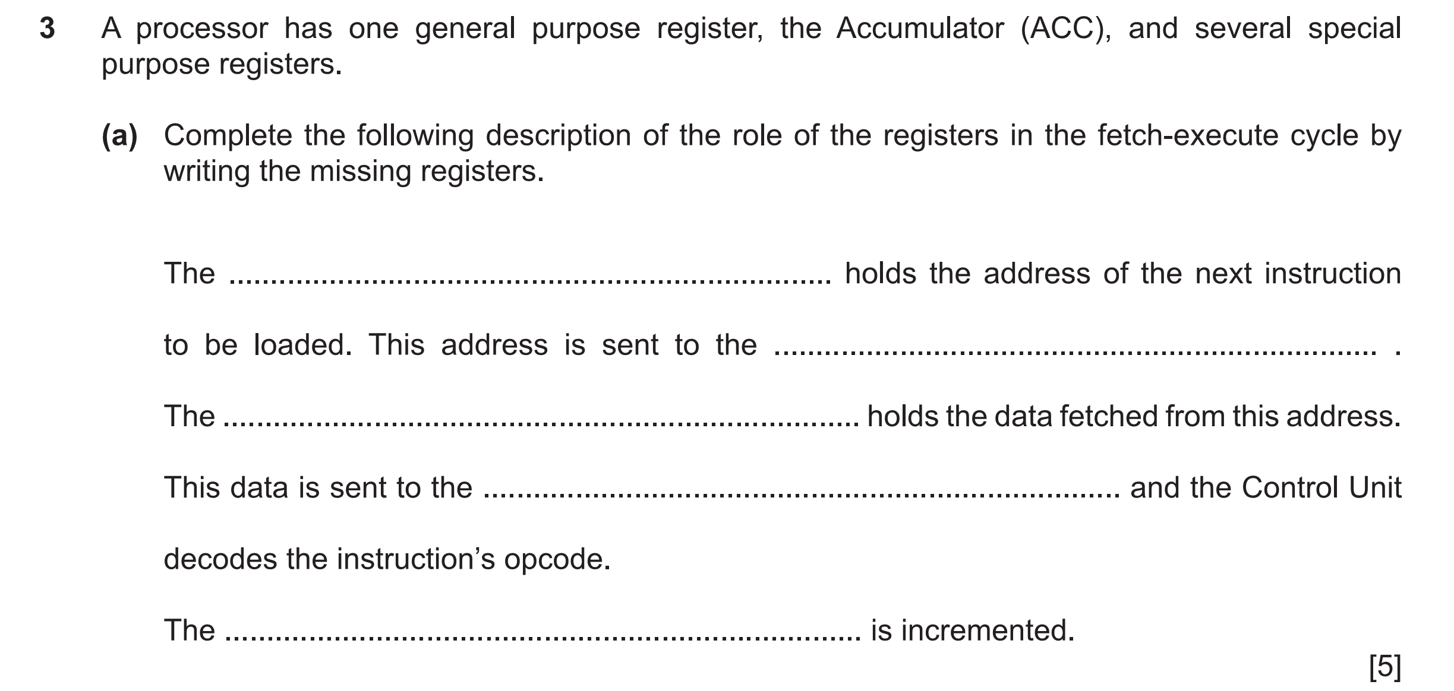
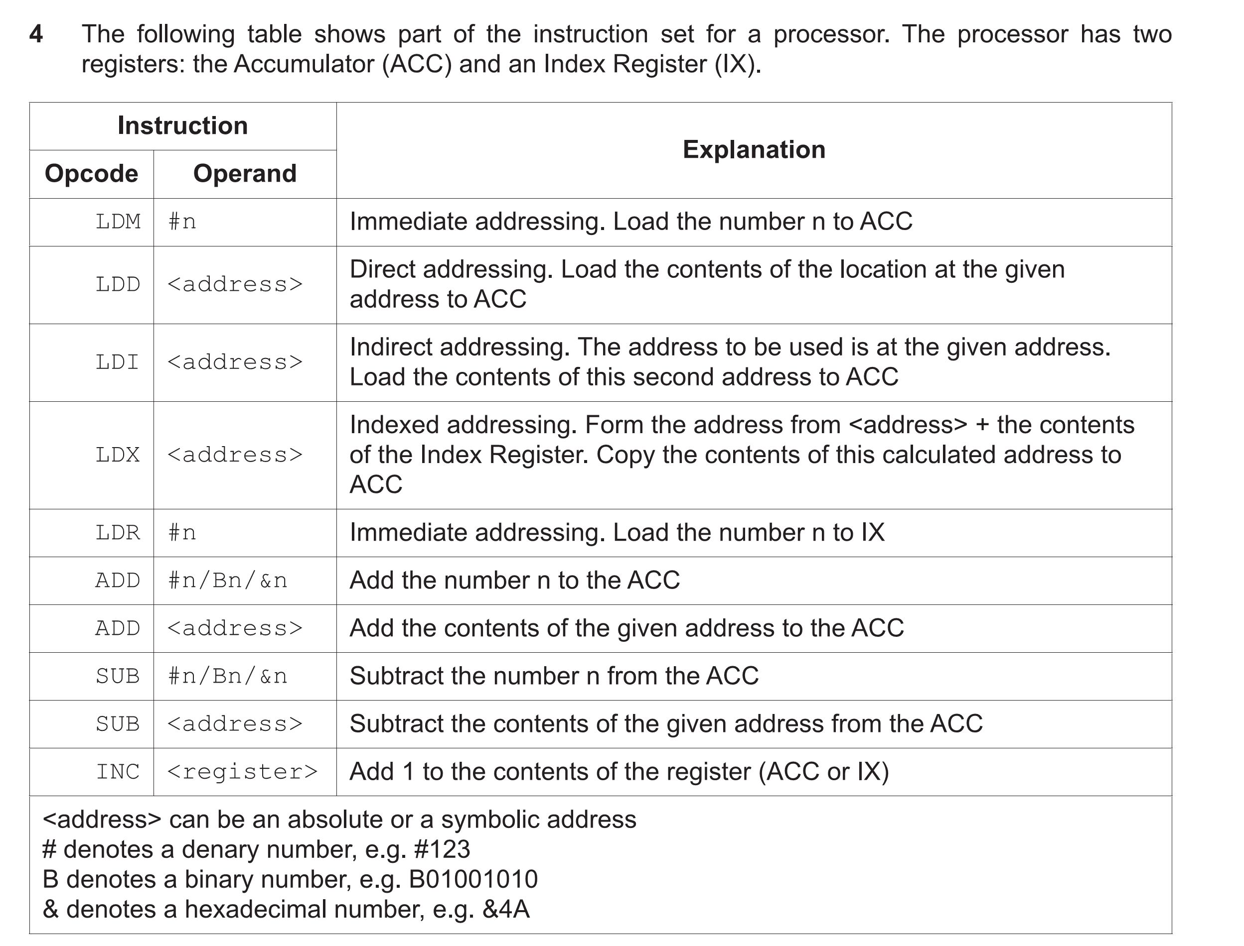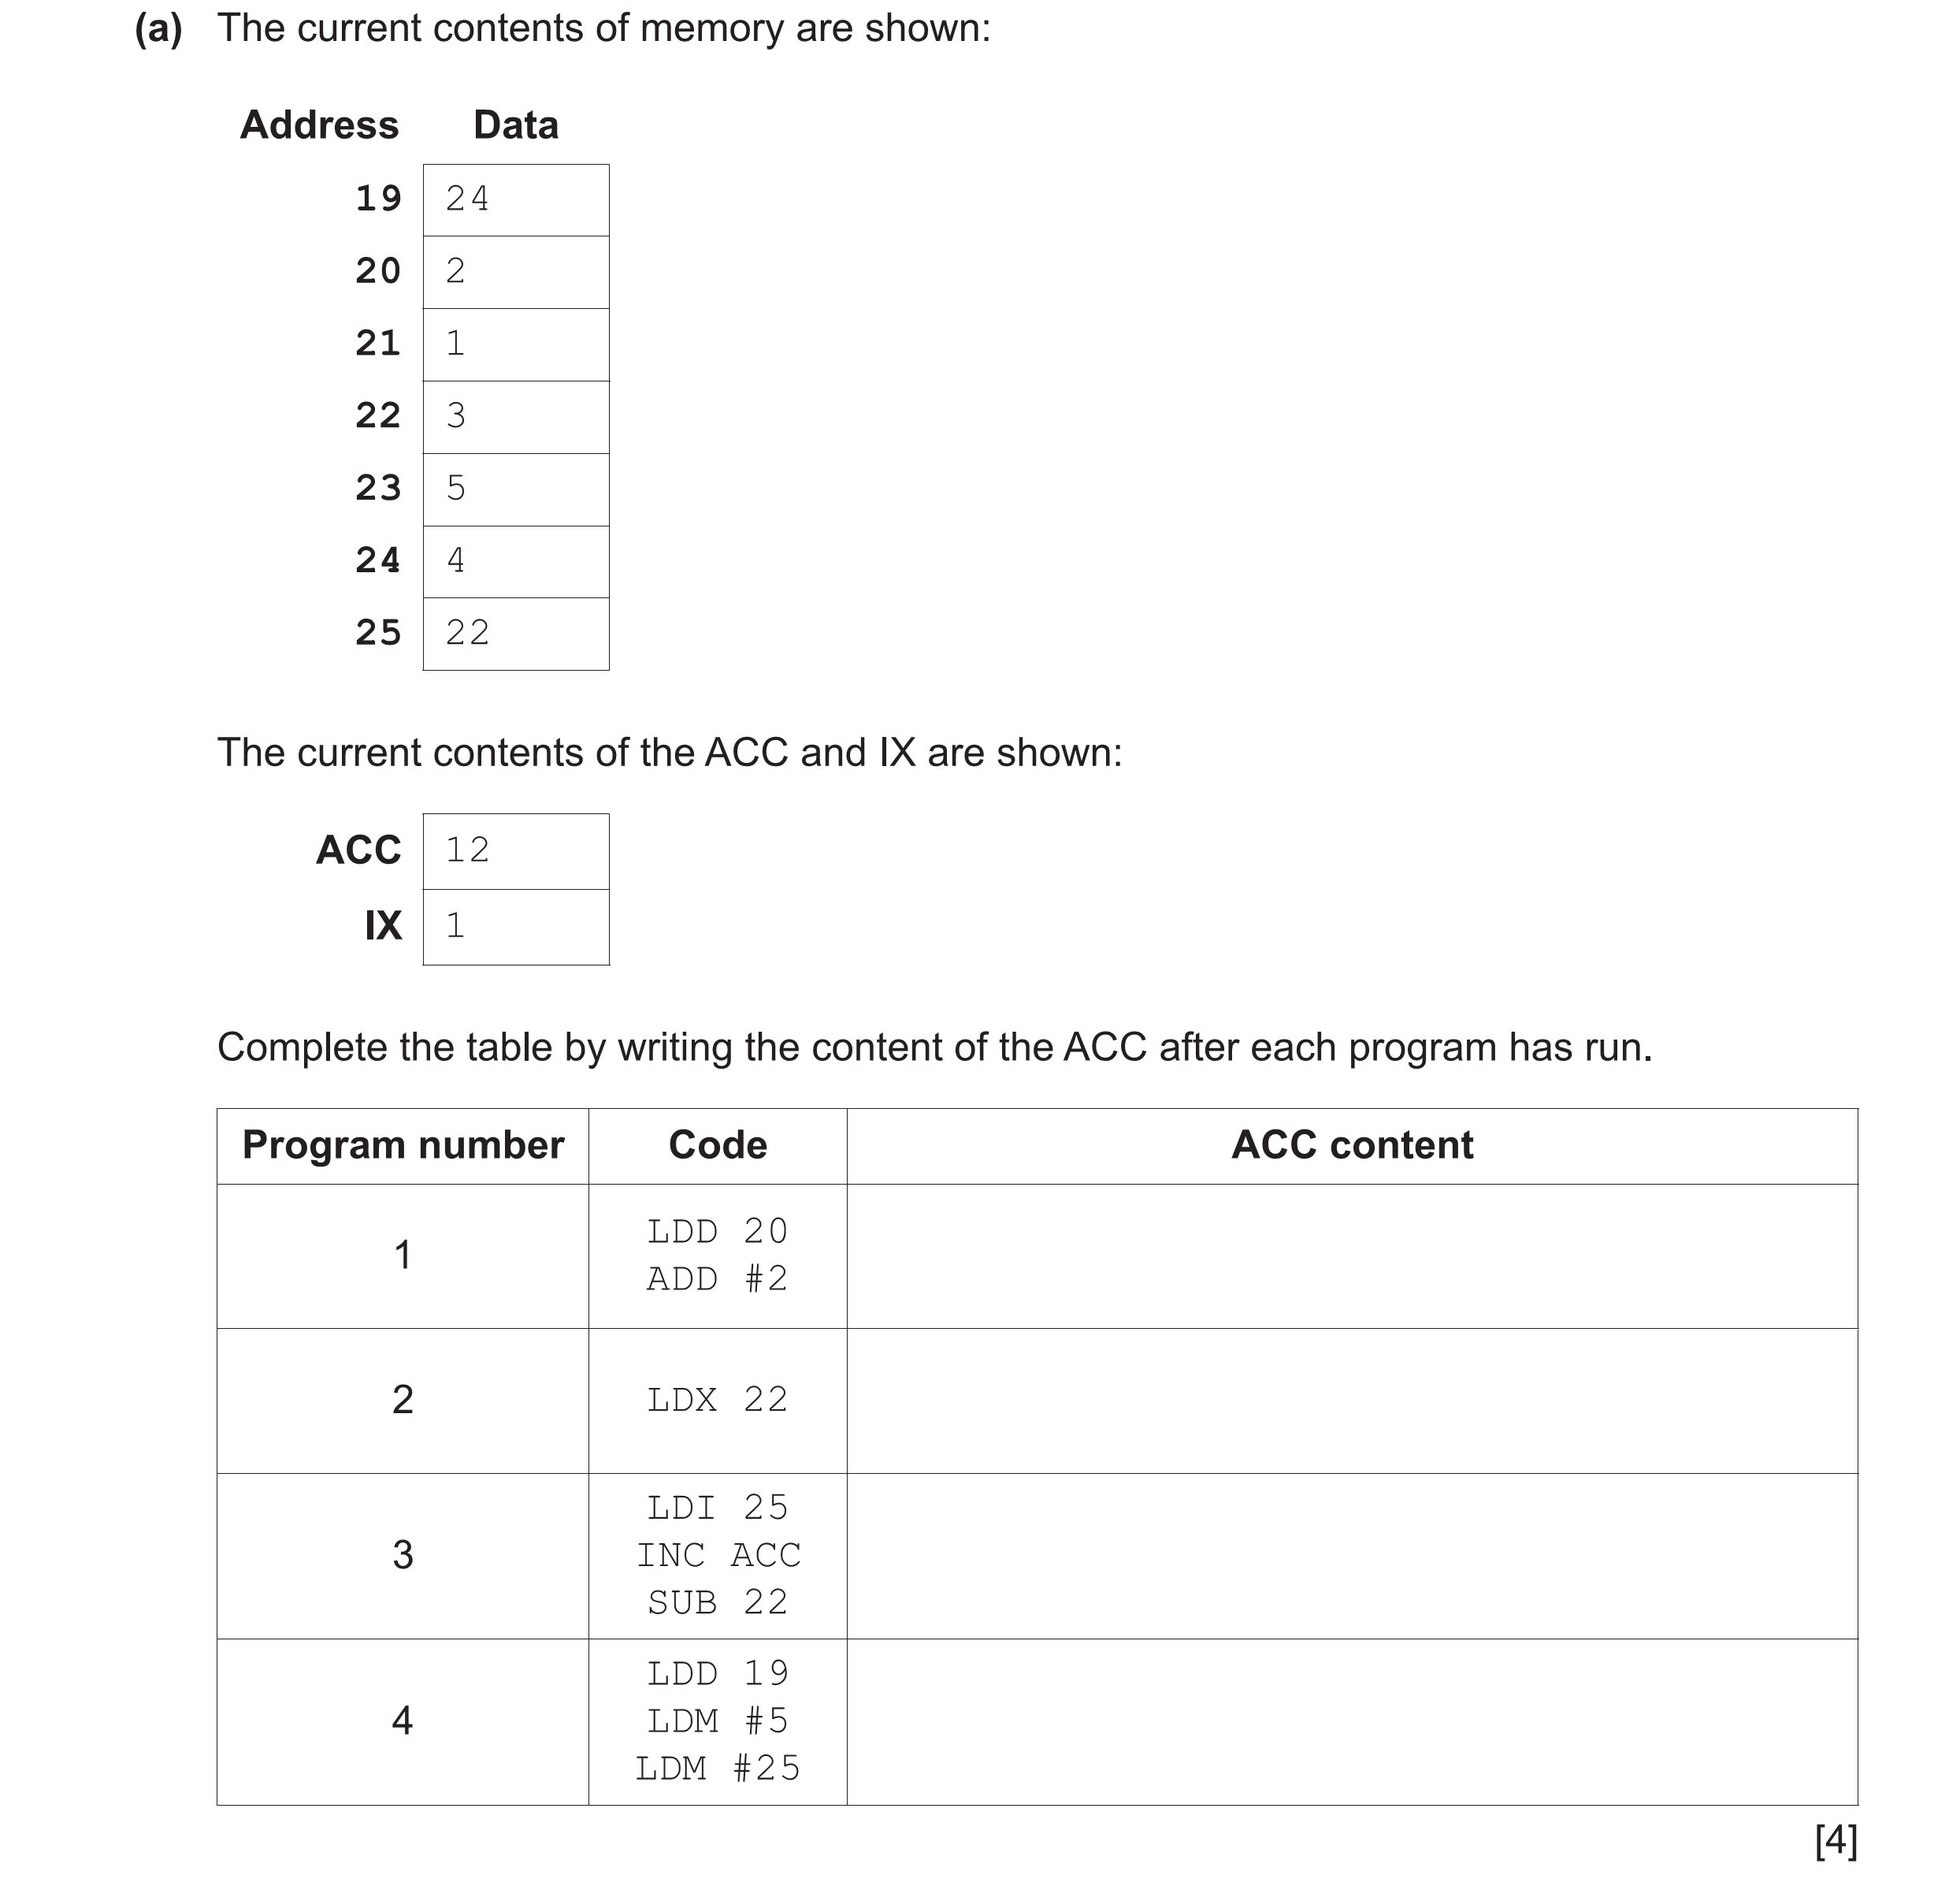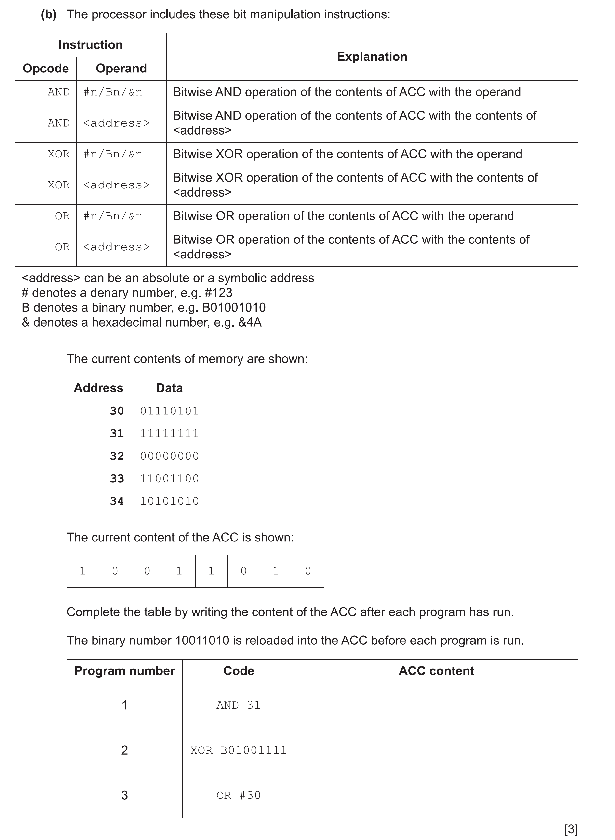

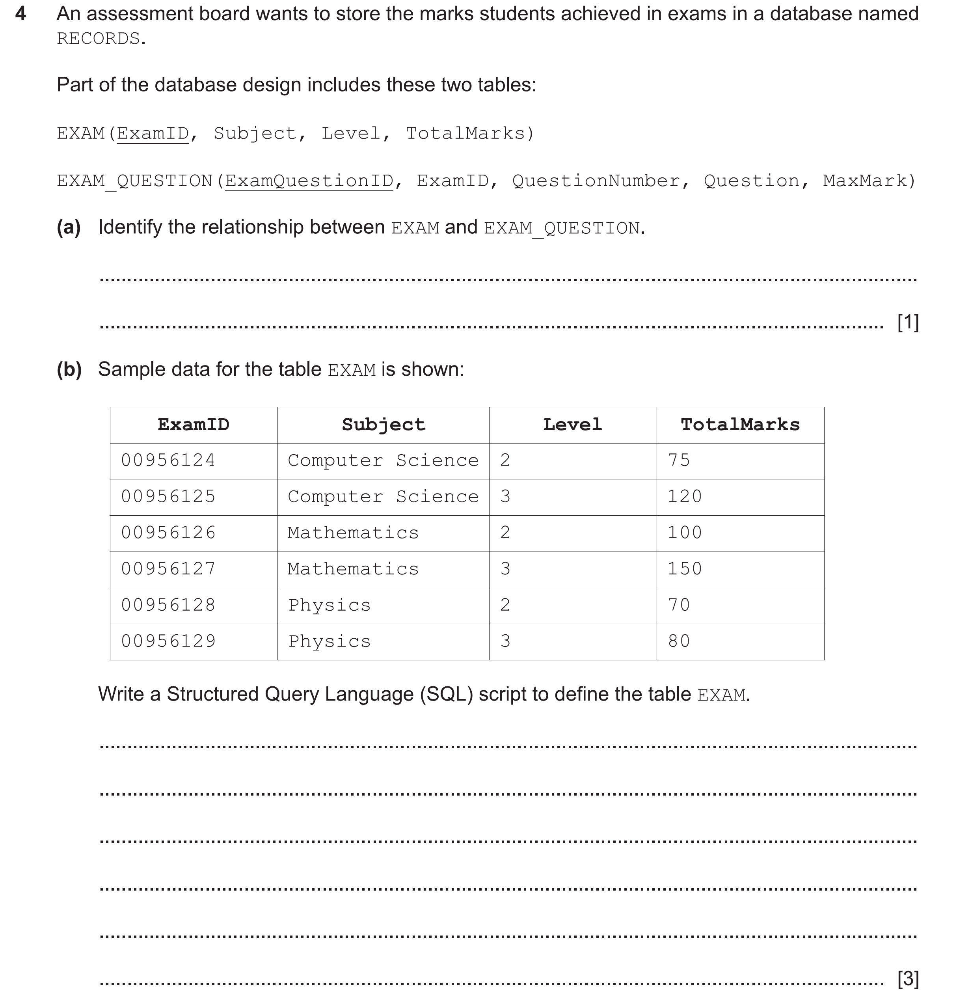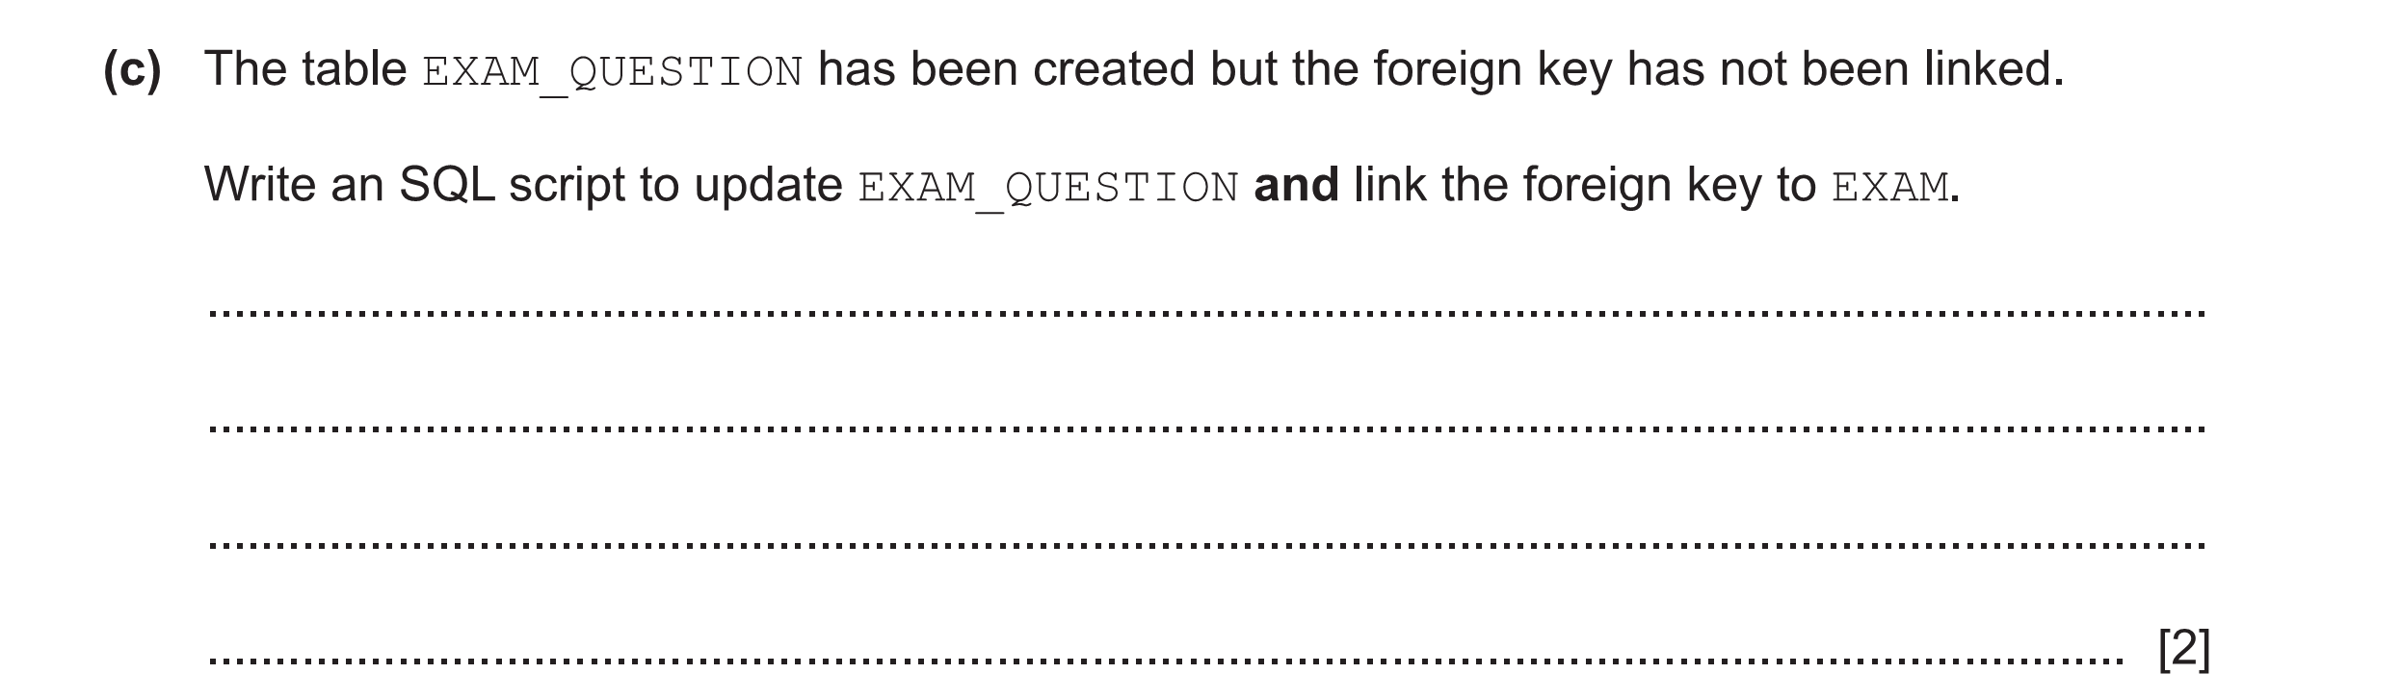
5

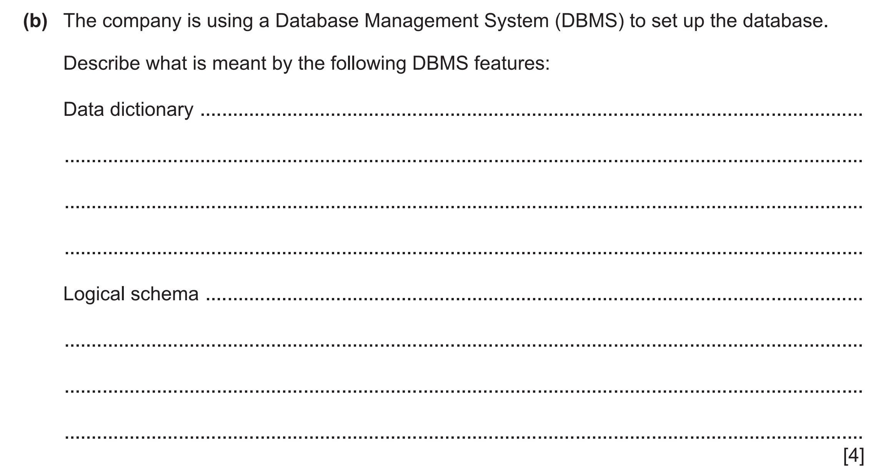

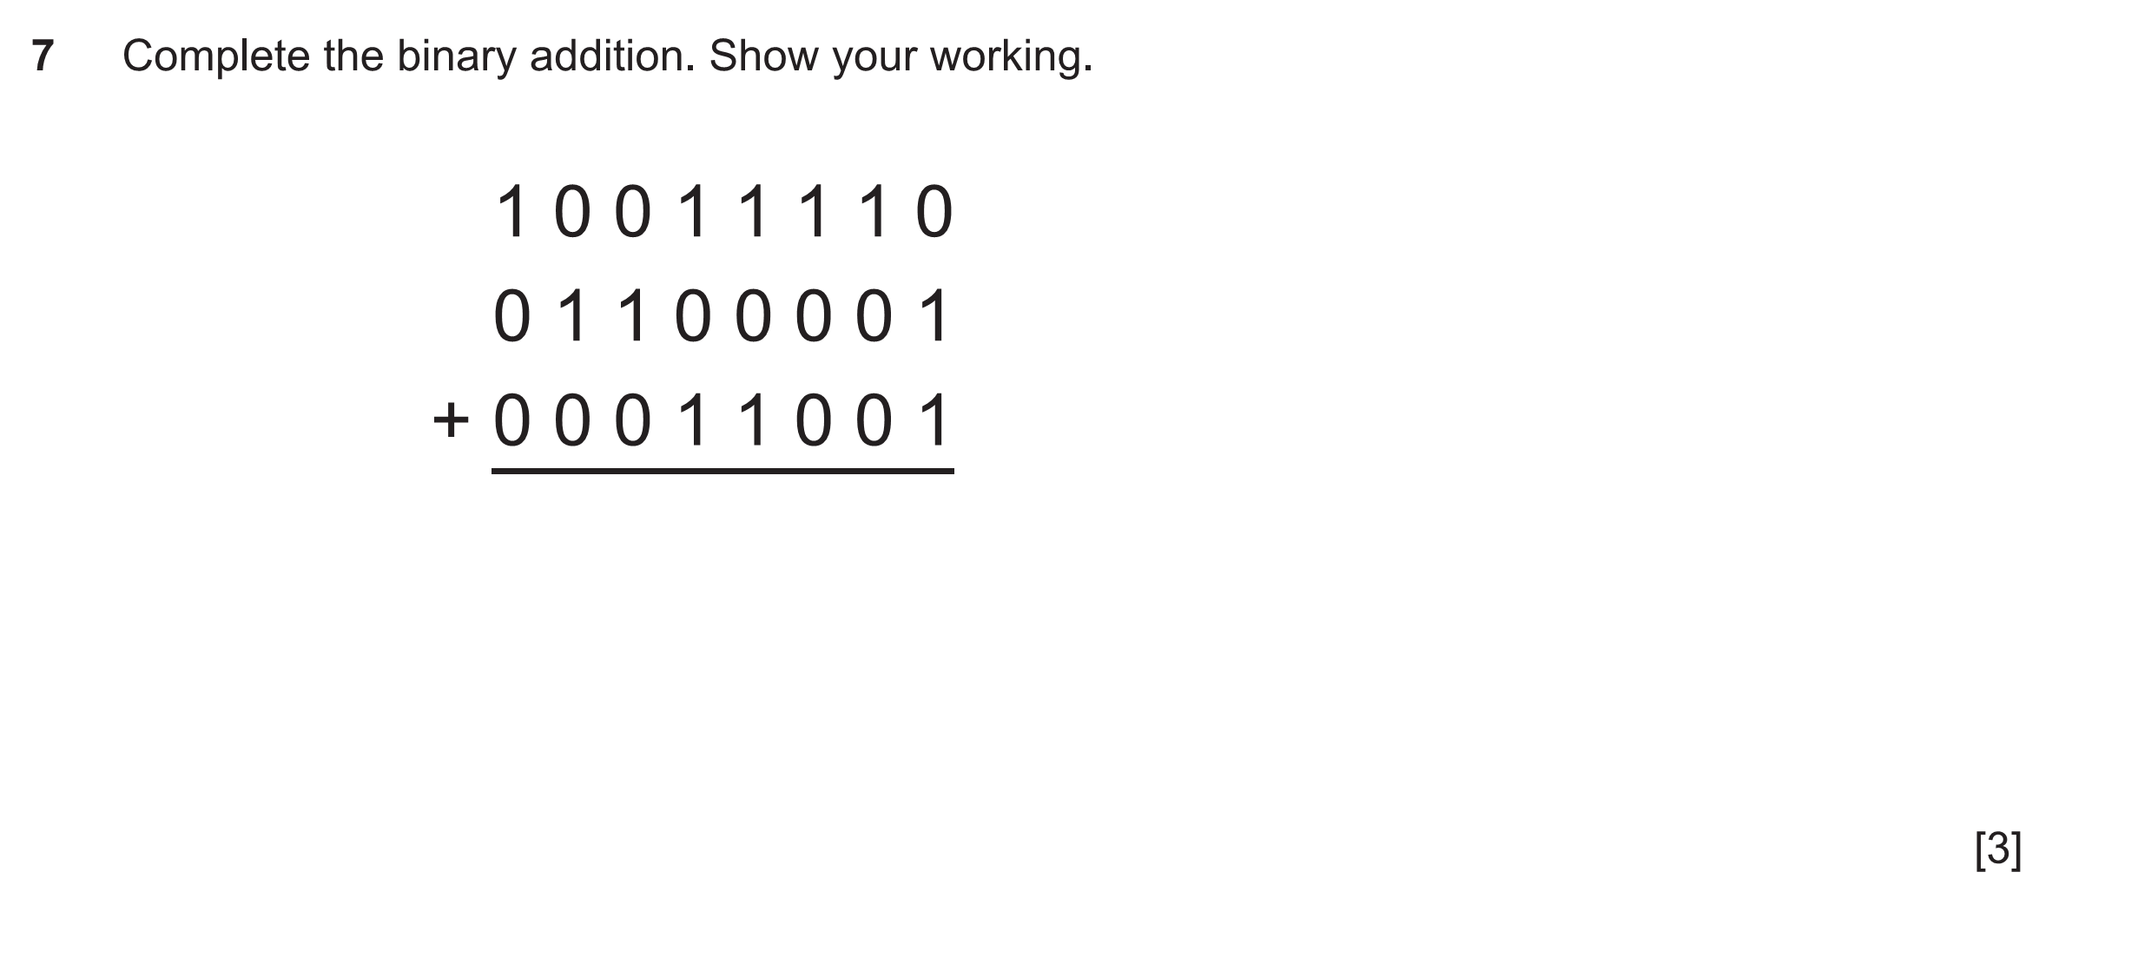
6

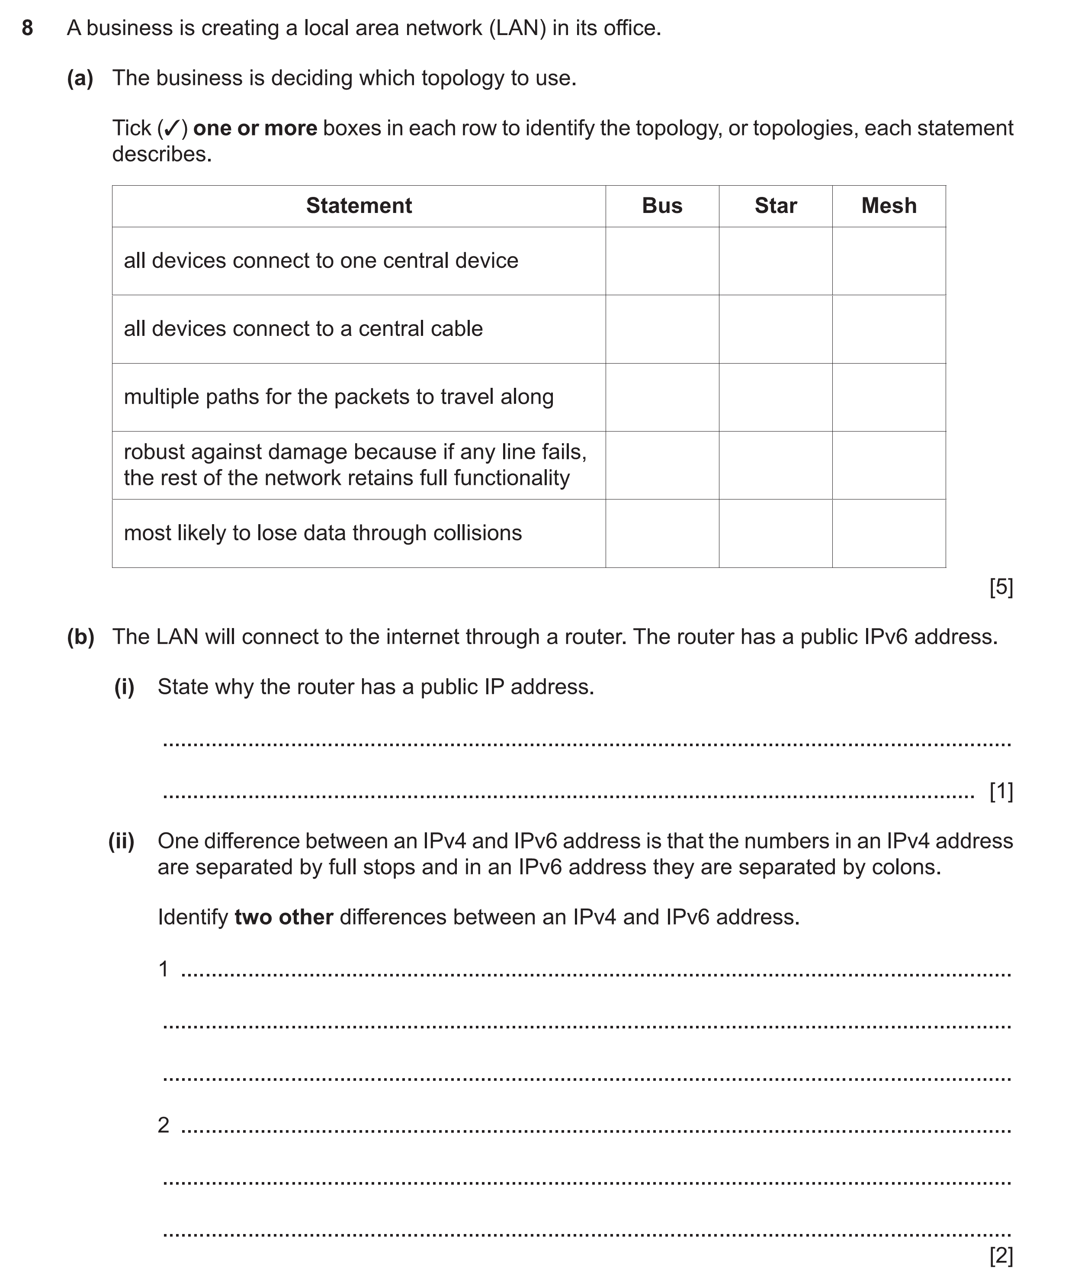
7

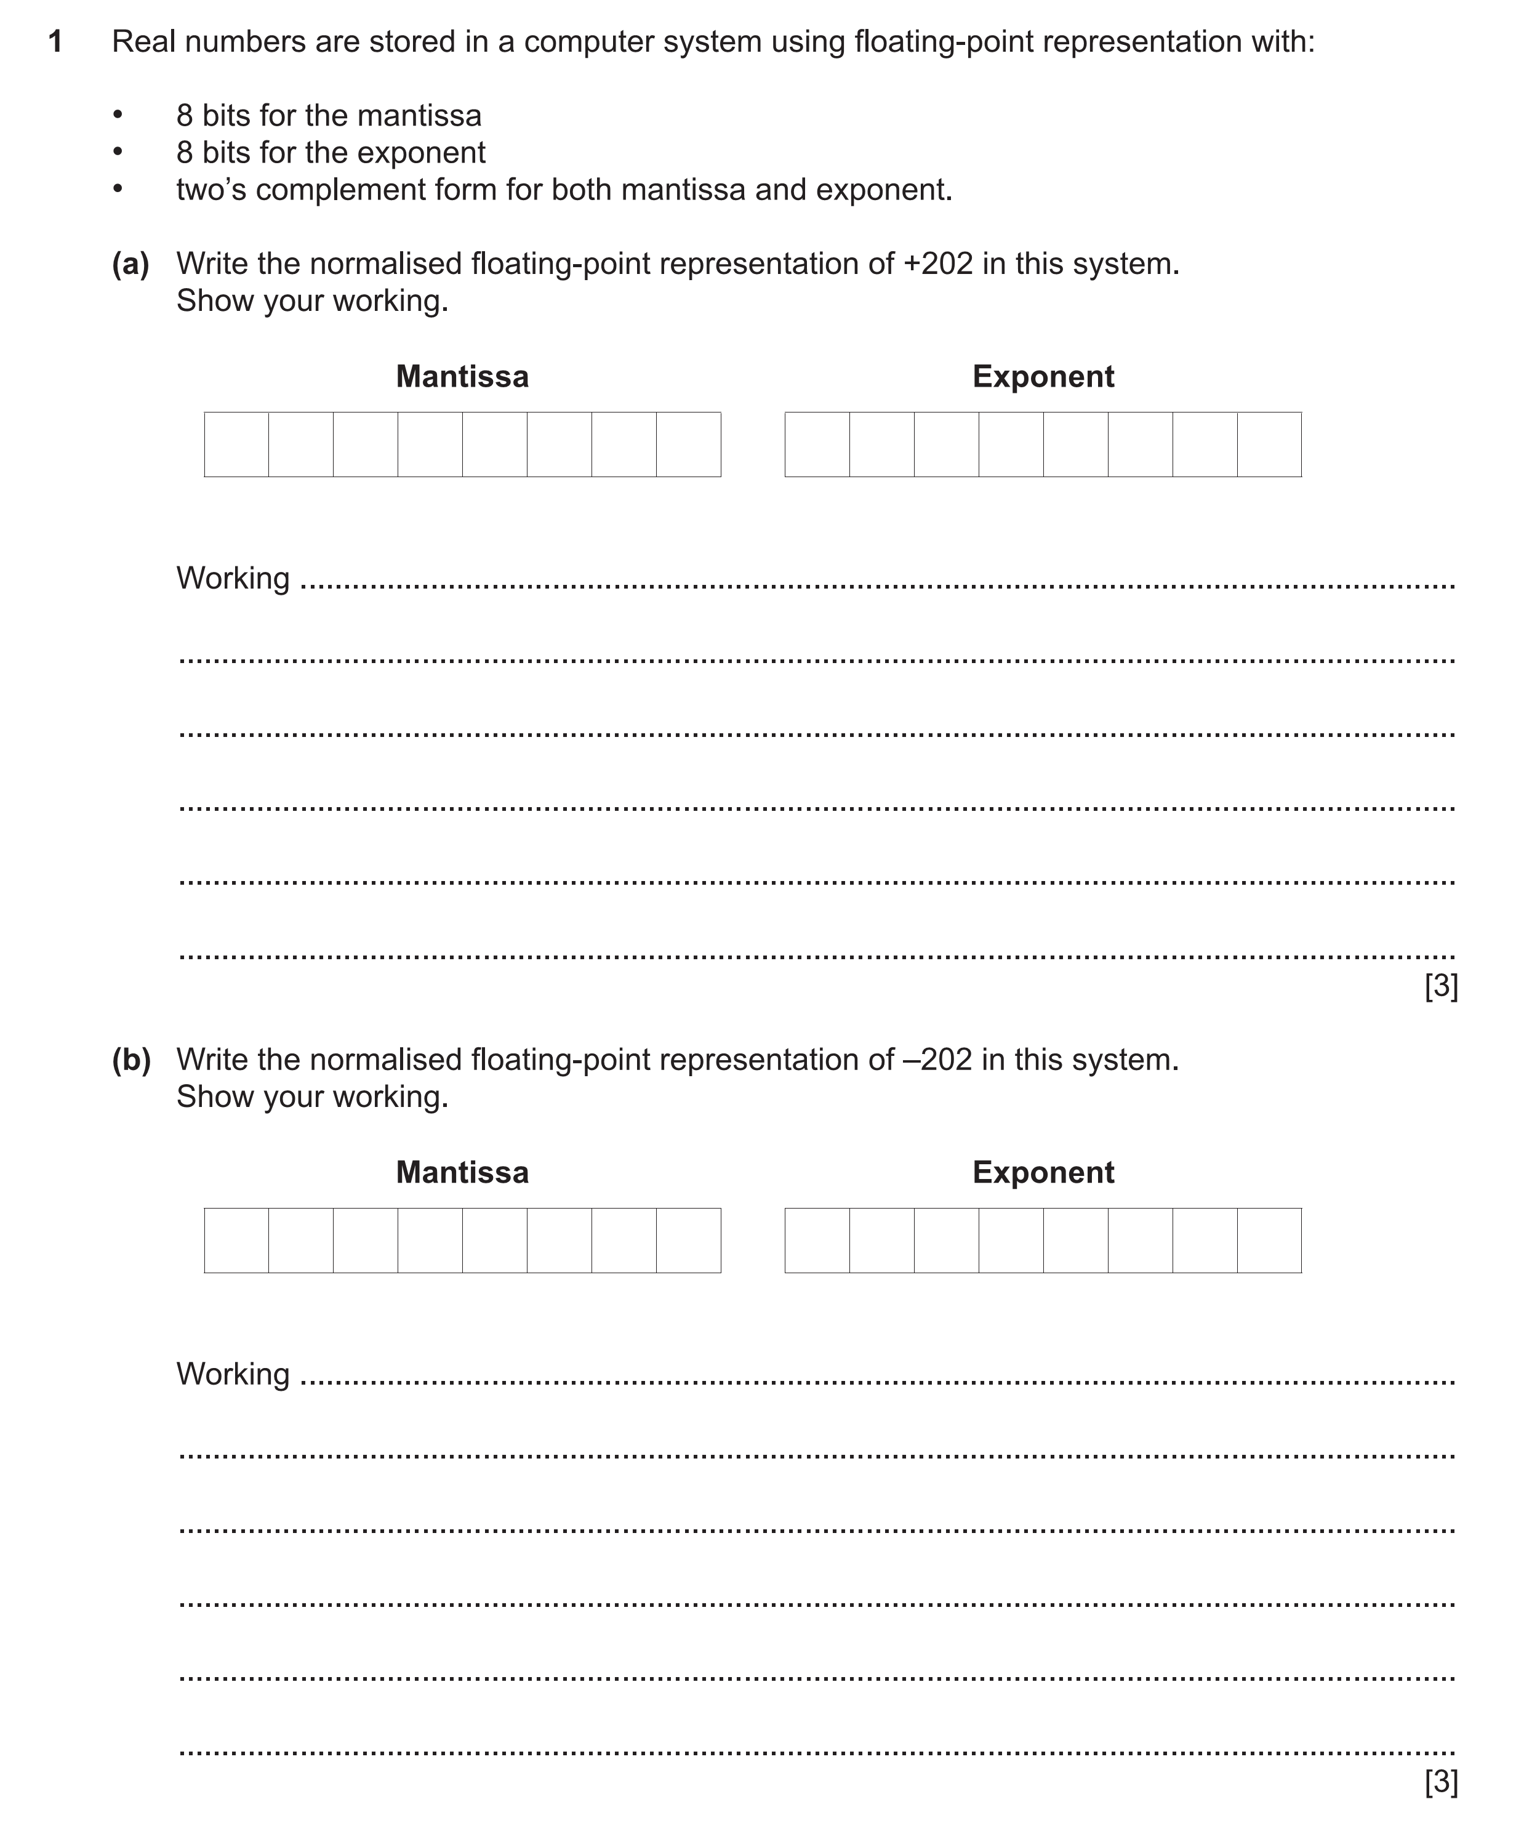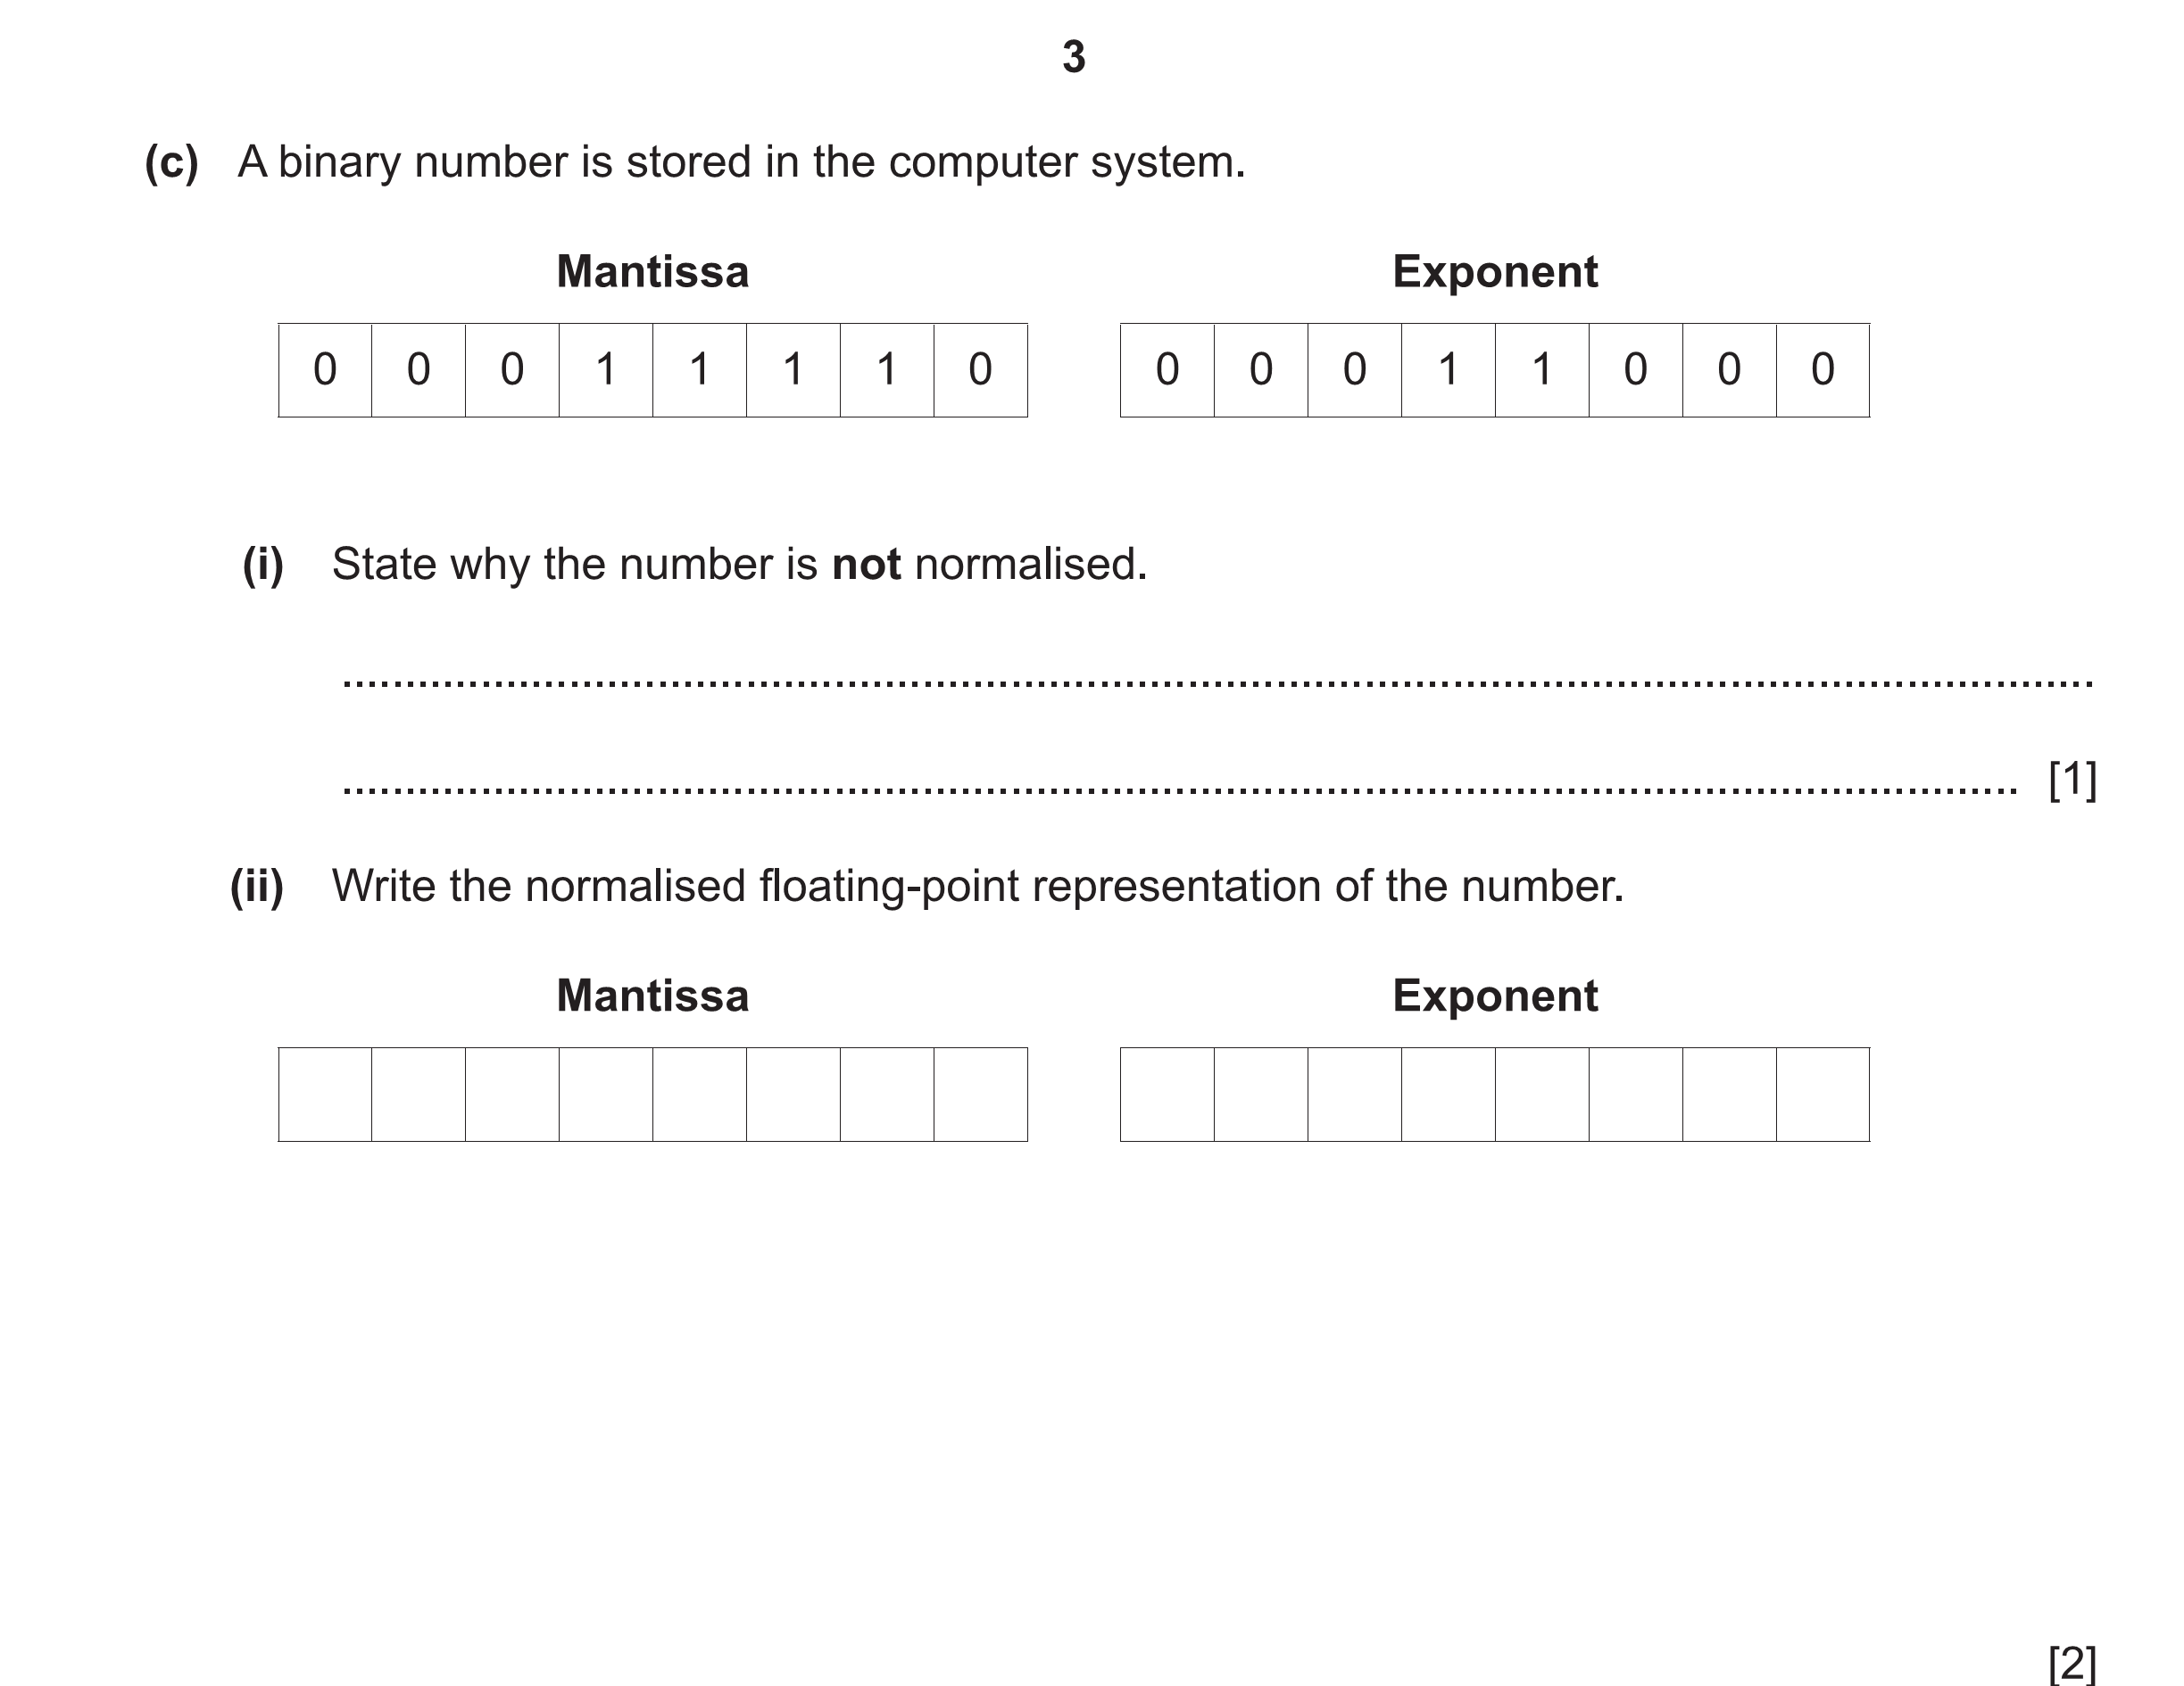
8

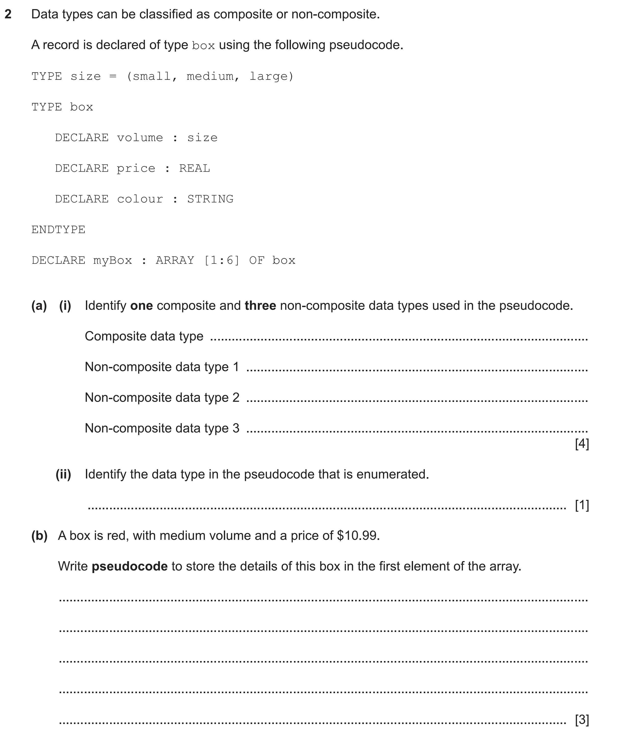
9

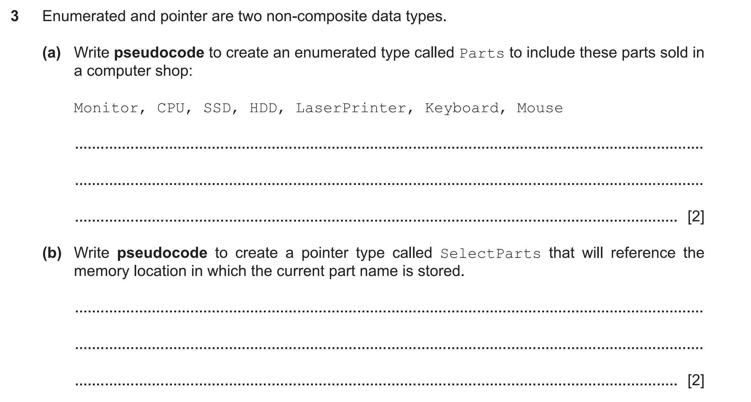
10

