FORM 3 COMPUTER SCIENCE TEST Answer all questions Date: 23 May 2025 Total: 50 Marks
 | 30588 Lundi Drive, Rhodene, Masvingo, Zimbabwe  Landline: +263 392 263 293 Cell: +263 78 604 4303  Email: info@juniorhighschool.ac.zw | 

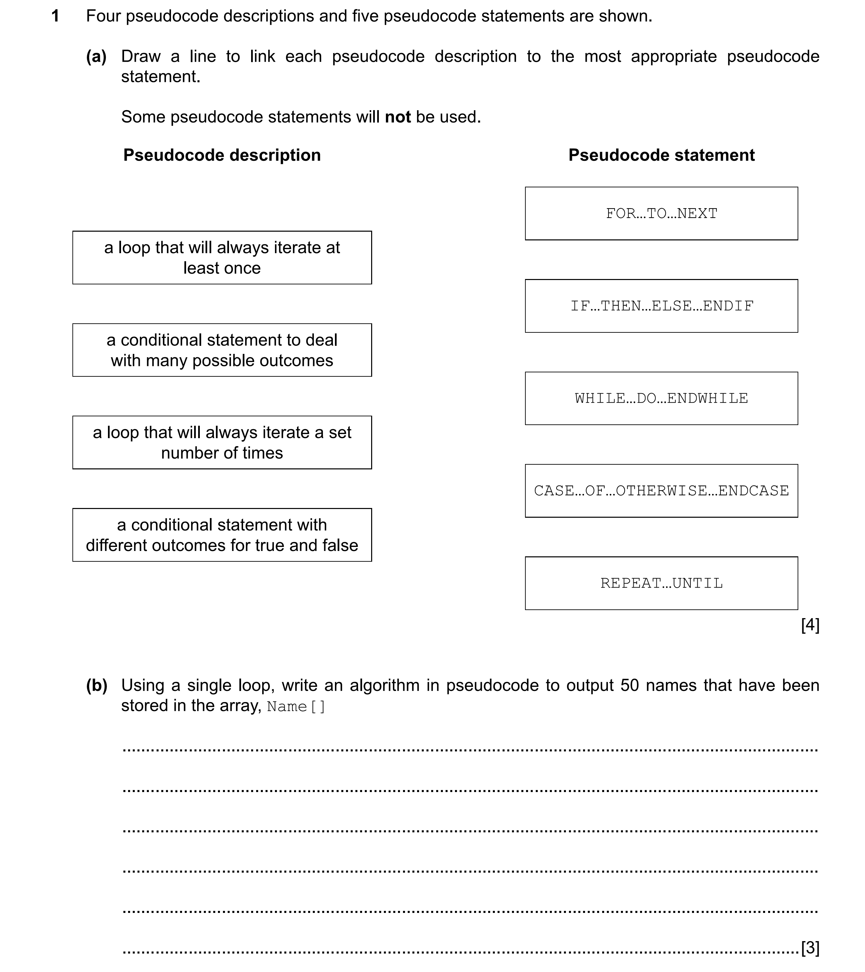

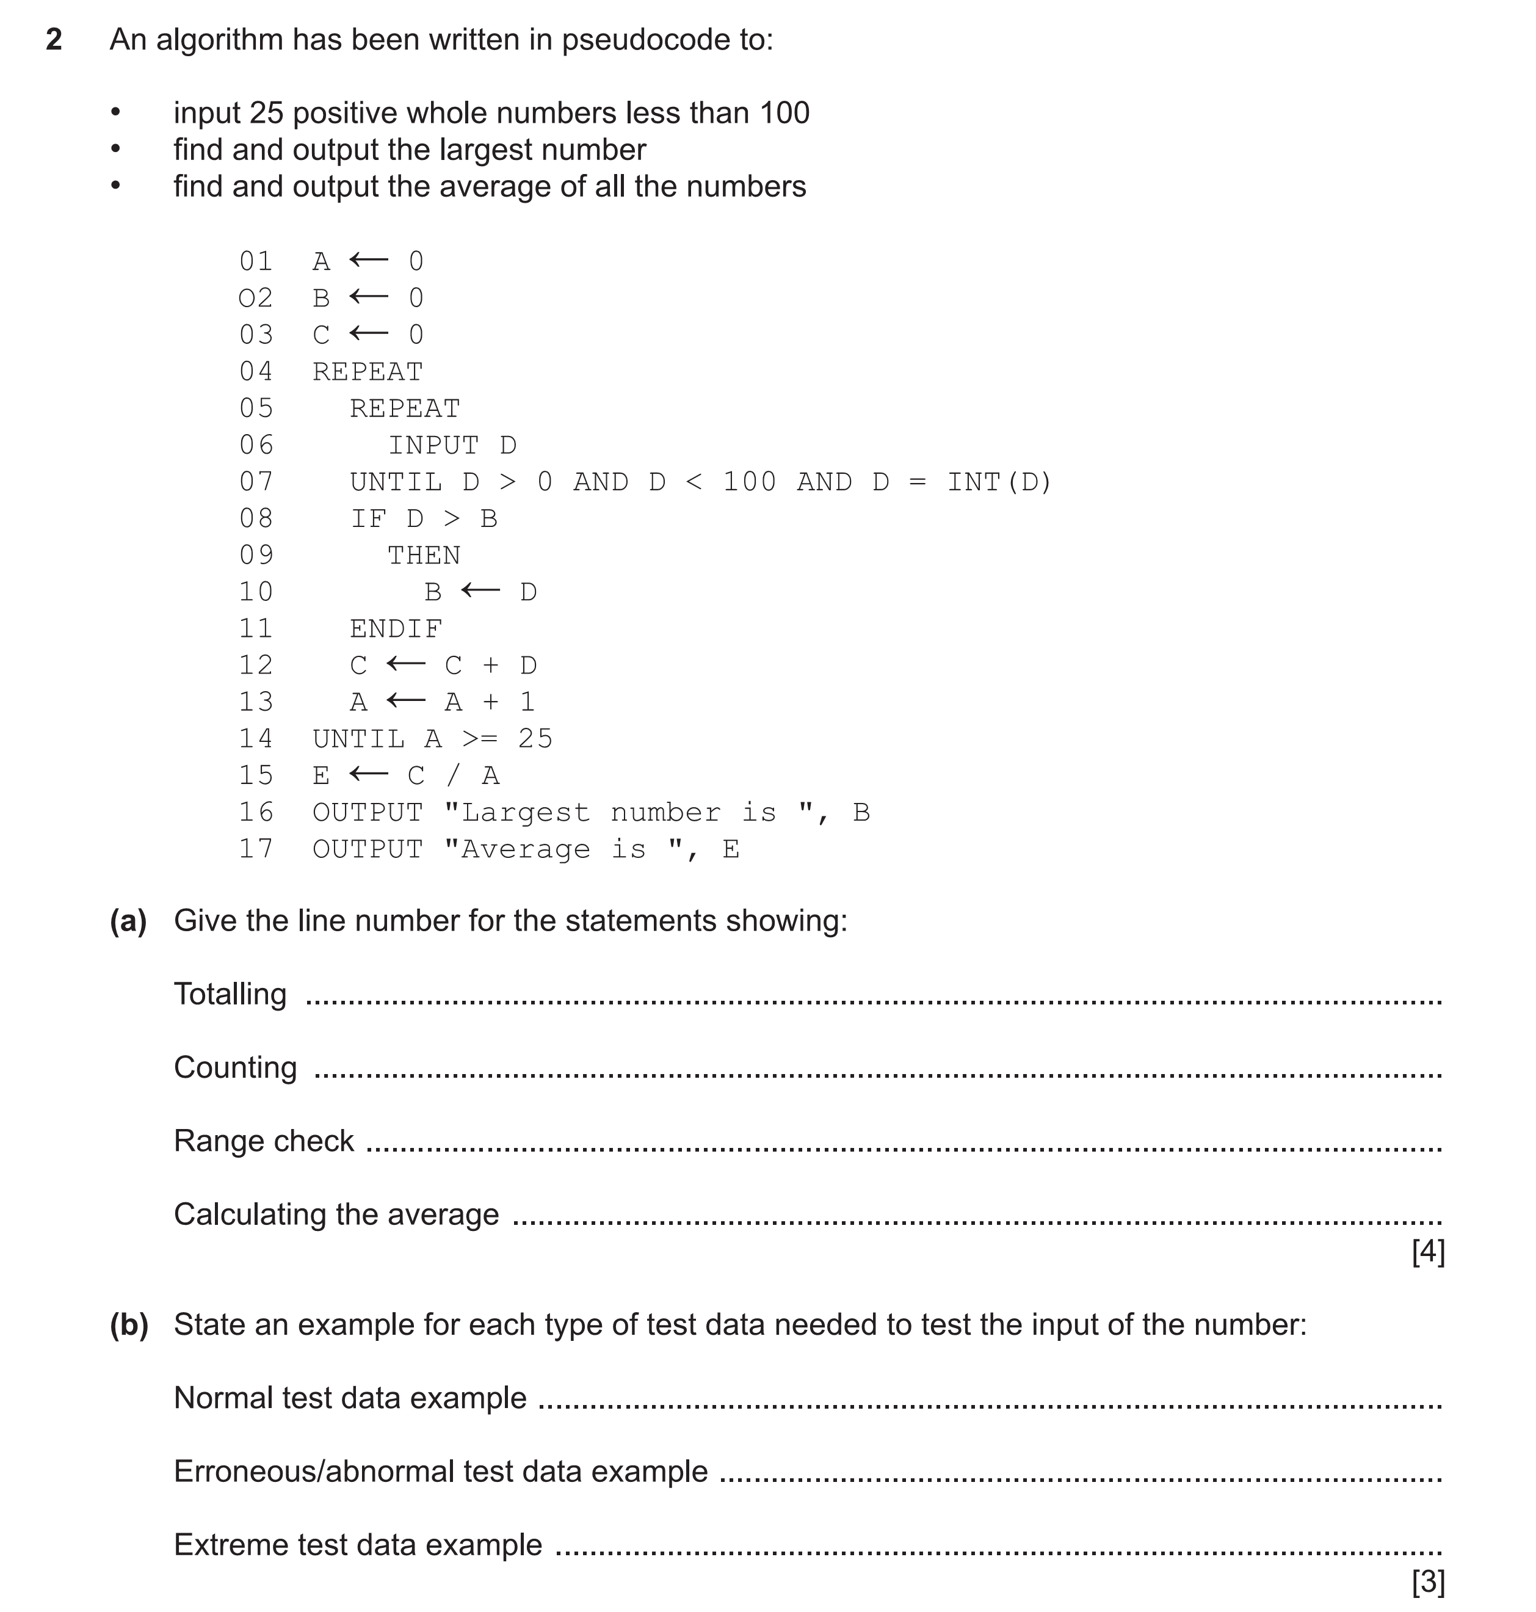
(c) Outline 4 stages of the program development life cycle
………………………………………………………………………………
……………………………………………………………………………….
……………………………………………………………………………….
……………………………………………………………………………..
……………………………………………………………………………. [4]
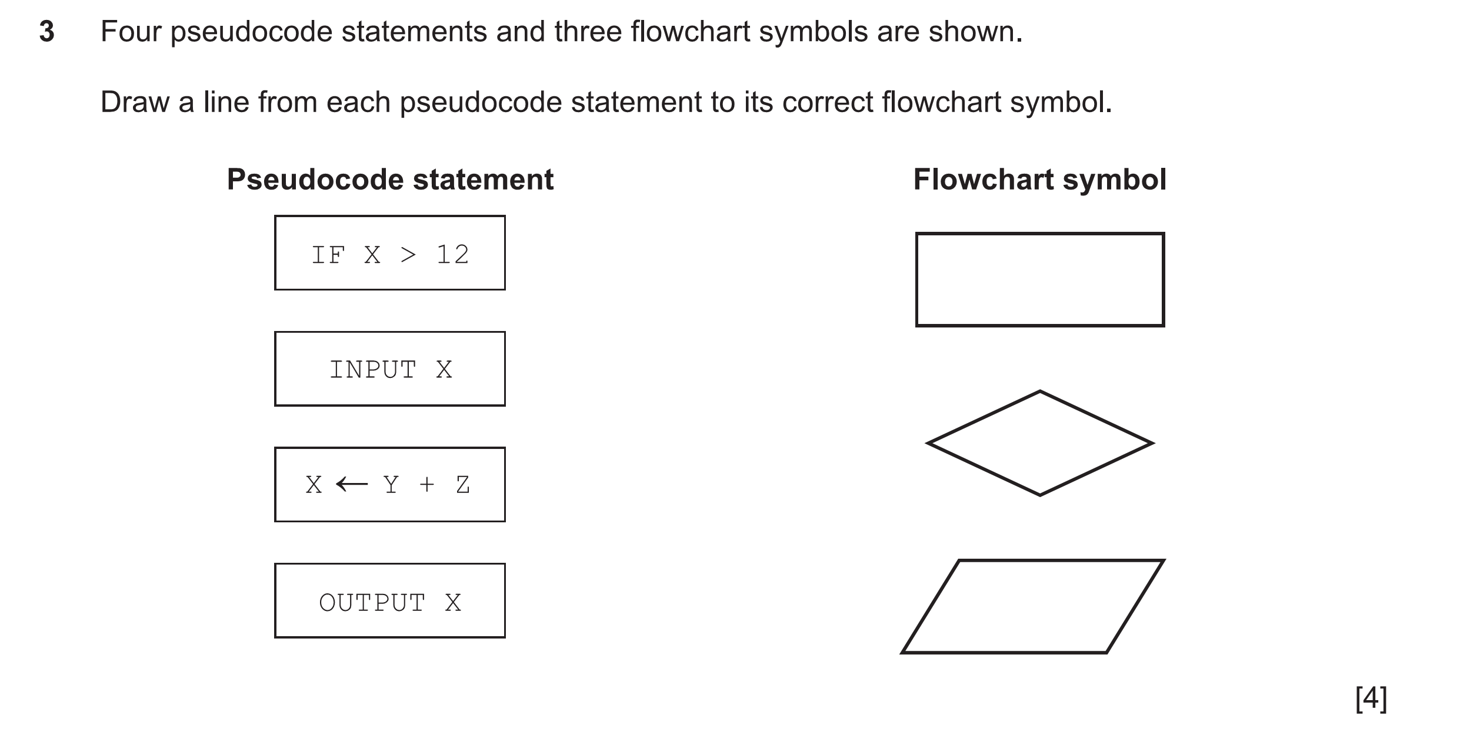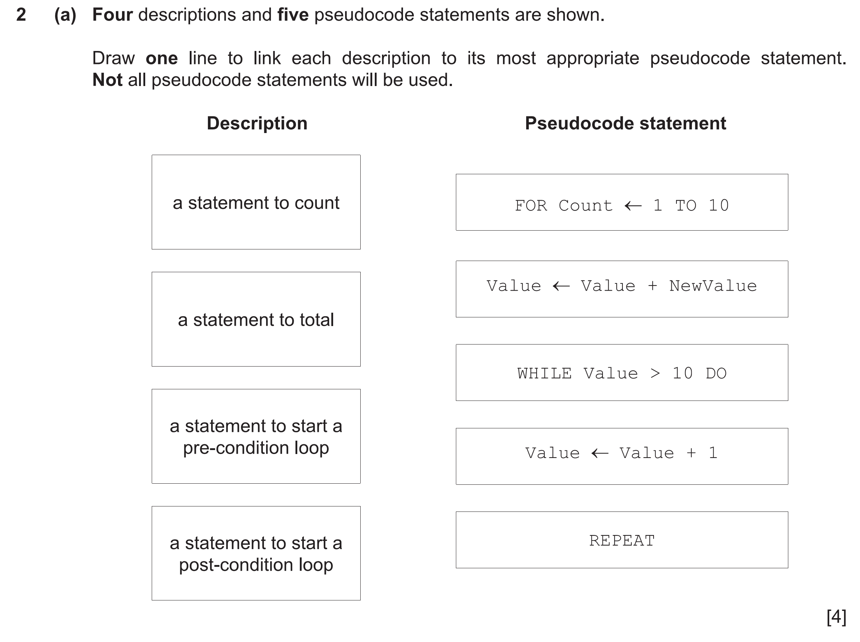
(b)

3 (a)
(c ) Complete the following sentences using the most appropriate loop structure that matches
the description(s)
i A loop that is used when the number of repetitions is finite(limited)……………………………………………
ii A loop that checks the condition before execution……………………………………………………………………….
iii A loop that checks the condition after execution ……………………………………………………………………[3]
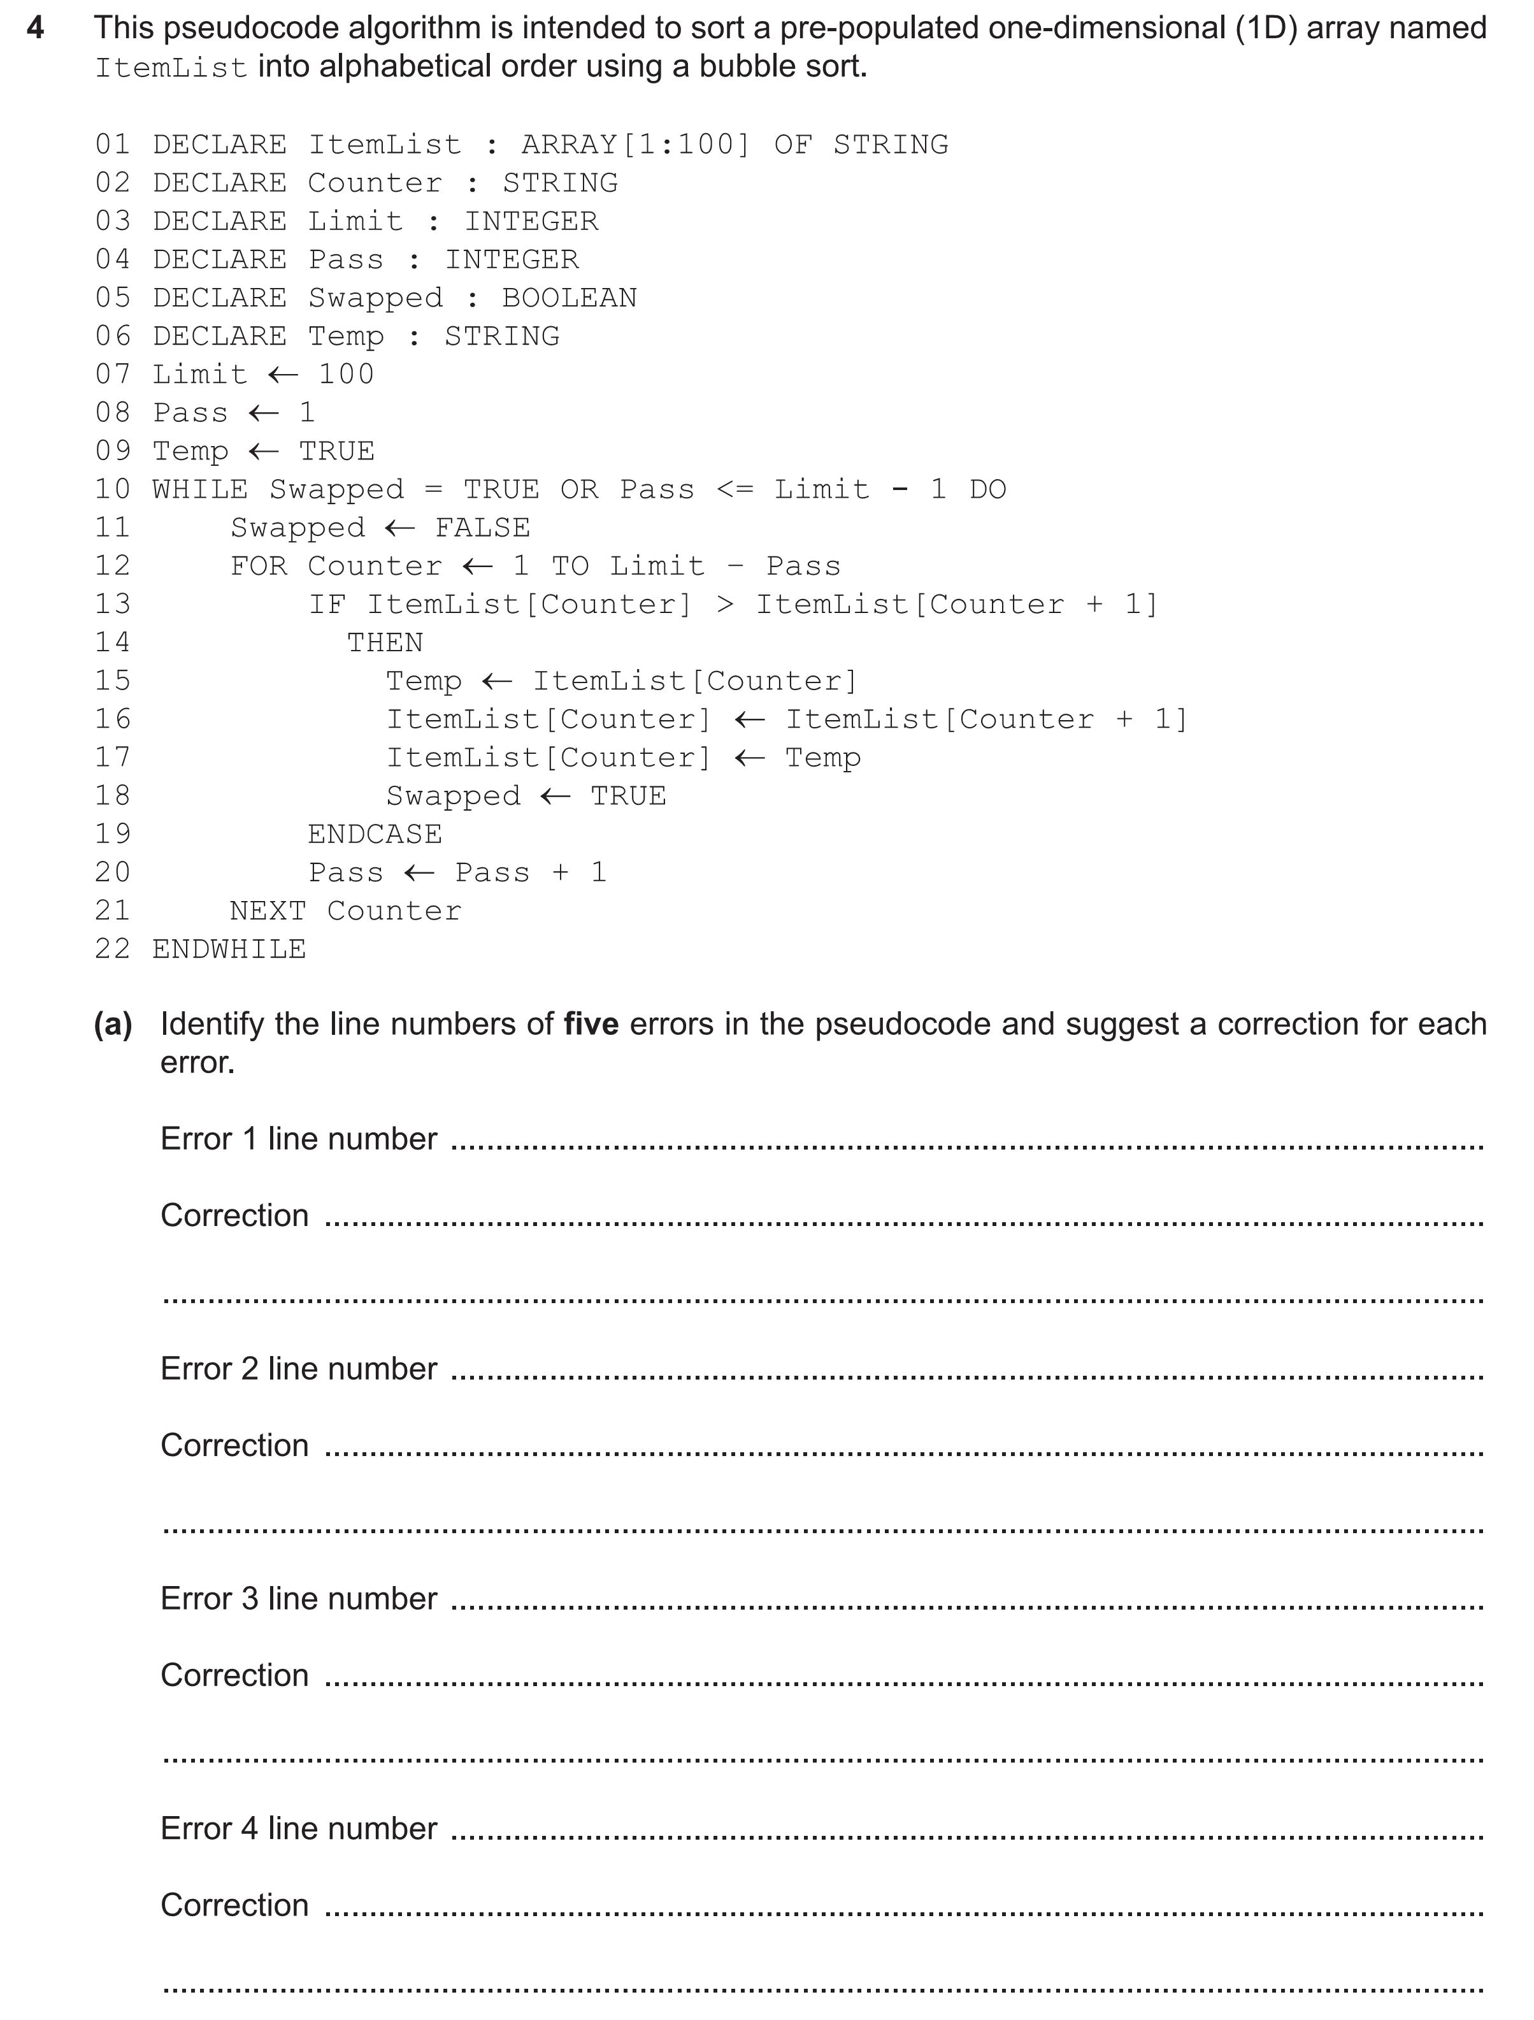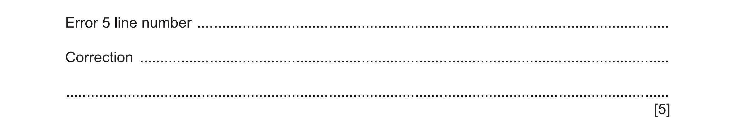
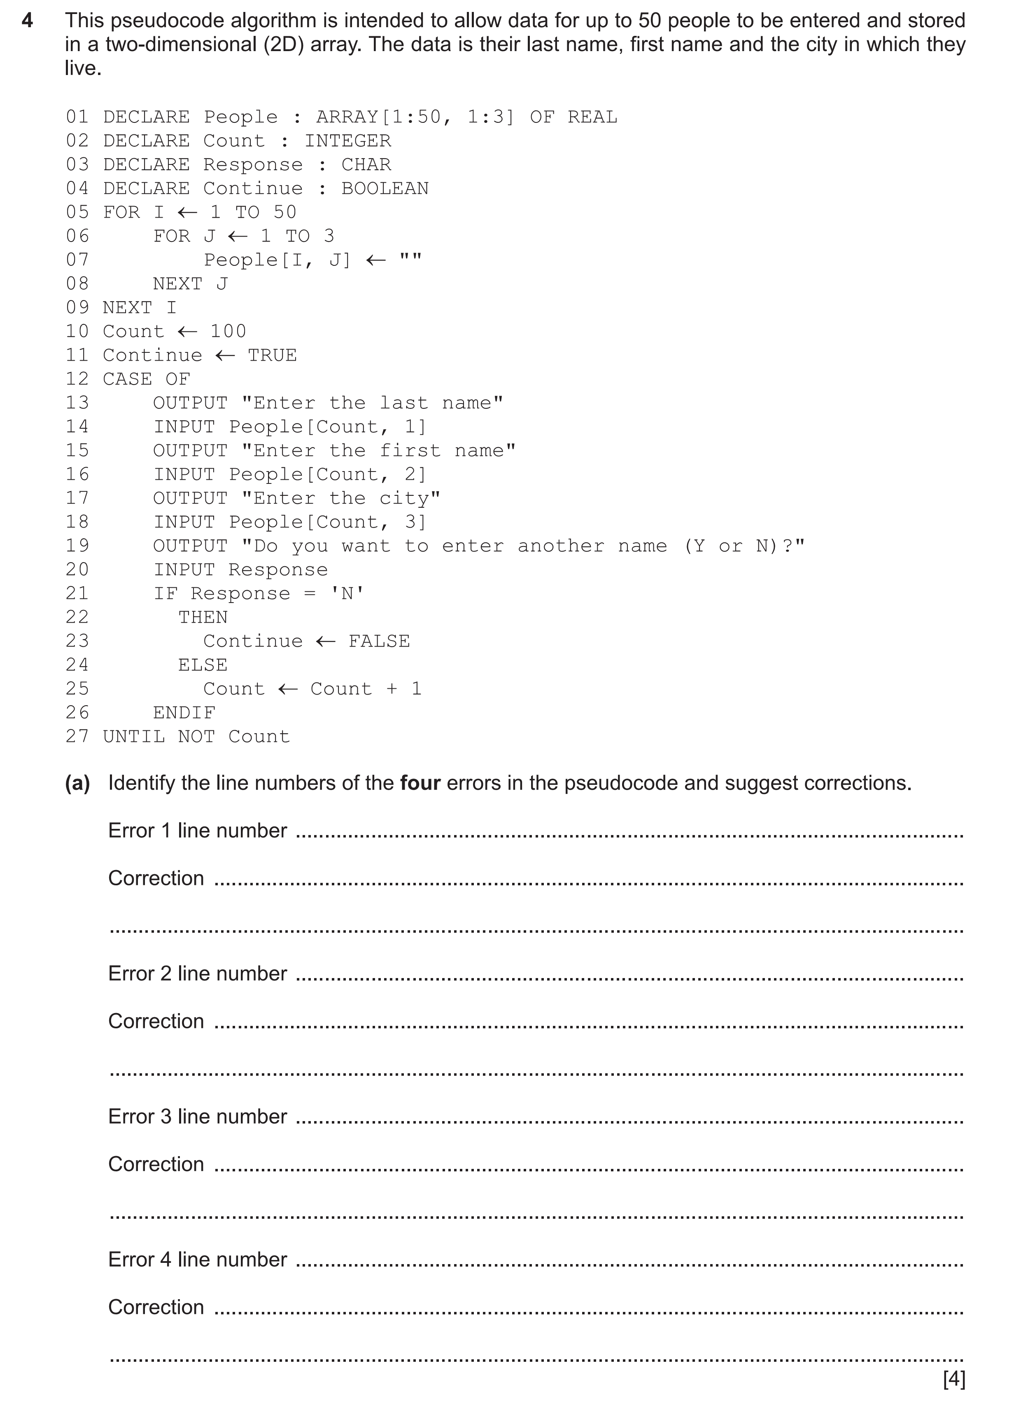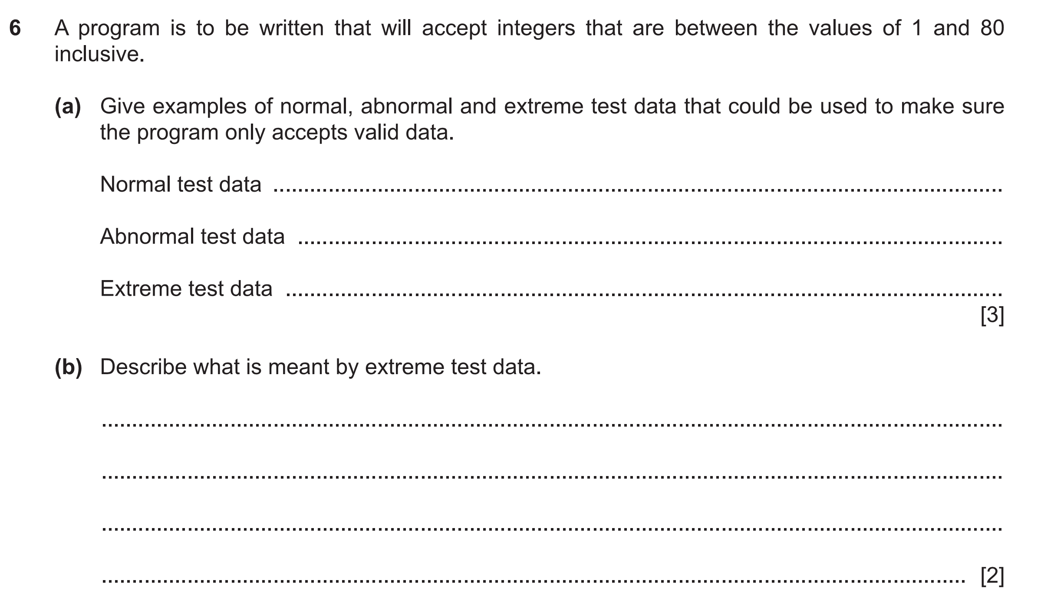
5
7 A class of Computer Science has 30 students .
a)Declare a 2D array Progress_Result to store the marks of the students for three consecutive terms in a particular year.
………………………………………………………………………………………………………………………………………………………………………………………………………………………………………………………………………………………………………………………………………………………………………………………………………………………………………………………………………………………………………………………………………………………………………………………………………………………………………………[2]
b) Write pseudo code algorithm to initialise the array using two nested loops.
………………………………………………………………………………………………………………………………………………………..
………………………………………………………………………………………………………………………………………………………………………………………………………………………………………………………………………………………………………………………………………………………………………………………………………………………………………………………………………………………………………………………………………………………………………………………………………………………………………………………………………………………………………………………………………………………………………………………………………………………………………………………………………………………………………………………………………………………………………….[5]

Total: 50 Marks

