INTERNSHIP PROJECT REPORT ON
Sales Data Analysis Using Python and MySql

SUBMITTED BY
Name : Thirumalashetty Bharathi

AT
ZEPHYR TECHNOLOGIES AND SOLUTIONS PVT LTD.



Bengaluru: #9 SP Naidu Layout Ramamurthy
Nagar New Police Station Road, Bengaluru,
Karnataka 560016

ACKNOWLEDGEMENT

I would like to express my sincere gratitude to my college, faculty members and internship organization for providing me with the opportunity to undertake this project on Sales Performance Analysis. I am thankful to my project guide for the valuable guidance, encouragement and suggestions provided throughout the development of this project.
I also thank everyone who supported me during the collection, preparation, analysis and documentation of the project. This work helped me strengthen my practical understanding of Python, data analysis, visualization, MySQL and machine learning.
Finally, I express my gratitude to my family and friends for their continuous support and encouragement during the completion of this project.

ABSTRACT

The Sales Performance Analysis project focuses on analysing retail sales data from the Sample Superstore dataset to understand sales performance, profitability and business trends. Python is used for data loading, cleaning, exploratory data analysis and visualization, while MySQL is used for structured storage and SQL-based analysis. Machine learning is applied to classify orders as profitable or loss-making.
The dataset contains 9,994 rows and 21 columns, including important attributes such as Order Date, Category, Sub-Category, Region, Sales, Profit, Quantity and Discount. The analysis examines sales by category and sub-category, regional profit performance, sales trends and the relationship between sales, quantity, discount and profit.
A correlation heatmap shows a moderate positive relationship between Sales and Profit (0.48) and a negative relationship between Discount and Profit (-0.22). A Decision Tree Classifier is trained using Sales, Quantity and Discount to predict whether an order is profitable. The model achieved 94.34% accuracy on the test data used in the project.
The project demonstrates how data analytics and machine learning can convert raw retail records into useful business insights. The findings can support inventory planning, regional strategy and better discount management.

INDEX

No. | Title | Page
1 | Introduction | 05
2 | Background Study | 06
3 | Problem Statement | 07
4 | Dataset Description | 08
5 | Methodology | 10
6 | Implementation | 12
7 | Result and Analysis | 17
8 | Conclusion | 24
9 | Scope for Future Enhancement | 25
10 | Appendix | 26
11 | Bibliography | 30

INTRODUCTION

1.1 Project Overview
In a data-driven business environment, analysing sales information is important for understanding customer demand, product performance and profitability. This project, Sales Performance Analysis, uses the Sample Superstore dataset to identify important patterns in sales and profit.
The project combines Python-based data analysis and visualization with MySQL queries. Python libraries such as Pandas, NumPy, Matplotlib and Seaborn are used to prepare and explore the dataset. MySQL queries are used to calculate totals and grouped business measures. A Decision Tree Classifier is then used to predict whether an order is profitable or loss-making.

1.2 Objectives
- Analyse sales and profit by Category, Sub-Category and Region.
- Identify top-performing and loss-making areas.
- Study sales trends and visualize important business patterns.
- Find relationships between Sales, Profit, Quantity and Discount using correlation analysis.
- Build a machine learning model to classify orders as profitable or loss-making.
- Evaluate the model and use the results to suggest practical business improvements.

1.3 Expected Outcomes
The expected outcome is a cleaned and analysed sales dataset, a set of visual reports, SQL summaries, correlation findings and a machine learning classification model. Together these outputs provide a clear view of factors associated with profitability.

BACKGROUND STUDY

Retail businesses generate large volumes of transaction data containing information about products, customers, regions, order dates, quantities, discounts and profits. When these records are viewed only as raw tables, important patterns can be difficult to identify. Data analytics provides methods for transforming such records into meaningful summaries and visual insights.
Exploratory Data Analysis (EDA) is commonly used to understand distributions, relationships and unusual observations before applying predictive models. In this project, grouped sales and profit analysis is combined with bar charts, pie charts, line-style comparisons and scatter plots.
Correlation analysis provides a numerical view of relationships among important numeric variables. In the project results, Sales and Profit show a moderate positive correlation, while Discount and Profit show a negative correlation. These relationships help explain why increasing sales alone does not necessarily guarantee higher profitability.
Machine learning provides an additional analytical layer. The project creates a binary target named Profitable, where an order is assigned 1 when Profit is greater than zero and 0 otherwise. A Decision Tree Classifier is trained using Sales, Quantity and Discount to classify orders.
MySQL complements Python by providing a relational environment for querying sales records. Aggregate functions such as SUM(), GROUP BY, ORDER BY and LIMIT are used to obtain total sales, total profit, category performance, top profitable sub-categories, loss-making sub-categories and regional results.

PROBLEM STATEMENT

Retail sales data contains many records and multiple factors that influence profitability. Without systematic analysis, it is difficult to identify which categories, regions and sub-categories contribute most to sales and profit, or to understand how discounting affects profitability.

3.1 Key Problems Addressed

- Large volume of transaction records makes manual analysis time-consuming.
- Sales and profit performance varies across categories, sub-categories and regions.
- High discounts may reduce profitability even when sales remain strong.
- Raw tables do not communicate trends as clearly as visualizations.
- The business needs a method for identifying orders that are likely to be profitable or loss-making.

3.2 Project Objective

The main objective is to build a reproducible analytical workflow that cleans the Superstore dataset, explores sales and profitability patterns, performs correlation analysis, executes SQL-based summaries and trains a Decision Tree Classifier for profit/loss prediction.

DATASET DESCRIPTION

The project uses the SampleSuperstore.csv dataset, obtained from Kaggle according to the project notebook. The dataset contains 9,994 records and 21 columns. It includes order, customer, product, geographical and financial information.

Important Features

Feature | Description
Order Date | Date on which the order was placed.
Ship Date | Date on which the order was shipped.
Category | Major product category.
Sub-Category | Specific product group within a category.
Region | Geographical sales region.
Sales | Sales value of the order.
Profit | Profit or loss generated by the order.
Quantity | Number of units sold.
Discount | Discount applied to the order.

Dataset Characteristics

- Rows: 9,994
- Columns: 21
- Source: Kaggle – SampleSuperstore.csv
- Important analysis variables: Sales, Profit, Quantity and Discount
- Categorical variables include Category, Sub-Category and Region.

Data Loading

# Import required libraries for data analysis and visualization
import pandas as pd # for data handling
import numpy as np # for numerical operations
import matplotlib.pyplot as plt # for plotting graphs
import seaborn as sns # for better visualizations
# Load the dataset
df = pd.read_csv('SampleSuperstore.csv')
# Show number of rows and columns
print(df.shape)
df

The notebook uses Pandas to load the CSV file and inspect its dimensions and contents. The first and last records are also displayed to verify that the dataset has been loaded correctly.

METHODOLOGY

The project follows a sequential data-analysis workflow. The major stages are data loading, data cleaning, exploratory analysis, visualization, correlation analysis, machine learning and interpretation.

Data Loading

The SampleSuperstore.csv file is loaded into a Pandas DataFrame. Shape, head and tail operations are used for initial inspection.

5.2 Data Cleaning

# Check for missing values in each column
print(df.isnull().sum())
# if any missing values... dropna() is used to drop rows
# to fill... fillna() is used
# if it is numerical col-- fill it with median, if it is categorical col-- fill it with mean
# Check for duplicate rows
print("\nDuplicates:", df.duplicated().sum())
# Remove duplicate rows
df = df.drop_duplicates()
print("Shape after removing duplicates:", df.shape)
# Check data types of columns
print(df.dtypes)

The notebook checks missing values, checks duplicate records, removes duplicate rows and verifies data types. Unique Category and Region values are also inspected.

5.3 Exploratory Data Analysis
- Sales share by Category.
- Total Profit by Region.
- Top 10 Sub-Categories by Sales.
- Sales versus Profit scatter plot.
- Sales comparison across the top sub-categories.

5.4 Data Visualization
Matplotlib and Seaborn are used to create bar charts, pie charts, line-style plots and scatter plots. These visualizations make comparisons between business dimensions easier to interpret.

5.5 Correlation Analysis
# Correlation Analysis
numeric_df = df[['Sales','Quantity','Discount','Profit']]
corr = numeric_df.corr()
print(corr)
plt.figure(figsize=(8,6))
sns.heatmap(corr, annot=True, cmap='coolwarm', fmt='.2f')
plt.title('Correlation Heatmap: Sales, Quantity, Discount, Profit')
plt.show()
The correlation matrix is calculated for Sales, Quantity, Discount and Profit. A Seaborn heatmap is used to display the relationships visually.

5.6 Machine Learning Method
A binary target column named Profitable is created. It contains 1 when Profit is greater than zero and 0 otherwise. Sales, Quantity and Discount are used as model features. The data is split into training and testing sets using an 80:20 split, and a Decision Tree Classifier with maximum depth 5 is trained.

IMPLEMENTATION

6.1 Technologies and Tools Used
Technology / Tool | Purpose
Python | Data analysis and machine learning.
Pandas | Data loading, cleaning and grouping.
NumPy | Numerical operations.
Matplotlib | Data visualization.
Seaborn | Statistical charts and heatmaps.
Scikit-learn | Decision Tree classification and evaluation.
MySQL | Database storage and SQL analysis.
Jupyter Notebook | Development and execution environment.

6.2 EDA Implementation
# Chart 5: Sales Share by Category
category_sales = df.groupby('Category')['Sales'].sum()
plt.figure(figsize=(6,6))
plt.pie(category_sales, labels=category_sales.index, autopct='%1.1f%%', startangle=90)
plt.title('Sales Share by Category')
plt.show()
# Chart 2: Total Profit by Region
profit_region = df.groupby('Region')['Profit'].sum().reset_index()
plt.figure(figsize=(8,5))
sns.barplot(x='Region', y='Profit', data=profit_region, hue="Region", palette='Set2')
plt.title('Total Profit by Region')
plt.ylabel('Total Profit')
plt.show()
# Chart 3: Total Sales by Sub-Category (Top 10)
top_sub = df.groupby('Sub-Category')['Sales'].sum().sort_values(ascending=False).head(10).reset_index()
plt.figure(figsize=(10,5))
sns.barplot(x='Sales', y='Sub-Category', data=top_sub, hue= "Sub-Category", palette='coolwarm')
plt.title('Top 10 Sub-Categories by Sales')
plt.xlabel('Total Sales')
plt.show()
# Chart 4: Sales vs Profit Scatter
plt.figure(figsize=(8,5))
sns.scatterplot(x='Sales', y='Profit', data=df, alpha=0.5) # alpha -- makes dots transparent
plt.title('Sales vs Profit')
plt.xlabel('Sales')
plt.ylabel('Profit')
plt.show()
# Chart 5: Sales Trend by Sub-Category (Top 10)
top_sub = df.groupby('Sub-Category')['Sales'].sum().sort_values(ascending=False).head(10)
plt.figure(figsize=(10,5))
plt.plot(top_sub.index, top_sub.values, marker='o')
plt.title('Sales Trend Across Top 10 Sub-Categories')
plt.xlabel('Sub-Category')
plt.ylabel('Total Sales')
plt.xticks(rotation=45)
plt.grid(True)
plt.show()

6.3 Machine Learning Implementation
from sklearn.model_selection import train_test_split
from sklearn.tree import DecisionTreeClassifier
from sklearn.metrics import accuracy_score, classification_report, confusion_matrix
import seaborn as sns
import matplotlib.pyplot as plt
# Create target: 1 = Profitable, 0 = Loss
df['Profitable'] = (df['Profit'] > 0).astype(int)
X = df[['Sales','Quantity','Discount']]
y = df['Profitable']
X_train, X_test, y_train, y_test = train_test_split(X, y, test_size=0.2, random_state=42)
model = DecisionTreeClassifier(max_depth=5, random_state=42)
model.fit(X_train, y_train)
y_pred = model.predict(X_test)
print("Accuracy:", accuracy_score(y_test, y_pred))
print(classification_report(y_test, y_pred))
# Confusion Matrix Heatmap
cm = confusion_matrix(y_test, y_pred)
plt.figure(figsize=(5,4))
sns.heatmap(cm, annot=True, fmt='d', cmap='Greens')
plt.xlabel('Predicted')
plt.ylabel('Actual')
plt.title('Confusion Matrix - Profit/Loss')
plt.show()

6.4 Decision Tree Visualization

from sklearn.tree import plot_tree
plt.figure(figsize=(18,8))
plot_tree(model, max_depth=3, filled=True,
feature_names=['Sales','Quantity','Discount'],
class_names=['Loss','Profit'])
plt.title('Decision Tree Structure - Profit/Loss (depth=3 for view)')
plt.show()

6.5 MySQL Implementation

The SQL file supplied with the project contains queries for row counting, table structure inspection, total sales and profit, sales by category, top profitable sub-categories, loss-making sub-categories and sales/profit by region.
-- 1. Count No. of rows - total orders in dataset
SELECT COUNT(*) FROM superstore_db.superstore;
-- 2. See table columns and data types
DESCRIBE superstore_db.superstore;
-- 3. Total Sales and Profit (convert text to numbers using CAST)
SELECT
SUM(CAST(Sales AS DECIMAL(10,2))) AS total_sales,
SUM(CAST(Profit AS DECIMAL(10,2))) AS total_profit
FROM superstore_db.superstore;
-- 4. Sales by Category
SELECT Category, SUM(CAST(Sales AS DECIMAL(10,2))) AS sales -- sum calculate total sales
FROM superstore_db.superstore
GROUP BY Category -- groups data by categories
ORDER BY sales DESC; -- it shows highest first
-- 5. Top 5 profitable Sub-Categories
SELECT Sub_Category, SUM(CAST(Profit AS DECIMAL(10,2))) AS profit
FROM superstore_db.superstore
GROUP BY Sub_Category
ORDER BY profit DESC
LIMIT 5; -- only top 5 highest profit
-- 6. Loss-making Sub-Categories
SELECT Sub_Category, SUM(CAST(Profit AS DECIMAL(10,2))) AS profit
FROM superstore_db.superstore
GROUP BY Sub_Category
ORDER BY profit ASC
LIMIT 5;
-- 7. Sales by Region
SELECT Region, SUM(CAST(Sales AS DECIMAL(10,2))) AS sales,
SUM(CAST(Profit AS DECIMAL(10,2))) AS profit
FROM superstore_db.superstore
GROUP BY Region
ORDER BY sales DESC;

7. RESULT AND ANALYSIS

7.1 Exploratory Findings

- Technology category has the highest sales according to the project analysis.
- West region has the highest profit performance.
- Phones is identified as a leading sub-category by sales.
- Phones and Chairs are identified as top-performing sub-categories in the notebook's interpretation.
- Sales and Profit show a positive relationship.

7.2 Correlation Results

Variable Pair | Correlation | Interpretation
Sales – Profit | 0.48 | Moderate positive relationship.
Discount – Profit | -0.22 | Negative relationship; higher discount is associated with lower profit.
Sales – Quantity | 0.20 | Weak positive relationship.
Quantity – Profit | 0.07 | Very weak relationship.
Discount – Sales | -0.03 | Almost no linear relationship in this analysis.

The results suggest that increasing sales is generally associated with higher profit, but discounting has a negative association with profit. Therefore, sales growth should be pursued without relying excessively on discounts.

7.3 Machine Learning Result

Item | Result
Model | Decision Tree Classifier
Target | Profitable: 1 = Profit, 0 = Loss
Features | Sales, Quantity, Discount
Train/Test Split | 80% / 20%
Max Depth | 5
Accuracy | 94.34%
The Decision Tree model achieved 94.34% accuracy on the project's test set. The notebook interpretation identifies Discount as an important factor and indicates that high discount values can contribute to loss-making outcomes.

7.4 Confusion Matrix

The notebook reports that the confusion matrix correctly classified 1,618 profitable orders and 268 loss orders, with comparatively few classification errors. This indicates that the model can be useful as a supporting analytical tool for identifying potentially loss-making orders.

7.5 Practical Recommendations

- Monitor discount levels carefully because discount and profit have a negative relationship.
- Focus inventory and marketing attention on strong categories and sub-categories.
- Use regional performance results when planning sales strategies.
- Use the classification model as an additional warning mechanism for potentially loss-making orders.
- Continue monitoring sales and profit together rather than treating high sales as the only measure of success.

7.6 Visual Outputs
Figure 7.1: Output generated by the project notebook (Cell 15).

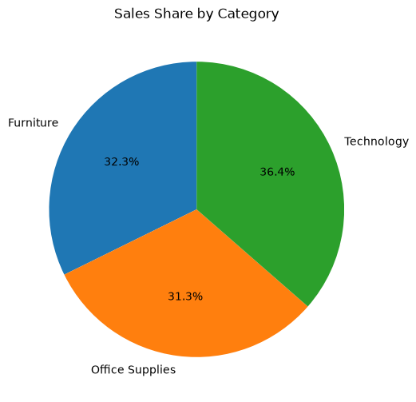
Figure 7.2: Output generated by the project notebook (Cell 16).
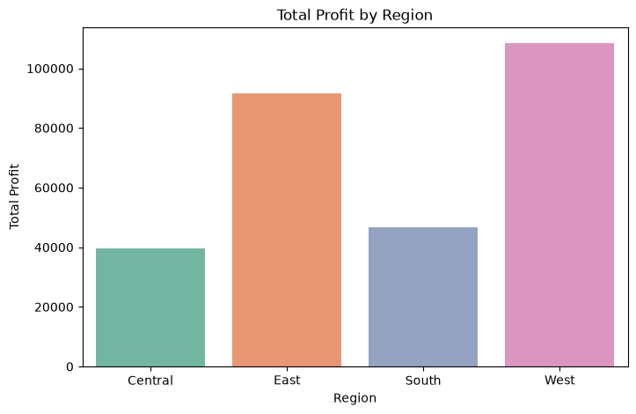
Figure 7.3: Output generated by the project notebook (Cell 17).

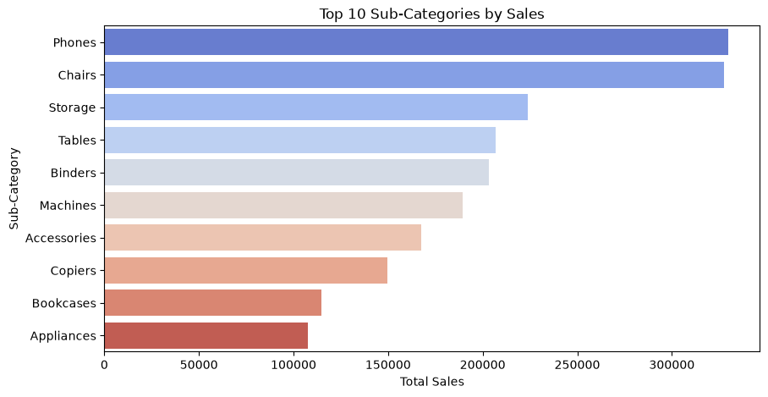

Figure 7.4: Output generated by the project notebook (Cell 18).
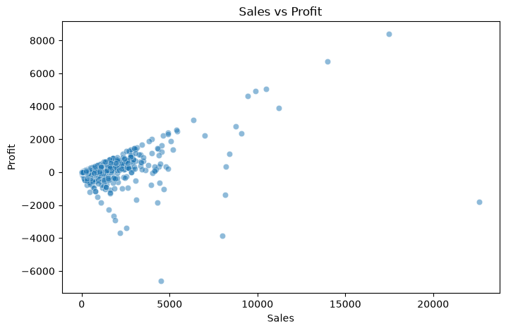
Figure 7.5: Output generated by the project notebook (Cell 19).

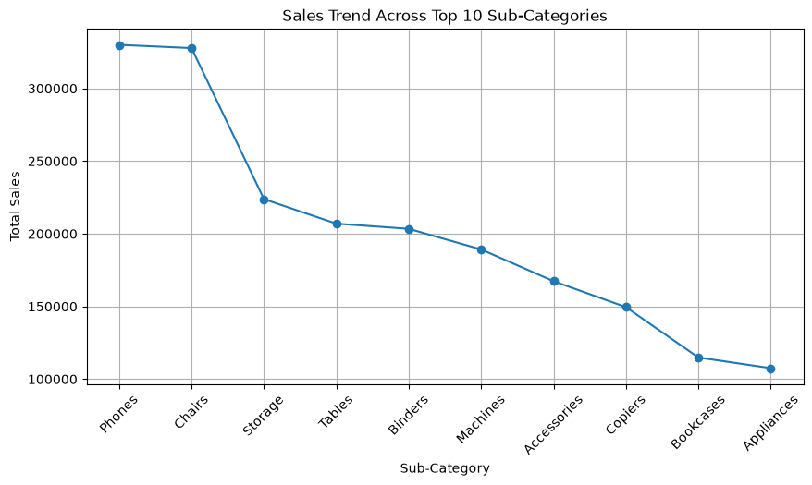
Figure 7.6: Output generated by the project notebook (Cell 23).
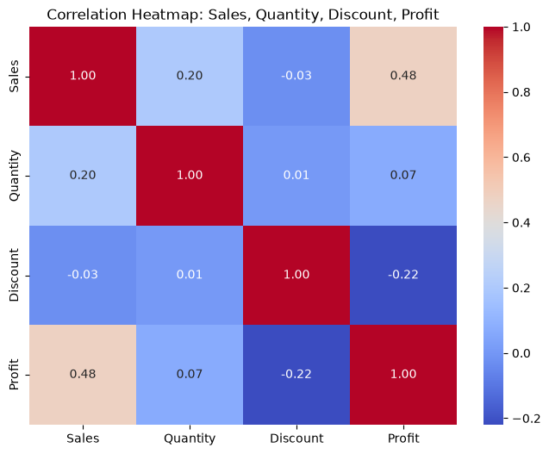

Figure 7.7: Output generated by the project notebook (Cell 26).
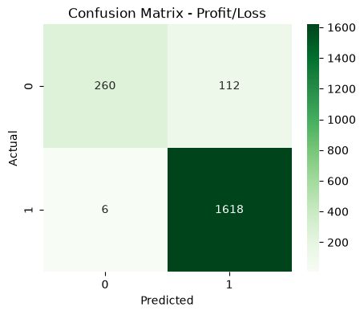
Figure 7.8: Output generated by the project notebook (Cell 28).

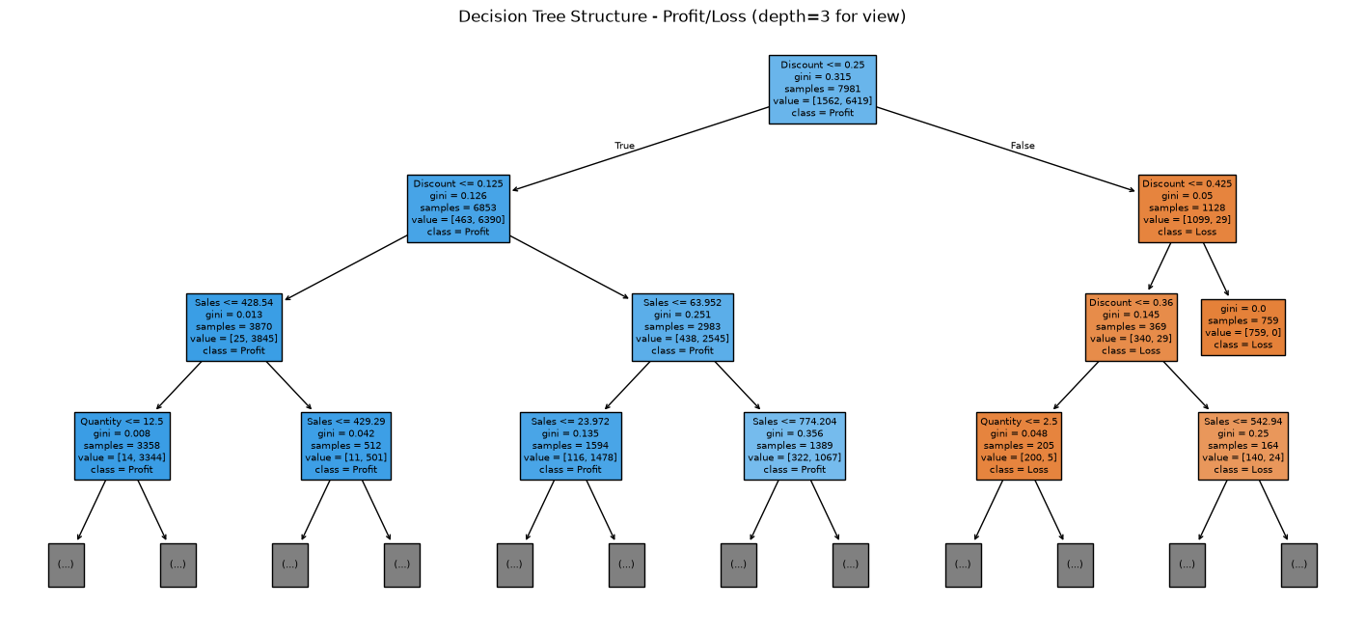

8. CONCLUSION

The Sales Performance Analysis project demonstrates how retail transaction data can be transformed into useful business information through Python, MySQL and machine learning. The project successfully loads and cleans the Sample Superstore dataset, performs exploratory analysis and generates visualizations for sales, profit, category and regional performance.
The EDA identifies Technology as the highest-sales category and the West region as a strong profit-performing region. Phones is identified as a leading sub-category. Correlation analysis shows a moderate positive relationship between Sales and Profit, while Discount has a negative relationship with Profit.
The Decision Tree Classifier provides an additional predictive component by classifying orders into profitable and loss-making groups. The model achieved 94.34% accuracy on the test data used in the project.
Overall, the project shows the value of combining database queries, visualization and machine learning for retail decision support. The findings can assist with discount control, inventory planning and regional strategy.

9. SCOPE FOR FUTURE ENHANCEMENT

- Develop an interactive dashboard using Power BI, Streamlit or a Django-based interface.

- Include customer-level segmentation and customer lifetime analysis.

- Add time-series forecasting for future sales and profit.

- Experiment with additional machine learning models and compare their performance.

- Include more features such as customer segment, shipping mode and product-level attributes in prediction.

- Automate periodic MySQL data loading and report generation.

- Add real-time or scheduled monitoring of loss-making orders.

- Provide interactive filters for region, category, sub-category and date.

10. APPENDIX

10.1 Project Code – Data Loading and Cleaning

# Import required libraries for data analysis and visualization
import pandas as pd # for data handling
import numpy as np # for numerical operations
import matplotlib.pyplot as plt # for plotting graphs
import seaborn as sns # for better visualizations
# Load the dataset
df = pd.read_csv('SampleSuperstore.csv')
# Show number of rows and columns
print(df.shape)
df
# Check for missing values in each column
print(df.isnull().sum())
# if any missing values... dropna() is used to drop rows
# to fill... fillna() is used
# if it is numerical col-- fill it with median, if it is categorical col-- fill it with mean
# Check for duplicate rows
print("\nDuplicates:", df.duplicated().sum())
# Remove duplicate rows
df = df.drop_duplicates()
print("Shape after removing duplicates:", df.shape)

10.2 Correlation Analysis Code

# Correlation Analysis
numeric_df = df[['Sales','Quantity','Discount','Profit']]
corr = numeric_df.corr()
print(corr)
plt.figure(figsize=(8,6))
sns.heatmap(corr, annot=True, cmap='coolwarm', fmt='.2f')
plt.title('Correlation Heatmap: Sales, Quantity, Discount, Profit')
plt.show()

10.3 Machine Learning Code

from sklearn.model_selection import train_test_split
from sklearn.tree import DecisionTreeClassifier
from sklearn.metrics import accuracy_score, classification_report, confusion_matrix
import seaborn as sns
import matplotlib.pyplot as plt
# Create target: 1 = Profitable, 0 = Loss
df['Profitable'] = (df['Profit'] > 0).astype(int)
X = df[['Sales','Quantity','Discount']]
y = df['Profitable']
X_train, X_test, y_train, y_test = train_test_split(X, y, test_size=0.2, random_state=42)
model = DecisionTreeClassifier(max_depth=5, random_state=42)
model.fit(X_train, y_train)
y_pred = model.predict(X_test)
print("Accuracy:", accuracy_score(y_test, y_pred))
print(classification_report(y_test, y_pred))
# Confusion Matrix Heatmap
cm = confusion_matrix(y_test, y_pred)
plt.figure(figsize=(5,4))
sns.heatmap(cm, annot=True, fmt='d', cmap='Greens')
plt.xlabel('Predicted')
plt.ylabel('Actual')
plt.title('Confusion Matrix - Profit/Loss')
plt.show()

10.4 SQL Analysis Queries
-- 1. Count No. of rows - total orders in dataset
SELECT COUNT(*) FROM superstore_db.superstore;
-- 2. See table columns and data types
DESCRIBE superstore_db.superstore;
-- 3. Total Sales and Profit (convert text to numbers using CAST)
SELECT
SUM(CAST(Sales AS DECIMAL(10,2))) AS total_sales,
SUM(CAST(Profit AS DECIMAL(10,2))) AS total_profit
FROM superstore_db.superstore;
-- 4. Sales by Category
SELECT Category, SUM(CAST(Sales AS DECIMAL(10,2))) AS sales -- sum calculate total sales
FROM superstore_db.superstore
GROUP BY Category -- groups data by categories
ORDER BY sales DESC; -- it shows highest first
-- 5. Top 5 profitable Sub-Categories
SELECT Sub_Category, SUM(CAST(Profit AS DECIMAL(10,2))) AS profit
FROM superstore_db.superstore
GROUP BY Sub_Category
ORDER BY profit DESC
LIMIT 5; -- only top 5 highest profit
-- 6. Loss-making Sub-Categories
SELECT Sub_Category, SUM(CAST(Profit AS DECIMAL(10,2))) AS profit
FROM superstore_db.superstore
GROUP BY Sub_Category
ORDER BY profit ASC
LIMIT 5;
-- 7. Sales by Region
SELECT Region, SUM(CAST(Sales AS DECIMAL(10,2))) AS sales,
SUM(CAST(Profit AS DECIMAL(10,2))) AS profit
FROM superstore_db.superstore
GROUP BY Region
ORDER BY sales DESC;

10.5 Project Structure
A practical project folder can contain the Jupyter Notebook, SampleSuperstore.csv, the MySQL SQL script and the final report document. The notebook acts as the main analytical implementation, while the SQL file contains the database analysis queries.

11. BIBLIOGRAPHY

- Kaggle – Sample Superstore dataset (SampleSuperstore.csv), as identified in the project notebook.

- Pandas Documentation – Python library for data manipulation and analysis.

- NumPy Documentation – Numerical computing library for Python.

- Matplotlib Documentation – Python visualization library.

- Seaborn Documentation – Statistical data visualization library.

- Scikit-learn Documentation – Machine learning tools and Decision Tree implementation.

- MySQL Documentation – SQL database management and query reference.

- Jupyter Documentation – Interactive notebook environment used for project implementation.

