《C语言程序设计》实验大作业反思报告
大作业题目 | 学生成绩管理系统 |  |  | 类型 | 信息管理系统 / 游戏
班 号 | （注意只写班号和学号，不写名字，互评要求匿名） |  | 学 号
所在院系 |  | 学 期 | 年 季学期 | 任课教师
实验类型 | 综合设计型
实验目的：
- 掌握程序设计的基本算法和简单数据结构基础，能够综合运用基本控制语句、算法和数据结构，以及自顶向下、逐步求精的模块化设计方法，能够设计具有一定规模的系统级C语言程序，提高系统编程能力；
- 针对计算相关的复杂工程问题，能够使用恰当的算法和数据结构，完成计算、统计、排序、检索、匹配等相关的软件系统的构造、测试与实现；
- 掌握常用的程序调试和测试方法。
实验要求：
- 采用自顶向下、逐步求精的模块化设计思想设计一个小型信息库管理系统，或者闯关式游戏程序。
- 要求解释说明采用了什么数据结构和算法，为什么选择这种数据结构或算法，系统实现过程中遇到了哪些问题，这些问题是如何解决的，还有什么问题尚未解决，今后打算从哪几个方面进行改进，本设计的亮点和难点在哪里，实验结果如何，有哪些收获和学习体会；
- 编写程序完成以下实验大作业内容并完成实验大作业反思报告。
实验内容：
设计一个学生成绩管理系统，包括学生成绩数据的增删改查等基本操作，要求编程实现如下菜单驱动的学生成绩管理系统：
（1）录入每个学生的学号、姓名和各科考试成绩；
（2）计算每门课程的总分和平均分；
（3）计算每个学生的总分和平均分；
（4）按每个学生的总分由高到低排出名次表；
（5）按每个学生的总分由低到高排出名次表；
（6）按学号由小到大排出成绩表；
（7）按姓名的字典顺序排出成绩表；
（8）按学号查询学生排名及其考试成绩；
（9）按姓名查询学生排名及其考试成绩；
（10）按优秀（90~100）、良好（80~89）、中等（70~79）、及格（60~69）、不及格（0~59）5个类别，对每门课程分别统计每个类别的人数以及所占的百分比；
（11）输出每个学生的学号、姓名、各科考试成绩，以及每门课程的总分和平均分；
（12）将每个学生的记录信息写入文件；
（13）从文件中读出每个学生的记录信息并显示。
要求程序运行后先显示如下菜单，并提示用户输入选项：
1.Input record
2.Calculate total and average score of every course
3.Calculate total and average score of every student
4.Sort in descending order by total score of every student
5.Sort in ascending order by total score of every student
6.Sort in ascending order by number
7.Sort in dictionary order by name
8.Search by number
9.Search by name
10.Statistic analysis for every course
11.List record
12.Write to a file
13.Read from a file
0.Exit
Please enter your choice:
然后，根据用户输入的选项执行相应的操作。
实验环境：
操作系统：Windows 11
集成开发环境：Visual Studio Code + MinGW 13.2.0 + CMake 3.29.0
外部库：暂未使用外部库
输入输出设计：
此程序的输入主要有两种：整数和字符串。以下四个工具函数负责安全地读取输入。
int fread_int(FILE* fp, int* target);
int read_int(int* target);
int fread_string(FILE* fp, char* target, int limit, char end, bool drop_left);
int read_string(char* target, int limit, char end, bool drop_left);
这些工具函数与scanf的区别在于，read_int会在读取失败时丢弃剩余的输入内容，read_string可以指定读取的数量上限和读取的结束符，并且可以控制在读取超限时是否丢弃结束符之前的所有输入。
基于这些工具函数，可以实现对输入的初步检验：
# 输入的不是有效的数字
Please enter your choice: nan
Input is not a number, retry:
# 输入字符串长度超限
Input student's name: aaaaaaaaaaaaaaaaaaaaaaaaaaaaaaaaaaaaaaaaaaaaaaaaaaaaaaaaa
Input exceeded length limit of 31, which is truncated.

在输出到文件时，此程序在文件的第一行标明学生数量，此后每行以逗号分隔的形式输出学生的学号、姓名与各科分数。这种格式很容易与其他语言兼容，便于分析。
在打开文件时，此程序会简单检测是否成功打开，若不成功，会报告发生的错误。
然而，此程序并没有覆盖所有的异常情况，例如：
- 在读取文件时并不会验证数据合法性，它只保证能读取自己输出的数据。
- 此程序假定在文件成功打开时，文件读写不会发生错误。
- 此程序假定动态内存分配总是会成功。事实上动态内存分配失败相当少见，而且在发生时程序并没有任何挽回的余地。
系统设计与实现:
- 系统功能模块划分
对系统进行自顶向下的模块分解，画出系统各个功能模块之间的结构图如下：
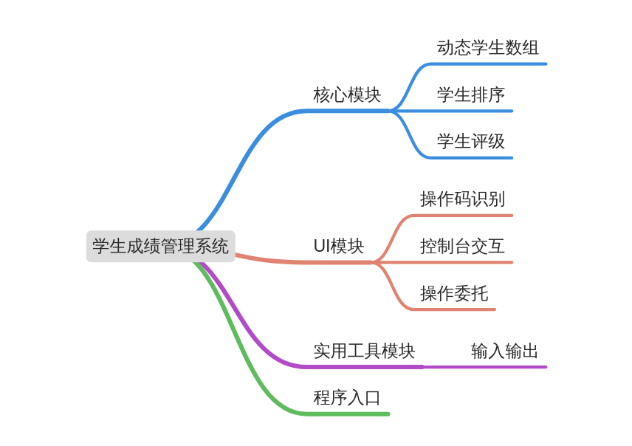
- 函数功能和外部接口设计
本系统总计设计了21(导出)+15(内部)个自定义函数，导出的自定义函数的功能如下表所示：
序号 | 函数名 | 函数功能 | 函数参数 | 函数返回值
1 | (f)read_int | 读取整数 | 目标整数指针 | 读取是否成功
2 | (f)read_string | 读取字符串 | 目标字符串指针 | 消耗输入流字符数
3 | subject_name | 获取课程代号的字符串名 | 课程代号 | 课程字符串名
4 | evaluation_name | 获取评级代号的字符串名 | 评级代号 | 评级字符串名
5 | evaluate_sore | 根据分数给出评级 | 学生某科分数 | 评级代号或-1
6 | studb_create | 创建学生数据库 | self | void
7 | studb_destroy | 销毁学生数据库 | self | void
8 | studb_preserve | 调整数组容量 | self, 新容量 | void
9 | studb_push | 向数组末尾插入数据 | self | 数据指针
10 | studb_pop | 删除数组末尾的数据 | self | void
11 | studb_index | 新建指针索引 | self, 索引 | void
12 | studb_sortidx | 排序指针索引 | self, 索引, 排序函数 | void
13 | stucmp_score | 索引排序函数：按总分 | 学生数据二重指针 | 大小结果
14 | stucmp_id | 索引排序函数：按学号 | 学生数据二重指针 | 大小结果
15 | stucmp_name | 索引排序函数：按姓名 | 学生数据二重指针 | 大小结果
16 | ui_read_int | 读取并验证整数 | 目标整数指针 | void
17 | ui_read_string | 读取并验证字符串 | 目标字符串指针 | void
18 | ui_listops | 列出所有可用操作 | void | void
19 | ui_create | 创建UI对象 | self | void
20 | ui_destory | 销毁UI对象 | self | void
21 | ui_dispatch | 根据操作码执行操作 | self, 操作码 | void
各个函数之间的调用关系如下所示：
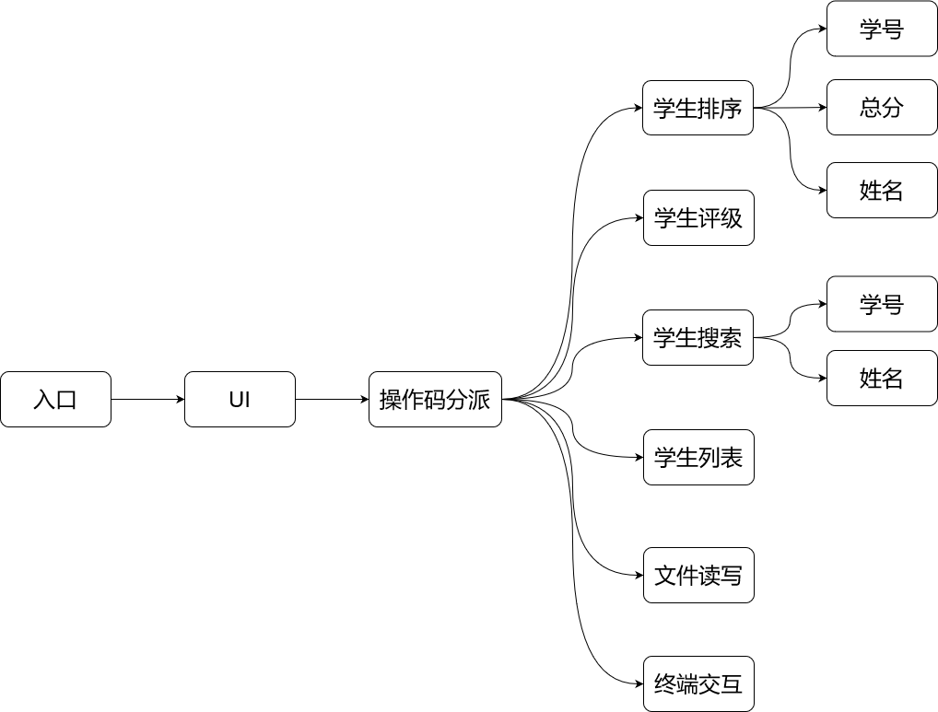
- 数据结构：动态结构体数组、函数指针、顺序存储结构
- 算法：枚举统计、快速排序、文件输入输出
- 程序流程图
系统总体流程图如下：
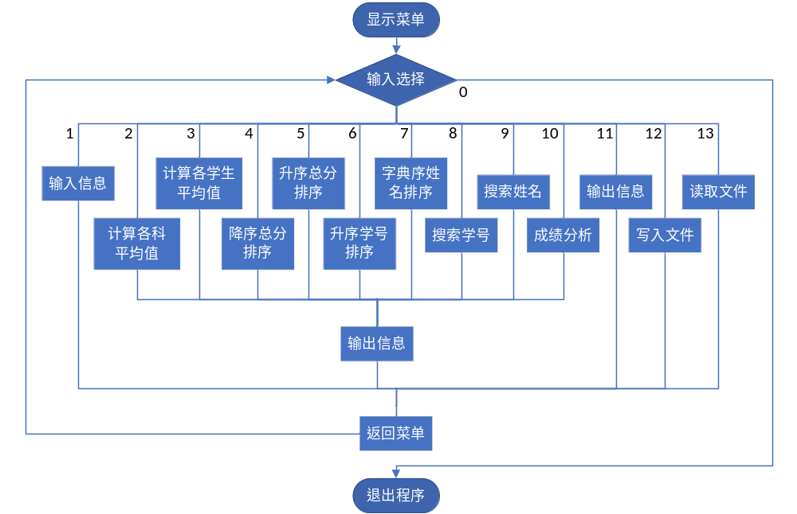

实验过程中遇到的问题及解决方法与思路：
问题1：无法使用类和对象
原因：纯C是面向过程的，没有类
解决方法：手动模拟面向对象

问题2：scanf不符合输入检测和处理的要求
原因：scanf在读取输入失败时会回滚输入缓冲区
解决方法：实现工具函数(f)read_int、(f)read_string以在读取失败时丢弃输入缓冲区

问题3：添加记录的操作延迟较大
原因：每次调整数组容量都重新分配内存，动态内存分配和数组元素复制开销较大
解决方法：按块分配内存，例如，块大小为256，则容量为257~512个元素时都使用容量为512个元素的数组，减少内存重分配
测试用例和系统测试结果：
注：以下输出省略了每次询问前展示选项的环节。
Please enter your choice: 1
=========================
Input student's ID: 1
Input student's name: P
Input student's score of math: 100
Input student's score of chinese: 100
Input student's score of english: 100
Input student's score of physics: 100
Input student's score of chemistry: 100
Input student's score of biology: 100
Input student's score of politics: 0
Input student's score of history: 0
Input student's score of geography: 0
=========================
Please enter your choice: 1
=========================
Input student's ID: 2
Input student's name: Z
Input student's score of math: 90
Input student's score of chinese: 90
Input student's score of english: 90
Input student's score of physics: 90
Input student's score of chemistry: 90
Input student's score of biology: 90
Input student's score of politics: 0
Input student's score of history: 0
Input student's score of geography: 0
=========================
Please enter your choice: 11
=========================
Student details:
<id=1>P: total=600, math=100, chinese=100, english=100, physics=100, chemistry=100, biology=100, politics=0, history=0, geography=0
<id=2>Z: total=540, math=90, chinese=90, english=90, physics=90, chemistry=90, biology=90, politics=0, history=0, geography=0
Overall statistics:
Score of math: total=190, average=95.000000
Score of chinese: total=190, average=95.000000
Score of english: total=190, average=95.000000
Score of physics: total=190, average=95.000000
Score of chemistry: total=190, average=95.000000
Score of biology: total=190, average=95.000000
Score of politics: total=0, average=0.000000
Score of history: total=0, average=0.000000
Score of geography: total=0, average=0.000000
=========================
Please enter your choice: 0
See you next time!

程序的全部源代码：
main.c
1  2  3  4  5  6  7  8  9  10  11  12  13  14  15  16  17  18  19  20  21  22  23 | #include <stdio.h>  #include "ui.h"  int main() {  StudentManagerUI ui;  ui_create(&ui);  int opcode;  while (1) {  ui_listops();  printf("0.Exit\n");  printf("Please enter your choice: "); ui_read_int(&opcode);  if (opcode == 0) {  printf("See you next time!\n");  break;  } else {  printf("=========================\n");  ui_dispatch(&ui, opcode);  printf("=========================\n");  }  }  ui_destroy(&ui);  }
core.h
1  2  3  4  5  6  7  8  9  10  11  12  13  14  15  16  17  18  19  20  21  22  23  24  25  26  27  28  29  30  31  32  33  34  35  36  37  38  39  40  41  42  43  44  45  46  47  48  49  50  51  52  53  54  55  56 | #include <stdint.h>  enum Subject {  S_MATH = 0,  S_CHINESE,  S_ENGLISH,  S_PHYSICS,  S_CHEMISTRY,  S_BIOLOGY,  S_POLITICS,  S_HISTORY,  S_GEOGRAPHY,  SUBJECT_MAX,  };  const char* subject_name(int code);  enum Evaluation {  EV_SUPREME = 0, // 优秀  EV_GREAT, // 良好  EV_MIDDLE, // 中等  EV_PASSING, // 及格  EV_FAILING, // 不及格  EVALUATION_MAX  };  const char* evaluation_name(int code);  int evaluate_score(int score);  typedef struct {  int id;  char name[32];  int scores[SUBJECT_MAX];  } StudentInfo;  int stu_score_sum(const StudentInfo* self);  typedef struct {  StudentInfo* data;  size_t size, capacity;  } StudentDatabase;  typedef StudentInfo* StudentPtr;  typedef StudentPtr* StudentIndex;  typedef int (*StudentIndexCompare)(const StudentPtr*, const StudentPtr*);  void studb_create(StudentDatabase* self);  void studb_destroy(StudentDatabase* self);  void studb_preserve(StudentDatabase* self, size_t new_size);  StudentInfo* studb_push(StudentDatabase* self);  void studb_pop(StudentDatabase* self);  void studb_index(const StudentDatabase* self, StudentIndex index);  void studb_sortidx(const StudentDatabase* self, StudentIndex index, StudentIndexCompare cmp);  int stucmp_score(const StudentPtr* a, const StudentPtr* b);  int stucmp_id(const StudentPtr* a, const StudentPtr* b);  int stucmp_name(const StudentPtr* a, const StudentPtr* b);
core.c
1  2  3  4  5  6  7  8  9  10  11  12  13  14  15  16  17  18  19  20  21  22  23  24  25  26  27  28  29  30  31  32  33  34  35  36  37  38  39  40  41  42  43  44  45  46  47  48  49  50  51  52  53  54  55  56  57  58  59  60  61  62  63  64  65  66  67  68  69  70  71  72  73  74  75  76  77  78  79  80  81  82  83  84  85  86  87  88  89  90  91  92 | #include <stdlib.h>  #include <string.h>  #include "core.h"  const char* subject_name(int code) {  static const char* name_table[SUBJECT_MAX] = {  "math",  "chinese",  "english",  "physics",  "chemistry",  "biology",  "politics",  "history",  "geography",  };  return name_table[code];  }  const char* evaluation_name(int code) {  static const char* name_table[EVALUATION_MAX] = {  "supreme", // 优秀  "great", // 良好  "middle", // 中等  "passing", // 及格  "failing", // 不及格  };  return name_table[code];  }  int evaluate_score(int score) {  if (score > 100) { return -1; }  if (score >= 90) { return EV_SUPREME; }  if (score >= 80) { return EV_GREAT; }  if (score >= 70) { return EV_MIDDLE; }  if (score >= 60) { return EV_PASSING; }  if (score >= 0) { return EV_FAILING; }  return -1;  }  int stu_score_sum(const StudentInfo* self) {  int sum = 0;  for (size_t i = 0; i < SUBJECT_MAX; ++i) {  sum += self->scores[i];  }  return sum;  }  static const size_t cap_block = 256;  void studb_create(StudentDatabase* self) {  self->size = 0; self->capacity = cap_block;  self->data = malloc(cap_block * sizeof(StudentInfo));  }  void studb_destroy(StudentDatabase* self) {  self->size = 0; self->capacity = 0;  free(self->data);  }  void studb_preserve(StudentDatabase* self, size_t new_size) {  if (new_size <= self->capacity) { return; }  size_t n_blocks = new_size ? ((new_size - 1) / cap_block + 1) : 1;  StudentInfo* new_data = malloc(n_blocks * cap_block * sizeof(StudentInfo));  memcpy(new_data, self->data, self->size * sizeof(StudentInfo));  free(self->data); self->data = new_data;  self->capacity = n_blocks * cap_block;  }  StudentInfo* studb_push(StudentDatabase* self) {  ++self->size;  studb_preserve(self, self->size);  return self->data + self->size - 1;  }  void studb_pop(StudentDatabase* self) {  --self->size;  studb_preserve(self, self->size);  }  void studb_index(const StudentDatabase* self, StudentIndex index) {  for (size_t i = 0; i < self->size; ++i) {  index[i] = self->data + i;  }  }  void studb_sortidx(const StudentDatabase* self, StudentIndex index, StudentIndexCompare cmp) {  qsort(index, self->size, sizeof(StudentPtr), (int (*)(const void*, const void*))cmp);  }  int stucmp_score(const StudentPtr* a, const StudentPtr* b) {  return stu_score_sum(*a) - stu_score_sum(*b);  }  int stucmp_id(const StudentPtr* a, const StudentPtr* b) {  return (*a)->id - (*b)->id;  }  int stucmp_name(const StudentPtr* a, const StudentPtr* b) {  return strcmp((*a)->name, (*b)->name);  }
utils.h
1  2  3  4  5  6  7 | #include <stdio.h>  #include <stdbool.h>  int fread_int(FILE* fp, int* target);  int read_int(int* target);  int fread_string(FILE* fp, char* target, int limit, char end, bool drop_left);  int read_string(char* target, int limit, char end, bool drop_left);
utils.c
1  2  3  4  5  6  7  8  9  10  11  12  13  14  15  16  17  18  19  20  21  22  23  24  25  26  27  28  29  30  31  32 | #include "utils.h"  #include <stdlib.h>  int fread_int(FILE* fp, int* target) {  int n_ok = fscanf(fp, "%d", target);  if (n_ok == EOF) { printf("INPUT FAILURE, PANICKING!"); exit(1); }  // 若未成功读入，丢弃缓冲区  if (n_ok < 1) { while (fgetc(fp) != '\n') {} return -1; }  return 0;  }  int read_int(int* target) {  return fread_int(stdin, target);  }  // 注：为了保留结尾\0，实际能读入的字符数为limit - 1  int fread_string(FILE* fp, char* target, int limit, char end, bool drop_left) {  fscanf(fp, " "); // 去除空白  int i; bool finish = false;  for (i = 0; i < limit - 1; ++i) {  int ch = fgetc(fp);  if (ch == end) { finish = true; break; }  target[i] = ch;  }  target[i] = 0;  if (!finish && drop_left) { while (fgetc(fp) != end) { ++i; } }  return i;  }  int read_string(char* target, int limit, char end, bool drop_left) {  return fread_string(stdin, target, limit, end, drop_left);  }
ui.h
1  2  3  4  5  6  7  8  9  10  11  12 | #include "core.h"  typedef struct {  StudentDatabase db;  } StudentManagerUI;  void ui_read_int(int* target);  void ui_read_string(char* target, int limit);  void ui_listops(void);  void ui_create(StudentManagerUI* self);  void ui_destroy(StudentManagerUI* self);  void ui_dispatch(StudentManagerUI* self, int code);
ui.c
1  2  3  4  5  6  7  8  9  10  11  12  13  14  15  16  17  18  19  20  21  22  23  24  25  26  27  28  29  30  31  32  33  34  35  36  37  38  39  40  41  42  43  44  45  46  47  48  49  50  51  52  53  54  55  56  57  58  59  60  61  62  63  64  65  66  67  68  69  70  71  72  73  74  75  76  77  78  79  80  81  82  83  84  85  86  87  88  89  90  91  92  93  94  95  96  97  98  99  100  101  102  103  104  105  106  107  108  109  110  111  112  113  114  115  116  117  118  119  120  121  122  123  124  125  126  127  128  129  130  131  132  133  134  135  136  137  138  139  140  141  142  143  144  145  146  147  148  149  150  151  152  153  154  155  156  157  158  159  160  161  162  163  164  165  166  167  168  169  170  171  172  173  174  175  176  177  178  179  180  181  182  183  184  185  186  187  188  189  190  191  192  193  194  195  196  197  198  199  200  201  202  203  204  205  206  207  208  209  210  211  212  213  214  215  216  217  218  219  220  221  222  223  224  225  226  227  228  229  230  231  232  233  234  235  236  237  238  239  240  241  242  243  244  245  246  247  248  249  250  251  252 | #include "ui.h"  #include "utils.h"  #include <stdio.h>  #include <stdlib.h>  #include <string.h>  #include <stdbool.h>  void ui_read_int(int* target) {  while (read_int(target) != 0) {  printf("Input is not a number, retry: ");  }  }  void ui_read_string(char* target, int limit) {  int read = read_string(target, limit, '\n', true);  if (read > limit - 1) {  printf("Input exceeded length limit of %d, which is truncated.\n", limit - 1);  }  }  typedef void(*UISubroutine)(StudentManagerUI*);  void add_student(StudentManagerUI* self) {  StudentInfo* stu = studb_push(&self->db);  printf("Input student's ID: "); ui_read_int(&stu->id);  printf("Input student's name: "); ui_read_string(stu->name, 32);  for (int sub = 0; sub < SUBJECT_MAX; ++sub) {  printf("Input student's score of %s: ", subject_name(sub));  ui_read_int(&stu->scores[sub]);  }  }  void course_score_info(StudentManagerUI* self) {  long long int course_sums[SUBJECT_MAX];  for (int sub = 0; sub < SUBJECT_MAX; ++sub) { course_sums[sub] = 0; }  for (size_t i = 0; i < self->db.size; ++i) {  StudentInfo* stu = &self->db.data[i];  for (int sub = 0; sub < SUBJECT_MAX; ++sub) { course_sums[sub] += stu->scores[sub]; }  }  for (int sub = 0; sub < SUBJECT_MAX; ++sub) {  double avg = (double)course_sums[sub] / self->db.size;  printf("Score of %s:\ttotal=%d, average=%lf\n", subject_name(sub), course_sums[sub], avg);  }  }  void student_score_info(StudentManagerUI* self) {  for (size_t i = 0; i < self->db.size; ++i) {  StudentInfo* stu = &self->db.data[i];  int blend_sum = stu_score_sum(stu);  double avg = (double)blend_sum / SUBJECT_MAX;  printf("Score of %s:\ttotal=%d, average=%lf\n", stu->name, blend_sum, avg);  }  }  void print_student_detail(StudentInfo* stu) {  int blend_sum = stu_score_sum(stu);  printf("<id=%d>%s:\ttotal=%d", stu->id, stu->name, blend_sum);  for (int sub = 0; sub < SUBJECT_MAX; ++sub) {  printf(", %s=%d", subject_name(sub), stu->scores[sub]);  }  }  void student_sort(StudentManagerUI* self, StudentIndexCompare cmp, bool desc) {  StudentIndex index = malloc(self->db.size * sizeof(StudentPtr));  studb_index(&self->db, index);  studb_sortidx(&self->db, index, cmp);  for (size_t i = 0; i < self->db.size; ++i) {  StudentInfo* stu = desc ? index[self->db.size - i - 1] : index[i];  int blend_sum = stu_score_sum(stu);  printf("Rank(%d)\t", i + 1);  print_student_detail(stu);  printf("\n");  }  free(index);  }  void student_sort_score_desc(StudentManagerUI* self) {  student_sort(self, stucmp_score, true);  }  void student_sort_score_asc(StudentManagerUI* self) {  student_sort(self, stucmp_score, false);  }  void student_sort_id_asc(StudentManagerUI* self) {  student_sort(self, stucmp_id, false);  }  void student_sort_name_asc(StudentManagerUI* self) {  student_sort(self, stucmp_name, false);  }  void find_by_id(StudentManagerUI* self) {  int target_id;  printf("Input student's ID: "); ui_read_int(&target_id);  StudentInfo* found = NULL;  for (size_t i = 0; i < self->db.size; ++i) {  StudentInfo* stu = &self->db.data[i];  if (stu->id == target_id) {  found = stu; break;  }  }  if (found) {  printf("Found student: ");  print_student_detail(found);  printf("\n");  } else {  printf("Specified student not found!\n");  }  }  void find_by_name(StudentManagerUI* self) {  char target_name[32];  printf("Input student's name: "); ui_read_string(target_name, 32);  StudentInfo* found = NULL;  for (size_t i = 0; i < self->db.size; ++i) {  StudentInfo* stu = &self->db.data[i];  if (strcmp(stu->name, target_name) == 0) {  found = stu; break;  }  }  if (found) {  printf("Found student: ");  print_student_detail(found);  printf("\n");  } else {  printf("Specified student not found!\n");  }  }  void classify_student(StudentManagerUI* self) {  for (int sub = 0; sub < SUBJECT_MAX; ++sub) {  size_t student_counts[EVALUATION_MAX];  for (int ev = 0; ev < EVALUATION_MAX; ++ev) { student_counts[ev] = 0; }  size_t invalid_count = 0;  for (size_t i = 0; i < self->db.size; ++i) {  StudentInfo* stu = &self->db.data[i];  int ev = evaluate_score(stu->scores[sub]);  if (ev == -1) { ++invalid_count; } else { ++student_counts[ev]; }  }  double invalid_percent = (double)invalid_count / self->db.size * 100;  printf("Subject %s: ", subject_name(sub));  printf("invalid=%d(%lf%%)", invalid_count, invalid_percent);  for (int ev = 0; ev < EVALUATION_MAX; ++ev) {  double percent = (double)student_counts[ev] / self->db.size * 100;  printf(", %s=%d(%lf%%)", evaluation_name(ev), student_counts[ev], percent);  }  printf("\n");  }  }  // 是的，这个函数就是复制了course_score_info然后加了几句话。  void list_students(StudentManagerUI* self) {  long long int course_sums[SUBJECT_MAX];  for (int sub = 0; sub < SUBJECT_MAX; ++sub) { course_sums[sub] = 0; }  printf("Student details:\n");  for (size_t i = 0; i < self->db.size; ++i) {  StudentInfo* stu = &self->db.data[i];  for (int sub = 0; sub < SUBJECT_MAX; ++sub) { course_sums[sub] += stu->scores[sub]; }  print_student_detail(stu);  printf("\n");  }  printf("Overall statistics:\n");  for (int sub = 0; sub < SUBJECT_MAX; ++sub) {  double avg = (double)course_sums[sub] / self->db.size;  printf("Score of %s:\ttotal=%d, average=%lf\n", subject_name(sub), course_sums[sub], avg);  }  }  void dump_data(StudentManagerUI* self) {  FILE* fp = fopen("students.txt", "w");  if (fp == NULL) {  printf("Cannot open file: %s", strerror(errno));  return;  }  fprintf(fp, "%zu\n", self->db.size);  for (size_t i = 0; i < self->db.size; ++i) {  StudentInfo* stu = &self->db.data[i];  fprintf(fp, "%d,%s", stu->id, stu->name);  for (int sub = 0; sub < SUBJECT_MAX; ++sub) {  fprintf(fp, ",%d", stu->scores[sub]);  }  fprintf(fp, "\n");  }  fflush(fp);  fclose(fp);  printf("Finished writing.\n");  }  void load_data(StudentManagerUI* self) {  FILE* fp = fopen("students.txt", "r");  if (fp == NULL) {  printf("Cannot open file: %s", strerror(errno));  return;  }  fscanf(fp, "%zu", &self->db.size);  studb_preserve(&self->db, self->db.size);  for (size_t i = 0; i < self->db.size; ++i) {  StudentInfo* stu = &self->db.data[i];  fscanf(fp, "%d,", &stu->id);  fread_string(fp, stu->name, 32, ',', true);  ungetc(',', fp);  for (int sub = 0; sub < SUBJECT_MAX; ++sub) {  fscanf(fp, ",%d", &stu->scores[sub]);  }  }  fflush(fp);  fclose(fp);  printf("Finished reading.\n");  }  const struct {  UISubroutine fn;  const char* info;  } dispatch_table[] = {  /* 0 */ {NULL, NULL},  /* 1 */ {add_student, "Input record"},  /* 2 */ {course_score_info, "Calculate total and average score of every course"},  /* 3 */ {student_score_info, "Calculate total and average score of every student"},  /* 4 */ {student_sort_score_desc, "Sort in descending order by total score of every student"},  /* 5 */ {student_sort_score_asc, "Sort in ascending order by total score of every student"},  /* 6 */ {student_sort_id_asc, "Sort in ascending order by number"},  /* 7 */ {student_sort_name_asc, "Sort in dictionary order by name"},  /* 8 */ {find_by_id, "Search by number"},  /* 9 */ {find_by_name, "Search by name"},  /* 10 */ {classify_student, "Statistic analysis for every course"},  /* 11 */ {list_students, "List record"},  /* 12 */ {dump_data, "Write to a file"},  /* 13 */ {load_data, "Read from a file"},  };  const int max_dispatch_code = sizeof(dispatch_table) / sizeof(dispatch_table[0]);  void ui_create(StudentManagerUI* self) {  studb_create(&self->db);  }  void ui_destroy(StudentManagerUI* self) {  studb_destroy(&self->db);  }  void ui_dispatch(StudentManagerUI* self, int code) {  if (code <= 0 || code >= max_dispatch_code) {  printf("Unknown operation code (%d)!\n", code);  } else {  dispatch_table[code].fn(self);  }  }  void ui_listops(void) {  for (int i = 1; i < max_dispatch_code; ++i) {  printf("%d.%s\n", i, dispatch_table[i].info);  }  }
CMakeLists.txt
1  2  3  4  5  6  7  8  9  10  11 | cmake_minimum_required(VERSION 3.15)  project(StudentScoreManager)  set(PROGRAM_SOURCE_ROOT ${CMAKE_CURRENT_SOURCE_DIR}/src)  file(GLOB_RECURSE PROGRAM_SOURCES ${PROGRAM_SOURCE_ROOT}/*.c)  add_executable(${PROJECT_NAME} ${PROGRAM_SOURCES})  if(MINGW)  target_link_libraries(${PROJECT_NAME} PRIVATE -static-libgcc)  endif()  target_include_directories(${PROJECT_NAME} PRIVATE ${PROGRAM_SOURCE_ROOT})

分析总结、收获和体会:
优点：

新颖之处：

不足之处：

需要改进的地方：

收获与学习体会：

自我评价： |  |  |  |  | 是 | 否
程序运行是否无bug？
是否在撰写报告之前观看了spoc里的代码规范视频？
程序代码是否符合代码规范(对齐与缩进，有必要的注释)？
是否按模块化要求进行了程序设计，系统功能是否完善？
是否是独立完成？
自我评语：
报告完成日期：

