**Instructions of how to run phantomjs code on your machine (Windows)**

1. Download phantomjs here: <http://phantomjs.org/download.html>

Make sure you do not download it on desktop. Unzip it and go to phantomjs-2.1.1-windows\phantomjs-2.1.1-windows\bin and copy the file location

2. Set up environment variable:

go to Control Panel > System and Security > System > Advanced setting

> click on Environment varialble > select “path” under users variable then click edit and add the file location that you copied on step 1

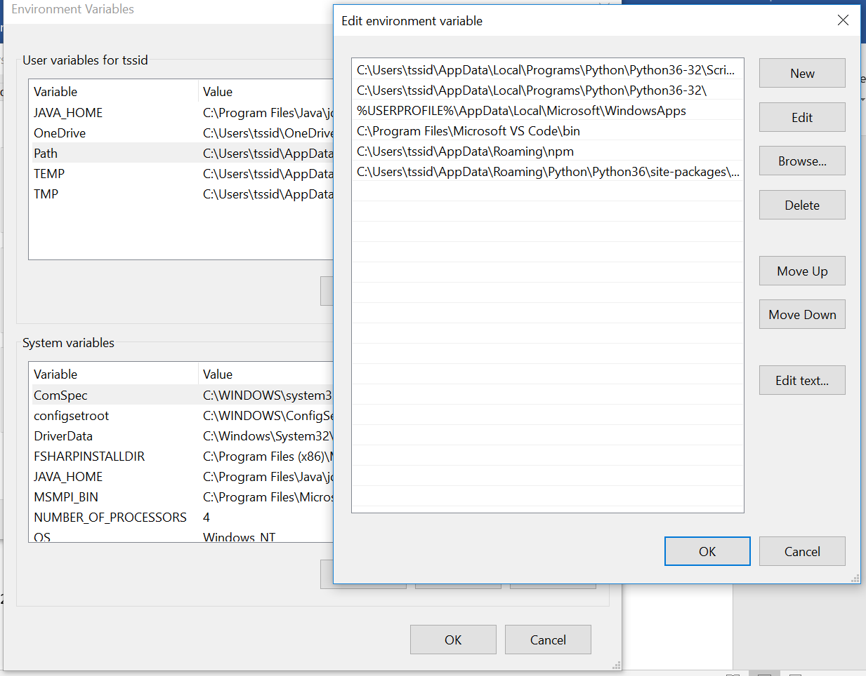

1. Open the Command Prompt and go to the location where your .js file is and run the following command:

* phantomjs yourScript.js

In my case .js file is in the folder named dot

