Name: Maksim Zubritckii

Class: IT354

Semester: Spring 2020

List of Languages/Technologies Being Used/Explored:

1. GitHub
2. Bootstrap
3. Mongodb
4. Node.js. (body-parser, express, nodemon, morgan, cors)
5. Vue.js
6. Webpack

Repository Name: <https://github.com/TsarGun/TheGameCloset>

Gherkin Statements:

1. I am, as a board game owner, want to be able to track my games online because accessibility is important and neat.
2. I am, as a board game owner, sometimes have a need to check gaming rules of the game, so I want to have them online because sometimes they get lost and then it is hard to find them
3. I am, as a user want to be able to perform all of the basic functions of storage (CRUD) to the list of games.
4. I am, as a user of the website, want to be able to choose the preferred color scheme.

Extra target:

1. I am as a board game owner want to be able to pick a random game with the pre-set criteria like (number of players or type of the game) because sometimes it hard to choose.

I like board games a lot and I have a lot of friends who like them as well. When you have only a few board games it's not a big deal to track them all, but usually, no one stops on 2 or 3. I came up with the idea of the web game closet when I saw my friend's real game closet with more than a hundred games. He himself does not remember all games he owns. There are around the top 10 games which he usually plays, but the rest is forgotten in the closet. I hope my project will be able to solve this problem.

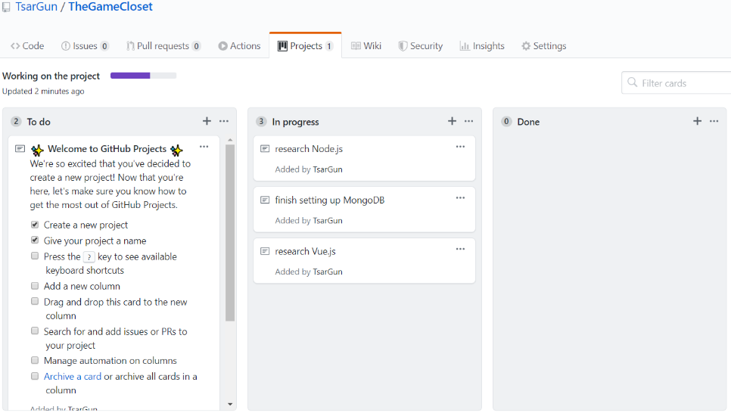I am, as a student, trying to get experience with advanced web development tools by doing this project. Also, I want to help board game owners to organize their board game closets and make it possible to access it even without being inside of it.

Are You Using Github Stories: Yes!

Are You Creating Branches, Then Merging Them Into master: Yes!

P.S. This thing is stories, right?