Kakau Dokumentation

- Common
  - Concepts
    - Items
    - Database
    - Tables
    - User
    - Indices

Common

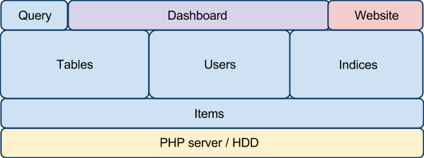

The Diagram above shows the overall strucutre of the CMS. On the bottom level there is a PHP server running that can handle HTTP-request and operate on the HDD. The whole state of the CMS and its Database ist stored in json-files on the HDD. The basic structure that represents data inside the CMS is an item. Every json file contains a list of items of one distinctive type.

There are two types of data stored: the metadata and the content itsself. The metadata contains information about the users of the cms the table structure of the database and the indices that represent this structure. The correpsonding lists of items are stored in json files in the "KkuDatabase/structure" directory.

For every table that is defined in the metadata in the content-part of the database there is a list of items in the "KkuDatabase/content" folder that contains the items inside this table.

For every index that is defined in the metadata, their is a json-file in the "KkuDatabase/indices" folder that contains all the files of the index including there belonging items from other tables.

Concepts

Items
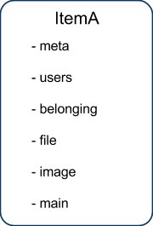

The most basic buildingblock of the database is the item. An item can be representing a newspost for example or it can be the file you attached to that newspost. An item is basically an associative array, or a dictionary. Its fields can be order in 5 five categories:

the meta part consist of the fields _dateCreated, _ID and _tablename and holds the information about the location of the object and its creation date.

the users part contains the information which users of the editors have access to this item. it consists of the field _users.

the belonging part whether the item is a parent item of an other item, and if so, whose. the parent item is referenced by _belongsToId and _belongsToTable.

the file part consist of the fields _fileUrl. If there is a file belonging to the item its relative url inside the database is store in the _fileUrl field.

the image part consists of the field _imageUrl. Its handles the same way as _fileUrl.

the main part consist of all the fields that are defined in the structure item that defines the table of which the item is part of. For example if theres a table called team, which has the fields "name" and "position" the main part would consist of exactly these fields.

Database
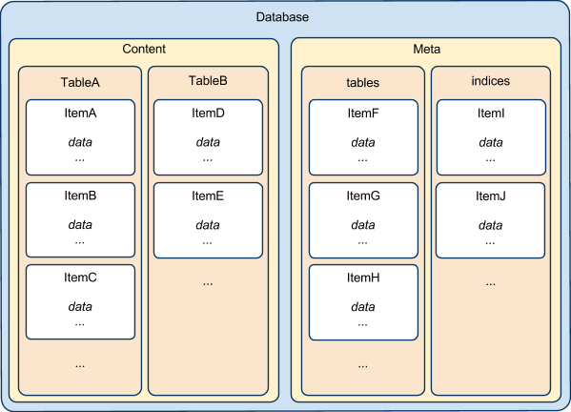

The database stores all the items. There is a content part that consists of tables that can hold items, and there is a meta part which consists of structures that can hold items. In the meta part is defined what kind of tables there are on the content side, who can edit them und how they are accessed from outside. There are 3 main structures: tables, indices and users.

Tables
Every table in the database has one corresponding item inside the tables structure. it has the following main fields:

- name - the name of the table
- canBelong - whether the item of that table can be parent of other itemsI
- canHaveFile - whether the item can have a file
- canHaveImage - whether there can be an image to that item
- everyoneCanAdd - whether everyon can add new entries via query
- everyoneCanEdit - whether everyon can edit entries via query
- everyoneCanDelete - whether everyon can delete entries via query

The rest of the fields are only display options for the dashboard.

Fields
Every table has fields in which the information is stored the items of this table represent. Fields for a table can be created in the overview of the table. fields have the following fields:

- position - on the edit form of the dashboard the files are ordereb by this field
- name - the name of the fields
- type - can be:
  - standard a string
  - date a datetime string in YYYY-MM-DD hh:mm:ss format
  - bool true or false
  - textarea a larger string
  - number a single integer value
  - multiple one of some options that specified in the options field
- options - options that can be selected for a multiple type field e.g. "yes;no;maybe;"
- description - is displayed in the edit form in the dashboard

belongingTables
If "tableA" is a belonging table of "tableB" there are items of "tableB" that are part of the items of "tableA". For example if there is a "news" table, and this table should have references in the form of links, you would create a "links" table and add "links" to the belonging tables of "news". You can add a table to the belongingTables of aspecific table in the edit form of this table. The belongingTable entries have the following fields:

- name - name of the belonging table
- subtable - specify if you want to have only a subtable of the table as belongig items
- oderField - When an index is build from the table the belonging items are sorted by this field

Subtables
Items that are part of a subtable of a table contain only a subset of the fields of the table. You can add subtables to tables in the edit form of the table. On the edit form of the subtable you can define which of the table files should be included in the subtable.

Users
If you want to make changes inside the database you have to athuanticate yourself as a user. There are two types of users: admins, which have full access over the database, and editor you have only access to certain items within the database. The Users-items have the following fields:

- name - the username
- md5hash - a md5-hash over the password
- type - the user type: admin or editor
- editedTables - if the user type is editor this is a list of the tables he may edit

Indices
Indices are prebuilt database queries, that are saved on the hard disk as json-files to provide fast access for the website. There are two types of indices:

Table indices are based on one table. If read into a variable in php, you will get an array of the items representing the items inside the database. If the items of that table have belonging items these are include in these items.

Example: table1 can have belonging items of table2

$index[5] - this would represent the 5th item of the table1

$index[5]['table2'][1] - this would respresent the first of the items of table2 that
belong to the 5th item of table1

Table indices are built by a php script that follows the following pseudocode:

get all items of that table

filter items using the filterFunction

append belonging items to every item

manipulate every item using the manipulateFunction

sort items using sortFunction

write index to hard disk

the filter, manipulate and sort Functions are saved in the index item. They are written in php and have access to the whole items functions layer.

Arbitrary Indices are built from a php script that the user provides. The php script has full access to the items function layer.

Indices have the following fields:

- indexname - the name of the index, with which it is called from the website
- tablename - the name of the table of which it representes the items
- subtablename - the name of the subtype fo the items it represents
- queryActive - whether the index is rebuilt after a query
- cronActive - whether the index is rebuilt by the cron.php
- indextype - the type of the index: table or arbitrary
- filterFunction - the script by which the items are filtered. return true for items that should be in the index
- manipulateFunction - the script by which the items are manipulated. return the item how it should be saved in de index the index
- sortFunction - the script which is used to sort the items, returning 1 means item1 should come before item2 in the index. -1 means the opposite. 0 means they are equal.
- indexFunction - the script that is used to build an arbitrary index. return the whole index as it should be saved

Tutorials

How to add a table and create an index for it

Login to as admin.

In the header section of the Dashboard on the right hand click on "tables".

click on "add new entry" besides "structures . tables".

specify the fields: name, canBelong, canHaveFile, canHaveImage, everyoneCanAdd, everyoneCanEdit, everyoneCanDelete. For information about these fields see the common section of this documentation.

leave the rest empty for now

click "save post" beneath the form.

To add fields to the table fill out he form at the bottom of the fields section (beneath the save post button). For information about the fields see the common section of this documentation.

click "Add"

do this for every fields you want to create.

in the top menu of the Dashboard your new table should be displayed now on the left.

Now we want to create an index to. click on "indices" in the top menu on the right.

click "add new entry"

For an standard index just fill in the indexname and the tablename. The tablename must of course be the name of the table we just generated. Keep the rest untouched and click "save post".

Youre done!

Walkthrough
This section is going to walk you through everything you need to build a website with KakauCMS. As an example during this we are going to build a simple blog.

Section 1: Basics - A Very Simple Blog

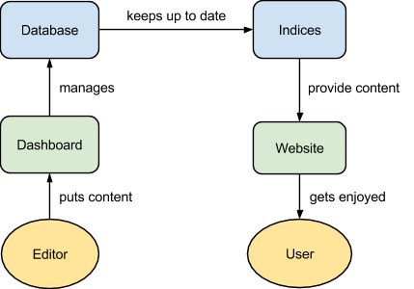

We are now going to use KakauCMS to build a very simple blog site. This diagram shows how KakauCMS is meant to be used to build a dynamic website. In the background their is a database which gets managed over a dashboard interface. Here the editor can bring in his content. The database stores this content and at the same time holds it available in so called indices. These are essentially prebuilt database queries which provide the content to the website, which again presents it to the user, who hopefully enjoys it.

Following this diagram we are first going to setup the database using the dashboard and fill it with content. Then we have to setup an index, which we then let be presented by the a website.

You should already have setup a webspace with a ftp-access and uploaded the KakauCMS release. The three folders KkuCommon, KkuDashboard and KkuDatabase should be in the same folder you want you website.

Now go to the URL of you website and add “/KkuDashboard/admin.php”. The standard login is “admin” with password “admin”. The first thing you might want to do is change the password. Cick on users. You see a list of the user accounts, which holds only one entry at this moment. Click on “edit” beneath the “admin”-account. The top box says “change pwd”. Type in your new password twice and hit “change password”. The page reloads and the password is changed now.

KakauCMS is now ready to be used. As mentioned we build a very simple blog or news section. For that we need to setup the database to hold corresponding items. KakauCMS uses tables to structure its database. A table holds items with predefined fields. In our case we need a table that holds the posts of the blog and that has fields like a date, a category and a content.
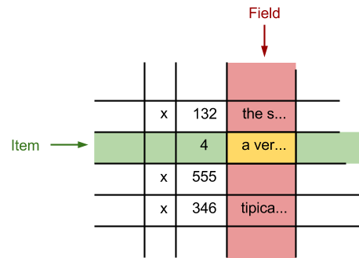

To add a table click on “tables” in the topmenu on the right and then “add new entry”. Don’t be scared by all the options here. Everything is set to default values that will work for all basic use cases.

To give the table a name type it into the main-form where it says name. We will call this table “posts”. Then scroll down until the main-form ends and hit “save item”. You will notice that in the top menu on the left a new entry appeared with the name of the new table. Adding fields to the table is just as easy. Scroll down to the fields-form. The first field we are adding is a date-field, which holds the date when the posts is published. Type in “datePublished” as the name of the field, select “date” as a field type, leave everything else empty and hit “add”.

Next we are adding a field that holds a boolean variable which says whether the posts should be displayed on the website or not. We call this field “published”. Set the type to “bool” and hit “add”. Now a standard field for the title of post. So type in “title” as the fields name and then select “standard” as a type and hit “add”. The same for a “content” field which should have the type “textarea”.

Additionally we want to have a “category” field which holds on of multiple values. For this there is the “multiple” field type. Fill in “category” as a name select “multiple” as type and the add your categories seperated by semicolons. There always should be a semicolon at the end of the list. So for example type “On Tour; Cats; Science;” and hit add. So now the names of our categories would be “On Tour”, “Cats” and “Science”.

Now that we have added the fields we have to choose which ones should be displayed at the overview inside the dashboard. This is just for our convenience and will become clear in just a second. Fill in “titel” as “overviewTitleField” in the main form. And again a list of fields, for example “datePublished;category;” as overviewFields. hit “save item” at the bottom of the main-form.

Ok, now we can add posts to the database. Click on the new “posts” menu entry at the top menu on the left. Then click on “add new entry”. You see a form with all the fields you just put into the table. Every field has a different input type depending on its type. We are now creating a dummy post which we then display on the website. So add some title, a text, select a category, check the published check box and hit “save item”.

We have added a post to the database now. Once again click on “posts” in the top menu. This is the overview of the “posts” table. You can see the post we have just created. Because we set the overviewTitleField to the title it gets used in this overview. And the other fields we set to be visible in the overview you can see here as well.

Now we have setup the database and filled it with content. Next we have to setup an index. As mentioned earlier indices are prebuilt database queries that are updated automatically everytime the database is changed. They hold the data from database available so it is easy and quick to access for the website. In the topmenu click on “indices” and then “add new entry”. For this example we only have to put in a name for the index and the name of the table this index should hold available and set a rule by which the items should be sorted inside the index. In the main form put in “posts_main” as indexname and “posts” as tablename. Now scroll down to where it says “sortFunction”. When the index is build this function is used in the sorting algorithm. It is directly passed to the “usort”-function of php. To let the items by sorted by the “datePublished” field just replace ‘_ID’ by ‘datePublished’ in the default setting. To have the items sorted by date descentantly we also have to put a minus sign to the function. So the whole sort function reads:

return -1*strnatcmp($item1['datePublished'], $item2['datePublished']);

We are now ready to write the mainpage of the website. Here is a example how that might look like:

<?php
require_once("KkuCommon/indexReadHelper.php"); (1)
$posts=getIndex("posts_main"); (2)
?>

<html>
<head><title>Dada Blog!</title></head>
<body>

<h1>Dada Blog!</h1>
<p><b>by me</b></p>

<?php

foreach($posts as $post) if($post['published']){ (3)

echo "<div> (4)
<h3>".$post['title']."</h3>
<small><i>".$post['datePublished']."</i> in ".$post['category']."</i></small>
<p>
".$post['content']."
</p>
</div>";

}

?>

</body>
</html>

At (1) a php-file is loaded that holds functions to read in the prebuilt index. At (2) the function “readIndex” is used to read in the index “post_main” we defined earlier into to the array $posts. Over this array is then iterated at (3) and the items are then written out at (4).

So thats it. Now we can try to ad another post and test if everything works.

Section 2: Belonging Items

We want to have multiple images for every post and files too

Section 3: Playing With Indices

We want to be able to place the images anywhere in the text.

Section 4: Interactive content

We want people to be able to comment/rate posts

Section 5: Dynamic indices

List of best rated and most commented posts in the sidebar

Section 6: Subtypes

