**Good Day, This is a birthday Invitation.**



**Got to website**

<https://bit.ly/bithday_invite>  
  
**Or Scan**

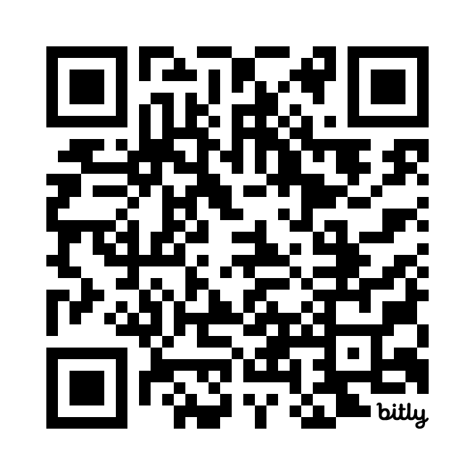

**You will get further instruction there.**Your attendance will be highly valued.