SUPERVISOR EXPLAINER
Vataleni PMSG + SSO
What the system does, what the scenarios mean, and how the results were calculated
Authoritative model: model/Vataleni_PMSG_SSO_Final.slx
Generated from fresh MATLAB/Simulink results - 21 October 2026

What this system is
This is a 5 MW full-converter wind-turbine model. Wind power accelerates a PMSG rotor, the machine-side converter controls generator torque, a DC capacitor transfers energy between converters, and the grid-side converter injects controlled dq current into a grid represented by a variable short-circuit ratio.
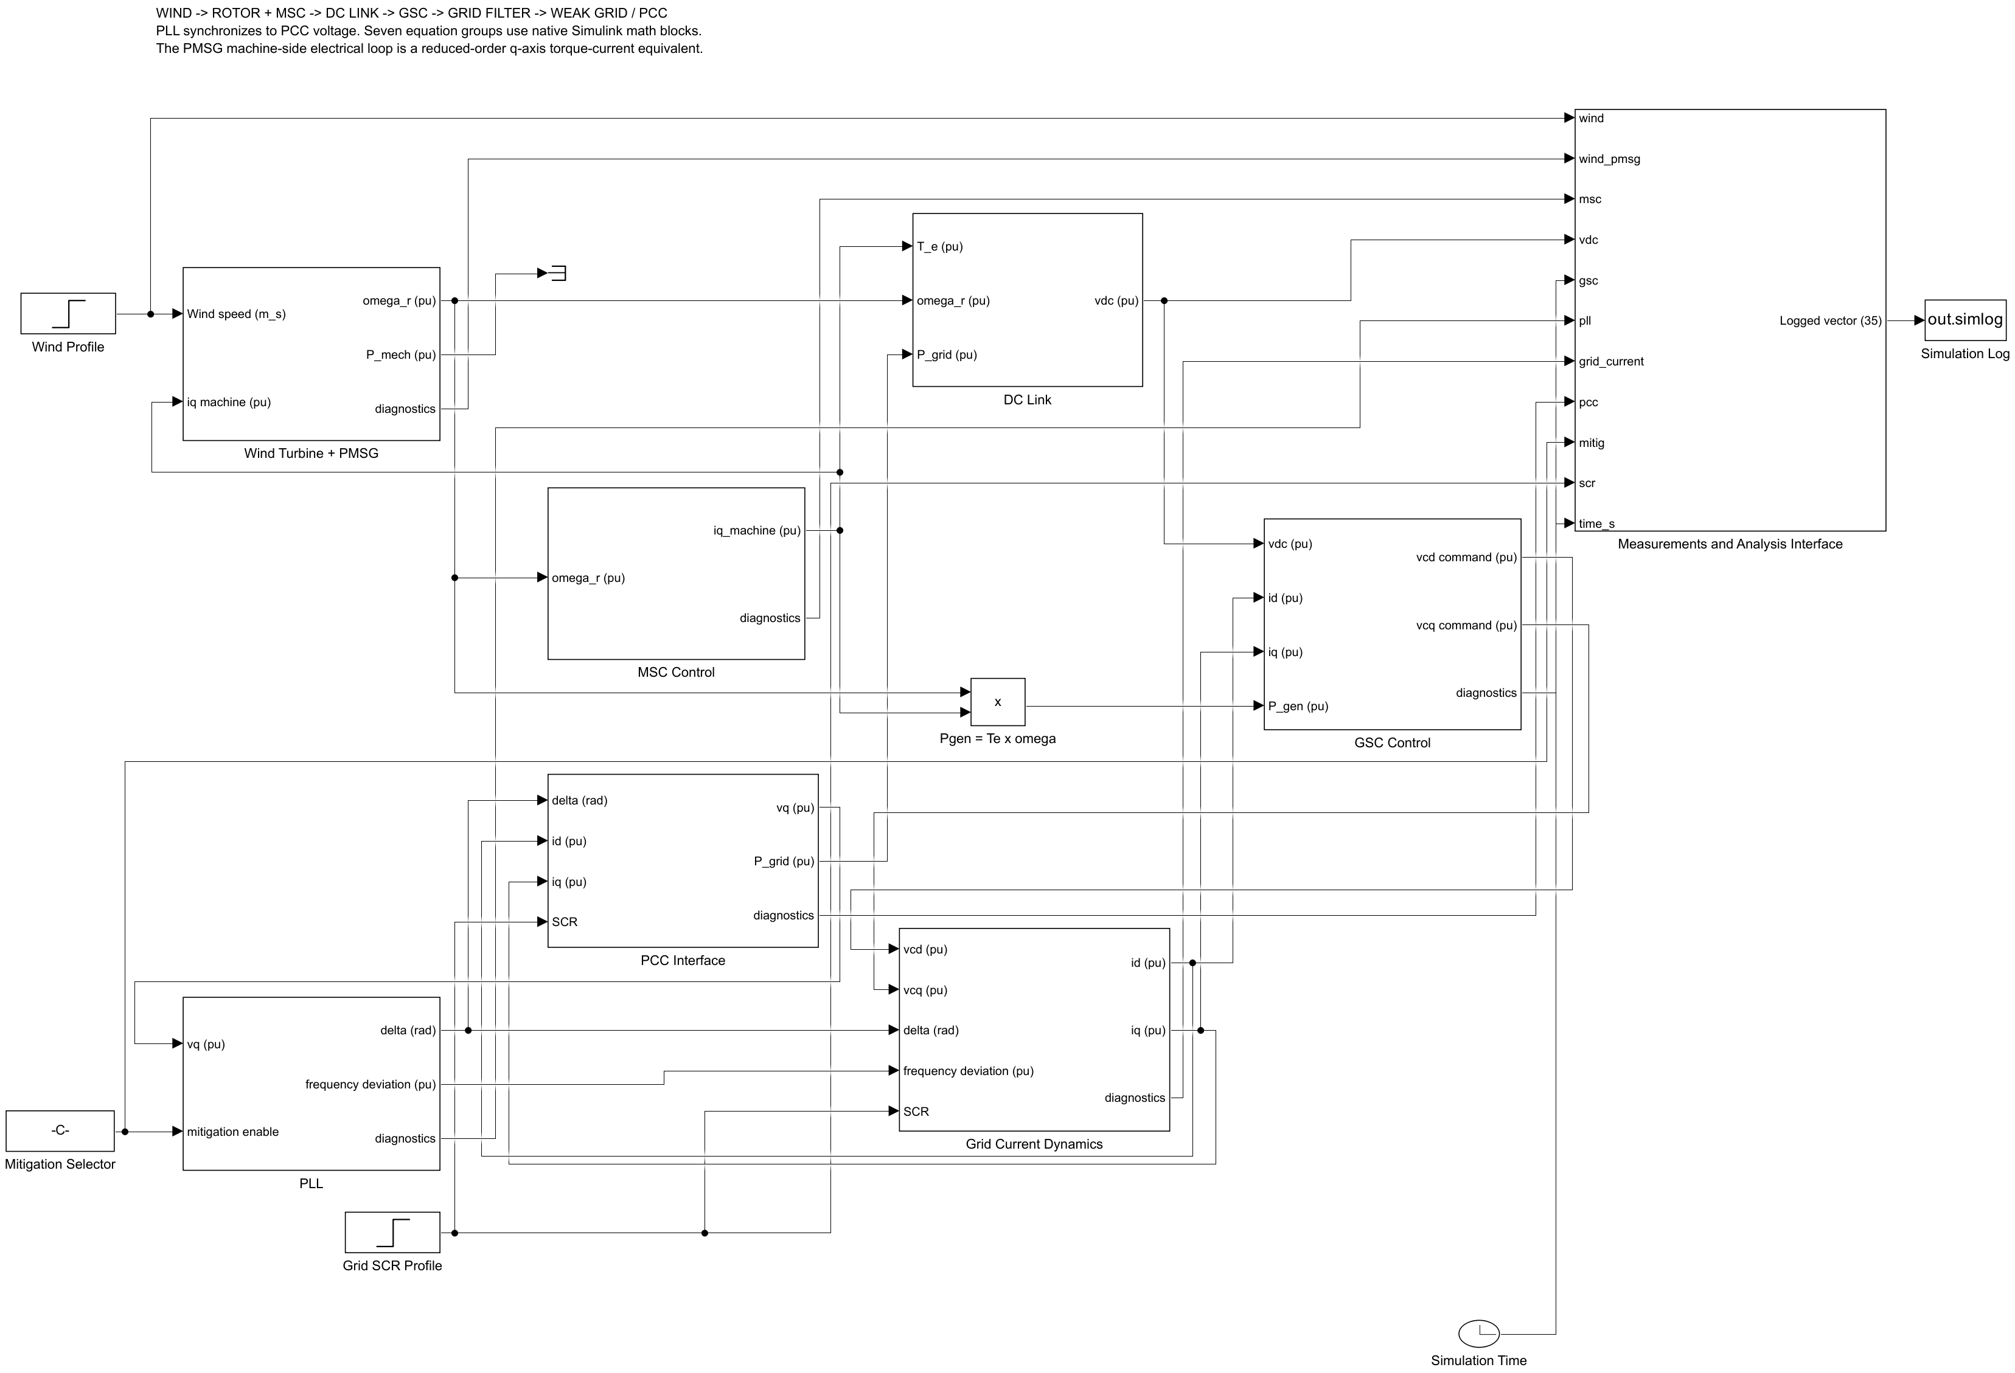
Figure 1. The repaired model's eight main engineering subsystems.

What each subsystem does
Wind Turbine + PMSG: converts wind speed into mechanical power and rotor acceleration.
MSC Control: uses rotor-speed error to command electromagnetic torque current.
DC Link: integrates the energy difference between machine input and grid output.
GSC Control: regulates DC voltage and dq grid current.
PLL: estimates grid angle and frequency from PCC q-axis voltage.
Grid Current: integrates filter and weak-grid dq current equations.
PCC Interface: computes terminal voltage and active/reactive power.
Measurements: exports 35 named channels used by the plots and metrics.

The three main scenarios
Scenario | Meaning | Expected reading
Baseline | Strong grid, SCR 10 | stable reference response
SSO | Grid weakens from SCR 10 to 5 | a growing converter-grid oscillation appears
Mitigation | Same weak grid; PLL Ki reduced | tracked mode becomes stable and oscillation decays

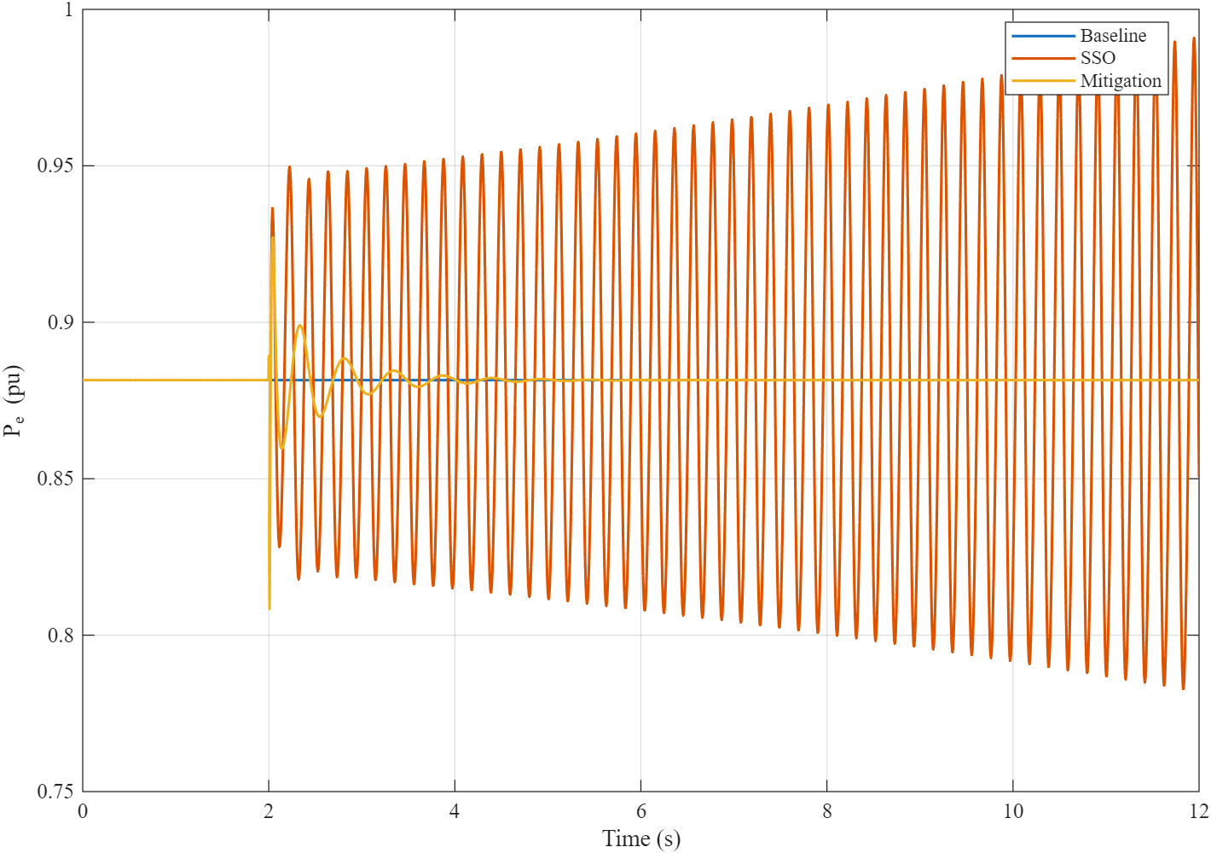
Figure 2. Direct comparison of baseline, SSO and mitigation.

What the main graphs show
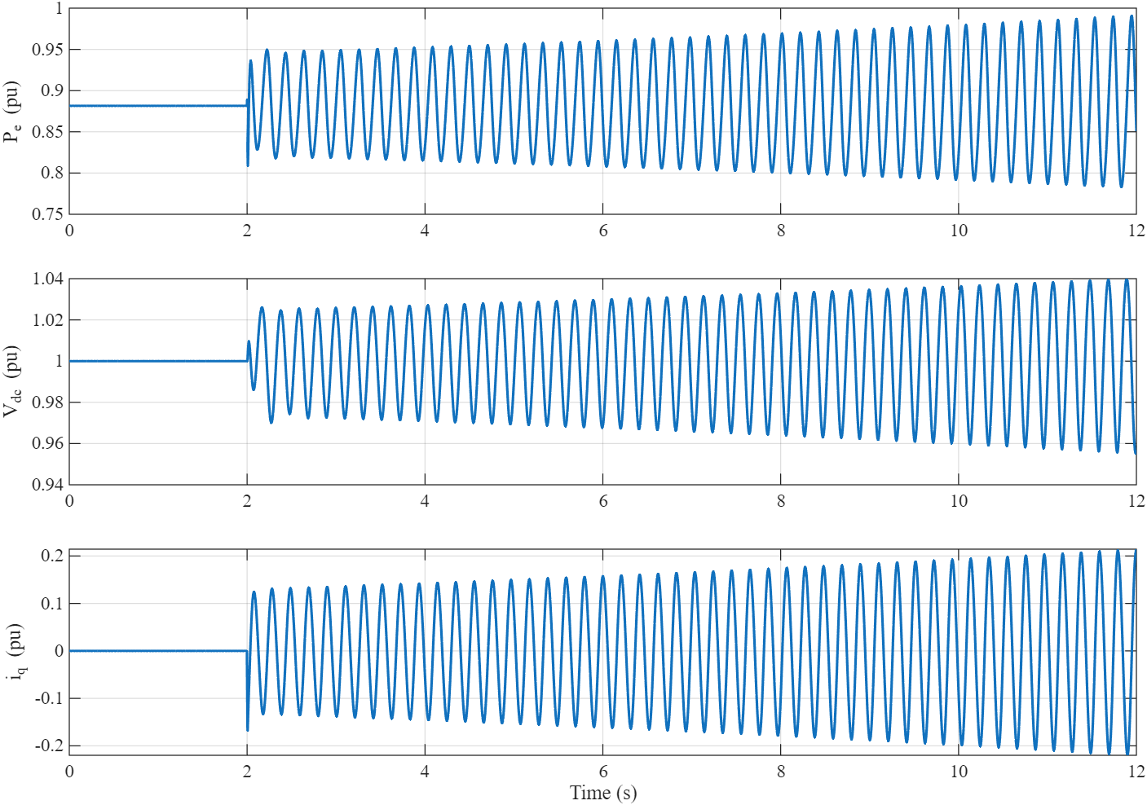
Figure 3. SSO appears together in active power, DC voltage and q-axis current.
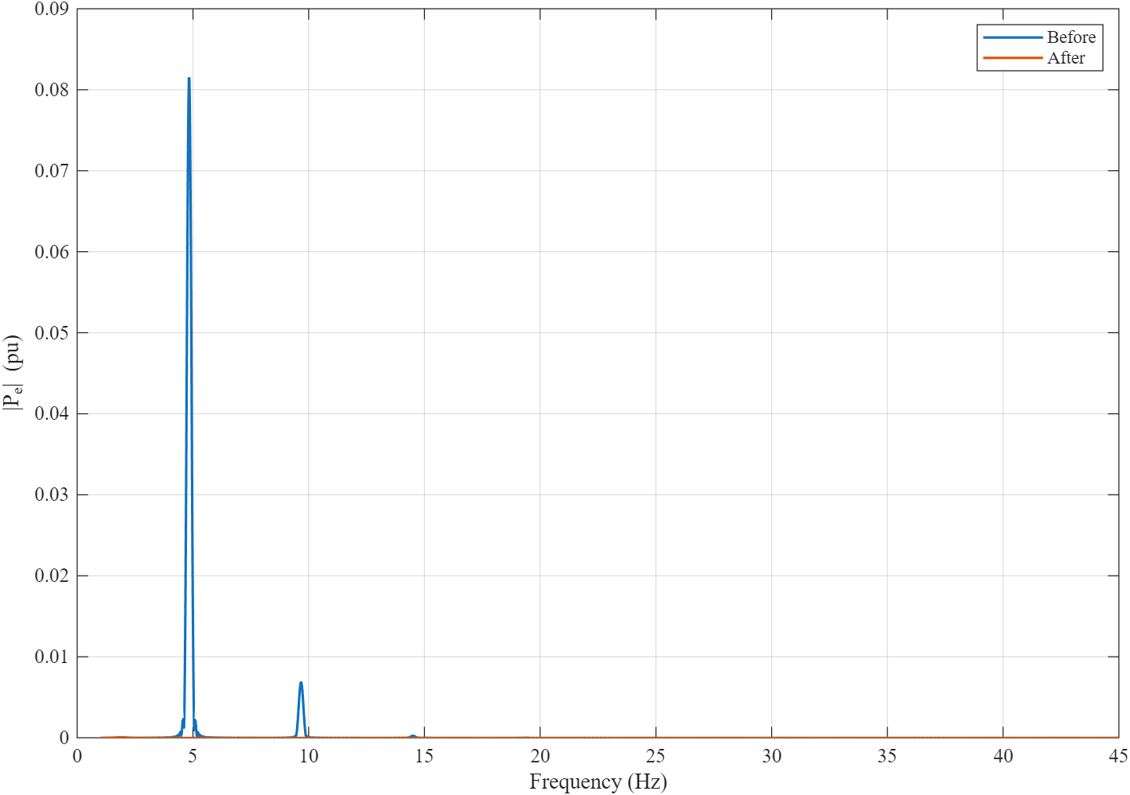
Figure 4. The dominant weak-grid spectral peak is removed by the tested mitigation.

How the reported values were calculated
- FFT: active power after the analysis start gives 4.8447 Hz before mitigation.
- Prony: a fitted damped sinusoid gives sigma = +0.05158 1/s before and -1.39358 1/s after.
- Eigenanalysis: the numerical Jacobian gives real part +0.04749 1/s before and -1.39437 1/s after.
- Time-domain RMS: the late active-power oscillation changes from 0.067754 pu to 2.657e-07 pu.
- DC-link excursion: maximum deviation changes from 0.0449 pu to 0.0148 pu.

What was repaired
The earlier SLX contained Level-2 MATLAB S-Function blocks whose external files were not available when a user opened the model. The seven plant and controller equation groups now use connected native Simulink math blocks and native Integrators. One internal MATLAB Function block assembles diagnostics. The stop time, fixed step, scenario defaults and initial conditions are stored in the model, so pressing Run requires no initialization script or pre-populated base workspace.

Interpretation
The agreement of FFT, Prony and eigenanalysis around the pre-mitigation 4.84 Hz mode supports the conclusion that the oscillation is generated by the model dynamics rather than by plotting artifacts. The mitigation result is strong for the tested operating point, but the model is averaged and reduced-order; broader robustness and hardware conclusions require additional studies.

