1 Physical model architecture
The saved Simulink model connects a wind turbine and single-mass shaft to a native PMSG, machine-side converter (MSC), DC capacitor, grid-side converter (GSC), RL filter, point of common coupling (PCC) and three-phase grid. The components in Figure 1 are the executable Simscape network.
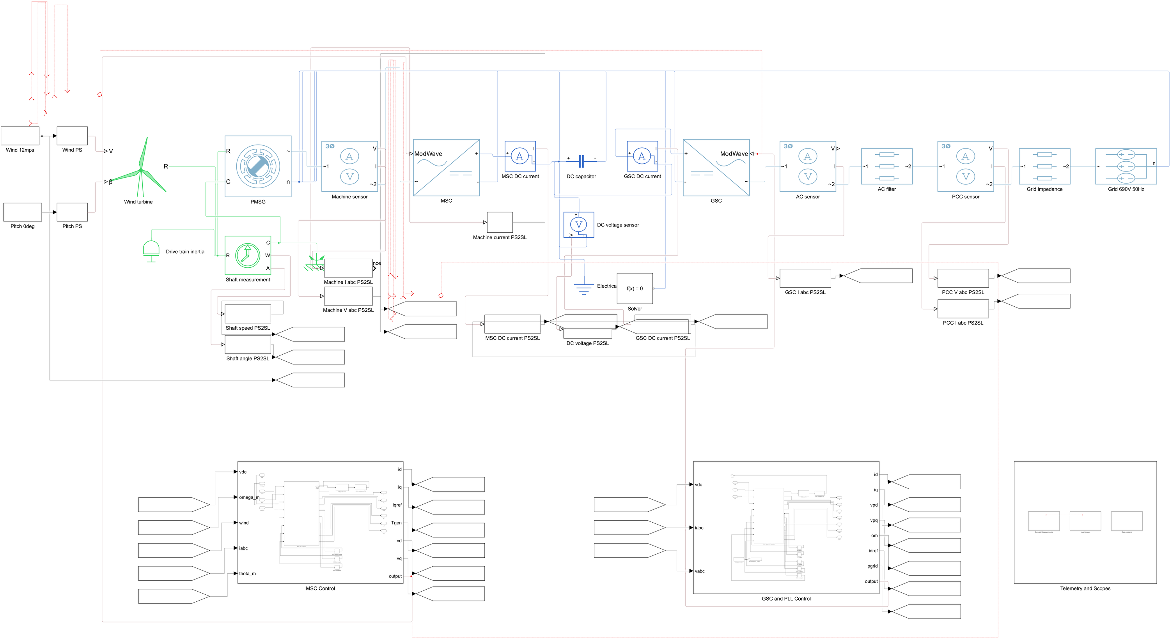
Figure 1. Full top-level model exported directly from Simulink. Power conversion runs left to right; grouped MSC and GSC/PLL controls sit below the physical network.
The native PMSM block integrates stator d- and q-axis current states and rotor dynamics. Both converters use average-value three-phase voltage-source models. The 5 MW rating follows Wang et al. (2019); other machine, turbine, filter, grid and controller numbers are project engineering assumptions.

2 Converter controls and weak-grid response
The MSC uses rotor-speed and d/q current loops to control generator torque. The GSC regulates DC-link voltage and grid current in a PLL-aligned frame. Figure 2 shows the actual control subsystems; measurement and Scope paths are separate from the power path.
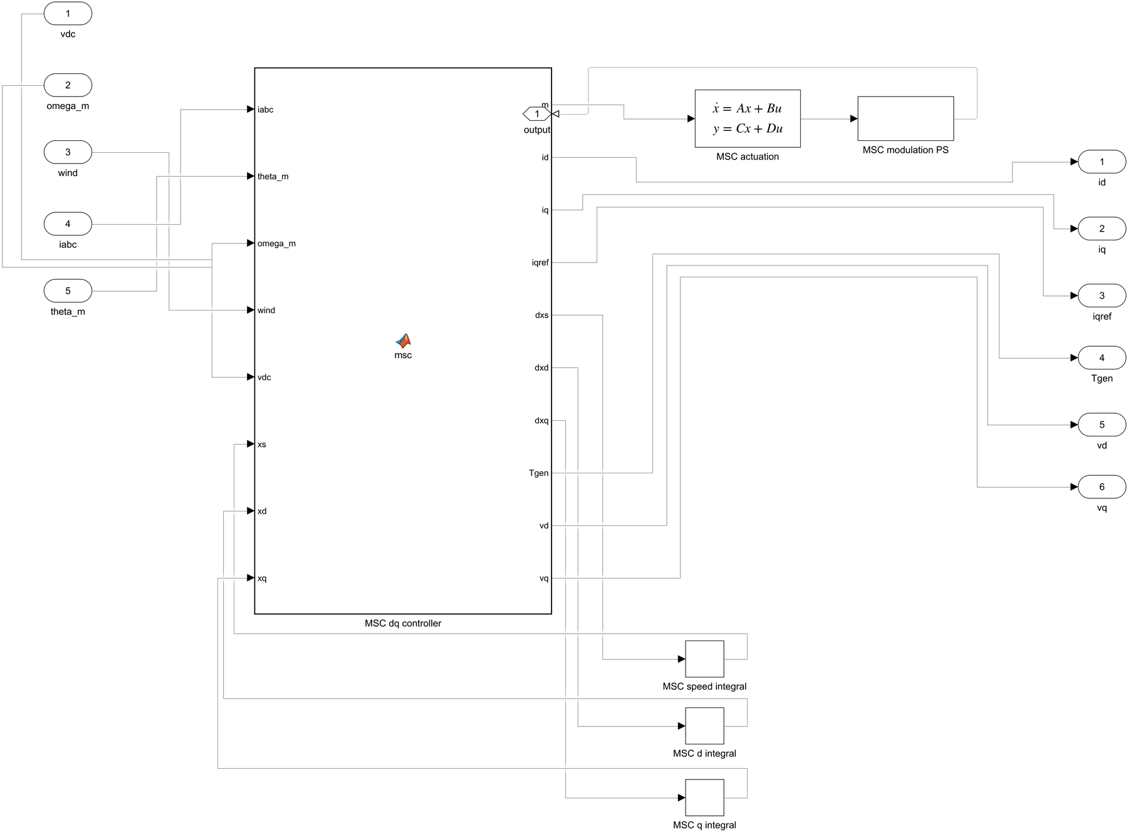 | 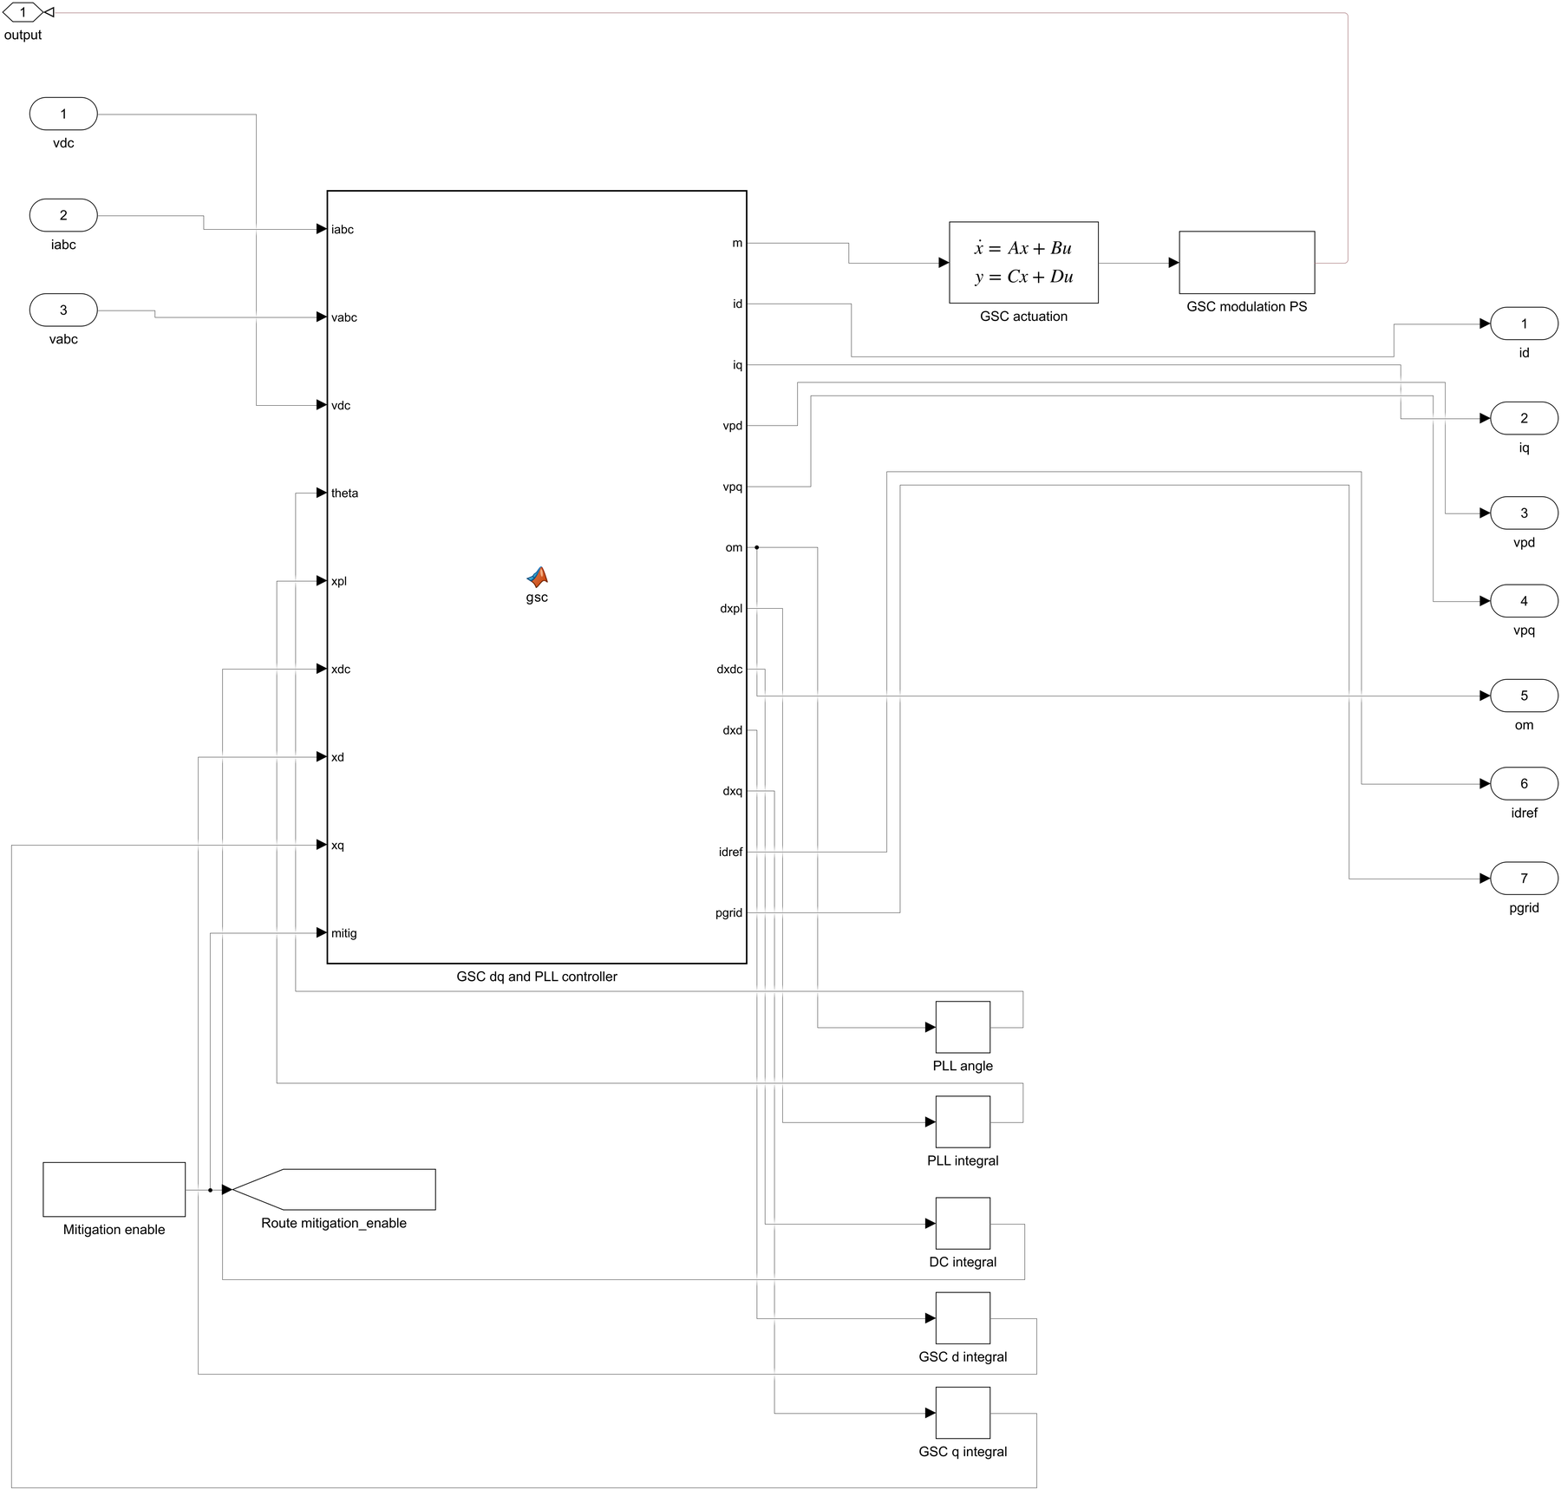
Figure 2. Machine-side control (left) and GSC/PLL control (right), exported from the saved Simulink model.
A 12 to 13 m/s wind step at 2 s changes turbine torque and converter power. With nominal external short-circuit ratio (SCR) reduced from 10 to 5, the same disturbance excites a larger, decaying PCC q-axis voltage oscillation. The oscillation is a coupled control/network response; no sinusoid is injected. Its weak-grid FFT peak is 4.681 Hz, and the near-equilibrium physical-model snapshot mode is 4.638 Hz with 5.24% damping.
The tested mitigation changes only PLL proportional gain from 0.00558 to 0.02 rad/(s V). The integral gain remains 1.56 rad/(s² V). Wang et al., DOI 10.1109/EI247390.2019.9061793, motivates Prony-based SSO analysis; these measured numbers are from this model.

3 Results and interpretation
Figure 3 compares identical wind steps with common voltage and time axes. Figure 4 is a captured native Simulink Scope display from the weak-grid run. The high-resolution comparison and the Scope both come from the saved physical model.
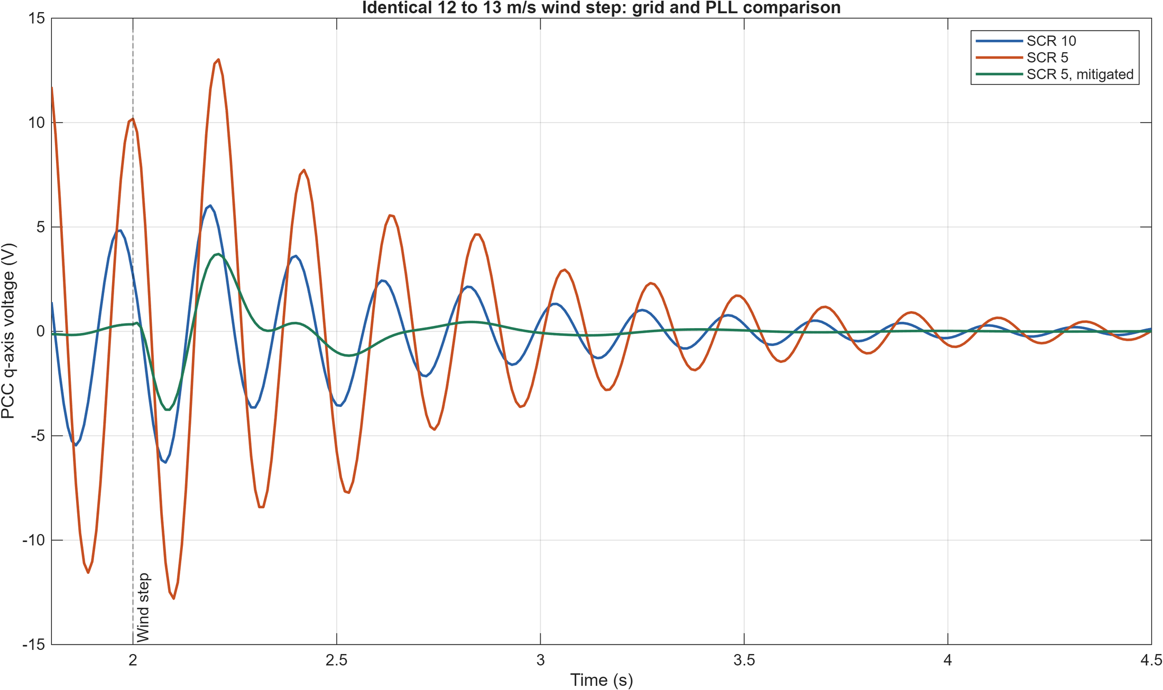 | 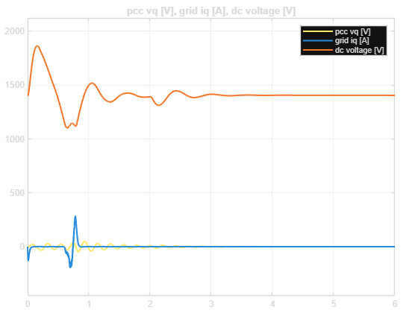
Figure 3. MATLAB comparison of PCC q-axis voltage. Figure 4. Native Simulink Scope snapshot from the weak-grid response.
Case | Early PCC q std | Late DC voltage | Late PCC power
SCR 10 / SCR 5 / mitigated | 1.788 / 3.997 / 0.554 V | 1405.27 / 1405.42 / 1405.42 V | 4.916 / 4.916 / 4.916 MW
The early standard deviation uses 2.25–3.25 s. Relative to the unmitigated weak-grid run, PLL retuning reduces that metric by a factor of 7.21. Damping of the matched approximately 4.6 Hz linearized mode rises from 5.24% to 18.99%. The mitigated least-damped mode overall is a different 1.843 Hz mode. All four scenario runs and 25 physical/numerical checks pass.
These are responses of an assumed, averaged single-turbine system. The model does not establish a sustained instability, a field-calibrated SCR threshold, PWM harmonics or shaft torsion. Full methods and parameter provenance are in the accompanying technical and validation reports.

