TECHNICAL REPORT
Vataleni PMSG + SSO Wind-Energy System
Self-contained Simulink implementation, oscillation study, mitigation and validation
Authoritative model: model/Vataleni_PMSG_SSO_Final.slx
Generated from fresh MATLAB/Simulink results - 21 October 2026

Executive summary
This report documents the repaired 5 MW averaged dq wind-energy model. The authoritative SLX contains the wind-turbine, PMSG rotor, machine-side control, DC link, grid-side control, PLL, grid-current dynamics, PCC algebra and measurement equations internally. It does not call custom Level-2 MATLAB S-Functions and it runs from a fresh MATLAB session without an initialization script.
The weak-grid disturbance changes short-circuit ratio (SCR) from 10 to 5 at 2 s. The fresh simulation identifies a dominant electrical-power oscillation at 4.8447 Hz. The matching nonlinear-state Jacobian mode is +0.04749 +/- j30.41449 per second, with negative damping ratio -0.00156. Reducing the PLL integral gain from 2.8 to 0.5 moves the tracked mode into the stable half-plane and reduces late-window power-oscillation RMS from 0.067754 pu to 2.657e-07 pu.
Item | Validated value
MATLAB / Simulink | R2025b / 25.2
Model | model/Vataleni_PMSG_SSO_Final.slx
Solver | ode4, fixed step, 0.0002 s
Simulation horizon | 12 s
Custom S-Functions | 0
Algebraic loops | 0

1. Objective and study scope
The model studies converter-grid interaction in a full-converter permanent-magnet synchronous-generator wind turbine. It is intended for time-domain and small-signal investigation of sub-synchronous oscillation (SSO) under changing grid strength, and for a controlled comparison of a PLL-gain mitigation.
- Base rating: 5 MVA, 690 V line-line, 50 Hz.
- Plant representation: nonlinear averaged dq model; no switching ripple.
- Disturbance: SCR step from 10 to 5 at 2 s.
- Mitigation: PLL integral gain changes from 2.8 to 0.5 with all other case parameters held equal.

2. System architecture
The top-level diagram is organized left-to-right. Compact diagnostic vectors feed the logging interface without altering the physical signal paths. Seven equation groups use connected native Simulink math blocks and every continuous state is an Integrator. One embedded MATLAB Function block assembles the diagnostic vector and reconstructed phase waveforms.
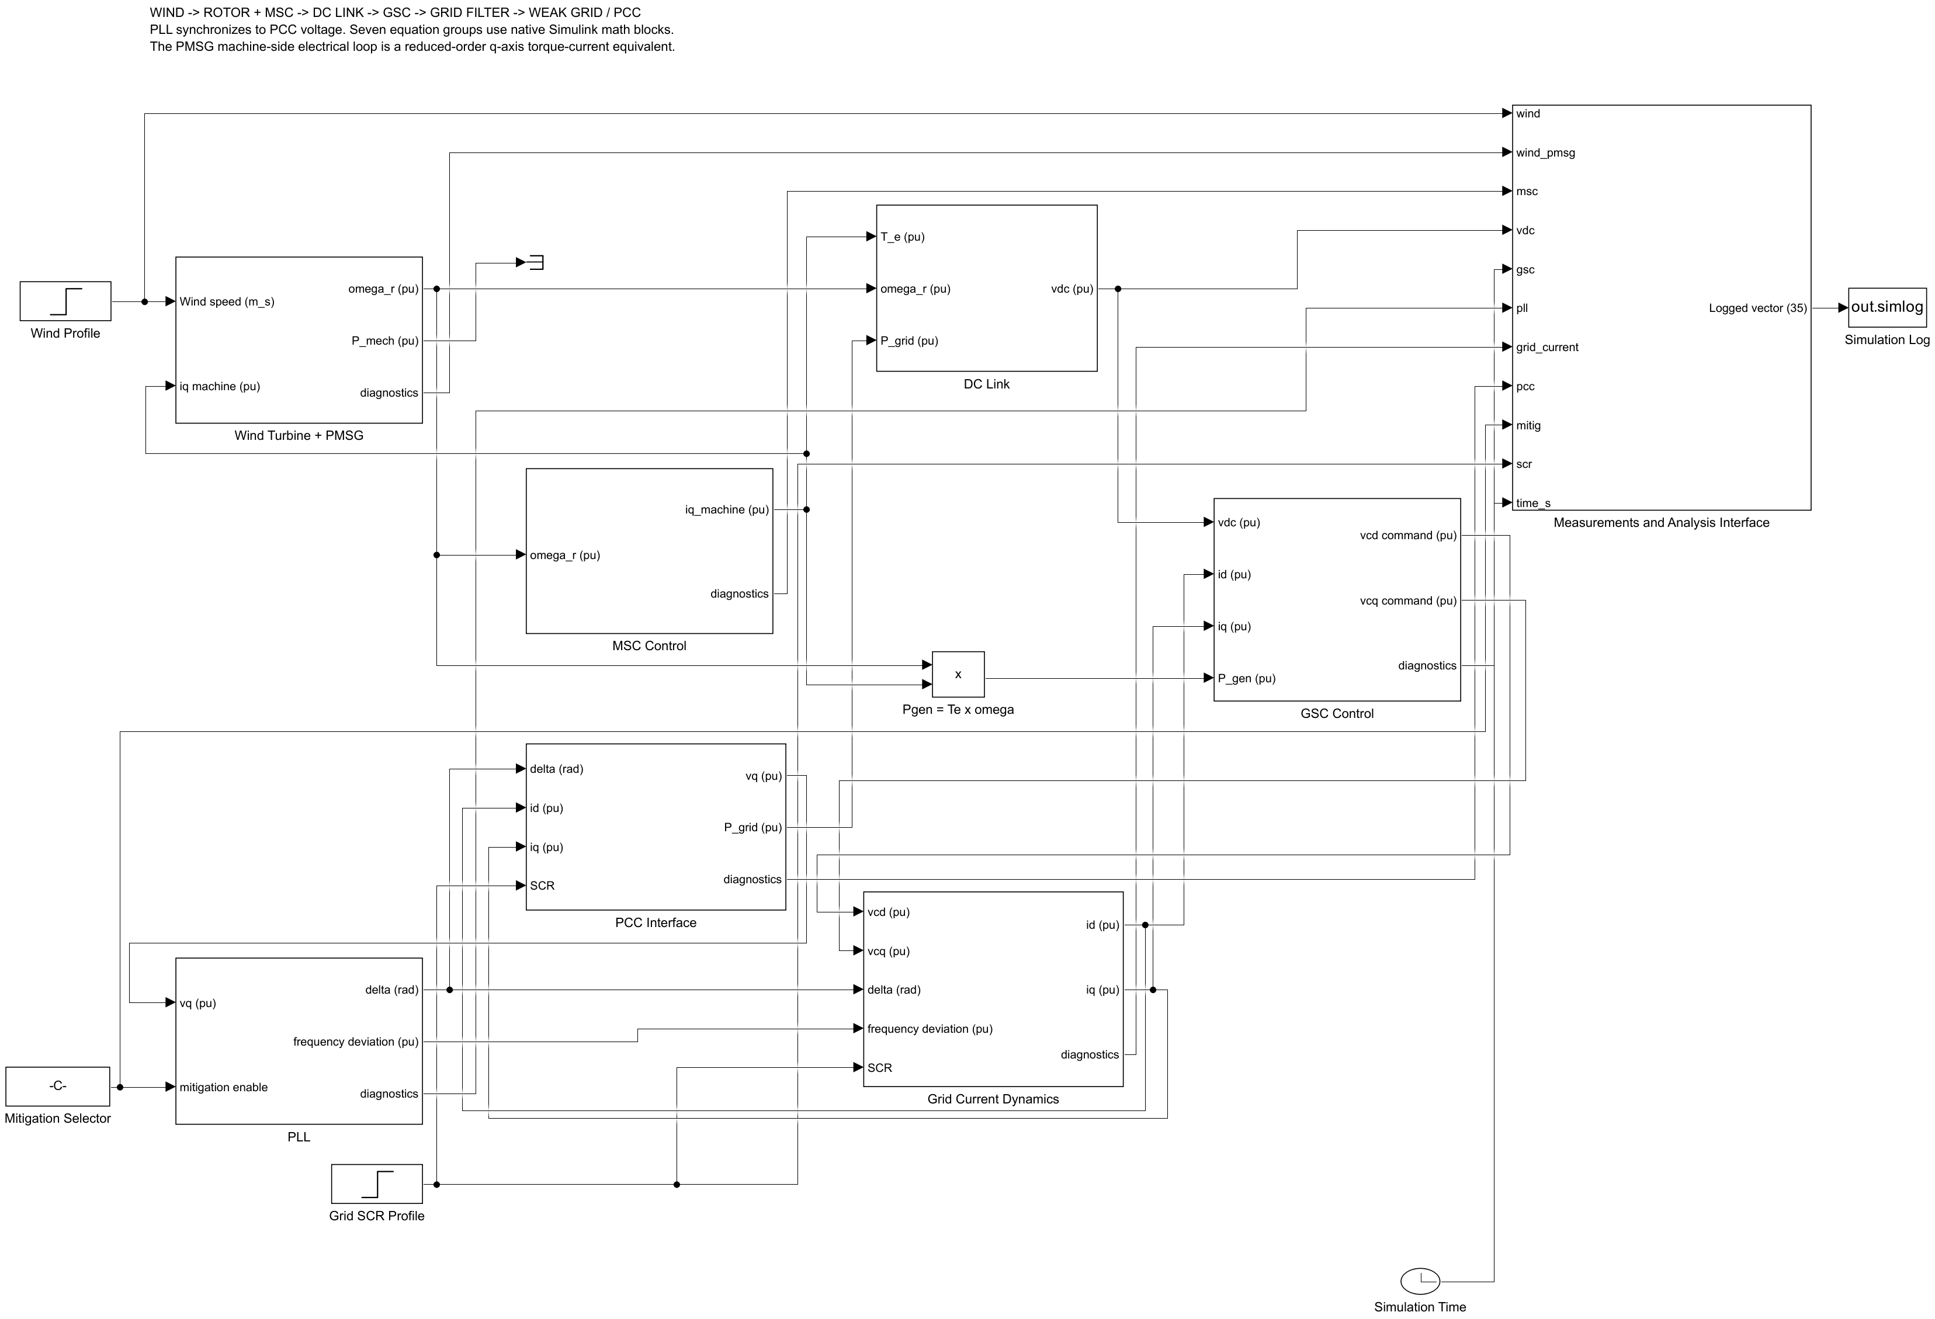
Figure 1. Authoritative top-level Simulink architecture.
Subsystem | Inputs | Outputs / states
Wind Turbine + PMSG | wind speed, machine iq | rotor speed, mechanical power/torque; omega_r
MSC Control | rotor speed | machine iq and reference; iq_m, speed PI state
DC Link | electromagnetic torque, speed, grid power | vdc; capacitor-energy state
GSC Control | vdc, id, iq, generator power | vcd/vcq commands; three PI states
PLL | PCC vq, mitigation selector | angle, frequency deviation; angle and PI states
Grid Current | converter voltage, PLL frame, SCR | id/iq; two current states
PCC Interface | angle, id, iq, SCR | vd/vq, P/Q, voltage magnitude
Measurements | diagnostic vectors and time | 35 logged engineering channels

3. Governing equations

3.1 Aerodynamics and rotor
The standard exponential power-coefficient fit is bounded to 0 <= Cp <= 0.50. Aerodynamic power is limited to 1.15 pu and torque follows from power divided by pu speed.
lambda = omega_r omega_base R / v_w ; P_m = 0.5 rho A Cp v_w^3 / S_base
d omega_r / dt = [T_m - i_qm - D(omega_r - 1)] / (2H)

3.2 Machine-side converter
i_qm,ref = Kp_speed(omega_r - 1) + xi_speed
d i_qm/dt = (i_qm,ref - i_qm)/tau_i ; d xi_speed/dt = Ki_speed(omega_r - 1)
The machine electrical inner loop is an averaged first-order torque-current channel. Machine d-axis current is zero in this reduced-order representation; switching-level machine voltage references are therefore outside the model fidelity.

3.3 DC link
d v_dc/dt = (T_e omega_r - P_grid) / [C_pu max(v_dc, 0.25)]
Generator electrical input is electromagnetic torque times rotor speed. The reduced-order machine assumes ideal conversion between air-gap power and the DC link; explicit stator copper and converter losses are outside this model.

3.4 Grid-side converter
i_d,ref = P_gen + Kp_dc(v_dc - v_dc,ref) + xi_dc ; i_q,ref = 0
v_cd = E + Kp_i(i_d,ref - i_d) + xi_id - X_f i_q
v_cq = Kp_i(i_q,ref - i_q) + xi_iq + X_f i_d

3.5 PLL and weak-grid interface
Delta omega_PLL = Kp_PLL v_q + xi_PLL ; d delta/dt = omega_base Delta omega_PLL
d xi_PLL/dt = Ki_PLL v_q ; Ki_PLL = 2.8 (base) or 0.5 (mitigated)
v_d = E cos(delta) + R_g i_d - X_g i_q ; v_q = -E sin(delta) + R_g i_q + X_g i_d
P = v_d i_d + v_q i_q ; Q = v_q i_d - v_d i_q

3.6 Grid current dynamics
d i_d/dt = omega_b/L_t [v_cd - E cos(delta) - R_t i_d + L_t(1+Delta omega_PLL)i_q]
d i_q/dt = omega_b/L_t [v_cq + E sin(delta) - R_t i_q - L_t(1+Delta omega_PLL)i_d]

4. Parameterization and initialization
Group | Parameter | Value
Base | S, Vll, f | 5 MVA; 690 V; 50 Hz
Wind | rho, R, lambda_opt | 1.225 kg/m3; 55 m; 6.3
Rotor | H, D | 4.0 s; 0.02 pu
MSC | Kp/Ki speed; tau_i | 2.0 / 1.0; 0.02 s
DC | C_pu; vdc_ref | 0.08 s; 1.0 pu
GSC | Kp_i/Ki_i; Kp_dc/Ki_dc | 0.30/20; 0.80/20
Filter | R_f; X_f | 0.01 pu; 0.15 pu
Grid | E; X/R | 1.0 pu; 10
PLL | Kp; Ki base/mitigated | 0.01; 2.8 / 0.5

Initial conditions are the consistent SCR=10 power-flow solution for nominal wind and 1 pu rotor speed. Those numerical state values, scenario defaults, stop time and fixed step are saved inside the model. No callback, addpath command or base-workspace parameter structure is needed for standalone execution.

5. Numerical configuration
The final configuration uses fixed-step classical fourth-order Runge-Kutta (ode4), dt = 0.0002 s, and a 12 s horizon. The model contains eleven continuous states and no zero-crossing-dependent logic. The fixed step resolves the approximately 4.84 Hz SSO with more than one thousand points per cycle while preserving deterministic batch reproducibility.
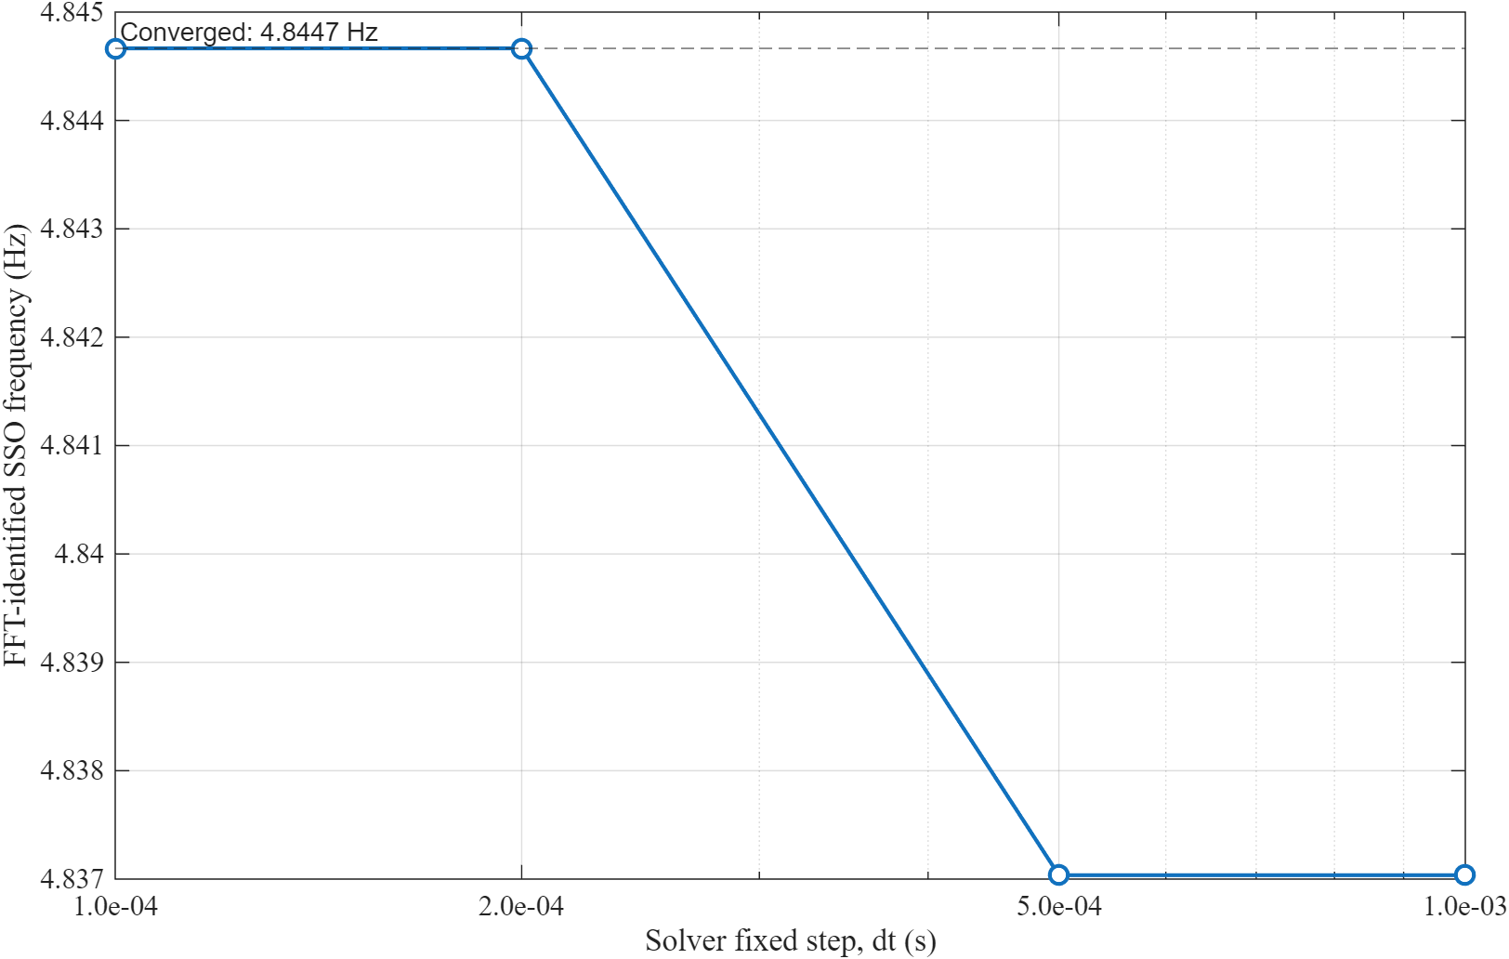
Figure 2. Timestep sensitivity of the FFT-identified SSO frequency.
A fresh sweep over 1.0 ms, 0.5 ms, 0.2 ms and 0.1 ms gives 4.8370, 4.8370, 4.8447 and 4.8447 Hz respectively. The 0.2 ms result is converged to the 0.1 ms rerun at the reported precision.

6. Scenario definitions
Scenario | SCR | Wind | PLL Ki | Purpose
Baseline | 10 -> 10 | 12 m/s | 2.8 | steady strong-grid reference
Wind step | 10 -> 10 | 12 -> 10.5 m/s at 4 s | 2.8 | aerodynamic/control response
SSO before | 10 -> 5 at 2 s | 12 m/s | 2.8 | weak-grid instability
SSO after | 10 -> 5 at 2 s | 12 m/s | 0.5 | controlled mitigation comparison

7. Time-domain results
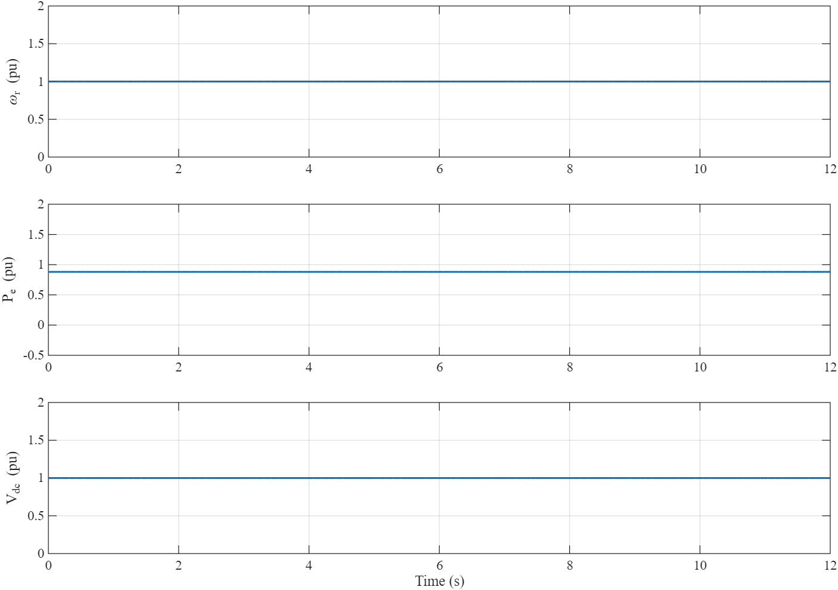
Figure 3. Baseline rotor speed, active power and DC-link voltage.
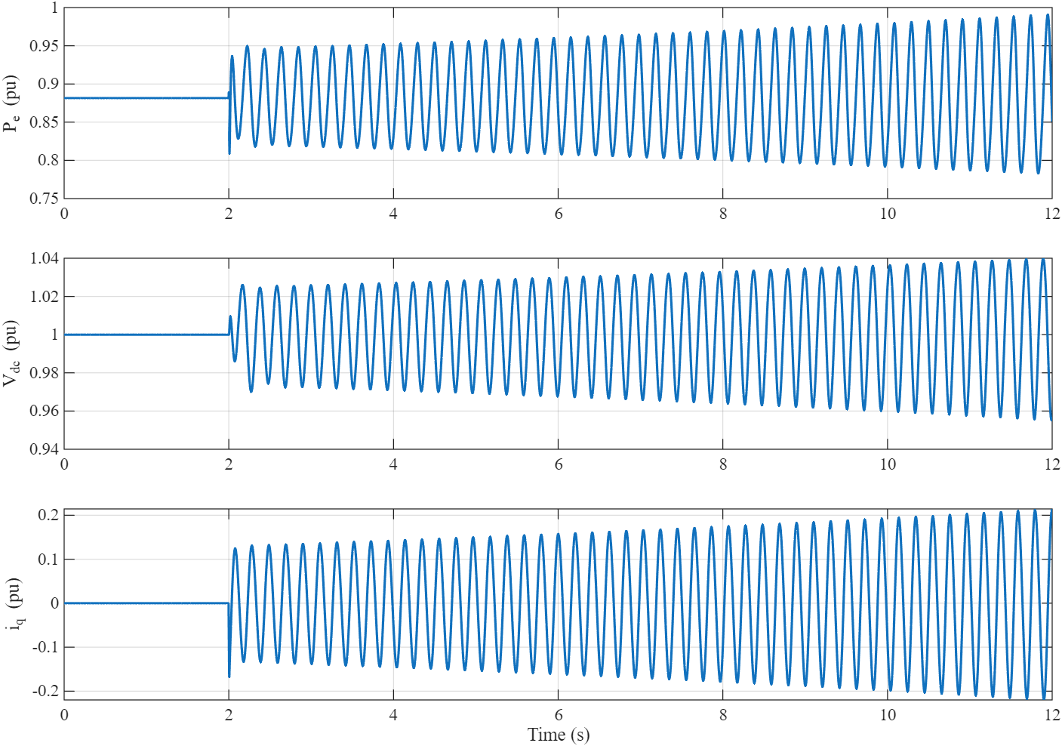
Figure 4. Weak-grid SSO response in power, DC-link voltage and q-axis grid current.
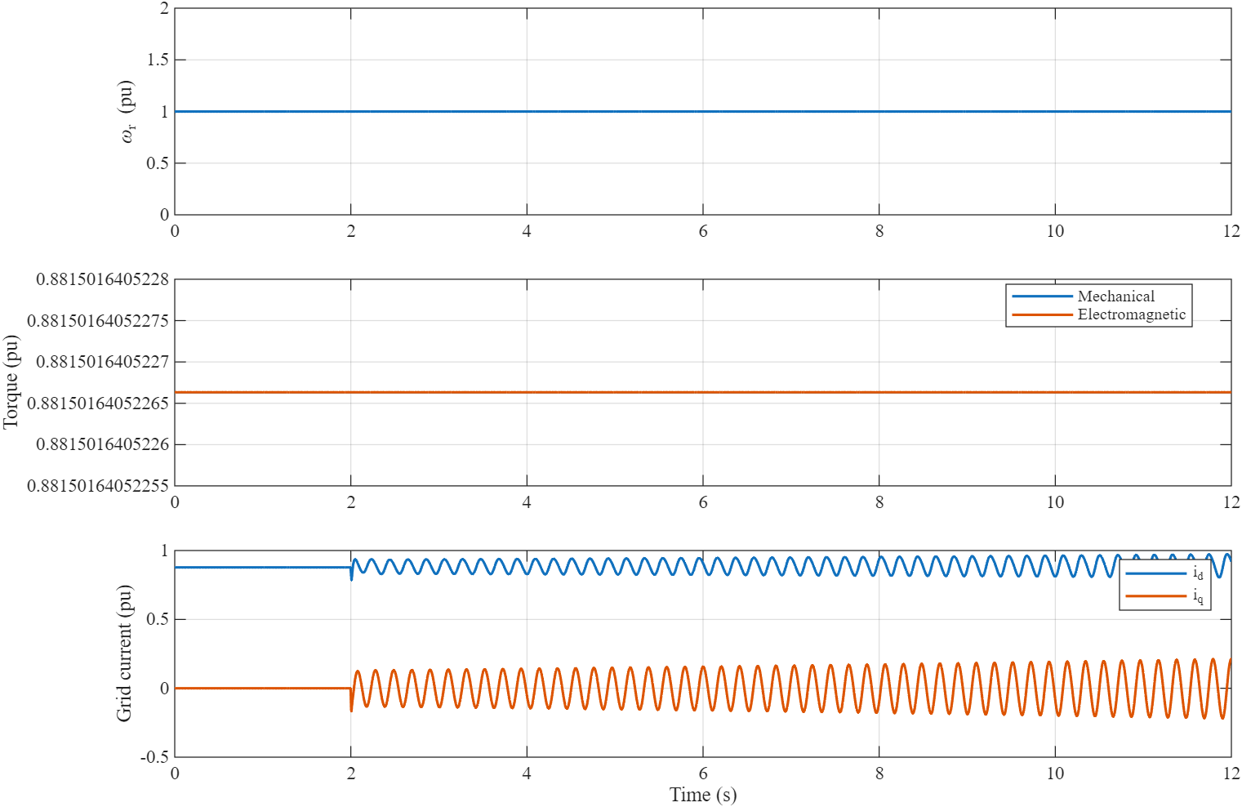
Figure 5. Generator speed, mechanical/electromagnetic torque and grid currents.
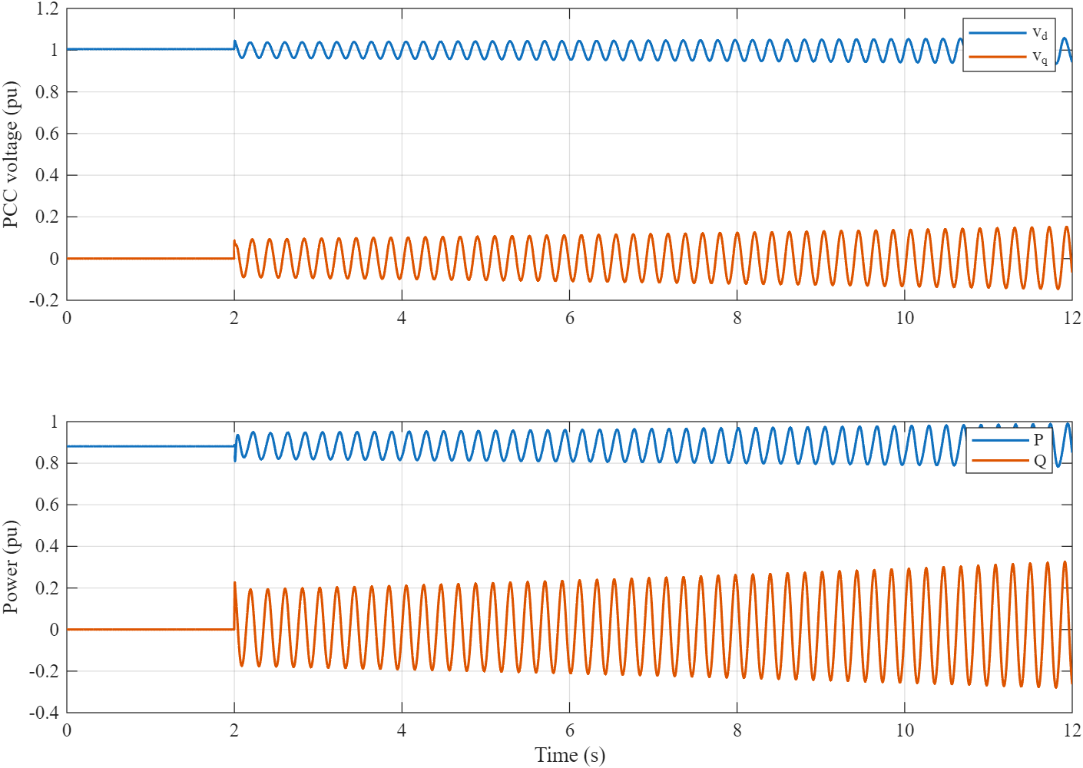
Figure 6. PCC dq voltage and active/reactive power.
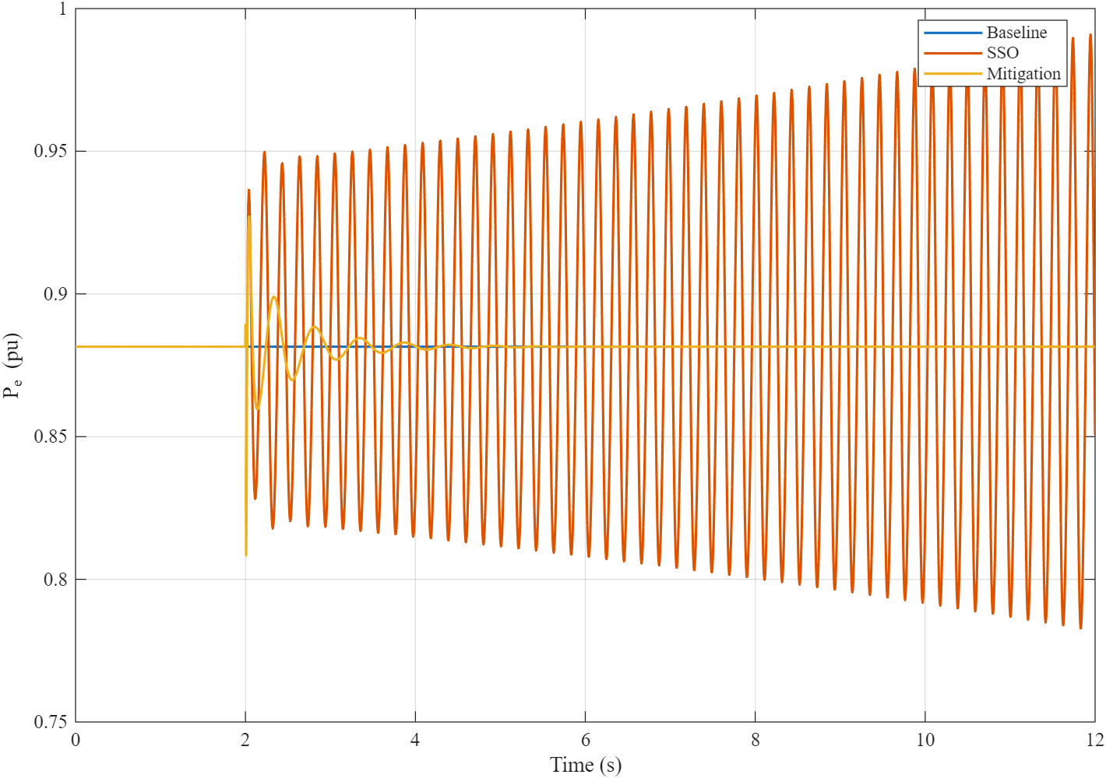
Figure 7. Baseline, weak-grid SSO and mitigated active-power responses.

8. Frequency-domain and modal analysis
FFT analysis uses the simulated active-power channel after the configured analysis start. The nonlinear model is also linearized numerically by a centered finite-difference Jacobian of the exact eleven-state ODE at the case equilibrium. Prony analysis provides an independent damped-sinusoid estimate. No eigenvalues or spectral peaks are loaded from a cache.
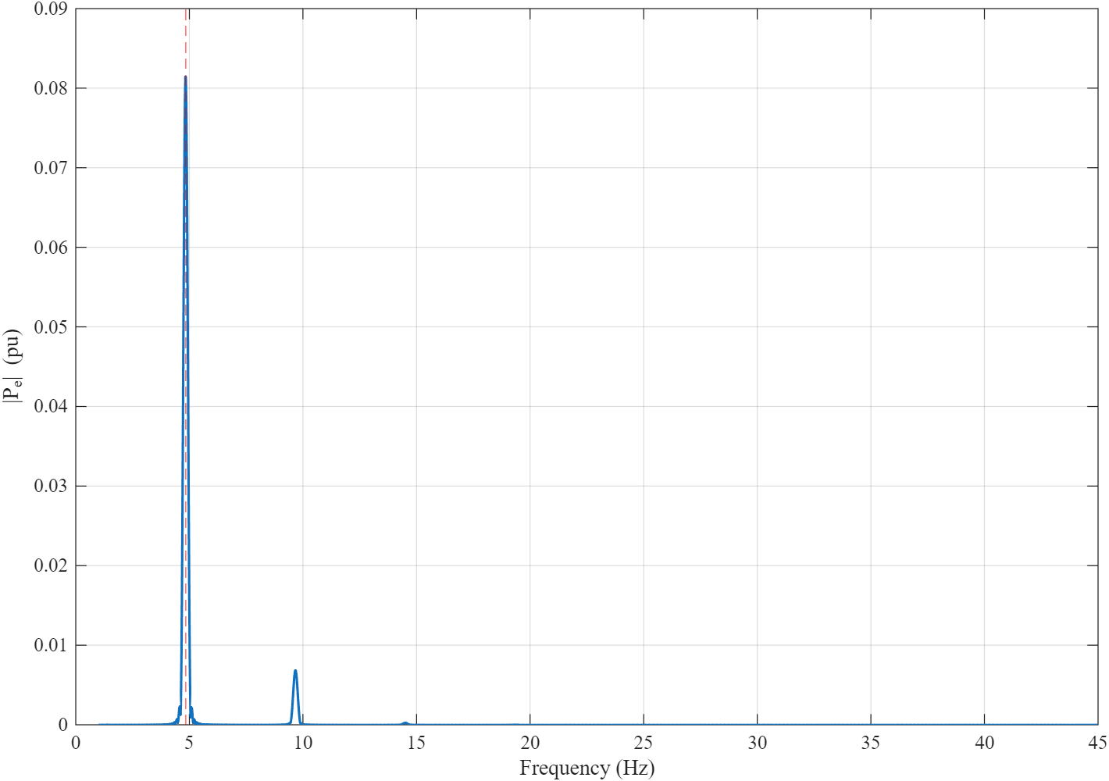
Figure 8. FFT spectrum of the weak-grid active-power oscillation.
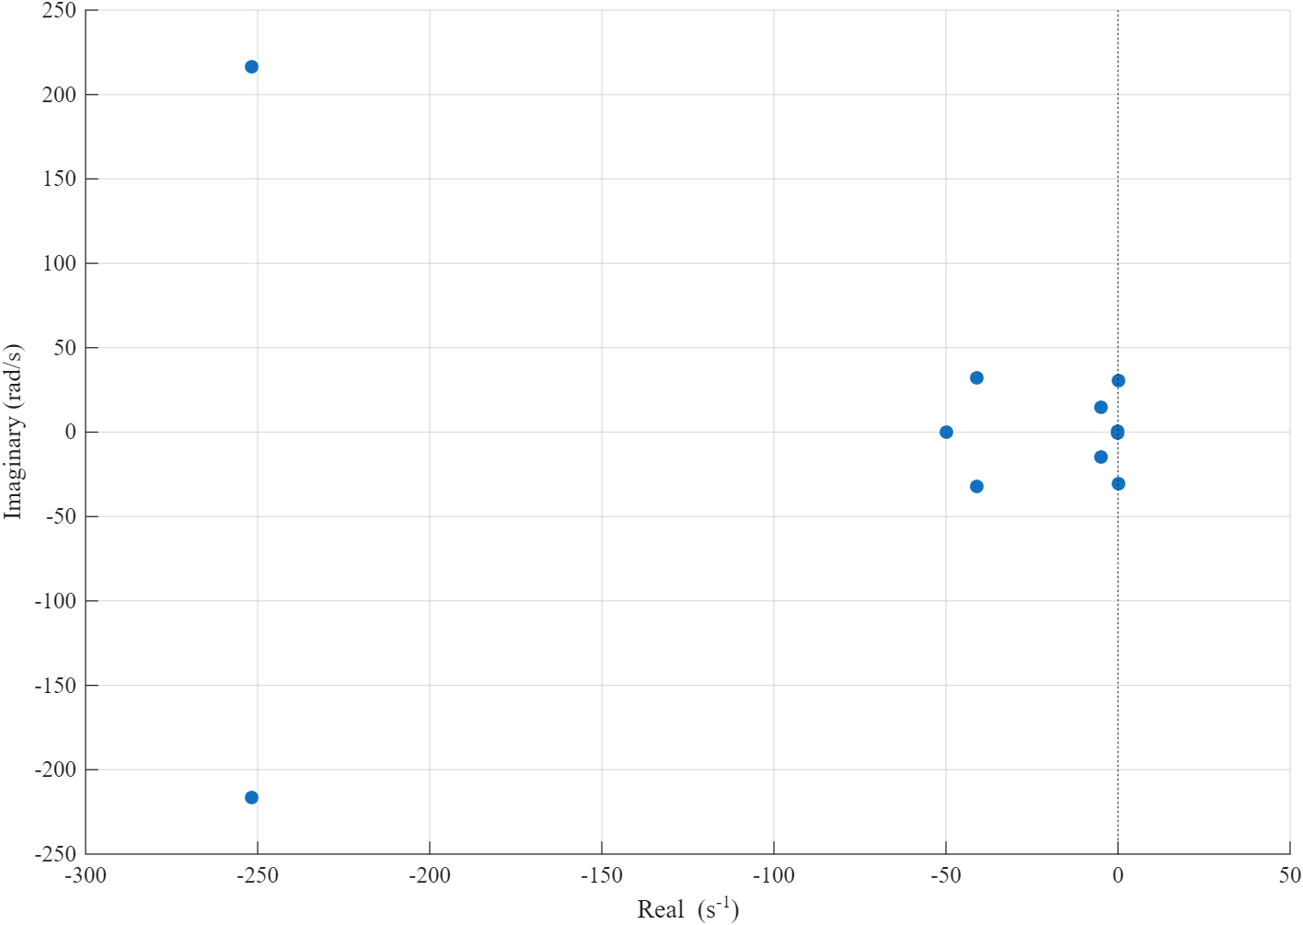
Figure 9. Eigenvalue map of the weak-grid state Jacobian.
Case | FFT (Hz) | Prony sigma (1/s) | Eigen real (1/s) | Eigen freq. (Hz) | Eigen damping
Before | 4.8447 | +0.05158 | +0.04749 | 4.8406 | -0.00156
After | 1.8883 | -1.39358 | -1.39437 | 1.8923 | +0.11648

9. Mitigation assessment
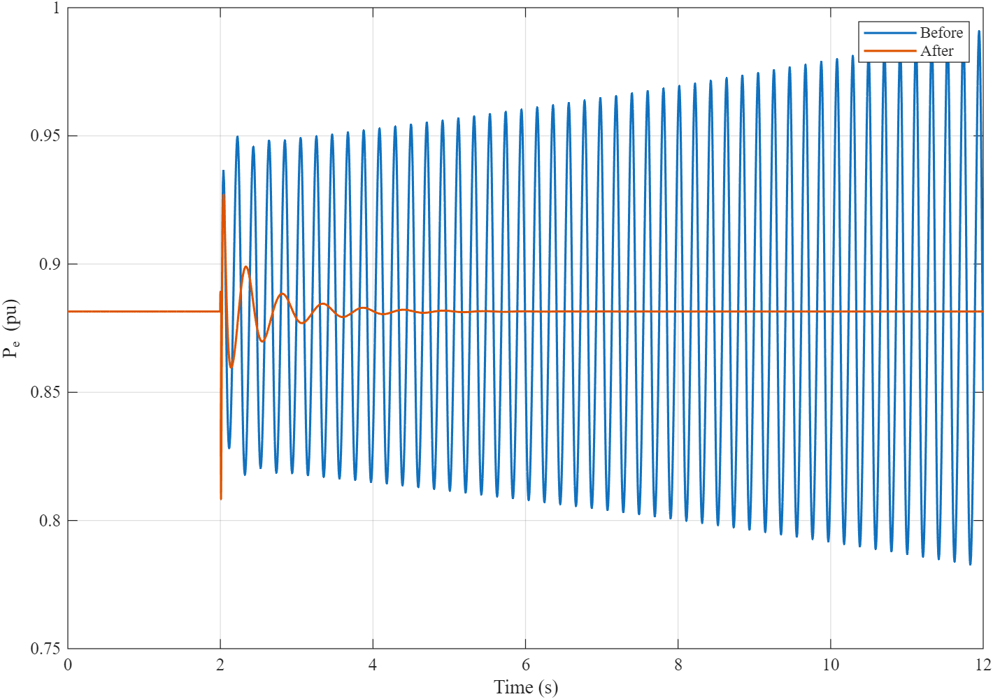
Figure 10. Active-power response before and after PLL-gain mitigation.
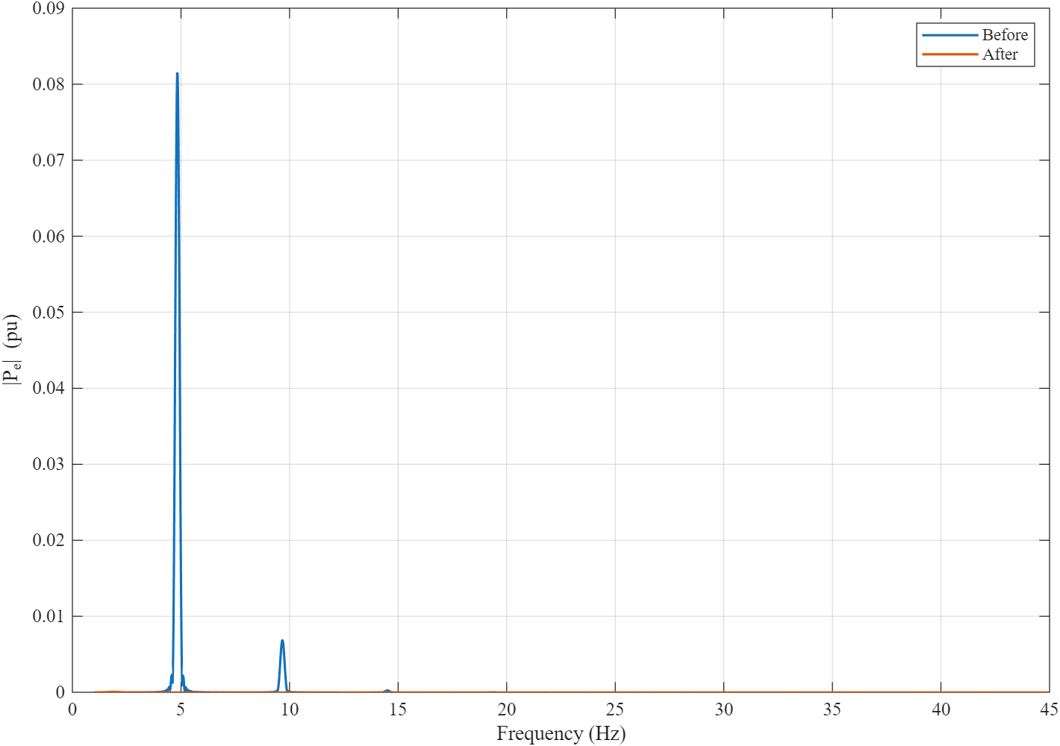
Figure 11. Spectral comparison before and after mitigation.
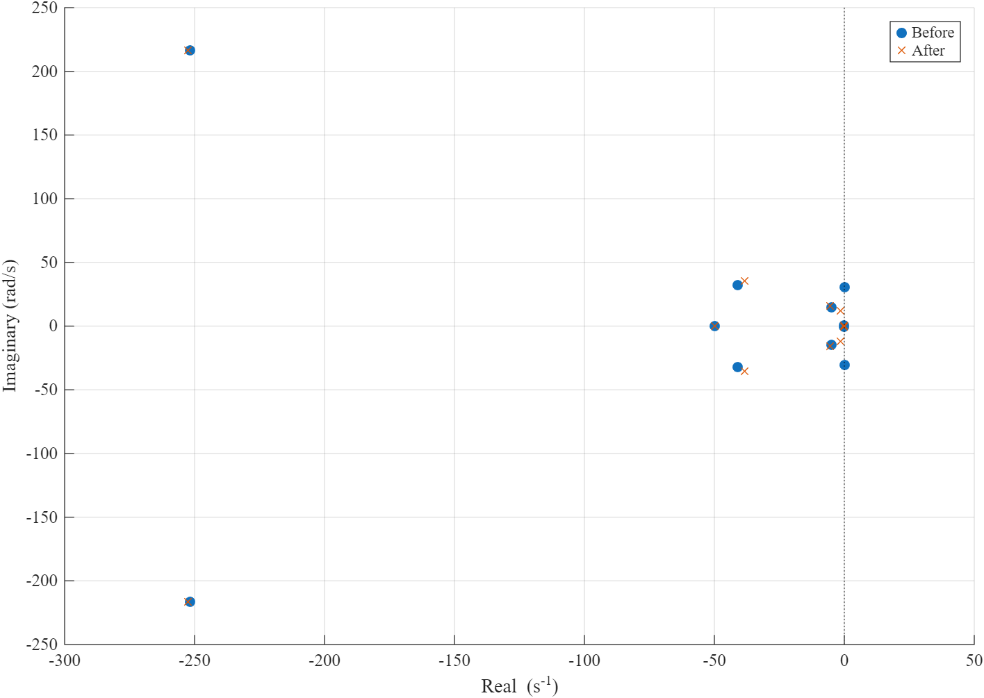
Figure 12. Eigenvalue comparison before and after mitigation.
Metric | Before | After | Change
SSO frequency FFT (Hz) | 4.84467 | 1.88828 | -2.95639
Prony frequency (Hz) | 4.83486 | 1.89236 | -2.9425
Prony damping ratio | -0.00169784 | 0.116408 | +0.118106
Eigenvalue frequency (Hz) | 4.84062 | 1.89234 | -2.94827
Eigenvalue damping ratio | -0.00156147 | 0.116475 | +0.118037
Power oscillation RMS (pu) | 0.0677542 | 2.65677e-07 | -0.067754
Peak current (pu) | 0.97445 | 0.914417 | -0.0600324
Vdc max deviation (pu) | 0.044871 | 0.0148467 | -0.0300243

The comparison supports the limited claim that the selected PLL integral-gain reduction stabilizes the tracked converter-grid mode for this parameter set. It is not evidence of universal robustness across turbine ratings, grid topologies, switching models or untested operating points.

10. Validation and portability
The validator starts with bdclose('all'), clear and clc. It opens and compiles the authoritative SLX without adding project scripts, executes its default simulation, audits S-Functions, callbacks, unresolved links, machine paths and algebraic loops, then regenerates baseline, SSO, mitigation, wind-step, figures and compact result exports. It throws an error unless all twenty checks pass.
- Core dynamics: seven connected native math subsystems, eleven Integrators, and one internal MATLAB Function block for diagnostic assembly.
- Custom Level-2 MATLAB S-Functions in authoritative model: zero.
- Model callbacks: empty.
- Unresolved library links: zero.
- Algebraic loops: zero; no artificial loop-breaking Memory or Unit Delay blocks are required.
- Standalone default simulation: load_system followed by sim from a clean MATLAB process.

11. Limitations
- The converter and machine are averaged; semiconductor switching, PWM ripple and detailed magnetic saturation are excluded.
- The rotor is a single-mass inertia; shaft torsional modes are not represented.
- The machine-side electrical loop is reduced to a first-order q-axis torque-current response with id = 0.
- Generator stator copper losses and detailed converter losses are not represented in the DC energy balance.
- Mitigation is evaluated for the documented SCR step and nominal operating point, not a full grid-code envelope.
- The study is a model-based investigation and is not a substitute for field, controller-hardware or EMT validation.

12. Conclusions
The repaired SLX is a portable, self-contained implementation of the recovered nonlinear averaged model. The weak-grid case produces an internally consistent 4.84 Hz SSO identified by FFT, Prony and eigenanalysis. The tested PLL-gain mitigation changes the critical modal real part from positive to negative and materially reduces DC-link deviation, peak current and active-power oscillation for the controlled comparison. The model, scripts, figures, result tables and reports are regenerated from the same authoritative equations and scenario definitions.

13. References and parameter provenance
The literature supports the architecture and analysis methods. Only the 5 MW machine rating is taken as a numeric model value from a cited paper. The 690 V base, rotor, filter, DC-link, network and controller values are documented engineering assumptions or study tuning; the simulated 4.84 Hz mode is a project result, not a published benchmark target. See docs/SOURCE_AUDIT.md and docs/PARAMETERS.md for equation and value traceability.
- C. Wang, C. Liu, J. Yu and S. Xu, 'Research on Sub-synchronous Oscillation Characteristics between PMSG-based Wind Farms and Weak AC Grids Based on Prony Method,' 2019, DOI 10.1109/EI247390.2019.9061793. GSC structure, SCR and Prony methodology; 5 MW rating.
- X. Zhan, C. Liu and Z. Wang, 'Analysis and control on Sub-synchronous oscillation (SSO) of HVDC transmission for large-scale PMSG-based wind farm integration,' 2019, DOI 10.1049/joe.2018.8811. PMSG dq equations and control-mediated SSO context; HVDC-specific controller is not implemented here.
- P. Kundur, Power System Stability and Control, 1994, ISBN 0-07-035958-X. Modal frequency and damping conventions.
- M. Bongiorno, A. Petersson and E. Agneholm, The Impact of Wind Farms on Subsynchronous Resonance in Power Systems, Elforsk report 11:29, 2011. Complementary time, frequency and eigenvalue analysis context.

Appendix A. Logged signal dictionary
# | Signal | # | Signal
1 | wind_speed | 19 | cp
2 | omega_r | 20 | lambda
3 | torque_m | 21 | turbine_speed
4 | power_m | 22 | electrical_rotor_speed
5 | iq_machine | 23 | torque_e
6 | vdc | 24 | id_machine
7 | id_grid | 25 | iq_machine_reference
8 | iq_grid | 26 | vcd_reference
9 | power_e | 27 | vcq_reference
10 | reactive_q | 28 | pll_frequency_hz
11 | vd_pcc | 29 | sso_signal
12 | vq_pcc | 30 | damping_gain
13 | v_pcc | 31 | controller_command
14 | pll_angle | 32 | grid_voltage_pu
15 | ia | 33 | id_grid_reference
16 | va | 34 | iq_grid_reference
17 | current_pu | 35 | pll_ki_selected
18 | scr

