Part1. Write a program to do the following requirement.

(a) upside-down lena.bmp

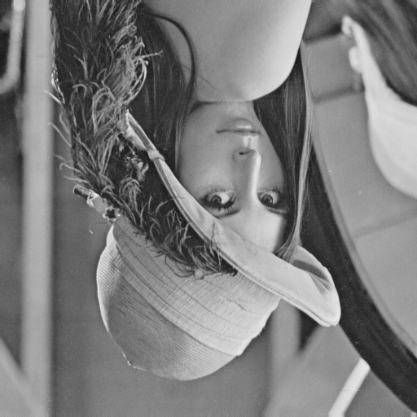

(b) right-side-left lena.bmp

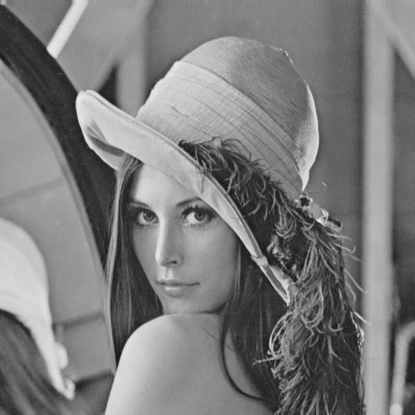

(c) diagonally mirrored lena.bmp

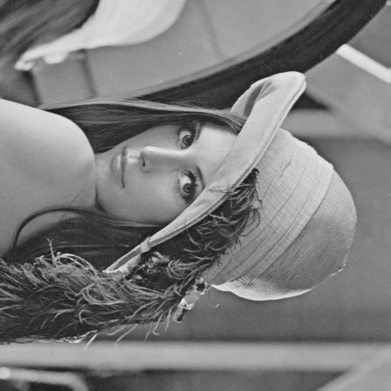

Part2. Write a program or use software to do the following requirement.

(d) rotate lena.bmp 45 degrees clockwise

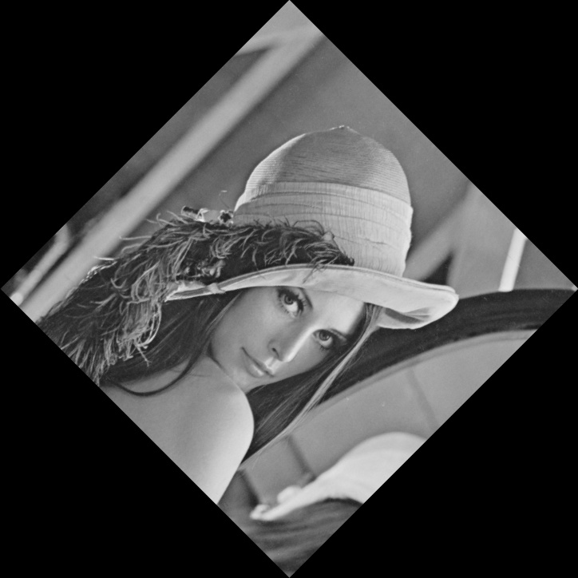

(e) shrink lena.bmp in half

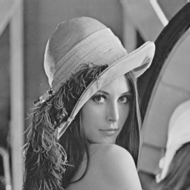

(f) binarize lena.bmp at 128 to get a binary image

