PROCESS MANAGEMENT AND MULTITHREADING.

- Introduction to Process Management.
Process management is an important function of an operating system. It involves various task like creation, scheduling, termination of process and dead lock.

Process is the execution of a program that performs the actions or task specified in that program or it is an execution unit where a program runs.
For example, we write our computer program in a text file and when we executed this program, it becomes a process which performs all the task mention in the program.

The Process Control Block(PCB).
The operation of a process can easily be controlled with the help of PCB(Process Controlled Block). You can consider it as the brain of the process, which contains all the crucial information related to processing like process id, priority, state, CPU register, etc. PCB is a daa structure that is maintaied by the operating system for every process.
Component of Process Control Block (PCB).
  - Process ID: It is an identification that uniquely identifies each process that runs in a computer and it is assign by the PCB.
  - Process State: The state of a process could be new, running, waiting, executing, blocked, suspended or terminated. The PCB is used to store the state of a process.
  - Program counter: It point to the address of the next instruction to be exacuted in any process.
  - Regiter Information: This information is made up of various registers such as, accumulator, base and the index register that are associated with a process.
  - Scheduling information: It is used to set piorities to different processes. It is very useful when different processes are running simultaneously it set proirity so each process can run smoothly.
  - Memory related information: This section of the PCB consist of the page and segment tables. It als stores the data contained in base and limit registers.
  - Accounting information: This section of PCB stores the details related to the CPU utilization and execution time of a process.
  - Status information related to input/output: This section of PCB stores the details about resource utilization and the file opened during the process execution.

- The Process State.
When a process executes, it passes through different states. These states may differ in different operating systems, and the names of these states are also not standardized.

Input/Output or event completion
Input/Output or event wait
Waiting

Interrupt
Running
Ready
Dispatch
Exit
Admitted

Terminated
New

Fig: The process life cycle

Let’s examine what is happening to a process or job in each state.

New(Create): In this state, a process is about to be created but not yet created. It is the program which is present in the hard disk that will be picked up by OS to create a process.
Ready: After the creating of a process, the process enters the ready state i.e the process is loaded into the main memory. Here the process is ready to run and is waiting to get the CPU time for its execution. Processes that are ready for execution by the CPU are maintained in the queue for ready processes.
Running: Once the process has been assigned to a processor by the OS schedular, the process state is set to running and the processor executes its intructions.
Waiting or Blocked: The process moves into the waiting state if it needs to wait for a resource, such as waiting for user input, or waiting for a file to become available.
Terminated or Exit: Once the process finishes its execution, or it is terminated by the operating system, it is moved to the terminated state where it waits to be removed from the main memory.

- The Creation and Termination of Processes.
Every process have a life span which is bounded by it creation and termination.
  - Process Creation.
Processes are created when a computer is powered on. e.g some processes start running immediately when the computer is powered on(booting on your operating system) while some process are called by the operating system.
  - Process Termination.
It occurs when the last instruction of a process is been executed .
- Important terms used in Process State Diagram.
        - Context Switching: It is the process of saving the context of a process and loading the context of the another process. It is the loading and unoading of the state of a process from running to ready state.
Example: It occurs when there is a interrupt, higher priority task and when preemtive scheduling algorithm is used.

        - Overhead: This is the timing when the CPU remain idel as a result of no process in the ready queue. The most important state is the running state as it execute inside the processor. So to maximize the use of the processor and increase the efficiency and performance of any system, the running state must never be empty (keeping the processor from being idel it sould have a task to do).
        - Dispatcher: A dispatcher is the processof transferring scheduled processes from the running state to the ready state one by one.

- Process Scheduling and Scheduling algorithm
  - Process scheduling: It is the act of determining which process is in the running state nd should be move to the ready state.
The aim of process scheduling is to always keep the CPU running always so it doesn’t become ideal and to deliver minimum response time for all program. For archieving this the schedular must apply appropriate rule for swapping processes IN and OUT of the CPU.
NB: A schedular is a program used by the OS to decide where each of the jobs(processes) which are in it control should be and in what order to execute them.
  - How does scheduling work:
A system will have many jobs (which we should more properly call 'processes) that need CPU time. For example, in a multiuser environment, one user may need to print a document, another may need to read a file of data, and another may need to do a series of calculations, and so on. Each job (or 'process') needs some CPU time. Besides, each process may require some input or output from a peripheral such as a printer. Processes that require lots of processor time and very little input/output are known as 'processor-bound' jobs. This might be a process, for example, that requires lots of calculations. A process that requires lots of input/output but very little actual CPU processing is known an 'I/O-bound' job. An example would be a process that needs to print a document or needs to read a lot of data from a file. Each process can be classified as a processor-bound job or an I/O-bound job and this is important because the scheduler looks at what resources are available when deciding what process will get CPU time. The scheduler software, then, is responsible for looking at what resources are available (CPU time and peripheral devices), seeing what processes need to be serviced along with what resources they need and then making decisions about what order to put all the processes in, when to start any particular process, and when to finish it. At first, the processes that are to be executed are placed in a queue called Job queue. The processes which are already placed in the main memory and are ready for CPU allocation, are placed in a queue called Ready queue. If the process is waiting for input/output, then that process is placed in the queue called Device queue.
- Type of Schedulers
Long term schedul:
It is also called a job scheduler or High-level scheduler (HLS). It selects the process that is to be placed in the ready queue. The long term scheduler decides the priority in which processes must be placed in the main memory. Processes of long term scheduler are placed in the ready state because in this state the process is ready to execute waiting for calls of execution from CPU which takes time that's why this is known as long term scheduler. When a process changes the state from new to ready, then there is the use of long-term scheduler.
Short term schedular:
It is also called CPU scheduler or Low-level scheduler (LLS). It decides the priority in which processes in the ready queue are allocated to the CPU time for their execution. Short-term schedulers also decide on which process to execute next.
Medium term scheduler:
Medium-term scheduling swaps jobs between the main memory and hard disk. It places the blocked and suspended processes in the secondary storage. The task of moving from the RAM to secondary storage is called swapping while the task of moving back a swapped out process from secondary storage to RAM is known as swapping in. The swapping of processes is performed to ensure the best utilization of the main memory.
- Scheduling Algorithms.
- Scheduling Objectives:
- Be Fair while allocating resources to the processes
- Maximize throughput of the system
- Maximize number of users receiving acceptable response times.
- Be predictable
- Balance resource use
- Avoid indefinite postponement
- Enforce Priorities
- Give preference to processes holding key resources
- Give better service to processes that have desirable behaviour patterns

- CPU and I/O Burst Cycle:

- Process execution consists of a cycle of CPU execution and I/O wait.
- Processes alternate between these two states.
- Process execution begins with a CPU burst, followed by an I/O burst, then another CPU burst ... etc
- The last CPU burst will end with a system request to terminate execution rather than with another I/O burst.
- The duration of these CPU burst have been measured.
- An I/O-bound program would typically have many short CPU bursts, A CPU-bound program might have a few very long CPU bursts.
- This can help to select an appropriate CPU-scheduling algorithm.
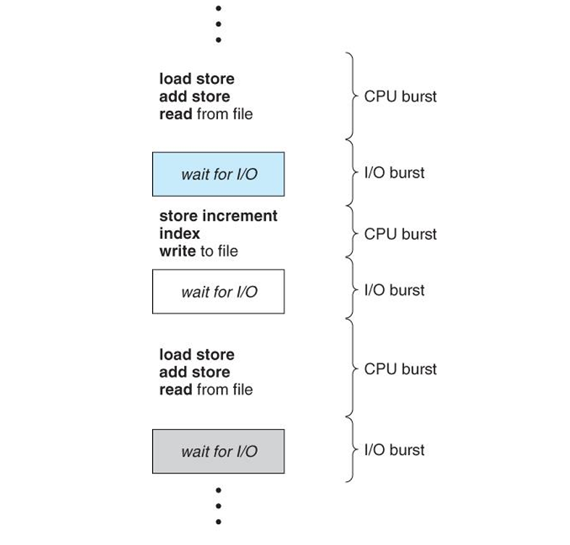
Preemptive Scheduling:
- Preemptive scheduling is used when a process switches from running state to ready state or from waiting state to ready state.
- The resources (mainly CPU cycles) are allocated to the process for the limited amount of time and then is taken away, and the process is again placed back in the ready queue
- if that process still has CPU burst time remaining.
- That process stays in ready queue till it gets next chance to execute.
Non-Preemptive Scheduling:
- Non-preemptive Scheduling is used when a process terminates, or a process switches from running to waiting state.
- In this scheduling, once the resources (CPU cycles) is allocated to a process, the process holds the CPU till it gets terminated or it reaches a waiting state.
- In case of non-preemptive scheduling does not interrupt a process running CPU in middle of the execution.
- Instead, it waits till the process complete its CPU burst time and then it can allocate the CPU to another process.

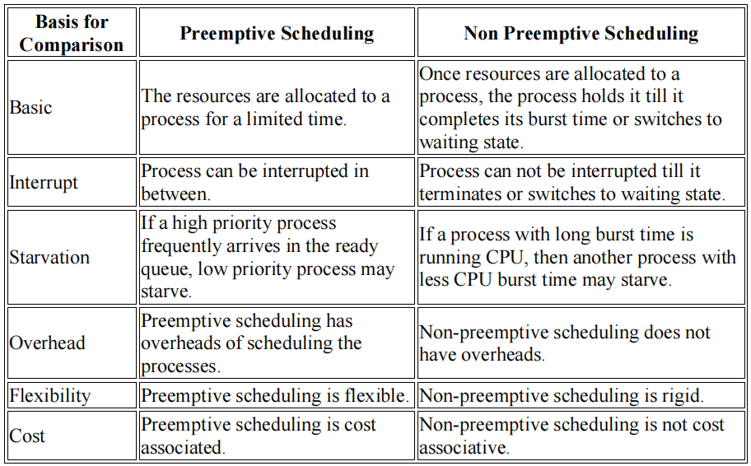

Scheduling Criteria
There are several different criteria to consider when trying to select the "best" scheduling algorithm for a particular situation and environment, including:
- CPU utilization - Ideally the CPU would be busy 100% of the time, so as to waste 0 CPU cycles. On a real system CPU usage should range from 40% ( lightly loaded ) to 90% ( heavily loaded. )
- Throughput - Number of processes completed per unit time. May range from 10 / second to 1 / hour depending on the specific processes.
- Turnaround time - Time required for a particular process to complete, from submission time to completion.
- Waiting time - How much time processes spend in the ready queue waiting their turn to get on the CPU.
- Response time - The time taken in an interactive program from the issuance of a command to the commence of a response to that command.

In brief:
Arrival Time: Time at which the process arrives in the ready queue.
Completion Time: Time at which process completes its execution.
Burst Time:
Time required by a process for CPU execution.
Turn Around Time: Time Difference between completion time and arrival time.
Turn Around Time = Completion Time – Arrival Time
Waiting Time(W.T): Time Difference between turnaround time and burst time.
Waiting Time = Turn Around Time – Burst Time
4.2 Types of Scheduling Algorithm
- First Come First Serve (FCFS)
In FCFS Scheduling
- The process which arrives first in the ready queue is firstly assigned the CPU.
- In case of a tie, process with smaller process id is executed first.
- It is always non-preemptive in nature.
- Jobs are executed on first come, first serve basis.
- It is a non-preemptive, pre-emptive scheduling algorithm.
- Easy to understand and implement.
- Its implementation is based on FIFO queue.
- Poor in performance as average wait time is high.
Advantages-
- It is simple and easy to understand.
- It can be easily implemented using queue data structure.
- It does not lead to starvation.
Disadvantages-
- It does not consider the priority or burst time of the processes.
- It suffers from convoy effect i.e. processes with higher burst time arrived before the processes with smaller burst time.

