|  |
| --- |
| Object – Oriented in C# |
|  |
| Manage book more efficiently |
|  |



Book manage system application



NAVIGATOR

1.INTRODUCTION 2

2. Required Tasks 2

3. Lesson learnt 4

4. Put your codes and outputs here. 4

Main function: 4

0.LOGIN 5

1.REGISTER FORM 8

2.MAIN FORM 11

3.MANAGE FORM 21

4.BOOKSEARCH 30

5.ADDTYPES FORM 33

6.file dealing class: 35

7.Database connect class: 36

Compile result: 36

Executable result: 38

## 1.INTRODUCTION

1. Objectives of the application  
1. Students are able to work well together as a team to produce good design of C#  
Application.  
2. Use previous knowledge in lecture and lab session to create application using .NET  
Framework IDE (Visual Studio 2012)  
3. Able to deploy Array, Inheritance and Exception. If you use more knowledge, you will gain  
higher scores.  
4. Able to demonstrate the concept of design/ development and implementation of software  
engineering.

## 2. Required Tasks

1 Design and create 1 C# Application (Console or GUI Application) for example Robot  
Application, Game Application, Employee application or Student Application.  
2.2 Must implement Array.  
2.3 Must implement Inheritance.

2.4 Must implement Exception.  
2.5 Must be able to have a successful run without compile errors or runtime errors.

## 3. Lesson learnt

(what have your learnt minimum 100 words).

student answer =

By this project , We have learn so much things. We develop a ‘BOOK MANAGE SYSTEM’ application ,it is a big challenge for us ,but we complete it finally . Our works contains many knowledge , it not only use the program or windows form of C# and involve Database ,file .our application by connect MSSQLSERVER to obtain date . Therefore ,we look up many information in the internet .We not only practice our C# and we expand Database and file. Most important of all ,we obtain team work ability and have learn how to find information that we need.

## 4. Put your codes and outputs here.

### Main function:

using System;

using System.Collections.Generic;

using System.Linq;

using System.Windows.Forms;

namespace BOOKSYSTEM

{

static class Program

{

/// <summary>

/// 应用程序的主入口点。

/// </summary>

[STAThread]

static void Main()

{

Application.EnableVisualStyles();

Application.SetCompatibleTextRenderingDefault(false);

Application.Run(new Login());

}

}

}

### 0.LOGIN

using System;

using System.Collections.Generic;

using System.ComponentModel;

using System.Data;

using System.Drawing;

using System.Linq;

using System.Text;

using System.Windows.Forms;

using System.IO;

using System.Data.SqlClient;

namespace BOOKSYSTEM

{

public partial class Login : Form

{

public Login()

{

InitializeComponent();

}

private void Login_Load(object sender, EventArgs e)

{

}

private void button1_Click(object sender, EventArgs e)

{

if (NametextBox.Text == "")

{

MessageBox.Show("请输入用户名", "警告", MessageBoxButtons.OK, MessageBoxIcon.Warning);

}

else

{

if (PasswordtextBox.Text == "")

{

MessageBox.Show("请输入密码", "警告", MessageBoxButtons.OK, MessageBoxIcon.Warning);

}

else

{

try

{

//实例化数据库连接对象，并设置连接到数据库的参数

//SqlConnection sqlConn = new SqlConnection("server=.;database=BOOK_MANAGE_SYSTEM;Trusted_Connection=SSPI");

SqlConnection sqlConn = DBconnect.BooksystemCon();

sqlConn.Open(); //打开连接

if (sqlConn.State == ConnectionState.Open)

{

string sql = "select * from USERS where NAME='" + NametextBox.Text + "' and PASSWORDS='" + PasswordtextBox.Text+ "'";

// MessageBox.Show(sql);

SqlCommand cmd = new SqlCommand(sql, sqlConn);

SqlDataReader sdr = cmd.ExecuteReader(); //使用ExecuteReader创建SqlDataReader对象

sdr.Read(); //读取/前进到下一条记录

if (sdr.HasRows) //查询结果集中是否有值

{

// MessageBox.Show("恭喜！登录成功");

sdr.Close();

cmd = new SqlCommand("select * from USERS where NAME='" + NametextBox.Text + "'", sqlConn);

SqlDataReader sdr1 = cmd.ExecuteReader();

sdr1.Read();

string UserPower = sdr1["POWERS"].ToString().Trim();

string UserId = sdr1["U_ID"].ToString().Trim();

sqlConn.Close();

Mainform main = new Mainform();

main.power = UserPower;

main.U_ID = UserId;

main.Names = NametextBox.Text;

main.Times = DateTime.Now.ToShortDateString();

main.Show();

this.Hide();

}

else

{

MessageBox.Show("用户名或密码错误");

}

}

else {

MessageBox.Show("数据库连接失败！");

}

}

catch (Exception ex)

{

MessageBox.Show(ex.Message);

}

}

}

}

private void button2_Click(object sender, EventArgs e)

{

//进入注册界面

Register register = new Register();

register.Show();

this.Hide();

}

}

}

### 1.REGISTER FORM

using System;

using System.Collections.Generic;

using System.ComponentModel;

using System.Data;

using System.Drawing;

using System.Linq;

using System.Text;

using System.Windows.Forms;

using System.Data.SqlClient;

namespace BOOKSYSTEM

{

public partial class Register : Form

{

public Register()

{

InitializeComponent();

}

//缓存注册基本信息word

//protected int ID;

//protected string Name;

//protected string Pass;

//protected string Department;

private void Register_Load(object sender, EventArgs e)

{

}

private void button1_Click(object sender, EventArgs e)

{

if (IDtextBox.Text == "")

{

MessageBox.Show("请输入ID", "警告", MessageBoxButtons.OK, MessageBoxIcon.Warning);

}

else

{

if (NametextBox.Text == "")

{

MessageBox.Show("请输入用户名", "警告", MessageBoxButtons.OK, MessageBoxIcon.Warning);

}

else

{

if (PasswordtextBox.Text == "")

{

MessageBox.Show("请输入密码", "警告", MessageBoxButtons.OK, MessageBoxIcon.Warning);

}

else {

if (DeparttextBox.Text == "")

{

MessageBox.Show("请输入您所在的班级", "警告", MessageBoxButtons.OK, MessageBoxIcon.Warning);

} //用户输入规范检查完毕，开始连接数据库

try

{

//实例化数据库连接对象，并设置连接到数据库的参数

// SqlConnection sqlConn = new SqlConnection("server=.;database=BOOK_MANAGE_SYSTEM;Trusted_Connection=SSPI");

SqlConnection sqlConn = DBconnect.BooksystemCon();

sqlConn.Open(); //打开连接

if (sqlConn.State == ConnectionState.Open)

{

//检查用户是否正在借阅该书

SqlCommand cmd1 = new SqlCommand("select U_ID from USERS where U_ID ='" + IDtextBox.Text+ "'", sqlConn);

SqlDataReader sdr1 = cmd1.ExecuteReader();

sdr1.Read();

if (sdr1.HasRows)

{

MessageBox.Show("sorry！该用户ID 已经存在了哦！请换个ID 号进行注册");

sqlConn.Close();

}

else

{

sqlConn.Close();

//将注册信息写入数据库

string sql = "insert into USERS (U_ID,NAME,DEPARTMENT,PASSWORDS) VALUES('" + IDtextBox.Text + "','" + NametextBox.Text + "','" + DeparttextBox.Text + "','" + PasswordtextBox.Text + "')";

// MessageBox.Show(sql);

SqlCommand cmd = new SqlCommand(sql, sqlConn);

sqlConn.Open();

cmd.ExecuteNonQuery();

MessageBox.Show("注册成功", "提示", MessageBoxButtons.OK, MessageBoxIcon.Asterisk);

//写入数据库完毕，将用户信息初始化到系统

Mainform main = new Mainform();

main.power = "0";

main.Names = NametextBox.Text;

main.Times = DateTime.Now.ToShortDateString();

main.Show();

this.Hide();

sqlConn.Close();

}

}

else

{

MessageBox.Show("数据库连接失败！");

}

}

catch (Exception ex)

{

MessageBox.Show(ex.Message);

}

}

}

}

}

private void Register_FormClosing(object sender, FormClosingEventArgs e)

{

// Login login = new Login();

// login.Show();

//this.Hide();

Application.Exit();

}

}

}

### 2.MAIN FORM

using System;

using System.Collections.Generic;

using System.ComponentModel;

using System.Data;

using System.Drawing;

using System.Linq;

using System.Text;

using System.Windows.Forms;

using System.Data.SqlClient;

using System.IO;

namespace BOOKSYSTEM

{

public partial class Mainform : Form

{

public Mainform()

{

InitializeComponent();

}

//预保留属性设置,用于显示用户信息以及判断操作权限

public SqlDataReader sdr;

public string power; //权限等级

public string Names; //用户名

public string U_ID;//用户id

public string Times; //登录时间

public static string Searchtext; //用户输入的搜索词

private void BindData()

{

// SqlConnection sqlConn = new SqlConnection("server=.;database=BOOK_MANAGE_SYSTEM;Trusted_Connection=SSPI");

SqlConnection sqlConn = DBconnect.BooksystemCon();

sqlConn.Open(); //打开连接

//创建一个SqlDataAdapter对象

SqlDataAdapter sda = new SqlDataAdapter("select B_ID,NAME,AUTHOR,PUBLISHER,IMAGES from BOOKS WHERE B_ID IN (SELECT B_ID FROM CUR_BORROW WHERE U_ID = '" + U_ID + "')", sqlConn);

//创建一个DataSet对象

DataSet ds = new DataSet();

//使用SqlDataAdapter对象的Fill方法填充DataSetS

sda.Fill(ds, "BOOKS");

//设置dataGridView1控件数据源

currentdataGridView1.DataSource = ds.Tables[0];

//select BOOKS.NAME,HIS_BORROW.BOR_TIME,HIS_BORROW.BACK_TIME,HIS_BORROW.U_ID FROM BOOKS inner join HIS_BORROW ON BOOKS.B_ID = HIS_BORROW.B_ID AND HIS_BORROW.U_ID = '201601';

//创建一个SqlDataAdapter对象

SqlDataAdapter sda1 = new SqlDataAdapter("select BOOKS.B_ID,BOOKS.NAME,BOOKS.AUTHOR,BOOKS.PUBLISHER,HIS_BORROW.BOR_TIME,HIS_BORROW.BACK_TIME FROM BOOKS inner join HIS_BORROW ON BOOKS.B_ID = HIS_BORROW.B_ID AND HIS_BORROW.U_ID = '" + U_ID + "'", sqlConn);

//创建一个DataSet对象

DataSet ds1 = new DataSet();

//使用SqlDataAdapter对象的Fill方法填充DataSetS

sda1.Fill(ds1, "BOOKS2");

//设置dataGridView1控件数据源

dataGridView1.DataSource = ds1.Tables[0];

}

private void Mainform_Load(object sender, EventArgs e)

{

switch (power)

{

case "0": UserInforrichTextBox2.Text = "权限：一般用户\n" + "欢迎," + Names; manageBookToolStripMenuItem.Enabled = false; break;

case "1": UserInforrichTextBox2.Text = "权限：超级管理员\n" + "欢迎," + Names; break;

}

//初始化图书导航

//SqlConnection sqlConn = new SqlConnection("server=.;database=BOOK_MANAGE_SYSTEM;Trusted_Connection=SSPI");

SqlConnection sqlConn = DBconnect.BooksystemCon();

sqlConn.Open(); //打开连接

SqlCommand cmd = new SqlCommand("select NAME from BOOK_TYPES ", sqlConn);

SqlDataReader sdr = cmd.ExecuteReader();

int i = 0;

TreeNode[] sup = new TreeNode[20]; //父节点

string[] savesup = new string[20]; //存放数据库查询到的数据

TreeNode[] sub = new TreeNode[50];

string sql;

while (sdr.Read())

{

//添加父节点

sup[i] = treeView2.Nodes.Add(sdr["NAME"].ToString().Trim());

savesup[i] = sdr["NAME"].ToString().Trim();

i++;

}

sqlConn.Close();

//添加当前查询到的父节点的子节点

int k = 0;

for (int j = 0; j < i; j++)

{

sqlConn.Open();

sql = "select NAME from BOOKS WHERE BOOKS.TYPE=(SELECT ID FROM BOOK_TYPES WHERE NAME ='" + savesup[j] + "')";

SqlCommand cmd1 = new SqlCommand(sql, sqlConn);

SqlDataReader sdr1 = cmd1.ExecuteReader();

while (sdr1.Read())

{

sub[k] = new TreeNode(sdr1["NAME"].ToString().Trim());

//将以上子节点添加到父节点中

sup[j].Nodes.Add(sub[k]);

k++;

}

sqlConn.Close();

}

//载入用户借书信息

BindData();

}

private void currentdataGridView1_CellClick(object sender, DataGridViewCellEventArgs e)

{

}

private void currentdataGridView1_CellContentClick(object sender, DataGridViewCellEventArgs e)

{

idtextBox2.Text = currentdataGridView1.SelectedCells[0].Value.ToString();

NAMEtextBox2.Text = currentdataGridView1.SelectedCells[1].Value.ToString();

AUTHORtextBox3.Text = currentdataGridView1.SelectedCells[2].Value.ToString();

PUBLISHERtextBox4.Text = currentdataGridView1.SelectedCells[3].Value.ToString();

string IMAGE = currentdataGridView1.SelectedCells[4].Value.ToString();

FileStream pFileStream = new FileStream(IMAGE, FileMode.Open, FileAccess.Read);

pictureBox2.Image = Image.FromStream(pFileStream);

pFileStream.Close();

pFileStream.Dispose();

}

private void treeView2_AfterSelect(object sender, TreeViewEventArgs e)

{

//在AfterSelect事件中获取控件中选中节点显示的文本

// label1.Text = "当前选中的节点：" + e.Node.Text;

// SqlConnection sqlConn = new SqlConnection("server=.;database=BOOK_MANAGE_SYSTEM;Trusted_Connection=SSPI");

SqlConnection sqlConn = DBconnect.BooksystemCon();

sqlConn.Open(); //打开连接

SqlCommand cmd = new SqlCommand("select B_ID,NAME,AUTHOR,PUBLISHER,NUMBER,PUB_TIME,TYPE,STORAGE,IMAGES from BOOKS where NAME ='" + e.Node.Text + "'", sqlConn);

SqlDataReader sdr = cmd.ExecuteReader();

sdr.Read();

if(sdr.HasRows)

{

idtextBox.Text = sdr["B_ID"].ToString().Trim();

nametextBox.Text = sdr["NAME"].ToString().Trim();

authortextBox.Text = sdr["AUTHOR"].ToString().Trim();

publishertextBox.Text = sdr["PUBLISHER"].ToString().Trim();

timetextBox.Text = sdr["PUB_TIME"].ToString().Trim();

storagetextBox.Text = sdr["STORAGE"].ToString().Trim();

NUMtextBox.Text = sdr["NUMBER"].ToString().Trim();

FileStream pFileStream = new FileStream(sdr["IMAGES"].ToString().Trim(), FileMode.Open, FileAccess.Read);

pictureBox1.Image = Image.FromStream(pFileStream);

pFileStream.Close();

pFileStream.Dispose();

}

sqlConn.Close();

//查询评论

//SqlConnection sqlConn = new SqlConnection("server=.;database=BOOK_MANAGE_SYSTEM;Trusted_Connection=SSPI");

sqlConn.Open(); //打开连接

string SQL = "select BOOK_COMMENT.CONTENT,BOOK_COMMENT.TIME,USERS.NAME from BOOK_COMMENT,USERS WHERE USERS.U_ID = BOOK_COMMENT.USERID AND BOOK_COMMENT.BOOK_ID = (SELECT B_ID FROM BOOKS WHERE NAME ='" + e.Node.Text.Trim() + "')";

//SQL = "select *from BOOK_COMMENT";

SqlCommand cmd4 = new SqlCommand(SQL, sqlConn);

// MessageBox.Show(SQL);

SqlDataReader sdr4 = cmd4.ExecuteReader();

string main = "";

commentrichTextBox.Text = "";

while (sdr4.Read())

{

main += sdr4["NAME"] + " " + sdr4["TIME"] + "\n" + sdr4["CONTENT"] + "\n\n";

commentrichTextBox.Text = main;

}

sqlConn.Close();

}

private void lookbutton_Click(object sender, EventArgs e)

{

}

private void brrow_Click(object sender, EventArgs e)

{

if (idtextBox.Text=="")

{

MessageBox.Show("还没有选择图书哦！请选好图书再借阅");

}else{

System.DateTime startTime = TimeZone.CurrentTimeZone.ToLocalTime(new System.DateTime(1970, 1, 1)); // 当地时区

long timeStamp = (long)(DateTime.Now - startTime).TotalMilliseconds; // 相差毫秒数

// SqlConnection sqlConn = new SqlConnection("server=.;database=BOOK_MANAGE_SYSTEM;Trusted_Connection=SSPI");

SqlConnection sqlConn = DBconnect.BooksystemCon();

sqlConn.Open(); //打开连接

//检查用户是否正在借阅该书

SqlCommand cmd1 = new SqlCommand("select C_ID from CUR_BORROW where U_ID ='" + U_ID + "' AND B_ID ='" + idtextBox.Text+"'", sqlConn);

SqlDataReader sdr1 = cmd1.ExecuteReader();

sdr1.Read();

if (sdr1.HasRows)

{

MessageBox.Show("您已经借阅了该书籍了，一次只能借一本哦！");

sqlConn.Close();

}

else

{

sqlConn.Close();

string sql = "insert into CUR_BORROW(C_ID,BOR_TIME,U_ID,B_ID) values('" + timeStamp + "','" + DateTime.Now.ToString("yyyy-MM-dd") + "','" + U_ID + "','" + idtextBox.Text + "')";

//MessageBox.Show(sql);

sqlConn.Open(); //打开连接

SqlCommand cmd = new SqlCommand(sql, sqlConn);

int a = cmd.ExecuteNonQuery(); //影响行数

MessageBox.Show("借阅成功！");

BindData(); //更新数据

sqlConn.Close();

}

}

}

private void lend_Click(object sender, EventArgs e)

{

if (idtextBox2.Text == "")

{

MessageBox.Show("还没有图书被选中哦！无法进行操作");

}

else

{

System.DateTime startTime = TimeZone.CurrentTimeZone.ToLocalTime(new System.DateTime(1970, 1, 1)); // 当地时区

long timeStamp = (long)(DateTime.Now - startTime).TotalMilliseconds; // 相差毫秒数

//SqlConnection sqlConn = new SqlConnection("server=.;database=BOOK_MANAGE_SYSTEM;Trusted_Connection=SSPI");

SqlConnection sqlConn = DBconnect.BooksystemCon();

sqlConn.Open(); //打开连接

//首先查询本书的借阅时间

SqlCommand cmd1 = new SqlCommand("select BOR_TIME from CUR_BORROW where U_ID ='" + U_ID + "' AND B_ID ='" + idtextBox2.Text + "'", sqlConn);

SqlDataReader sdr1 = cmd1.ExecuteReader();

sdr1.Read();

string BOR_TIME = sdr1["BOR_TIME"].ToString().Trim();

sqlConn.Close();

//将本书的信息插入到历史借阅表

string sql = "insert into HIS_BORROW(H_ID,BOR_TIME,BACK_TIME,U_ID,B_ID) values('" + timeStamp + "','" + BOR_TIME + "','" + DateTime.Now.ToString("yyyy-MM-dd") + "','" + U_ID + "','" + idtextBox2.Text + "')";

// MessageBox.Show(sql);

sqlConn.Open(); //打开连接

SqlCommand cmd = new SqlCommand(sql, sqlConn);

int a = cmd.ExecuteNonQuery(); //影响行数

sqlConn.Close();

//然后从当前借阅表中删除本条书的记录

string sql2 = "delete from CUR_BORROW where U_ID ='" + U_ID + "' AND B_ID ='" + idtextBox2.Text + "'";

// MessageBox.Show(sql2);

sqlConn.Open(); //打开连接

SqlCommand cmd2 = new SqlCommand(sql2, sqlConn);

int a2 = cmd2.ExecuteNonQuery(); //影响行数

sqlConn.Close();

//将用户评论存入数据库

if (richTextBox2.Text != "") //判断用户是否有输入评论，有才插入数据库

{

string sql3 = "insert into BOOK_COMMENT(BC_ID,CONTENT,TIME,BOOK_ID,USERID) values('" + timeStamp + "','" + richTextBox2.Text + "','" + DateTime.Now.ToString("yyyy-MM-dd") + "','" + idtextBox2.Text + "','" + U_ID + "')";

MessageBox.Show(sql3);

sqlConn.Open(); //打开连接

SqlCommand cmd3 = new SqlCommand(sql3, sqlConn);

int a3 = cmd3.ExecuteNonQuery(); //影响行数

}

MessageBox.Show("还书成功！");

BindData(); //更新数据

sqlConn.Close();

}

}

private void button1_Click(object sender, EventArgs e)

{

Searchtext = textBox1.Text;

//MessageBox.Show(textBox1.Text);

BookDisplay bookdisplay = new BookDisplay();

bookdisplay.Show();

}

private void manageBooksToolStripMenuItem_Click(object sender, EventArgs e)

{

Manage manage = new Manage();

manage.Show();

// this.Hide();

}

private void existToolStripMenuItem_Click(object sender, EventArgs e)

{

if (MessageBox.Show("确定退出本系统吗？", "提示", MessageBoxButtons.OKCancel, MessageBoxIcon.Exclamation) == DialogResult.OK)

{

Application.Exit();

}

}

private void button2_Click(object sender, EventArgs e)

{

if (MessageBox.Show("确定退出本系统吗？", "提示", MessageBoxButtons.OKCancel, MessageBoxIcon.Exclamation) == DialogResult.OK)

{

// Application.Exit();

System.Environment.Exit(0);

}

}

private void treeView1_AfterSelect(object sender, TreeViewEventArgs e)

{

MessageBox.Show("当前选中的节点是"+e.Node.Text);

}

private void manageBooktypesToolStripMenuItem_Click(object sender, EventArgs e)

{

ADDtypes addtypes = new ADDtypes();

addtypes.Show();

}

}

}

### 3.MANAGE FORM

using System;

using System.Collections.Generic;

using System.ComponentModel;

using System.Data;

using System.Drawing;

using System.Linq;

using System.Text;

using System.Windows.Forms;

using System.IO;

using System.Data.SqlClient;

namespace BOOKSYSTEM

{

public partial class Manage : Form

{

public Manage()

{

InitializeComponent();

}

string newfilepath = ""; //保存数据表中的图片上传的目标路径

string oldfilepath = null; //保存用户上传图片的来源路径

string tempfilepath = null; //保存点击数据表时的图片路径

private void BindData()

{

//实例化SqlConnection变量sqlConn，连接数据库

// SqlConnection sqlConn = new SqlConnection("server=.;database=BOOK_MANAGE_SYSTEM;Trusted_Connection=SSPI");

SqlConnection sqlConn = DBconnect.BooksystemCon();

//创建一个SqlDataAdapter对象

SqlDataAdapter sda = new SqlDataAdapter("select B_ID,NAME,AUTHOR,PUBLISHER,NUMBER,PUB_TIME,TYPE,STORAGE,IMAGES from BOOKS", sqlConn);

//创建一个DataSet对象

DataSet ds = new DataSet();

//使用SqlDataAdapter对象的Fill方法填充DataSetS

sda.Fill(ds, "BOOKS");

//设置dataGridView1控件数据源

dataGridView1.DataSource = ds.Tables[0];

}

private void Manage_Load(object sender, EventArgs e)

{

addbutton.Enabled = true;

changebutton.Enabled = false;

deletebutton.Enabled = false;

searchbutton.Enabled = true;

savebutton.Enabled = false;

cancelbutton.Enabled = false ;

BOOKIDtextBox.Enabled = false;

BOOKNAMEtextBox.Enabled = false;

AUTHORtextBox.Enabled = false;

PUBLISHERtextBox.Enabled = false;

STORAGEtextBox.Enabled = false;

numtextBox.Enabled = false;

dateTimePicker1.Enabled = false;

TYPEcomboBox.Enabled = false;

PICTUREbutton.Enabled = false;

//从数据库中读取图书类型，并放入下拉菜单中

TYPEcomboBox.DropDownStyle = ComboBoxStyle.DropDownList;

// SqlConnection sqlConn = new SqlConnection("server=.;database=BOOK_MANAGE_SYSTEM;Trusted_Connection=SSPI");

SqlConnection sqlConn = DBconnect.BooksystemCon();

sqlConn.Open(); //打开连接

SqlCommand cmd = new SqlCommand("select NAME from BOOK_TYPES ", sqlConn);

SqlDataReader sdr = cmd.ExecuteReader();

while (sdr.Read())

{

TYPEcomboBox.Items.Add(sdr["NAME"].ToString().Trim());

}

//TYPEcomboBox.SelectedIndex = 0;

}

private void Form1_FormClosing(object sender, FormClosingEventArgs e)

{

DialogResult dr;

dr = MessageBox.Show("确认退出吗？", "确认对话框", MessageBoxButtons.YesNo, MessageBoxIcon.Question, MessageBoxDefaultButton.Button2);

if (dr == DialogResult.Yes)

{

Mainform main = new Mainform();

main.Show();

this.Close();

}

else

{

e.Cancel = true;

}

}

private void button1_Click_1(object sender, EventArgs e)

{

BOOKIDtextBox.Text = "";

BOOKNAMEtextBox.Text = "";

AUTHORtextBox.Text = "";

PUBLISHERtextBox.Text = "";

STORAGEtextBox.Text = "";

numtextBox.Text = null;

newfilepath = "";

addbutton.Enabled = false;

savebutton.Enabled = true;

cancelbutton.Enabled = true;

searchbutton.Enabled = false;

deletebutton.Enabled = false;

changebutton.Enabled = false;

BOOKIDtextBox.Enabled = true;

BOOKNAMEtextBox.Enabled = true;

AUTHORtextBox.Enabled = true;

PUBLISHERtextBox.Enabled = true;

STORAGEtextBox.Enabled = true;

numtextBox.Enabled = true;

dateTimePicker1.Enabled = true;

TYPEcomboBox.Enabled = true;

PICTUREbutton.Enabled = true;

}

private void savebutton_Click(object sender, EventArgs e)

{

if (BOOKIDtextBox.Text=="")

{

MessageBox.Show("还没有图书被选中哦！无法进行操作");

}else{

//实例化SqlConnection变量sqlConn，连接数据库

// SqlConnection sqlConn = new SqlConnection("server=.;database=BOOK_MANAGE_SYSTEM;Trusted_Connection=SSPI");

SqlConnection sqlConn = DBconnect.BooksystemCon();

sqlConn.Open(); //打开连接

SqlCommand cmd = new SqlCommand("select count(*) from BOOKS where NAME='" + BOOKNAMEtextBox.Text + "'", sqlConn);

int i = Convert.ToInt32(cmd.ExecuteScalar());

SqlCommand cmd1 = new SqlCommand("select ID from BOOK_TYPES WHERE NAME ='" + TYPEcomboBox.Text + "'", sqlConn);

SqlDataReader sdr = cmd1.ExecuteReader();

sdr.Read();

string Type = sdr["ID"].ToString().Trim();

// MessageBox.Show(Type);

sqlConn.Close();

// MessageBox.Show( Convert.ToString(i));

if (i > 0)

{

if (tempfilepath != oldfilepath) //当用户更改了图片时才执行此步操作

{ //tempfilepath为用户点击dategridview时，传过来的路径，即原来数据库中保存的那个;

//oldfilepath为用户点击选择图片按钮时选择的图片路径

//如果用户点击了选择图片按钮，则oldfilepat会发生改变

MessageBox.Show(tempfilepath);

Filedealing upfile = new Filedealing();

newfilepath = upfile.uploadfile(oldfilepath); //将用户选定图片上传至系统制定目录后，将其完整的路径赋给一个变量

this.pictureBox1.Load(newfilepath);

FileInfo delete = new FileInfo(tempfilepath);

delete.Delete(); //删除记录对于的图片文件

MessageBox.Show("图片更新成功！" + tempfilepath);

sqlConn.Open(); //打开连接

string sql = "update BOOKS set NAME='" + BOOKNAMEtextBox.Text.Trim() + "',AUTHOR='" + AUTHORtextBox.Text.Trim() + "',PUBLISHER='" + PUBLISHERtextBox.Text.Trim() + "',NUMBER=" + numtextBox.Text.Trim() + ",TYPE='" + Type.Trim() + "',PUB_TIME='" + dateTimePicker1.Text.Trim() + "',STORAGE='" + STORAGEtextBox.Text.Trim() + "',IMAGES='" + newfilepath.Trim() + "' where B_ID='" + dataGridView1.SelectedCells[0].Value.ToString().Trim() + "'";

SqlCommand cmd2 = new SqlCommand(sql, sqlConn);

cmd2.ExecuteNonQuery();

MessageBox.Show(newfilepath);

sqlConn.Close();

BindData();

}

else

{

MessageBox.Show(tempfilepath);

sqlConn.Open(); //打开连接

string sql = "update BOOKS set NAME='" + BOOKNAMEtextBox.Text.Trim() + "',AUTHOR='" + AUTHORtextBox.Text.Trim() + "',PUBLISHER='" + PUBLISHERtextBox.Text.Trim() + "',NUMBER=" + numtextBox.Text.Trim() + ",TYPE='" + Type.Trim() + "',PUB_TIME='" + dateTimePicker1.Text.Trim() + "',STORAGE='" + STORAGEtextBox.Text.Trim() + "',IMAGES='" + tempfilepath.Trim() + "' where B_ID='" + dataGridView1.SelectedCells[0].Value.ToString().Trim() + "'";

MessageBox.Show(sql);

SqlCommand cmd2 = new SqlCommand(sql, sqlConn);

int a = cmd2.ExecuteNonQuery();

MessageBox.Show("affect---" + a);

sqlConn.Close();

BindData();

}

addbutton.Enabled = true;

deletebutton.Enabled = false;

changebutton.Enabled = false;

searchbutton.Enabled = true;

savebutton.Enabled = false ;

cancelbutton.Enabled = true;

BOOKNAMEtextBox.Enabled = false;

}

else

{

Filedealing upfile = new Filedealing();

newfilepath = upfile.uploadfile(oldfilepath); //将用户选定图片上传至系统制定目录后，将其完整的路径赋给一个变量

MessageBox.Show(newfilepath);

sqlConn.Open(); //打开连接

string sql = "insert into BOOKS(B_ID,NAME,AUTHOR,PUBLISHER,NUMBER,TYPE,PUB_TIME,STORAGE,IMAGES ) values('" + BOOKIDtextBox.Text.Trim() + "','" + BOOKNAMEtextBox.Text.Trim() + "','" + AUTHORtextBox.Text.Trim() + "','" + PUBLISHERtextBox.Text.Trim() + "','" + numtextBox.Text.Trim() + "','" + Type.Trim() + "','" + dateTimePicker1.Text.Trim() + "','" + STORAGEtextBox.Text.Trim() + "','" + newfilepath.Trim() + "')";

MessageBox.Show(sql);

cmd = new SqlCommand(sql, sqlConn);

int a = cmd.ExecuteNonQuery();

MessageBox.Show("affect---"+a);

sqlConn.Close();

BindData();

addbutton.Enabled = true;

deletebutton.Enabled = false;

changebutton.Enabled = false;

searchbutton.Enabled = true;

savebutton.Enabled = false;

cancelbutton.Enabled = true;

BOOKNAMEtextBox.Enabled = false;

}

}

}

private void button1_Click(object sender, EventArgs e)

{

//将用户选择的图片上传到系统指定目录

OpenFileDialog fileDialog = new OpenFileDialog();

fileDialog.Multiselect = true;

fileDialog.Title = "请选择文件";

fileDialog.Filter = "所有文件(*jpg*)|*.jpg*"; //设置要选择的文件的类型

if (fileDialog.ShowDialog() == DialogResult.OK)

{

oldfilepath = fileDialog.FileName;//返回文件的完整路径

// MessageBox.Show("文件的路径是：" + oldfilepath);

}

this.pictureBox1.Load(oldfilepath);

}

private void changebutton_Click(object sender, EventArgs e)

{

oldfilepath = tempfilepath;

addbutton.Enabled = false;

deletebutton.Enabled = false;

searchbutton.Enabled = false;

savebutton.Enabled = true;

cancelbutton.Enabled = true;

BOOKIDtextBox.Enabled = false;

BOOKNAMEtextBox.Enabled = false;

AUTHORtextBox.Enabled = true;

PUBLISHERtextBox.Enabled = true;

STORAGEtextBox.Enabled = true;

numtextBox.Enabled = true;

dateTimePicker1.Enabled = true;

TYPEcomboBox.Enabled = true;

PICTUREbutton.Enabled = true;

}

private void searchbutton_Click(object sender, EventArgs e)

{

addbutton.Enabled = true;

deletebutton.Enabled = true;

changebutton.Enabled = true;

searchbutton.Enabled = true;

savebutton.Enabled = false;

cancelbutton.Enabled = true;

BOOKIDtextBox.Enabled = false;

BOOKNAMEtextBox.Enabled = false;

AUTHORtextBox.Enabled = false;

PUBLISHERtextBox.Enabled = false;

STORAGEtextBox.Enabled = false;

numtextBox.Enabled = false;

dateTimePicker1.Enabled = false;

TYPEcomboBox.Enabled = false;

PICTUREbutton.Enabled = false;

BindData(); //查询所有数据

}

private void cancelbutton_Click(object sender, EventArgs e)

{

addbutton.Enabled = true;

changebutton.Enabled = false;

deletebutton.Enabled = false;

searchbutton.Enabled = true;

savebutton.Enabled = false;

cancelbutton.Enabled = true;

BOOKIDtextBox.Enabled = false;

BOOKNAMEtextBox.Enabled = false;

AUTHORtextBox.Enabled = false;

PUBLISHERtextBox.Enabled = false;

STORAGEtextBox.Enabled = false;

numtextBox.Enabled = false;

dateTimePicker1.Enabled = false;

TYPEcomboBox.Enabled = false;

PICTUREbutton.Enabled = false;

}

private void dataGridView1_CellContentClick(object sender, DataGridViewCellEventArgs e)

{

}

private void dataGridView1_CellClick(object sender, DataGridViewCellEventArgs e)

{

//实例化SqlConnection变量sqlConn，连接数据库

// SqlConnection sqlConn = new SqlConnection("server=.;database=BOOK_MANAGE_SYSTEM;Trusted_Connection=SSPI");

SqlConnection sqlConn = DBconnect.BooksystemCon();

sqlConn.Open(); //打开连接

SqlCommand cmd1 = new SqlCommand("select NAME from BOOK_TYPES WHERE ID =" + dataGridView1.SelectedCells[6].Value.ToString().Trim() , sqlConn);

SqlDataReader sdr = cmd1.ExecuteReader();

sdr.Read();

string Type = sdr["NAME"].ToString().Trim();

sqlConn.Close();

BOOKIDtextBox.Text = dataGridView1.SelectedCells[0].Value.ToString();

BOOKNAMEtextBox.Text = dataGridView1.SelectedCells[1].Value.ToString();

AUTHORtextBox.Text = dataGridView1.SelectedCells[2].Value.ToString();

PUBLISHERtextBox.Text = dataGridView1.SelectedCells[3].Value.ToString().Trim();

numtextBox.Text = dataGridView1.SelectedCells[4].Value.ToString().Trim();

dateTimePicker1.Text = dataGridView1.SelectedCells[5].Value.ToString().Trim();

TYPEcomboBox.Text = Type;

STORAGEtextBox.Text = dataGridView1.SelectedCells[7].Value.ToString().Trim();

tempfilepath = dataGridView1.SelectedCells[8].Value.ToString().Trim();

FileStream pFileStream = new FileStream(tempfilepath, FileMode.Open, FileAccess.Read);

pictureBox1.Image = Image.FromStream(pFileStream);

pFileStream.Close();

pFileStream.Dispose();

changebutton.Enabled = true;

deletebutton.Enabled = true;

// MessageBox.Show(dataGridView1.SelectedCells[5].Value.ToString().Trim());

}

private void deletebutton_Click(object sender, EventArgs e)

{

if (BOOKIDtextBox.Text == "")

{

MessageBox.Show("还没有图书被选中哦！无法进行操作");

}

else

{

//实例化SqlConnection变量sqlConn，连接数据库

// SqlConnection sqlConn = new SqlConnection("server=.;database=BOOK_MANAGE_SYSTEM;Trusted_Connection=SSPI");

SqlConnection sqlConn = DBconnect.BooksystemCon();

sqlConn.Open(); //打开连接

string sql = "delete from books where B_ID='" + dataGridView1.SelectedCells[0].Value.ToString() + "'";

MessageBox.Show(dataGridView1.SelectedCells[0].Value.ToString() + sql);

SqlCommand cmd = new SqlCommand(sql, sqlConn);

cmd.ExecuteNonQuery();

sqlConn.Close();

pictureBox1.Image = null;

FileInfo delete = new FileInfo(tempfilepath);

delete.Delete();

MessageBox.Show("删除成功！" + tempfilepath);

BindData();

}

}

}

}

### 4.BOOKSEARCH

using System;

using System.Collections.Generic;

using System.ComponentModel;

using System.Data;

using System.Drawing;

using System.Linq;

using System.Text;

using System.Windows.Forms;

using System.Data.SqlClient;

namespace BOOKSYSTEM

{

public partial class BookSearch : Form

{

public BookSearch()

{

InitializeComponent();

}

private void BookDisplay_Load(object sender, EventArgs e)

{

// MessageBox.Show(Mainform.Searchtext);

NAMEtextBox1.Text = Mainform.Searchtext;

}

private void button1_Click(object sender, EventArgs e)

{

string sql = "";

string where = " WHERE ";

if (NAMEtextBox1.Text == "")

{

sql +="";

}

else

{

sql = "NAME LIKE '%" + NAMEtextBox1.Text + "%' ";

}

if (AUTHORtextBox2.Text == "")

{

sql += "";

}

else if (NAMEtextBox1.Text != "")

{

sql += " AND AUTHOR LIKE '%" + AUTHORtextBox2.Text + "%' ";

}

else {

sql += "AUTHOR LIKE '%" + AUTHORtextBox2.Text + "%' ";

}

if (PUBLISHERtextBox3.Text == "")

{

sql += "";

}

else if (AUTHORtextBox2.Text != ""&&NAMEtextBox1.Text!="")

{

sql += " AND PUBLISHER LIKE '%" + PUBLISHERtextBox3.Text + "%' ";

}

else {

sql += "PUBLISHER LIKE '%" + PUBLISHERtextBox3.Text + "%' ";

}

if (NAMEtextBox1.Text == ""&&AUTHORtextBox2.Text == "" && NAMEtextBox1.Text == "")

{ //如果三个输入框都为空则将所有数据都查出来

where = "";

}

// SqlConnection sqlConn = new SqlConnection("server=.;database=BOOK_MANAGE_SYSTEM;Trusted_Connection=SSPI");

SqlConnection sqlConn = DBconnect.BooksystemCon();

sqlConn.Open(); //打开连接

// MessageBox.Show("select B_ID,NAME,AUTHOR,PUBLISHER,NUMBER,PUB_TIME,TYPE,STORAGE,IMAGES from BOOKS " + where + sql.Trim());

//创建一个SqlDataAdapter对象

SqlDataAdapter sda = new SqlDataAdapter("select B_ID,NAME,AUTHOR,PUBLISHER,NUMBER,PUB_TIME,TYPE,STORAGE,IMAGES from BOOKS " +where+ sql.Trim(), sqlConn);

//创建一个DataSet对象

DataSet ds = new DataSet();

//使用SqlDataAdapter对象的Fill方法填充DataSetS

sda.Fill(ds, "BOOKS");

//设置dataGridView1控件数据源

dataGridView1.DataSource = ds.Tables[0];

}

}

}

### 5.ADDTYPES FORM

using System;

using System.Collections.Generic;

using System.ComponentModel;

using System.Data;

using System.Drawing;

using System.Linq;

using System.Text;

using System.Windows.Forms;

using System.Data.SqlClient;

namespace BOOKSYSTEM

{

public partial class ADDtypes : Form

{

public ADDtypes()

{

InitializeComponent();

}

private void ADDtypes_Load(object sender, EventArgs e)

{

}

private void submitbutton_Click(object sender, EventArgs e)

{

if (addtypestextBox.Text != "")

{

try

{

//实例化数据库连接对象，并设置连接到数据库的参数

// SqlConnection sqlConn = new SqlConnection("server=.;database=BOOK_MANAGE_SYSTEM;Trusted_Connection=SSPI");

SqlConnection sqlConn = DBconnect.BooksystemCon();

sqlConn.Open(); //打开连接

if (sqlConn.State == ConnectionState.Open)

{

//将注册信息写入数据库

string sql = "insert into BOOK_TYPES (NAME) VALUES('"+addtypestextBox.Text+ "')";

MessageBox.Show(sql);

SqlCommand cmd = new SqlCommand(sql, sqlConn);

cmd.ExecuteNonQuery();

MessageBox.Show("插入数据成功", "提示", MessageBoxButtons.OK, MessageBoxIcon.Asterisk);

//写入数据库完毕，清空输入框

addtypestextBox.Text = "";

}

else

{

MessageBox.Show("数据库连接失败！");

}

}

catch (Exception ex)

{

MessageBox.Show(ex.Message);

}

}

else

{

MessageBox.Show("输入不能为空！");

}

}

}

}

### 6.file dealing class:

using System;

using System.Collections.Generic;

using System.Linq;

using System.Text;

using System.IO;

namespace BOOKSYSTEM

{

public class Filedealing

{

static string defaultpath = "..\\..\\..\\images\\";

//删除冗余文件

public void deletefile(string filename)

{

string deletefilename = defaultpath;

deletefilename += filename;

File.Delete(defaultpath);

}

//将用户选择的图片上传到系统指定目录

public string uploadfile(string filename)

{

System.DateTime startTime = TimeZone.CurrentTimeZone.ToLocalTime(new System.DateTime(1970, 1, 1)); // 当地时区

long timeStamp = (long)(DateTime.Now - startTime).TotalMilliseconds; // 相差毫秒数

string newfilepath = defaultpath; //将指定上传路径复制给newfilepath

newfilepath += timeStamp + ".jpg";//使用时间戳作为文件名称

if (filename != null) //防止用户取消后出现的异常提示

{

File.Copy(filename, newfilepath);

return newfilepath;

}else

{

return "";

}

}

}

}

### 7.Database connect class:

using System;

using System.Collections.Generic;

using System.Linq;

using System.Text;

using System.Data.SqlClient;

namespace BOOKSYSTEM

{

class DBconnect

{

public static SqlConnection BooksystemCon()

{

return new SqlConnection("server=.;database=BOOK_MANAGE_SYSTEM;Trusted_Connection=SSPI");

}

}

}

### Compile result:

线程 'vshost.LoadReference' (0x40e4) 已退出，返回值为 0 (0x0)。

“BOOKSYSTEM.vshost.exe”(托管(v4.0.30319)): 已加载“C:\Users\tsh\Desktop\BOOKSYSTEM\BOOKSYSTEM\bin\Release\BOOKSYSTEM.exe”，符号已加载。

“BOOKSYSTEM.vshost.exe”(托管(v4.0.30319)): 已加载“C:\Windows\Microsoft.Net\assembly\GAC_MSIL\mscorlib.resources\v4.0_4.0.0.0_zh-Hans_b77a5c561934e089\mscorlib.resources.dll”

线程 'vshost.RunParkingWindow' (0x1984) 已退出，返回值为 0 (0x0)。

线程 '<无名称>' (0x2888) 已退出，返回值为 0 (0x0)。

程序“[7868] BOOKSYSTEM.vshost.exe: 程序跟踪”已退出，返回值为 0 (0x0)。

程序“[7868] BOOKSYSTEM.vshost.exe: 托管(v4.0.30319)”已退出，返回值为 0 (0x0)。

---------------------- Done ----------------------

Build successful.

### Executable result:

#### 1.Login:

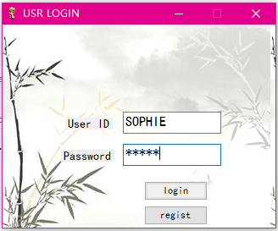

#### 2. Register:

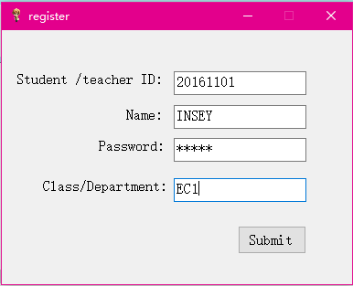

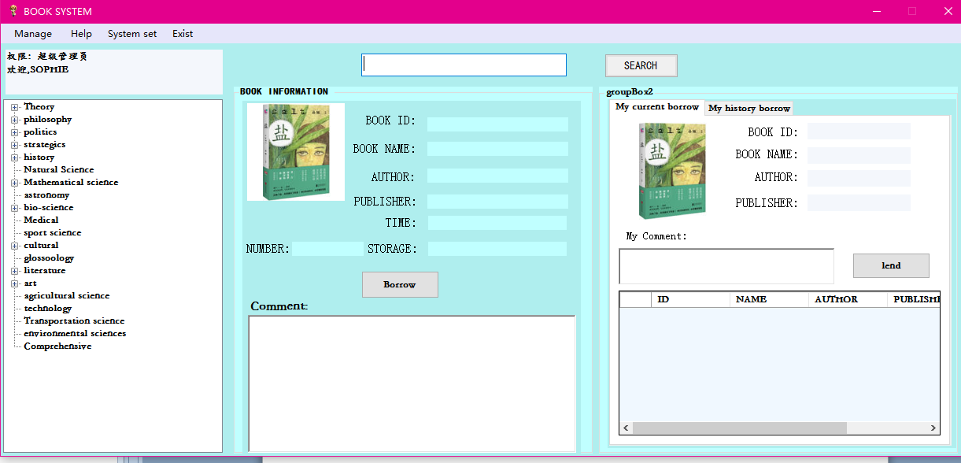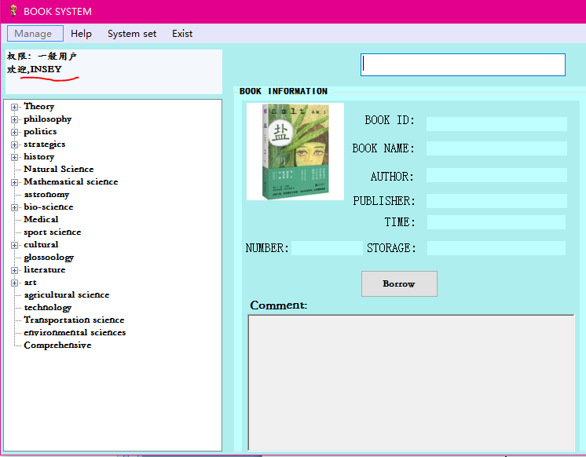

#### 3.main form:

#### 4.Book type navigator

（on the left ,we can look the types of books。If we choose one of the books, on the right ,it will display details of the book）:

#### 5.Borrow books

(click borrow button ,we can borrow books that we want to, and on the right My current borrow will display our borrowing )

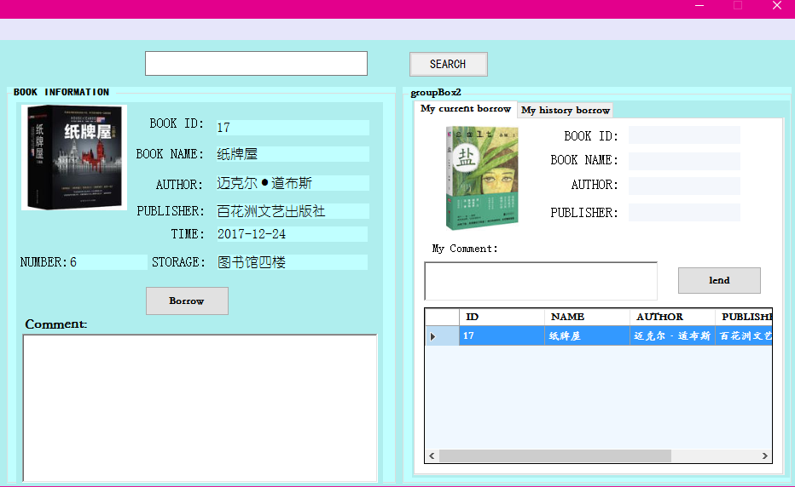

#### 6.Lend books:

( click the lend button, we can lend the book that we choosing, and we can also write our comments about the book)

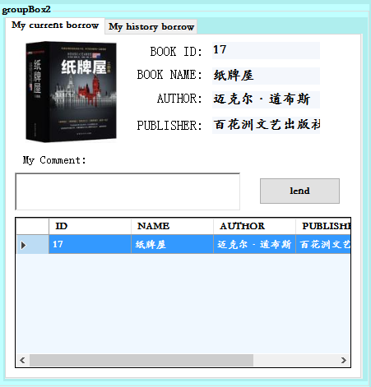

#### 7.Look the history record of our borrow:

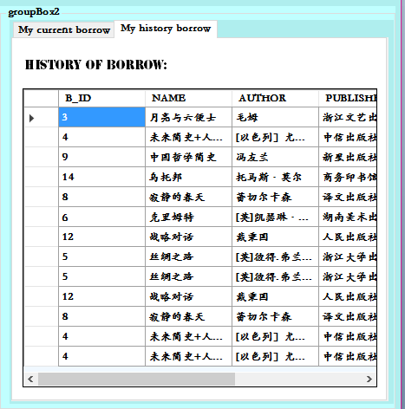

#### 8.Search books:

**(**Enter the key words ,it will can find all records of books about the key words **)**

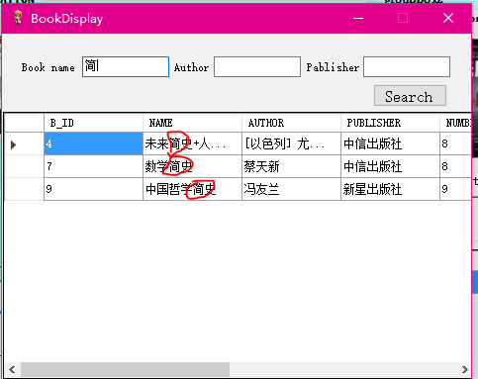

#### 9.Manage books:

(we can add ，delete，change ,search books but only accept manager Sophie)

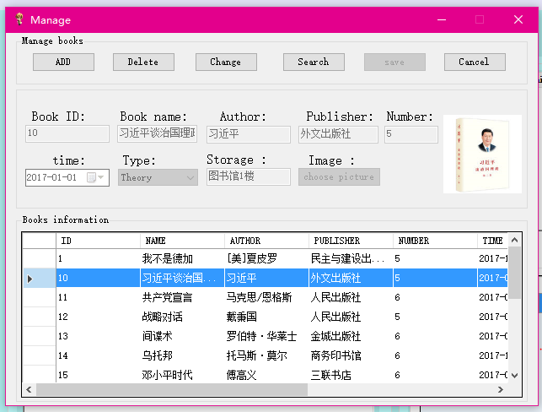

Plagiarism Declaration: I confirm that this report is my own work. I acknowledge that coping  
someone else's report will result a zero scoring for entire lab assignment.  
Name:____________________________