introduction to robotics: isat
  - SUBTASK 1: CONFIGURATION 1 (LINE FOLLOW-UP ROBOT)
OBJECTIVE: Building a line-following robot (LFR) offers a valuable hands-on learning experience with practical applications. It fosters skills in robotics, programming, and problem-solving, preparing students for STEM careers. This project bridges theoretical knowledge with real-world implementation, enhancing students understanding of automation and control systems. Line Following robots also find practical use in industries like manufacturing and logistics, making it a relevant and engaging educational tool that equips students with skills applicable in a technologically driven world.
Below are the screenshots of the assembled chassis:
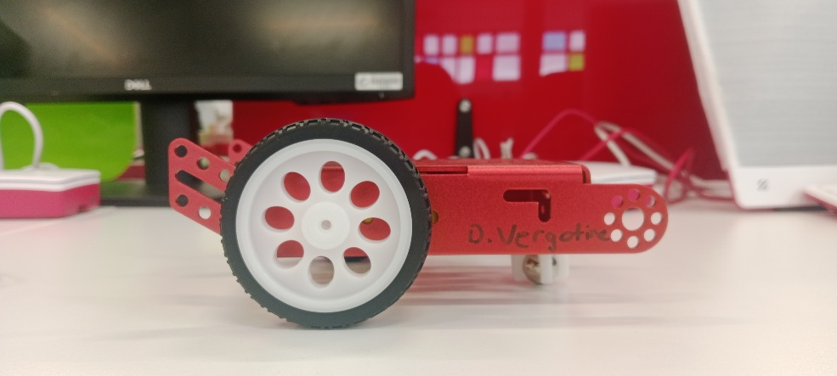
Figure 1: Right-View Follow_UP
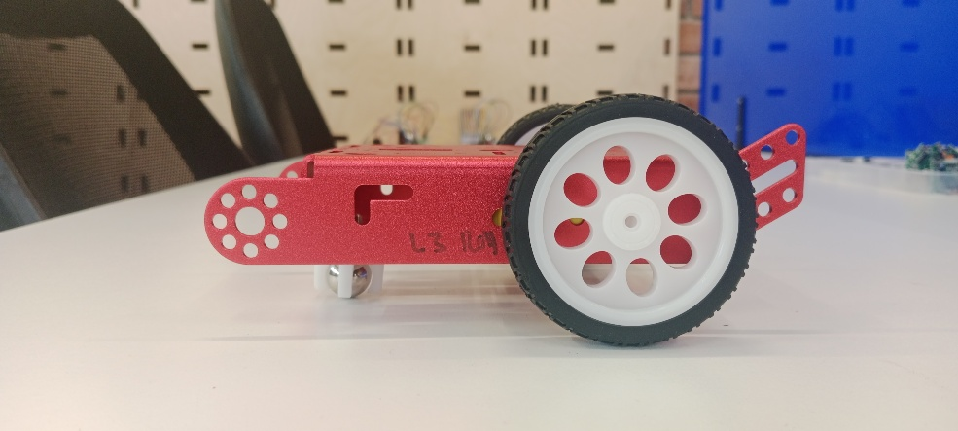
Figure 2: Left-View Follow_Up
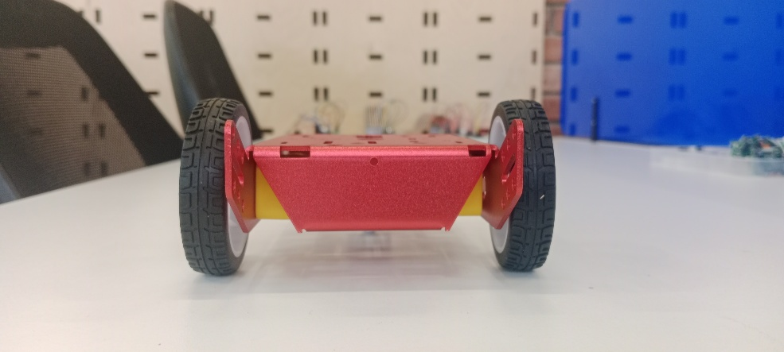
Figure 3: Rear-View Follow_Up

  - SUBTASK 2: FRITZING DESIGN CONFIGURATION
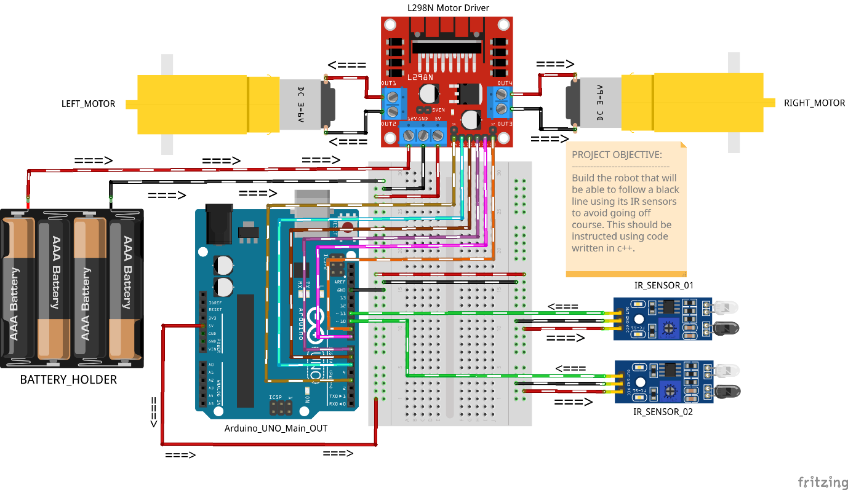
Figure 4: FOLLOW_UP CONFIGURATION
OBJECTIVE: Build the robot that will be able to follow a black line using its IR Sensors to avoid getting off course. This should be instructed using the code written with C++.

  - TABLE PIN CONFIGURATION BELOW:
PIN CONFIGURATIONS PLANNED OUT IN THIS TABLE NEEDS TO CORRESPOND WITH THE PHYSICAL CONNECTIONS OF THE OUTPUT.
COMPONENT | CONFIGURATION PIN | DESCRIPTION_OUT | ARDUINO_PINOUTIN
Left IR Sensor | OUT | Use this component to detect the left lane | PIN D10
 | VCC | Use this to supply power | 5V
 | GND | transmit this to ground | GND
RIGHT IR Sensor | OUT | Use this component to detect the right lane | PIN D11
 | VCC | Use this to supply power | 5V
 | GND | transmit this to ground | GND
L298N Motor Driver | ENA | This will control the left motor speed | D3 (PWM)
 | IN1 | LEFT_MOTOR_DIR | D4
 | IN2 | LEFT_MOTOR_DIR | D6
 | IN3 | RIGHT_MOTOR_DIR | D7
 | IN4 | RIGHT_MOTOR_DIR | D8
 | ENB | This will control the right motor speed | D9 (PWM)
DC_LEFT_MOTOR | Terminals_+_- | Connected to Motor Driver | OUT1 & OUT2
DC_RIGHT_MOTOR | Terminals_+_- | Connected to Motor Driver | OUT3 & OUT4
HOLDER_BATT | POS_(+) | Supplying_power_main | L298N +12V (VIN)
 | NEG_(-) | CMN_GRND | L298N_GND
ARDUINO_UNO_MAIN | GND | CMN_GRND | L298N_GND

  - SUBTASK 3: ADDITIONAL COMPONENTS TO THE CHASSIS
Below the components required for this part of the robot to function:
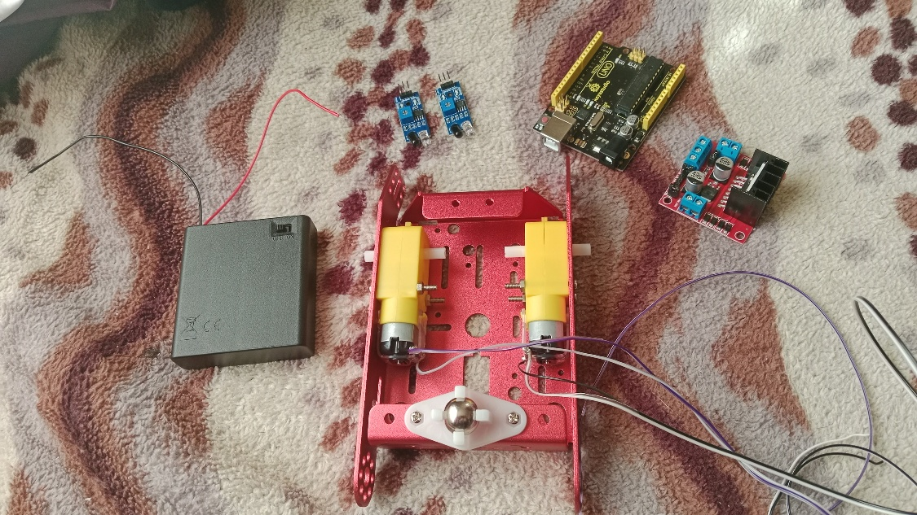
Figure 5: Electrical prerequisites
COMPONENTS NEEDED HERE:
- BATTERY_HOLDER: 4x 1.5V AA Batteries will be applicable for this build. Transferring voltage and current to our L298N motor driver module through its 12V socket.
- 2x IR Sensors: Useful for detecting non-reflective objects along the track. In this case, the black line located between the two sensors need to steer the robot based on which sensor detects it.
- Arduino Uno: The secret sauce in getting our motors and IR sensors to function using our Arduino IDE code written to the core to make this operate perfectly.
- L298N motor driver module: Useful to run the 2 TT DC motors. This will supply power to the motors through 3 cables for each connected to the Arduino. Voltage is transmitted between the driver and Arduino through a 5V connection as the Arduino is limited to 5V.
- 2x TT DC motors: Useful for moving our robot across the track. Wheels are attached to it along with a metal ball in the front.
FULL BUILD REVIEW BELOW:
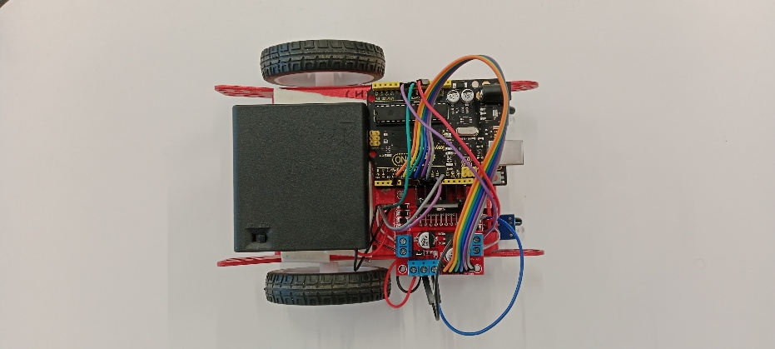
Figure 6: TOP-VIEW PERSPECTIVE

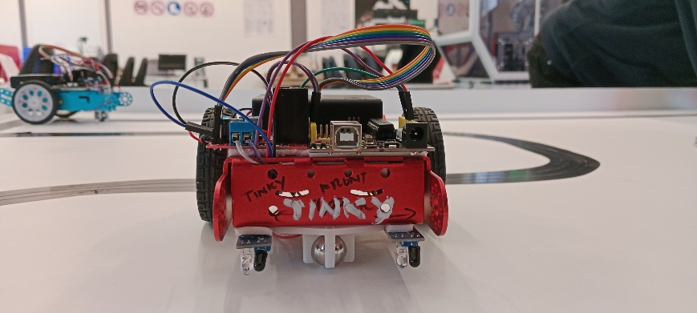
Figure 7: FRONT-VIEW PERSPECTIVE

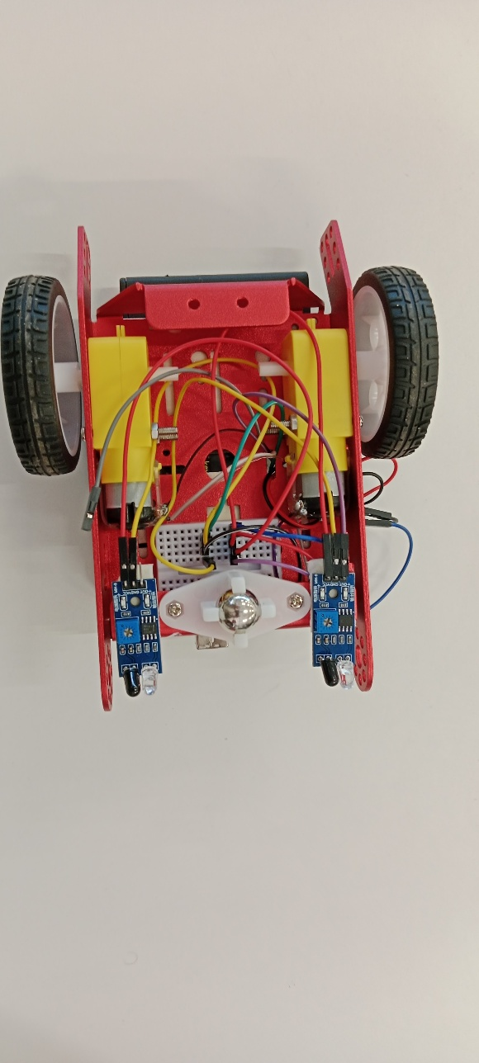
Figure 8: BOTTOM-VIEW PERSPECTIVE

  - SUBTASK 4: ARDUINO CODE WRITTEN TO THE CORE
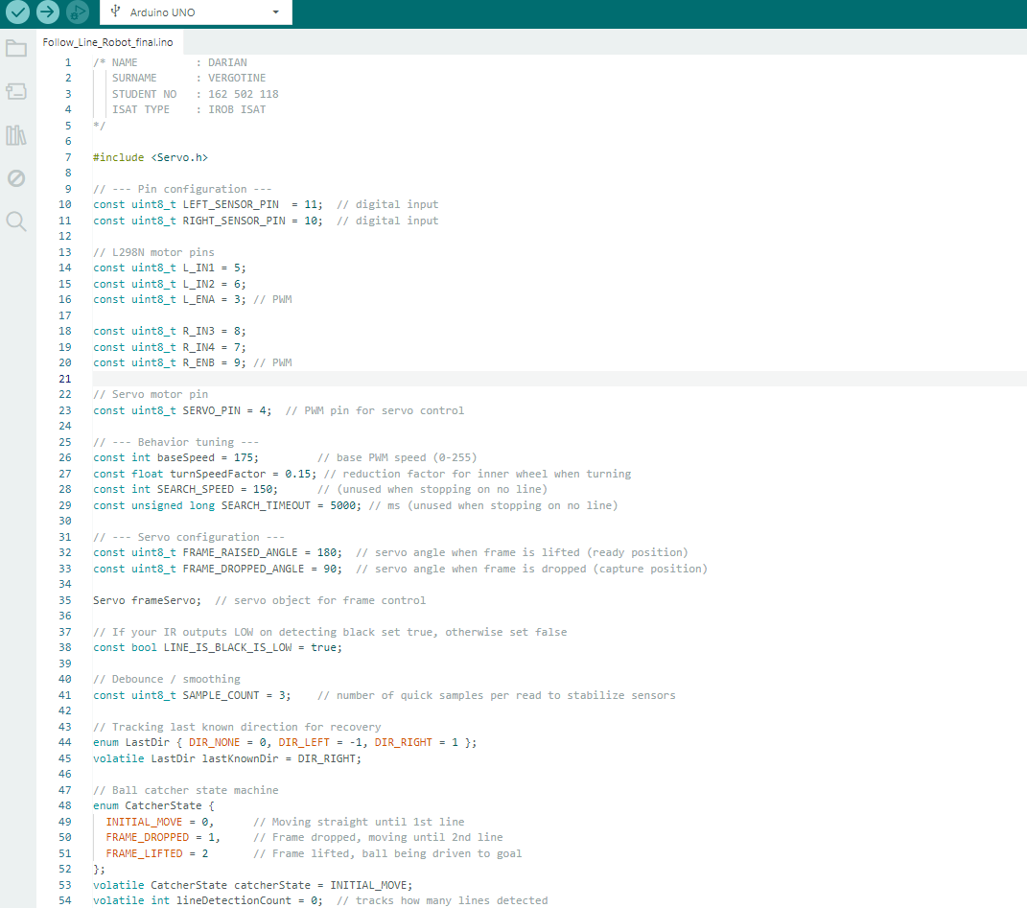
Figure 9: Initializing the components and variables
CODE DESCRIPTION:
- Global constants define pins, speeds, servo angles, sensor sampling, and a boolean (LINE_IS_BLACK_IS_LOW) used to normalize IR sensor polarity. Two enums track the last-known direction and a three-state catcher state machine (INITIAL_MOVE → FRAME_DROPPED → FRAME_LIFTED). A Servo object controls the catcher frame.

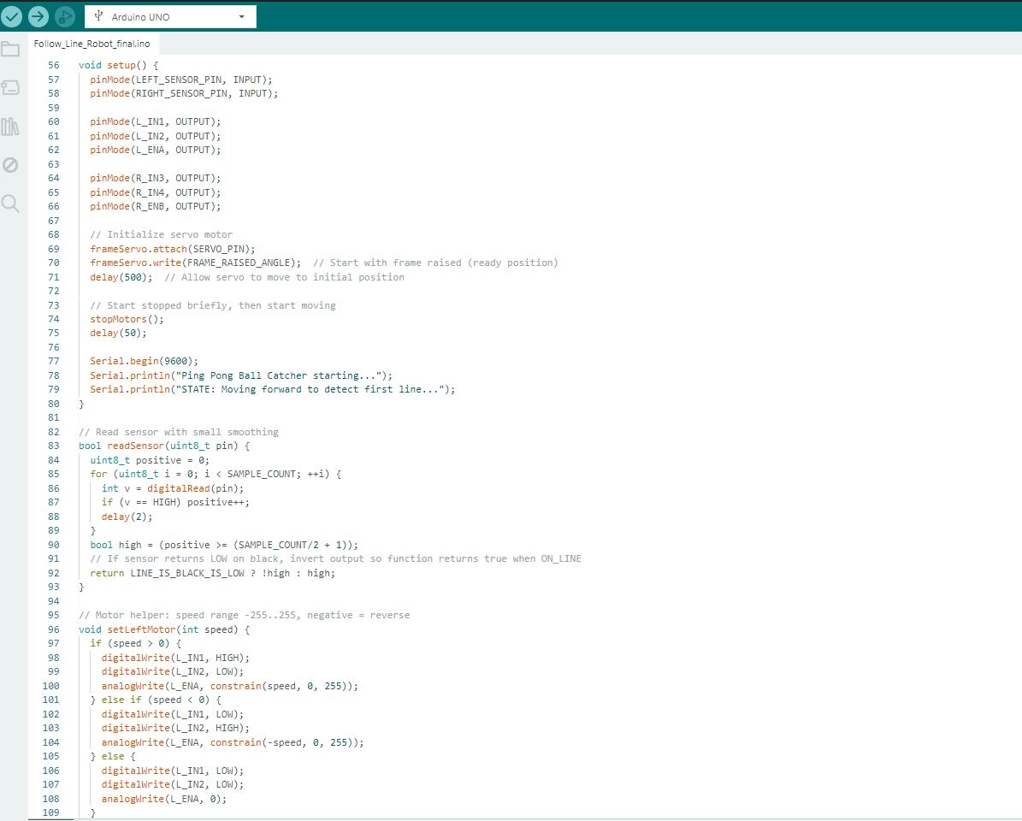
Figure 10: Boolean expressions
CODE DESCRIPTION:
- readSensor(pin) samples a digital IR input SAMPLE_COUNT times with tiny delays, counts HIGH readings, and computes a stable boolean. It then inverts the result when sensors output LOW on black so callers always get true = "on the line." That provides debounce/smoothing and a polarity abstraction.
- setLeftMotor(speed) and setRightMotor(speed) accept signed speeds; positive drives forward, negative reverses, zero brakes by disabling both inputs. They manipulate the L298N direction pins and analogWrite the EN PWM pin with a constrained magnitude (0–255). stopMotors() and drive(left,right) are simple helpers that stop or set both motors.
- setup() configures I/O, attaches the servo and moves it to the raised (ready) angle, briefly stops, and prints startup messages.

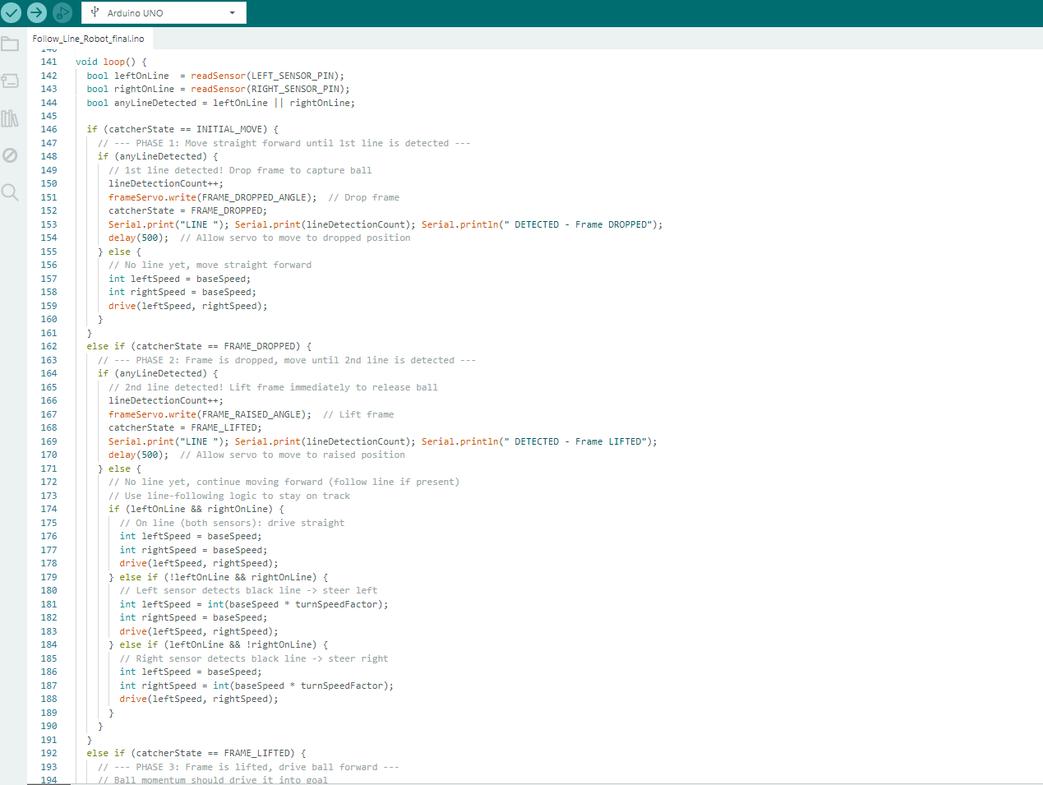
Figure 11: Void Loop Encounter
CODE DESCRIPTION:
- loop() implements the catcher state machine. In INITIAL_MOVE the robot drives straight until either sensor detects a line, increments lineDetectionCount, drops the frame and enters FRAME_DROPPED. In FRAME_DROPPED it follows the line using a simple two-sensor differential rule: both sensors → straight; left-only → steer right (reduce inner wheel by turnSpeedFactor); right-only → steer left similarly.
- When another line is detected it raises the frame and enters FRAME_LIFTED. In FRAME_LIFTED it continues line following to drive the ball to the goal and stops motors if both sensors lose the line, printing completion. Small delays after servo moves allow mechanical settling; a short loop delay prevents overly tight polling. Overall the code is structured for robustness (sampling/inversion) and simple proportional turning via reducing the inner wheel speed rather than full pivoting.

  - SUBTASK 5: FINAL LFR TRACK RUN TEST
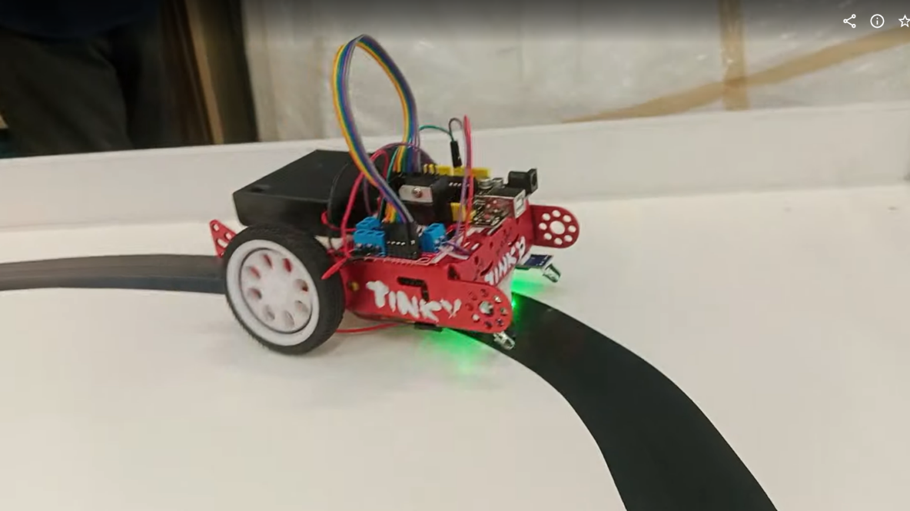
Figure 12: FINAL ASSEMBLY (LFR)
- The robot has been assembled together with the necessary components to run the track. After a few failed attempts to accomplish the task, the robot (TINKY) finally managed to complete a full checkpoint track flawlessly. Important to note that every turn on the track represents a checkpoint.
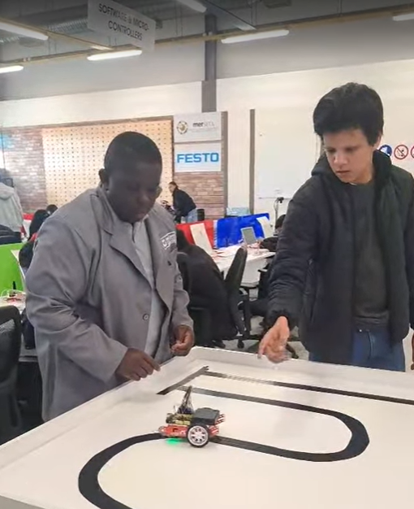
Figure 13: Myself and a lecturer testing the track
- Above is an image of myself and one of my lecturers doing the final track test as evidence that robot works successfully and that the build is my own.

