PING PONG BALL CATCHER
  - SUBTASK 6: 3D DESIGN & MODIFICATION
PLACE SCREENSHOT OF THE TINKERCAD WITH YOUR FRAME DESIGN IN IT.
(TAKE A SCREENSHOT OF THE SOFTWARE YOU USED TO DESIGN YOUR 3D FRAME, MAKE SURE THE MODEL IS VIRTAULLY PRESENT WHEN TAKING THE SHOT.)
EXAMPLE:
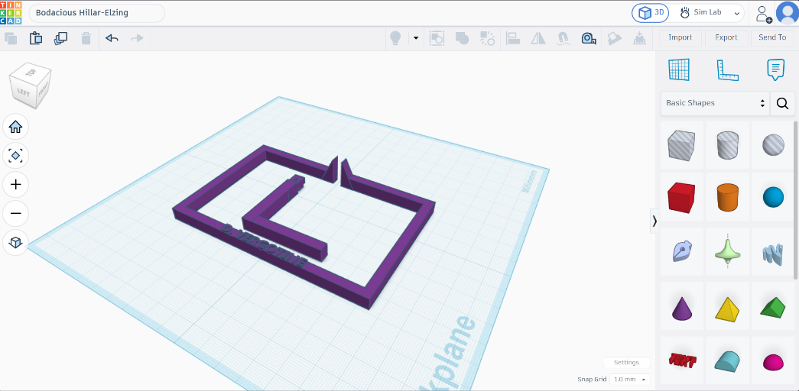
Figure 11: 3D DESIGN PART 1
PLACE SCREENSHOT OF THE ORCA SLICER SOFTWARE HERE WITH YOUR 3D SLICED DESIGN IN IT. (REPLACE TEXT WITH IMAGE)

Figure 12: 3D DESIGN PART 2

  - SUBTASK 7: CONSTRUCTION OF PING PONG BALL CATCHER
PLACE TOP VIEW IMAGE OF YOUR PING PONG BALL CATCHER HERE WITH ADDITIONAL COMPONENTS (SERVO AND FRAME ADDED)

Figure 13: TOP VIEW (PPBC)
PLACE FRONT VIEW OF YOUR PING PONG BALL CATCHER HERE WITH ADDITIONAL COMPONENTS (SERVO AND FRAME ADDED)

Figure 14: FRONT VIEW (PPBC)
PLACE SIDE VIEW OF YOUR PING PONG BALL CATCHER HERE WITH ADDITIONAL COMPONENTS ADDED (SERVO AND FRAME ADDED)

Figure 15: SIDE VIEW (PPBC)

  - SUBTASK 8: BREADBOARD DESIGN MODIFICATION (FRITZING)
PLACE YOUR SCREENSHOT OF THE MODIFIED FRITZING DESIGN HERE.
ENSURE THAT THE WIRES ARE NOT CROSSING OVER TOO MUCH AND MAKE SURE THE PULSE OF THE SERVO IS CONNECTED TO PWM PIN ON ARDUINO.
YOU CAN CHANGE THIS PAGE TO LANDSCAPE IF YOU WANT

Figure 16: MODIFIED FRITZING DESIGN

COMPONENT | CONFIG | DESCRIPTION | ARDUINO PIN
Left IR Sensor | OUT
 | VCC
 | GND
RIGHT IR Sensor | OUT
 | VCC
 | GND
L298N Motor Driver | ENA
 | IN1
 | IN2
 | IN3
 | IN4
 | ENB
LEFT MOTOR | TERMINALS
RIGHT MOTOR | TERMINALS
BATTERY | POSITIVE
 | NEGATIVE
ARDUINO UNO | GROUND
SERVO MOTOR (SG90) | VCC
 | GND
 | PULSE (PWM)

  - SUBTASK 9: FINAL CODE TESTING
SCREENSHOT THE TOP PART OF YOUR CODE.
THIS IMAGE FOR THE COMMENTS SPECIFICALLY.

Figure 17: CODE WITH COMMENTS
SCREENSHOT THE VARIABLE DECLARATIONS PART OF YOUR CODE ONLY.

Figure 18: VARIABLE DECLARATIONS
SCREENSHOT THE SERVO CONTROL PART OF YOUR CODE ONLY.

Figure 19: SERVO CONTROL PART
SCREENSHOT THE SETUP FUNCTIONS PART OF YOUR CODE ONLY

Figure 20: CODE WITH COMMENTS
SCREENSHOT THE USER-DEFINED FUNCTIONS DEFINITIONS HERE ONLY.

Figure 21: CODE WITH USER-DEFINED FUNCTIONS DEFINITIONS
SCREENSHOT THE LOOP FUNCTIONS.

Figure 22: CODE WITH LOOP FUNCTIONS.
SCREENSHOT THE CAPTURE AND RELEASE LOGIC HERE ONLY.

Figure 23: CODE WITH CAPTURE AND RELEASE LOGIC HERE.

  - SUBTASK 10: COMPETITION
PLACE IMAGE HERE OF THE ROBOT STARTING THE TRACK (START LINE)

Figure 24: START LINE SCREENSHOT
PLACE IMAGE HERE OF THE ROBOT AT THE FIRST BLACK LINE (FIRST STOP).
THIS IS WHERE THE BALL IS CAPTURED.

Figure 25: FIRST STOP SCREENSHOT (CAPTURED)
PLACE IMAGE HERE OF THE ROBOT AT THE SECOND BLACK LINE (SECOND STOP) THE BALL IS RELEASED

Figure 26: SECOND STOP SCREENSHOT
PLACE IMAGE HERE OF THE BALL HAS REACHED THE GOAL NET (BALL RELEASED)

Figure 27: GOAL SCREENSHOT

