Lithium – Casino Provider - Roxor

**Solution Overview**

**Prepared By:** Richard Flamengo

PlaySafeSA

**Contents**

Document History 2

Approval List 2

Distribution List 2

Related Documentation 2

Overview 3

Service Casino Provider Roxor – API Breakdown 4

Data Model 6

Document Control

# Document History

|  |  |  |
| --- | --- | --- |
| **Revision Number** | **Revision Date** | **Change Summary** |
| 0.1 | 2020-09-30 | Initial Overview |
|  |  |  |
|  |  |  |

# Approval List

|  |  |  |  |
| --- | --- | --- | --- |
| **Name** | **Title / Role** | **Date** | **Signature** |
|  |  |  |  |
|  |  |  |  |

# Distribution List

|  |  |  |
| --- | --- | --- |
| **Name** | **Title / Role** | **E-Mail** |
|  |  |  |
|  |  |  |
|  |  |  |

# Related Documentation

|  |  |  |  |  |  |
| --- | --- | --- | --- | --- | --- |
|  | **Document Name** | **Revision** | **Revision Date** | **Author** | **Comments** |
| **1** | Roxor RGP Integration API - Version 2.1.0-GA, 26 November 2019.pdf |  |  |  |  |
| **2** |  |  |  |  |  |
| **3** |  |  |  |  |  |
| **4** |  |  |  |  |  |

# **Overview**

The aim of the project is to enable Lithium as a Player and Wallet provider to Roxor Casino Games, this is achieved by exposing a specific set of Rest Controller API’s to be consumed by the RGP (Roxor Gaming Platform) as well as the Player FrontEnd Website.

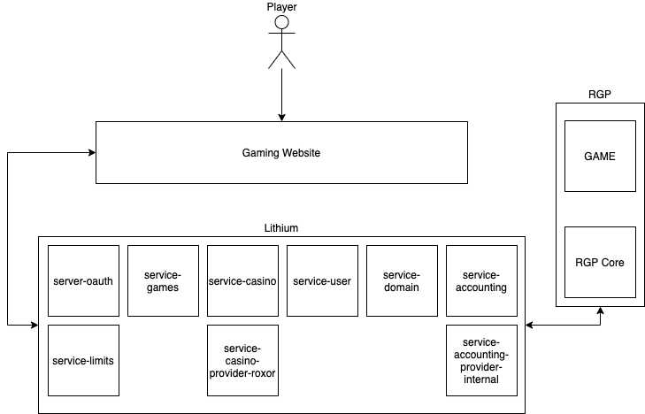

Figure 1: **Solution Overview**

|  |  |
| --- | --- |
| Component | Description |
| Gaming Website | The website the player will be making use of to login, deposit / withdraw funds, visit a lobby page and select a game to play |
| server-oauth | Used by Gaming Website to authenticate the player – https://<server:port>/server-oauth2/token |
| Service-games | Used be lithium to store the games and enable / disable them per domain.  Used by the Gaming Website to query a list of games to display in the lobby.  Used by the Gaming Website to retrieve the game url to embed in iFrame.  Service-Games is also aware of the provider providing the game (currently adding a game is done via postman but there is a WIP livescore ticket LIVESCORE-810 to support this from UNA) |
| Service-casino | Used by lithium for casino processing, interacts with service-accounting to balance retrieval and bet processing. |
| Service-user | Used by lithium to store players and their related login events data which has been enhanced to support an additional session-key which correlates between the Gaming Website, Lithium and RGP. This component was also enhanced to support additional queries relating to the session-key to cover validation scenarios. |
| Service-domain | Used by lithium to store domain specific information including Default Country and Currency which relates to the RGP game. This component also stores the service-casino-provider-roxor configuration properties. |
| Service-accounting | Acts as the main proxy for all accounting transactions for Lithium to a configured accounting provider, by default this is set to provider-internal. |
| Service-accounting-provider-internal | Used by lithium to process all accounting related transactions. |
| Service-limits | Used by the service-casino-provider-roxor component for validation of player limits linked to gameplay. |
| Service-casino-provider-roxor | Component supports service-casino and service-games as the provider of certain lithium functions such as game-start URL retrieval requests from the gaming website and also acts as the translation layer between Lithium and RGP. |
| RGP Core | RGP Core communicates and retrieves all events between the RGP Game and lithium. |
| RGP Game | RGP Game selected by the player and opens via a Roxor wrapped within the gaming website iFrame. |

# **Service Casino Provider Roxor – API Breakdown**

|  |  |
| --- | --- |
| API | Description |
| Authenticate Player | Used by RGP to authenticate a player within a game.  Interacts with   * service-user to retrieve lastLoginEvent for the SessionKey provided * Service-domain (providerConfig) to retrieve all provider config properties required for validation |
| Balance | Used by RGP to retrieve the balance of a player to be displayed within the Game  Interacts with   * service-user to retrieve lastLoginEvent for the SessionKey provided * Service-domain (providerConfig) to retrieve all provider config properties required for validation, the domain is also retrieved from the cache * service-casino to extract the balance of a player, service-casino in turn interacts with service-accounting which in turn retrieves the information from service-accounting-provider-internal |
| Check Transfer | Used by RGP to retrieve details from a game-play event transfer.  Interacts with   * service-user to retrieve lastLoginEvent for the SessionKey provided * Service-domain (providerConfig) to retrieve all provider config properties required for validation |
| Start Game | Used by service-games which in turn is used by the Gaming website to retrieve the game load url by means of a redirect view for a selected game which is provided by Roxor. Demo game would return a Roxor game on GUEST mode indicating demo vs CASH mode which feeds of an authenticated players wallet.  Interacts with   * service-user to retrieve lastLoginEvent for the SessionKey provided * service-domain (providerConfig) to retrieve all provider config properties required to be passed as URL Parameters to the Roxor game wrapper for the game to load and function accordingly. * Service-domain domain is also retrieved to extract the currency and country code linked to the default country of the domain. |
| Rewards – GrantReward | Used by RGP to inform Lithium to create a new bonus (reward / free spin etc) to a specific player as a result of a Daily Free Game (DFG) win.  **only the shell is implemented at this stage – business service to be completed depending on the final design, for go-live this appears to be out of scope** |
| Rewards - GetRewards | Used by RGP as part of the game load function to query against lithium if there are any rewards that RGP can grant to the player.  **only the shell is implemented at this stage – business service to be completed depending on the final design, required for go-live** |
| Progressive – ByGame | RGP has the concept of shared JackPot games labelled progressive games, this query will be used by these games to query the jackpot bonus associated to the specific game.  **only the shell is implemented at this stage – business service to be completed depending on the final design, for go-live this appears to be out of scope** |
| Progressive – ByWebsite | RGP has the concept of shared JackPot games labelled progressive games, this query will be used by to query all the jackpot bonus associated to the specific website.  **only the shell is implemented at this stage – business service to be completed depending on the final design, for go-live this appears to be out of scope** |
| Game Play | RGP uses this service to publish game play events to Lithium for all spins and rounds executed by the player these include the following   * START – indicates start of the round * FINISH – indicates the end of the round * TRANSFER (DEBIT) – indicates a debit to the players account (BET) * TRANSFER (CREDIT) – indicates a credit to the players account (WIN) * TRANSFER (JACKPOT_CREDIT) – indicates a large credit to the players account (JACKPOT_WIN) * CANCEL_TRANSFER – indicates the rolling back of a TRANSFER (DEBIT) transaction. * ACCRUAL – indicates the CREDIT (increase) of a Jackpot wallet on a progressive game * CANCEL_ACCRUAL – indicates the rolling back of an ACCRUAL transaction. * FREE_PLAY – to be clarified, original assumption could be linked to REWARD free spins * CANCEL_FREE_PLAY – indicates the rolling back of a FREE_PLAY transaction.   Interacts with   * service-user to retrieve lastLoginEvent for the SessionKey provided, also verifies that the user is enabled * Service-domain (providerConfig) to retrieve all provider config properties required for validation, the domain is also retrieved from the cache * service-limits to validate the various loss limits linked to the player * service-game to retrieve the game definition * service-casino to process all wallet impacting events via the multiBetV1 interface which in turn interacts with service-accounting which in turn interacts with service-accounting-provider-internal for processing |

## **Data Model**

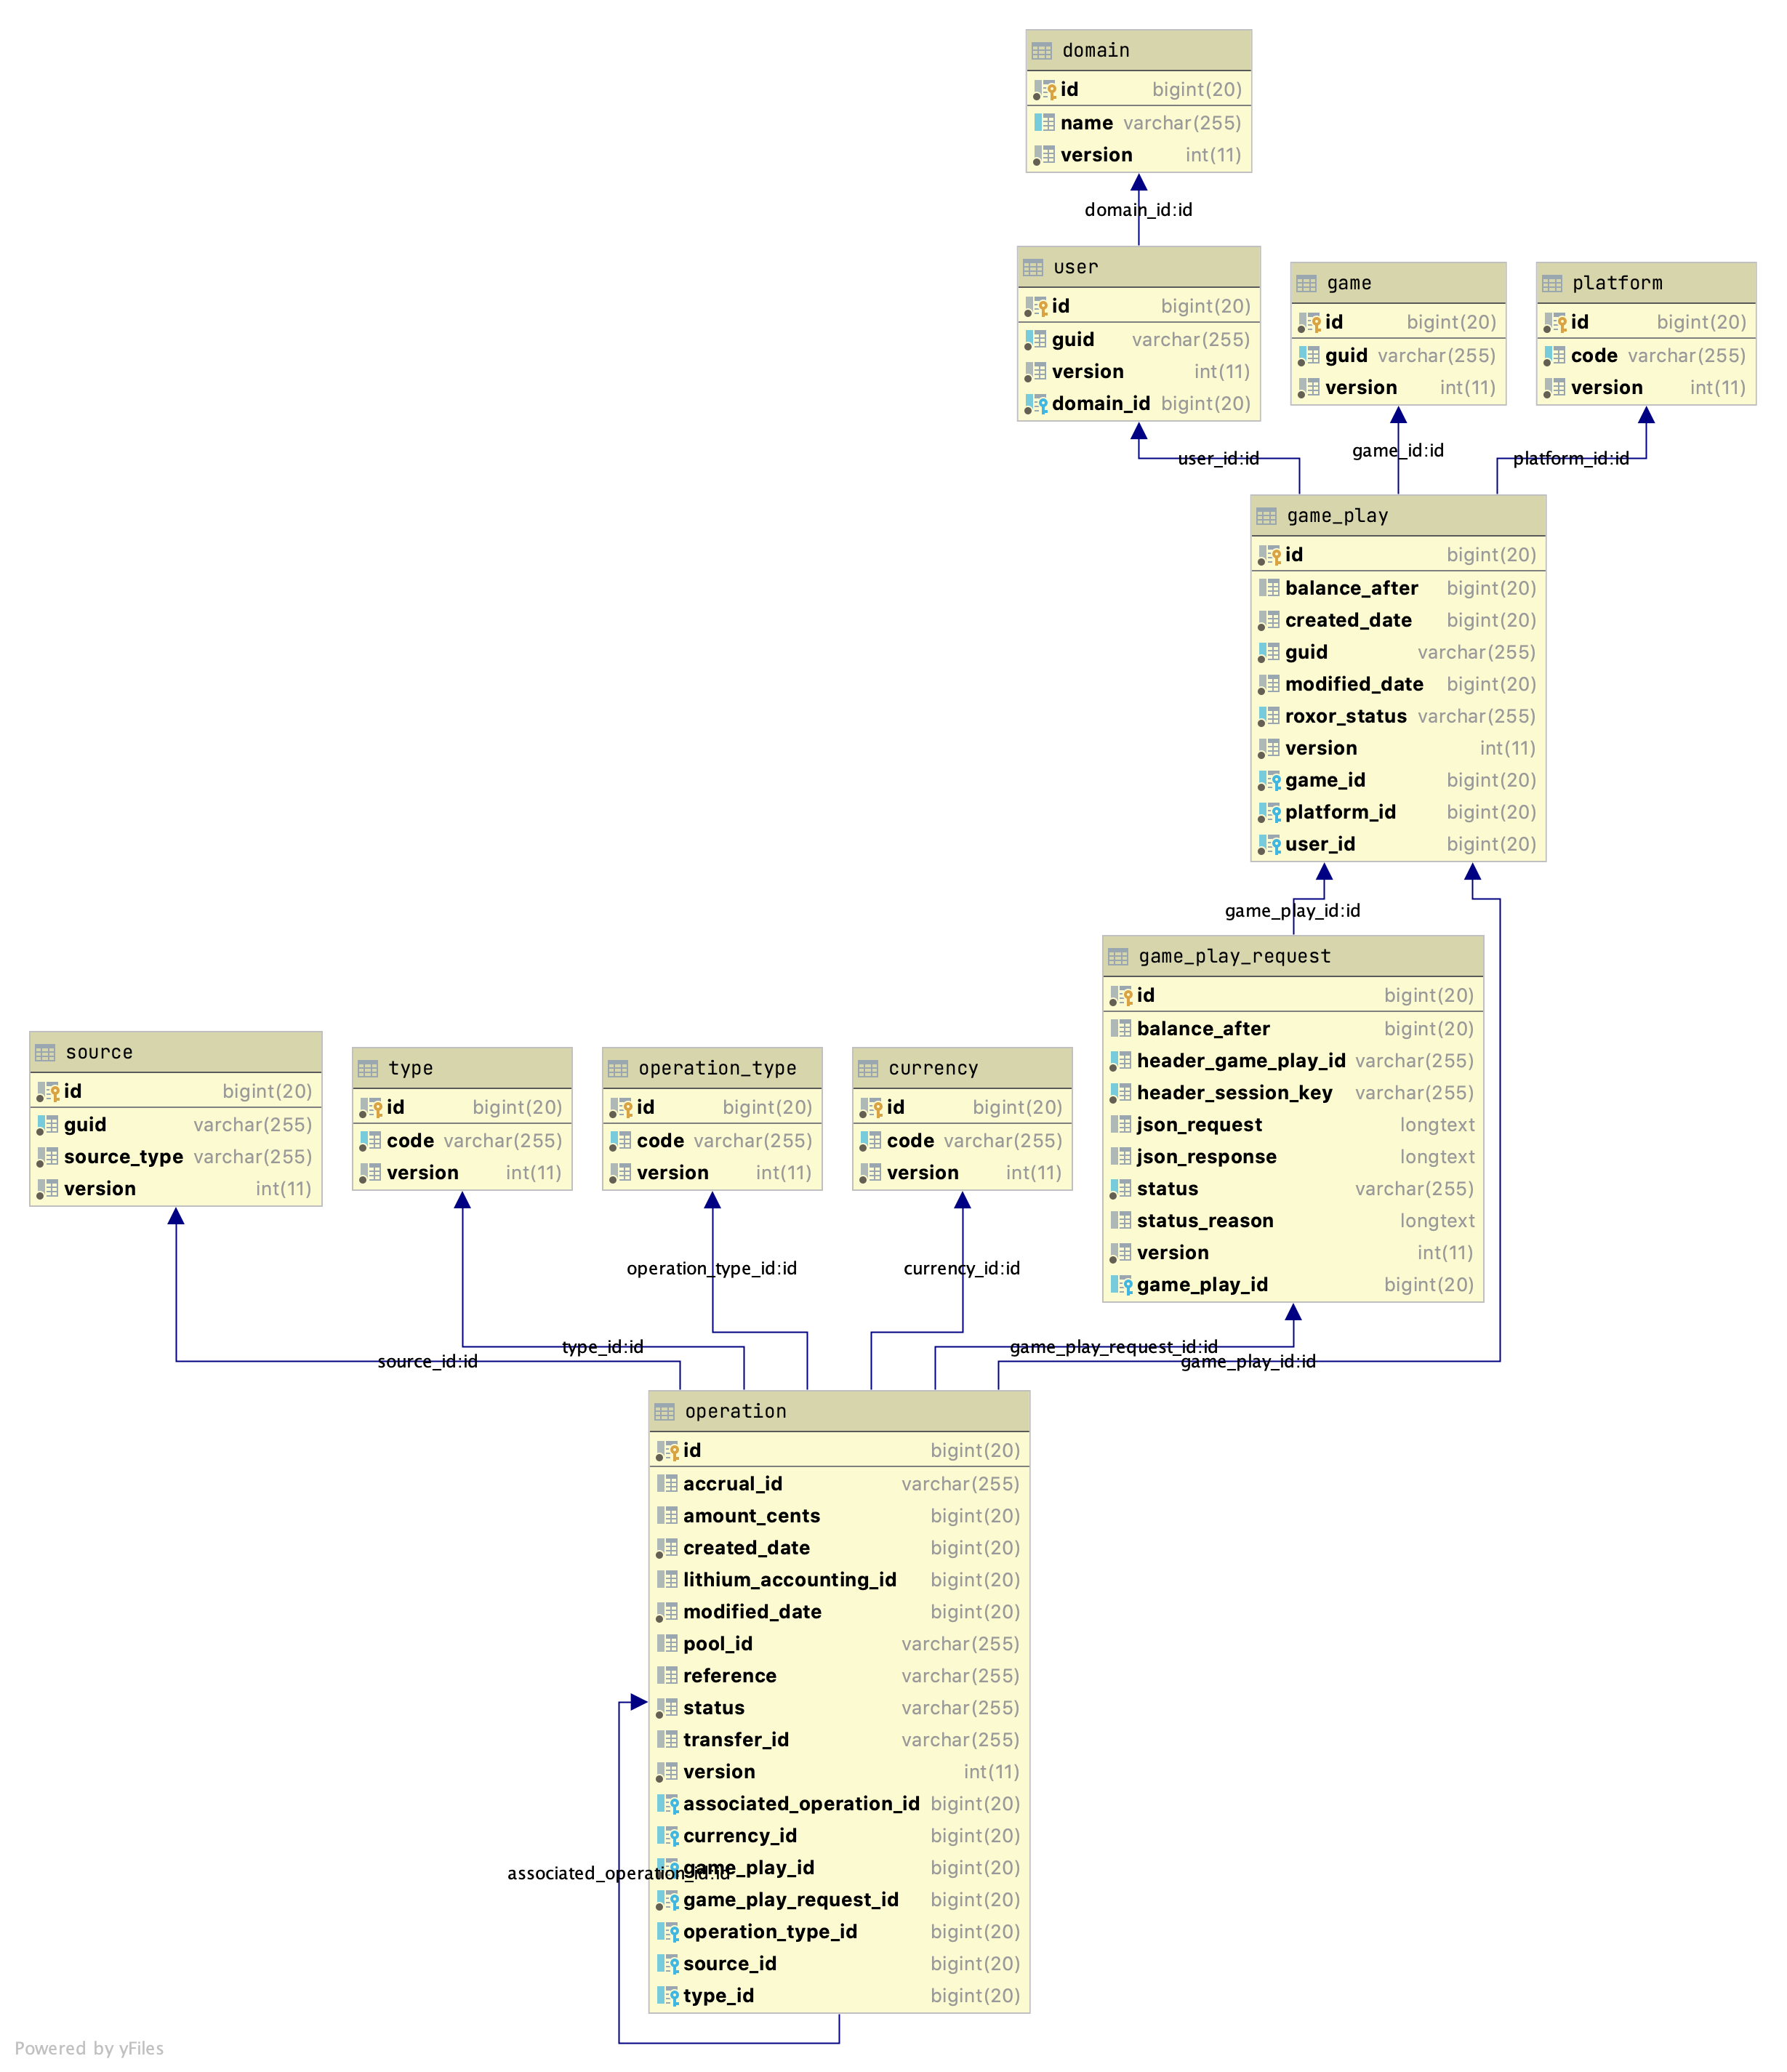

Figure 2: **Data Model Overview**

|  |  |
| --- | --- |
| Game Play Request  This table will contain all Game-Play requests initiated by RGP | |
| Column | Description |
| ID | PK ID for table |
| Version | Optimistic Locking version column |
| Created Date | Date time row was created in table |
| Modified Date | Date time row was last updated in table. |
| Balance After | Player balance after processing completed for the specific request. |
| Header game play id | Game Play ID supplied in the http header of the game-play call by RGP. |
| Header Session Key | Session Key supplied in the http header of the game-play call by RGP. |
| JSON Request | Original JSON Body received from RGP |
| JSON Response | JSON Body returned to RGP |
| Status | Status of the corresponding request   * CAPTURED – Indicates the request is captured and in progress * SUCCESS – Indicates the request has completed processing * ERROR – Indicates the request has resulted in an error |
| Status Reason | Error reason providing additional information as to why the request failed. |
| Game Play ID | Foreign Key (many to one) to GAME_PLAY Table |
| Game Play  Table used to store the unique Game Play event (Spin / Round) | |
| Id | Primary Key |
| Version | Optimistic Locking version column |
| Created Date | Date time row was created in table |
| Modified Date | Date time row was last updated in table |
| Balance After | Player balance after processing of the Round completed. |
| GUID | Unique game-play-id from RGP. |
| Roxor Status | Roxor specific round status   * STARTED – indicates the round is still open and more requests can be received for the round for processing relating to the game-play-id * FINISHED – indicates the round has completed and no more requests will be processed for the game-play-id. |
| Game Id | Foreign Key linked to the Game Table |
| Platform Id | Foreign Key linked to the Platform Table |
| User Id | Foreign Key linked to the User Table. |
| Operation  Table used to store each operation event within a game-play event associated to the game-play-request | |
| Id | Primary Key |
| Version | Optimistic Locking version column |
| Created Date | Date time row was created in table |
| Modified Date | Date time row was last updated in table |
| Accrual Id | Accrual operation event ID |
| Amount Cents | Amount in cents |
| Lithium Accounting ID | Lithium accounting transaction id returned from service-casino – multiBet interface |
| Pool Id | Accrual operation jackpot pool id |
| Reference | Optional reference information supplied by Accrual events |
| Status | Processing Status   * REQUESTED – Indicates the operation event has been captured due for validation and processing * PROCESSING – Indicates the operation passed validation and is being processed * RESULT – Indicates the operation completed processing as yielded a result * ERROR – Indicates an Error occurred, error reason will be provided on game play request table. * IGNORE – Indicates that the event will be ignored for processing (Transfer Cancel without corresponding Transfer) * DUPLICATE – Indicates that the event is a duplicate event and wont be processed again. |
| Transfer Id | Unique ID associated to Transfer / Cancel Transfer events |
| Associated operation id | FK Link to associated operation for the following cases   * CANCEL_TRANSFER -> Associated TRANSFER that is being cancelled * STATUS = DUPLICATE -> The event that resulted in this operation labelled as DUPLICATE * TRANSFER -> For cases where CANCEL_TRANSFER is received prior to the TRANSFER the TRANSFER event would need to be disallowed this will relate back to the CANCEL_TRANSFER event that caused the ERROR. |
| Currency Id | FK Link to Currency Table |
| Game Play Id | FK Link to the Game Play (Spin / Round) table |
| Game Play Request Id | FK Link to the Game Play Request table |
| Operation Type Id | FK Link to the Operation Type table |
| Source Id | FK Link to the Source Table |
| Type Id | FK Link to the Type Table |