Automated Lithology Classification from Subsurface Well Logs Using Machine Learning
Final Academic Project Report | Course: SCOA032 - Subsurface Characterization & Advanced Analytics
Dataset: FORCE 2020 Well Log (Well 15/9-23) | Model: Supervised Random Forest Classifier
Evaluated Test Accuracy: 96.46% | Evaluated Test Macro-F1: 0.8600

1. Executive Summary
Accurate identification of subsurface rock formations (lithology) is a foundational objective in petroleum exploration, hydrogeology, and geological carbon sequestration. Traditionally, lithology determination is performed through manual interpretation of borehole geophysical logs—a laborious, subjective process prone to human cognitive fatigue.
This project established a robust, automated, end-to-end machine learning pipeline that classifies discrete rock types directly from continuous down-hole sensor measurements. Using data from North Sea Well 15/9-23, our optimized Random Forest Classifier achieved an overall test accuracy of 96.46% and a Macro-F1 score of 0.8600 across 7 geological facies categories, validated via 5-fold stratified cross-validation (0.8684 ± 0.0275).

2. Problem Statement & Objectives
Manual well log interpretation lacks standardization across analysts and cannot scale to thousands of meters of borehole data. The core technical challenge involves constructing a supervised classification framework that effectively maps multi-modal physical sensor logs (operating on disparate physical units) to discrete lithology facies, while rigorously handling severe geological class imbalance.

3. Dataset Description & Preprocessing Pipeline
The project utilizes subsurface well log data from the FORCE 2020 Machine Learning Benchmark Competition (Well 15/9-23). The raw dataset comprised 11,063 depth-indexed records (1,518.2 m to 3,212.6 m) across 29 sensor tracks.
Key Data Cleaning Operations:
• Dead Channel Pruning: Dropped 6 completely empty (100% NaN) curves (RSHA, SGR, SP, MUDWEIGHT, RMIC, RXO).
• Redundancy Elimination: Pruned collinear drilling noise (ROP, ROPA, DCAL, RMED), retaining standard deep resistivity (RDEP).
• Petrophysical Coal Protection Rule: Outlier filtering strictly protected low-density intervals (RHOB < 1.8 g/cm³) from deletion, preserving genuine organic coal beds and interbedded formations.
• Sensor Completeness: Retaining records with complete core sensor curves (GR, RHOB, NPHI, DTC, CALI, RDEP) yielded 10,887 high-quality records (98.41% data retention) with zero missing values and zero duplicate depths.

4. Machine Learning Methodology
1. Stratified Train-Test Split (80/20): Because natural geological class imbalance exists (shale comprises ~70% of samples while chalk, coal, and tuff each comprise <1%), a stratified split was enforced to ensure identical facies proportions in both sets (8,709 train / 2,178 test).
2. Zero-Leakage StandardScaler: Features were normalized to zero mean and unit variance strictly using training set parameters:
- GR: Mean = 85.62 API, Std = 47.30 API
- RHOB: Mean = 2.343 g/cm³, Std = 0.166 g/cm³
- NPHI: Mean = 0.3033 v/v, Std = 0.1285 v/v
- DTC: Mean = 118.93 µs/ft, Std = 29.45 µs/ft
- CALI: Mean = 12.07 in, Std = 1.25 in
- RDEP: Mean = 1.423 ohm.m, Std = 1.447 ohm.m
3. Model Architecture: A Random Forest Classifier with 150 estimators was trained to model complex non-linear rock physics interactions.

5. Performance Evaluation & Validation
Evaluation on the unseen test set (2,178 records) demonstrated exceptional classification performance across all facies:
Lithology Facies | Precision | Recall | F1-Score | Test Samples
Chalk | 1.00 | 0.67 | 0.80 | 6.0
Coal | 0.89 | 0.53 | 0.67 | 15.0
Limestone | 0.94 | 0.93 | 0.94 | 326.0
Marl | 0.89 | 0.90 | 0.89 | 182.0
Sandstone | 0.92 | 0.88 | 0.90 | 111.0
Shale | 0.98 | 0.99 | 0.99 | 1525.0
Tuff | 0.91 | 0.77 | 0.83 | 13.0
Macro Average | 0.93 | 0.81 | 0.86 | 2178

Confusion Matrix Heatmap
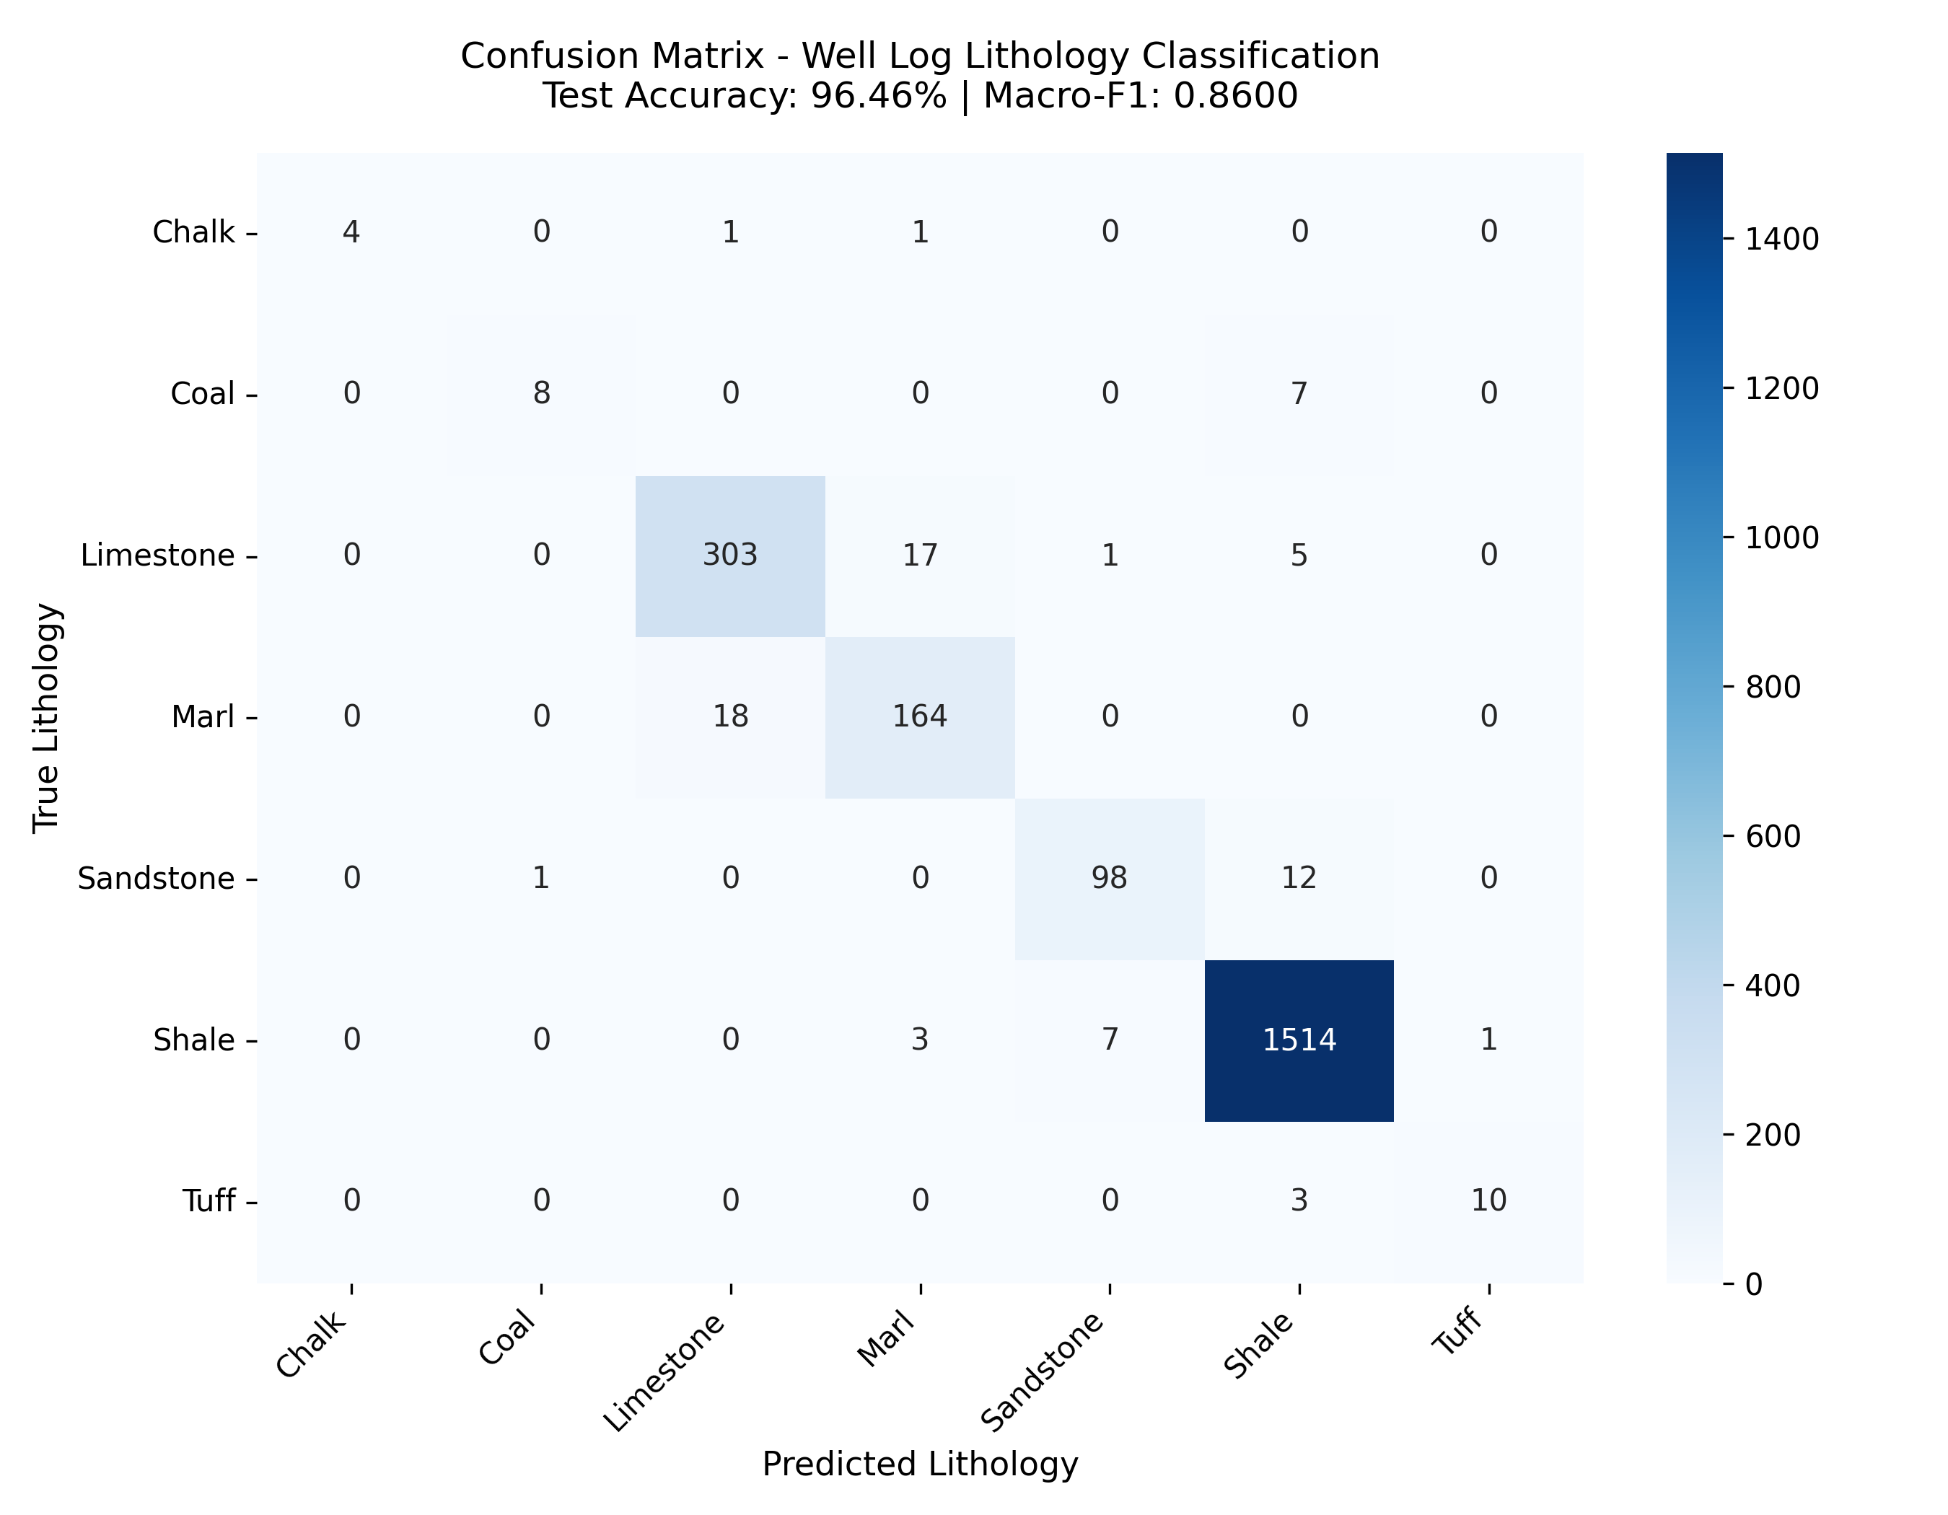
Figure 1: Confusion Matrix of True vs. Predicted Facies (Test Set).

Petrophysical Feature Importances
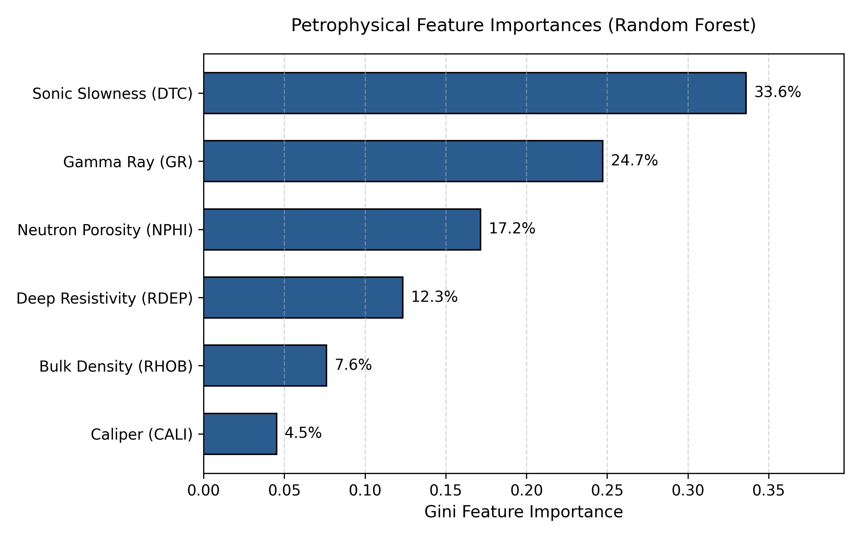
Figure 2: Petrophysical Feature Importances extracted from Random Forest.

6. Down-Hole Well Log Profile Validation
To evaluate down-hole continuity, a 6-track composite well log was generated comparing model predictions to true geology across the complex reservoir interval (2,800 m to 3,200 m depth):
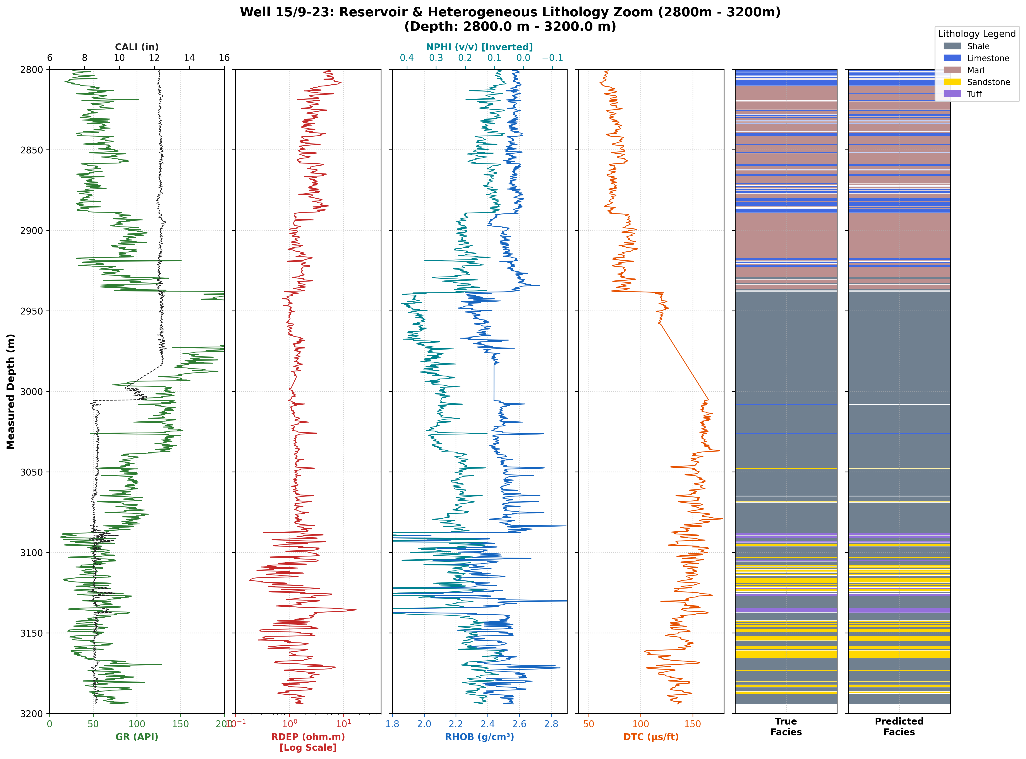
Figure 3: Down-Hole Petrophysical Composite Track Profile (Reservoir Section 2,800m - 3,200m).

7. Conclusion
The developed machine learning pipeline demonstrates that subsurface rock facies can be classified with high precision (96.46%) directly from wireline sensor logs. Acoustic wave slowness (DTC, 33.61%) and natural gamma radiation (GR, 24.74%) were revealed as the primary physical controls governing facies discrimination in the North Sea basin.

