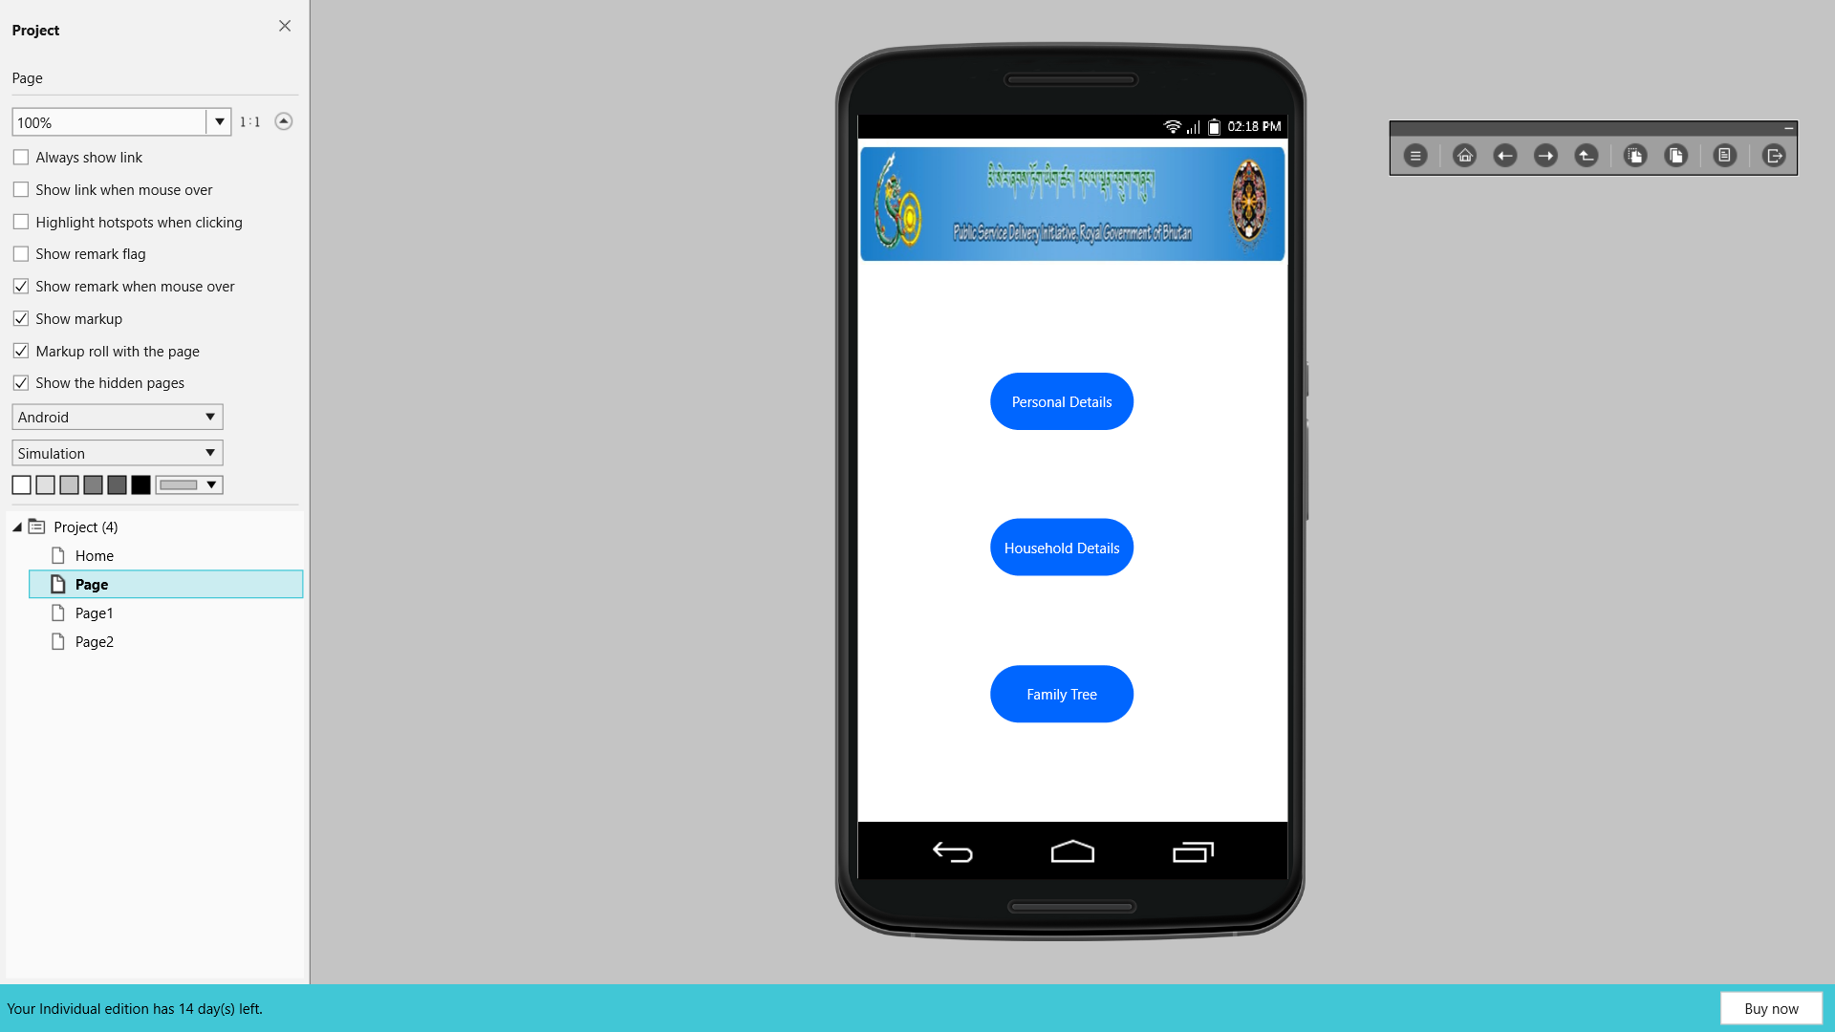
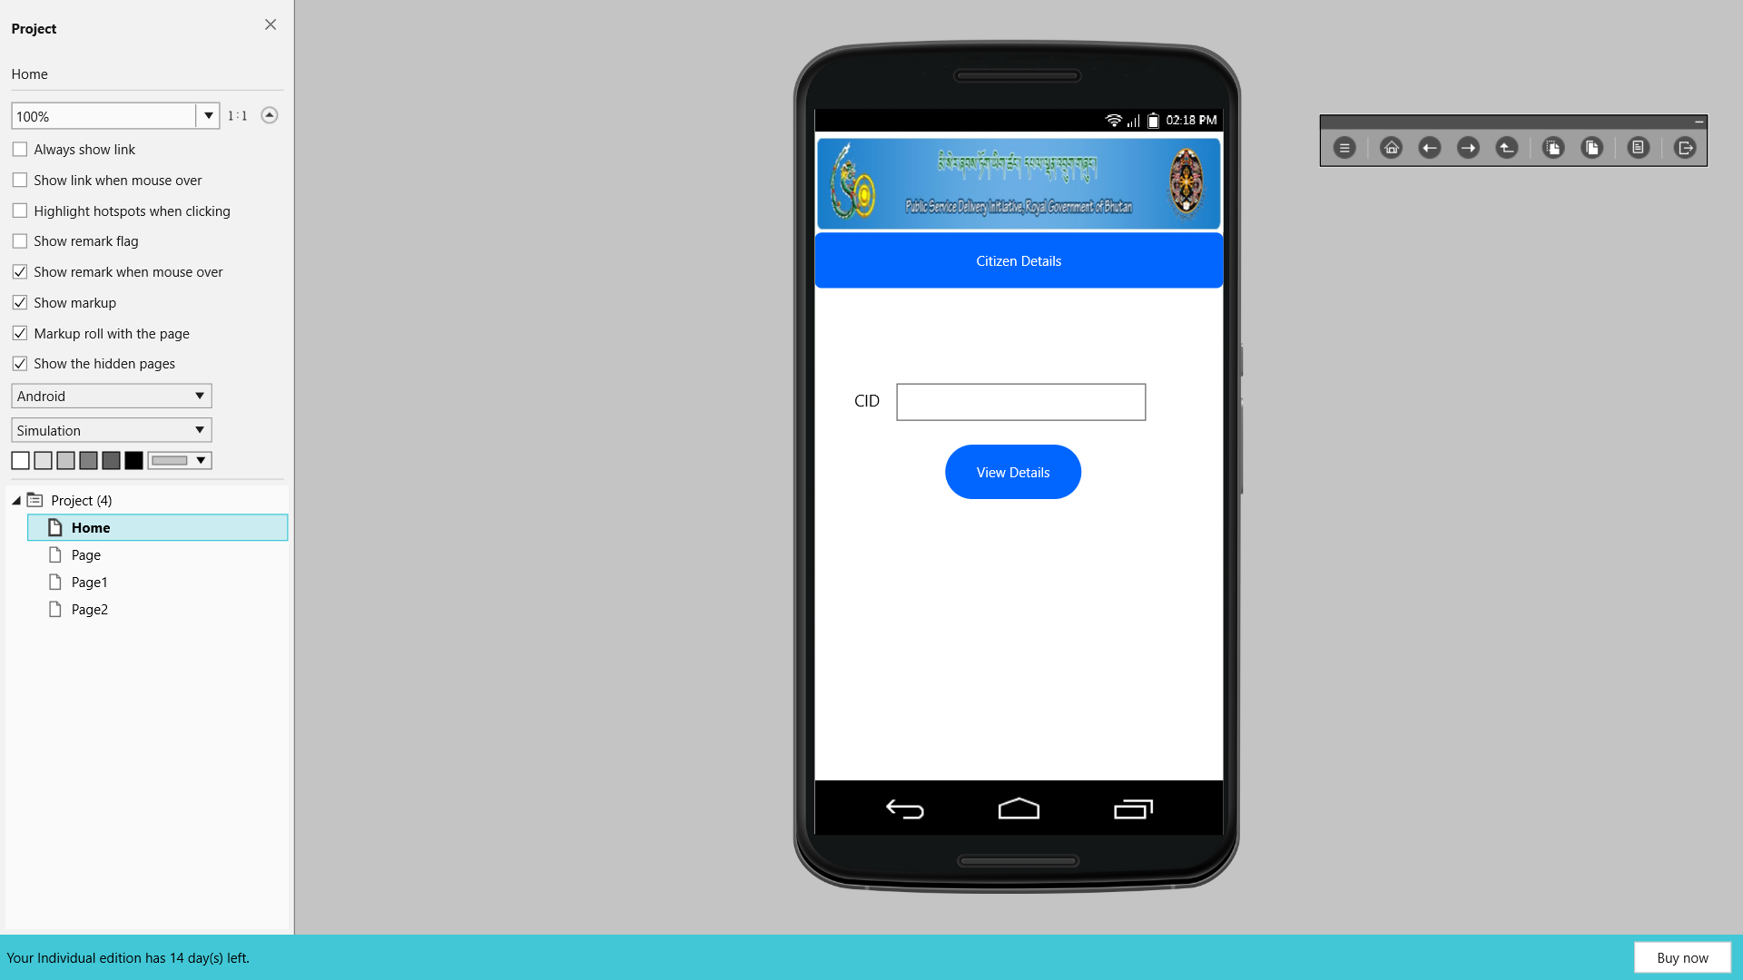
Prototype

1 .Home page
This is the home page where the user can view their details by entering their CID number. Once the user enters the CID number you can click on the view details view the details.

Once the user enters the CID number it will navigate to this page and here you can choose to view your personal details and the household details.

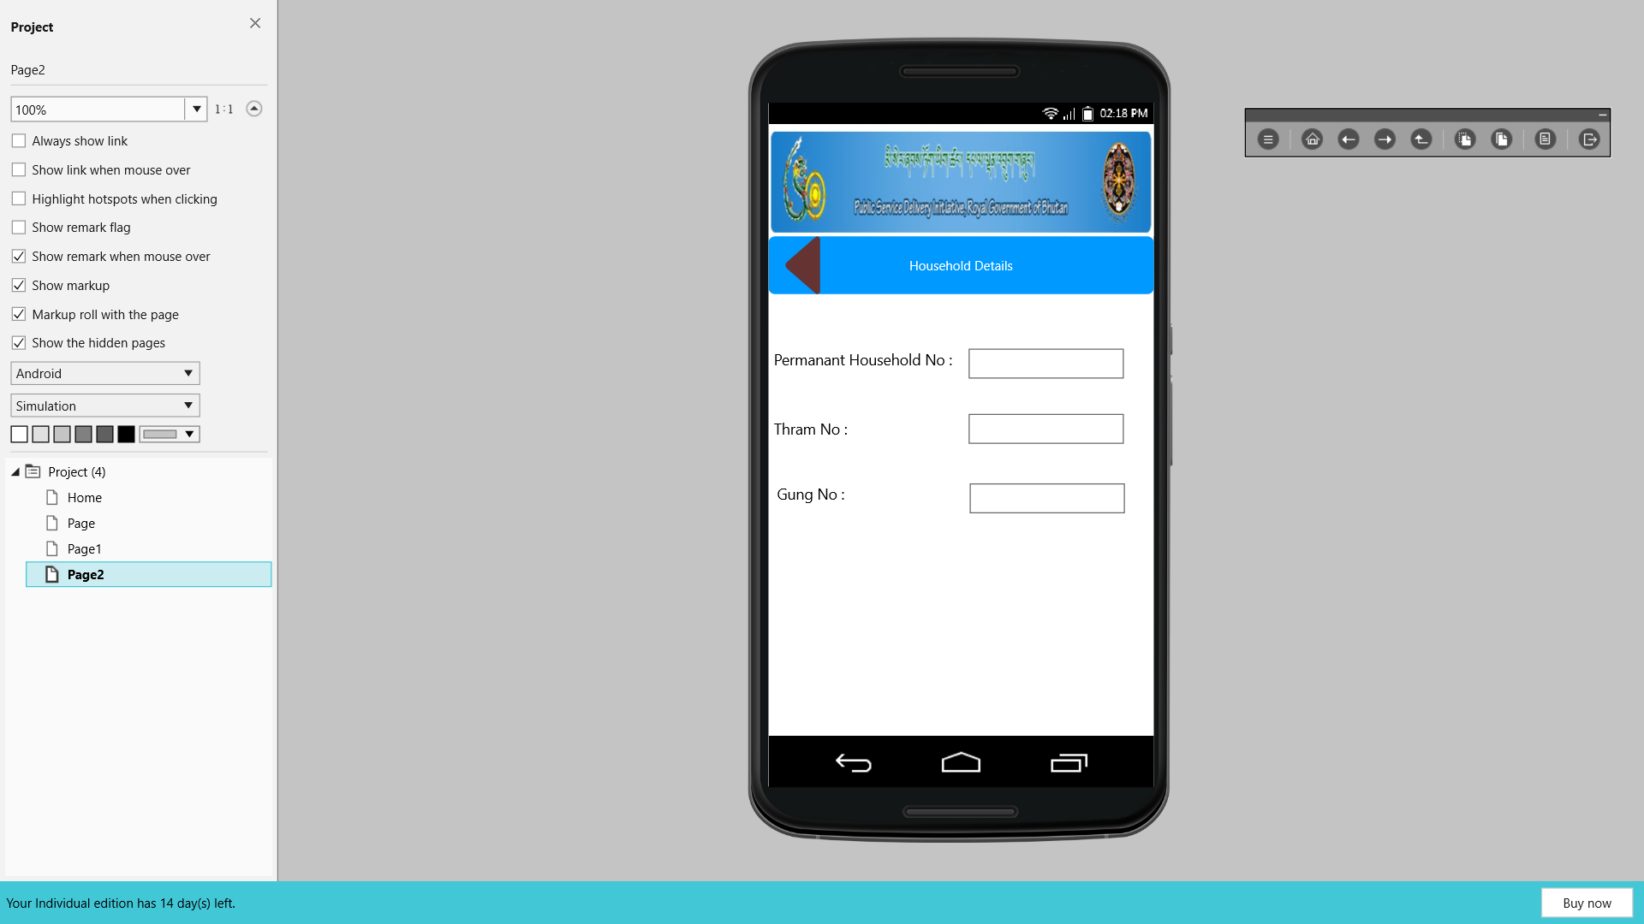
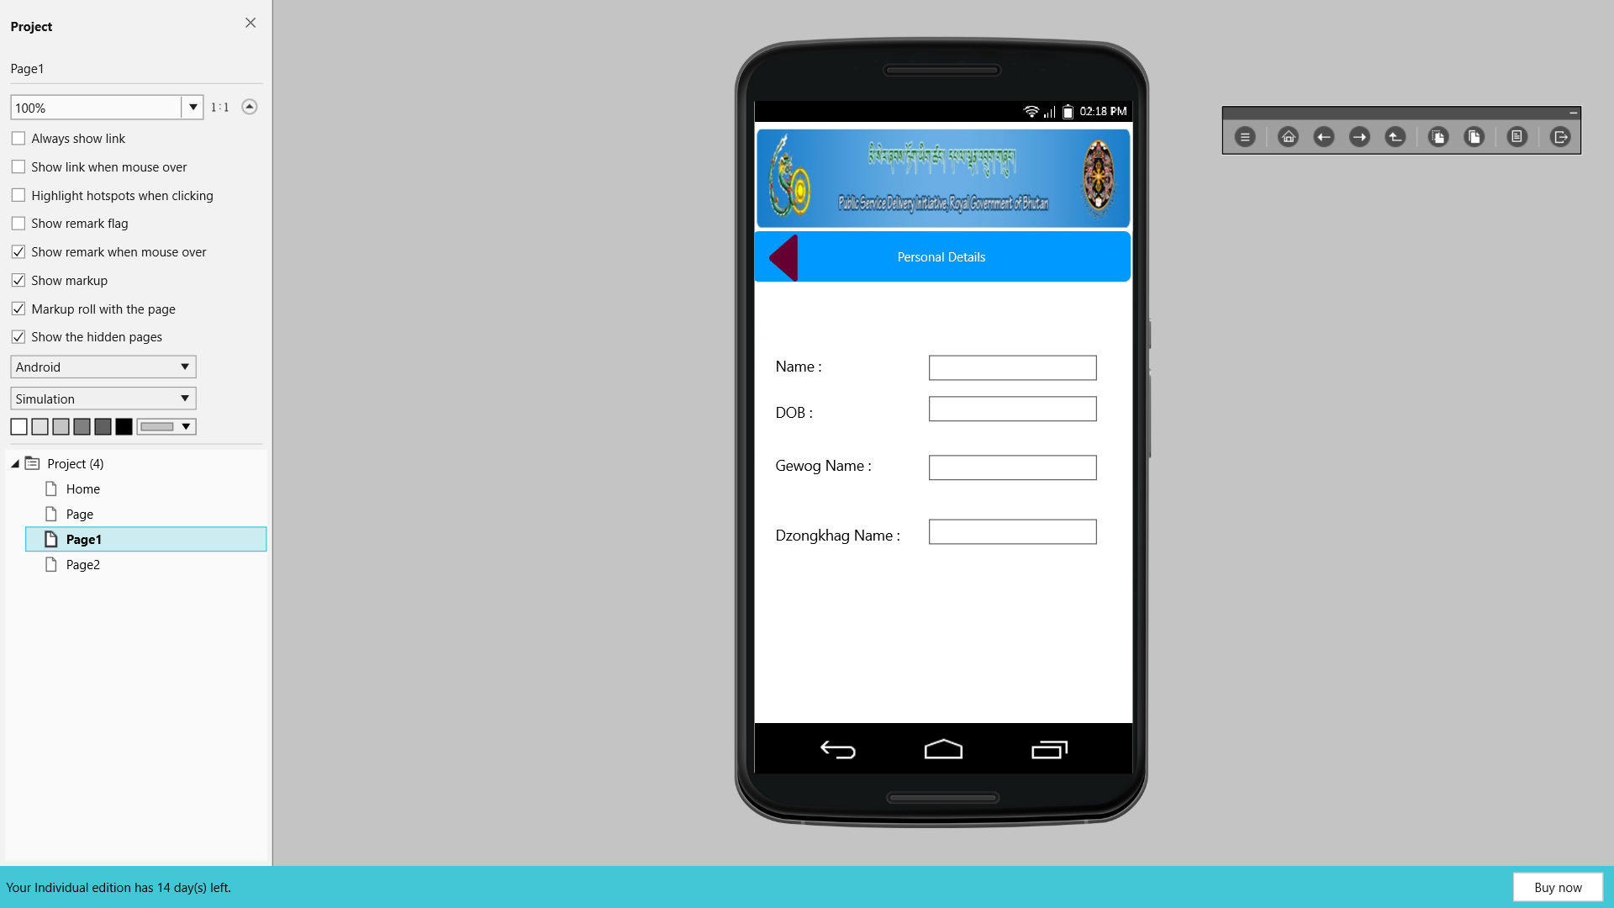

When you click on the personal details this page will be displayed and you can view your personal details.

When you click on the household details this page will be displayed and you can view your household details.

