

ROYAL UNIVERSITY OF BHUTAN
JIGME NAMGYEL ENGINEERING COLLEGE
DEWATHANG: BHUTAN

GUI Application with Database Integration
(Tkinter + SQLite)
Submitted by- Tshering Deki

Table of Contents
GUI Application with Database Integration 1
Instruction: 3
Requirements: 3
2.1 Database s (SQLite) 3
2.2 GUI Development (Tkinter) 4
2.3 Core Functionality (CRUD Operations) 8

Instruction:
Design and develop a custom GUI-based desktop application using Tkinter for the interface and SQLite for database storage. You may choose any real-world application idea (e.g., library system, inventory tracker, employee manager, quiz app, expense tracker, hospital appointment manager, hostel/room booking system, gym membership tracker, recipe organizer, etc.).

Requirements:

2.1 Database s (SQLite)
- Create a database (your_app_name.db) with at least one table relevant to your application (two or more tables are encouraged if your idea needs related data).
- Define appropriate columns (e.g., id, name, date, quantity, price.).
- Ensure proper data types (INTEGER, TEXT, REAL, DATE, etc.) and constraints (PRIMARY KEY, UNIQUE, NOT NULL, FOREIGN KEY where relevant).
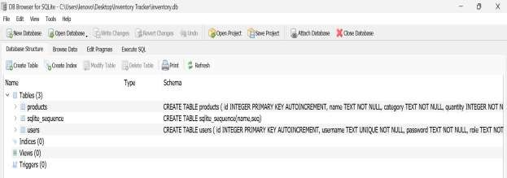

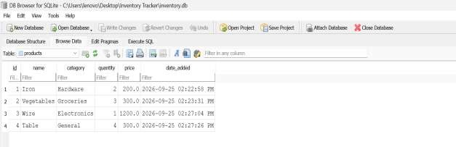

2.2 GUI Development (Tkinter)
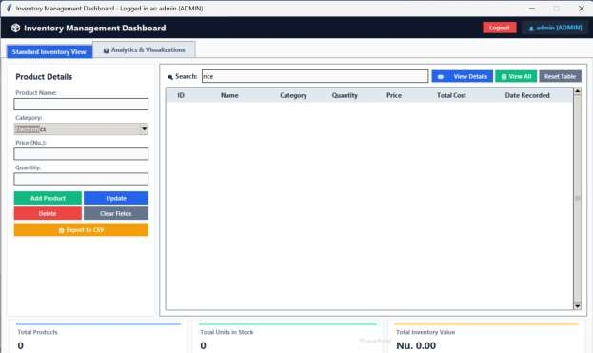
•

A main window
.

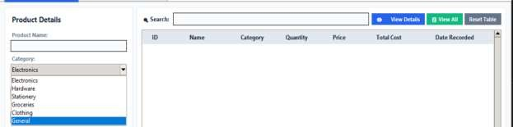

•

Input fields
(
Dropdown)
for user data.

- Buttons for key actions (Add, Update, Delete, Clear, Export, View, Search).
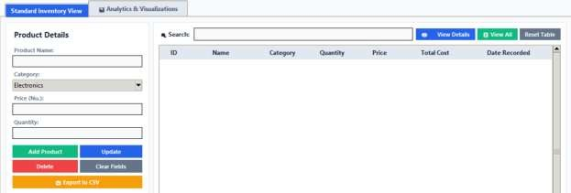

•

A display component to show records.

- Error handling (e.g., messagebox for success/errors, inline warning labels).
Messagebox success for (Add):
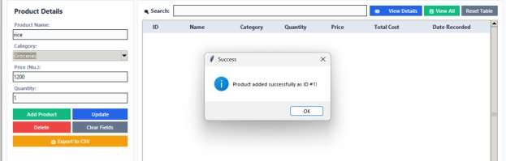

Messagebox error for (Add) when we don’t add anything:
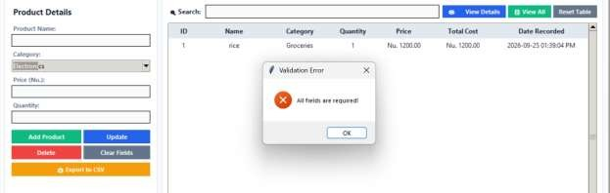

Message box Success for
(
Update
):

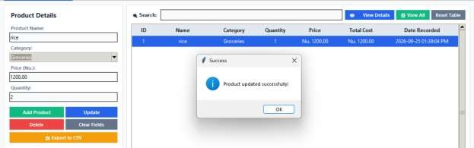

Error message box for (Update) when we didn’t select the list:
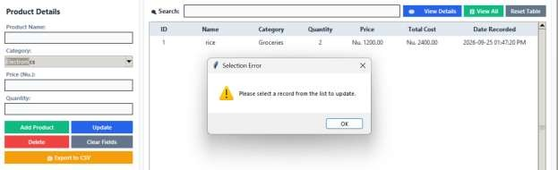

Asking for User Opinion when we are trying to (Delete):
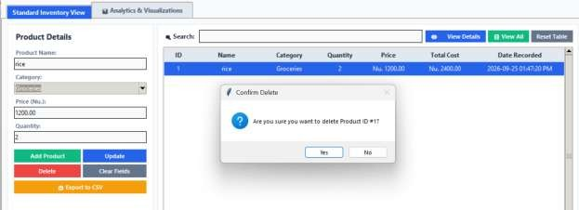

Message box success for (Delete):

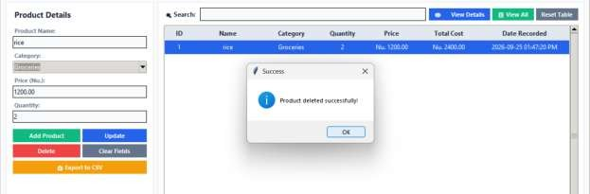

Error message box for (Delete):
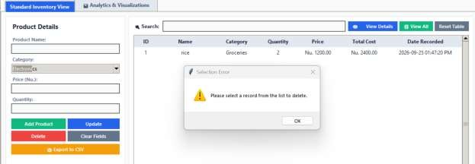

2.3 Core Functionality (CRUD Operations)
- Create (Add): Inserting new records into the database.
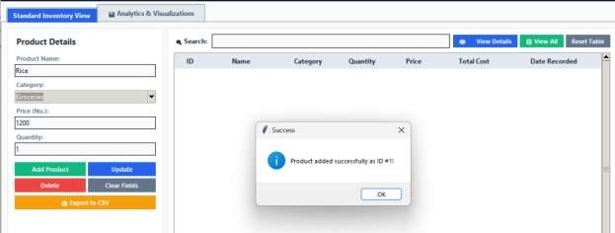

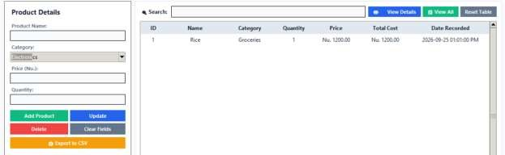

- Read (View): Displaying records from the database.
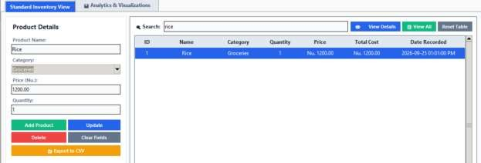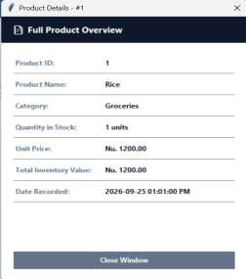

Update: Modify existing records like (selecting a record, editing fields, saving changes).
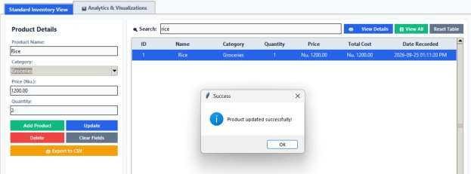

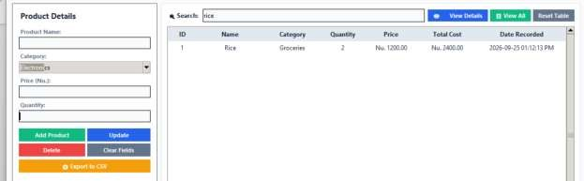

- Delete: Removing records from the database (with a confirmation prompt).
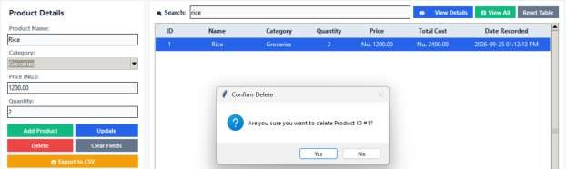

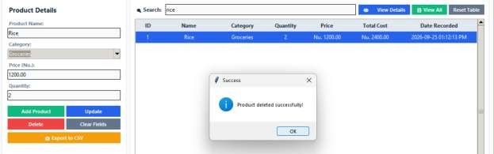

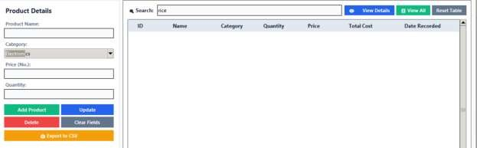

2.4
Additional Features

- Search/Filtering (search by name).
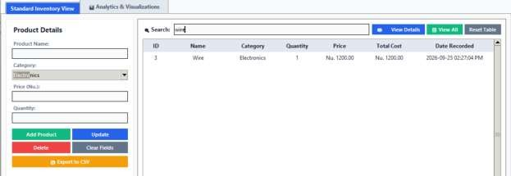

File Export (saving data to CSV or import a CSV into the database).
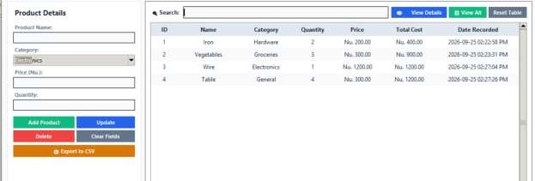

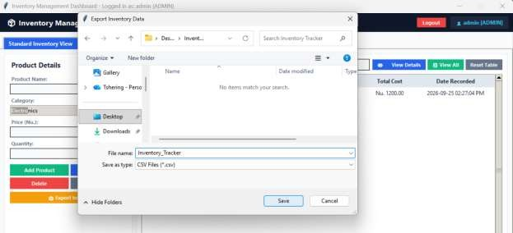

Message box for Success export to CSV:
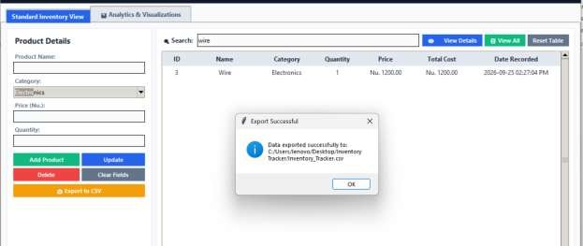

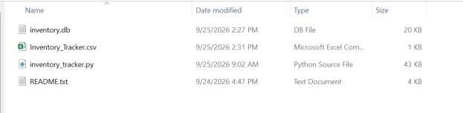

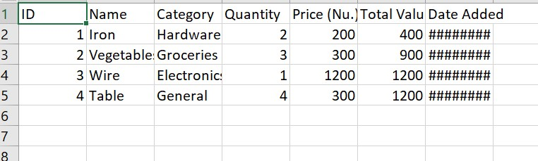
Inside CSV

Login/Authentication System (admin).

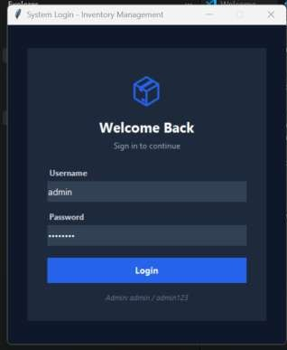

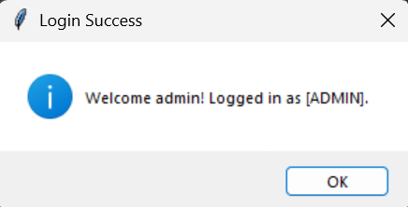

- Graphs/Charts (stock levels, expenses by category).
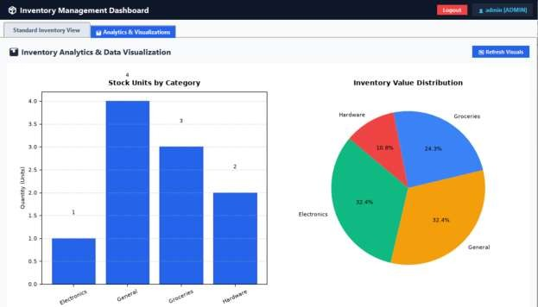

Multi-window Navigation (e.g., separate screens for admin/user, or a dashboard + detail view).
= Figure 1: Main Management View displaying record entry forms, database table, action controls, and summary metric cards.

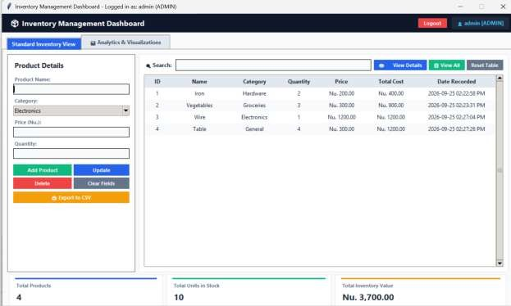

Figure 2: Analytics View providing detailed Matplotlib data visualizations.

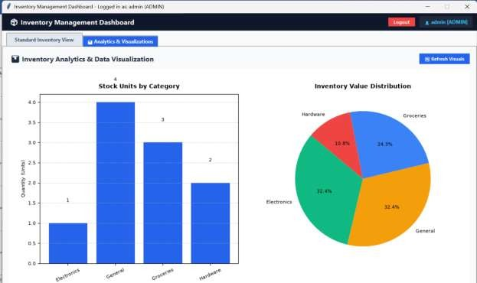

- Sorting records by column (click-to-sort on Treeview headers).
Before Sorting:
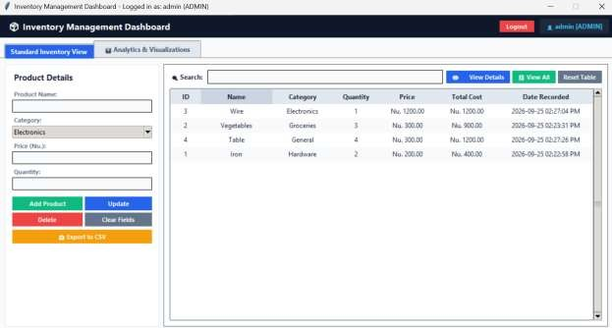

After sorting:




