TODO List Design Document

Todo

Overview

To-Do List project is an application specially built to keep track of tasks that need to be done. This application allows the user to add tasks that they need to do. Once they are done with their tasks they can also remove them from the list.

The TodoListApp will provide the clients with the following tools & support options:

* client will be able to add task
* client will be able to delete tasks once completed

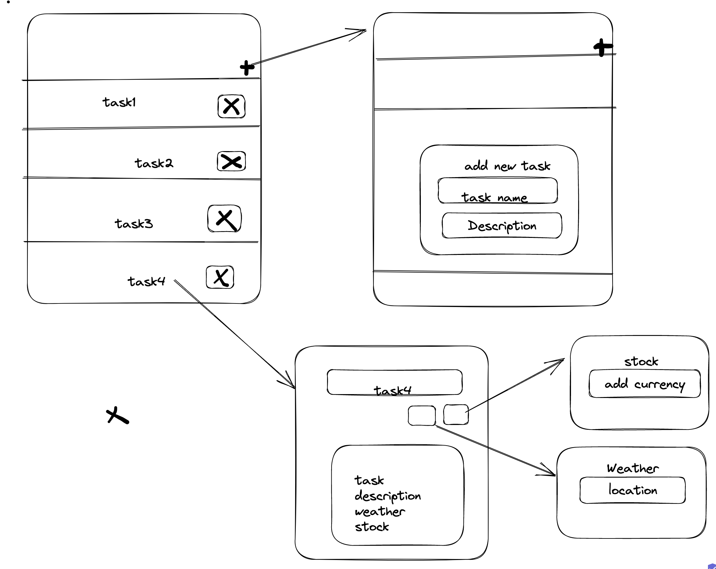

Steps:

Once the app launches user will be presented with Todo list screen

On the Todo list screen there will be a plus button.

User must click the button to be able to add a task on the list.

On the list view the user will be presented with cells where they can delete a task.

The user can select a task on the list to view full description.

Once the user is on full description of a task

User will be presented with 2 buttons to add weather and stock price to the task.

When the user clicks on the weather button a popup will show requestion the location. A service call will be made to get the weather and the weather will be shown on the task description

When the user clicks on the stock the popup will show requesting the currency.

A service call will be made to get the stock and the price will be shown on the task description

The user can navigate back to the list view and back to the home page.

Flow:

The flow is a demonstration of how the

