Nicholas – Data Understanding & Preparation
Diabetes Risk Segmentation & Decision Support System
BC Analytics | MLG382 Guided Project 2026

1. Dataset Overview
The dataset contains 97,297 rows and 31 columns.
There are 24 numeric columns and 7 categorical columns.
The target feature is 'diabetes_stage'.
Metric | Value
Rows | 97297
Columns | 31
Numeric Columns | 24
Categorical Columns | 7
Target Feature | diabetes_stage

2. Feature Grouping
The dataset was grouped into the following feature categories:
Demographic Features:
- Age
- gender
- ethnicity
- education_level
- income_level
- employment_status
Lifestyle Features:
- smoking_status
- alcohol_consumption_per_week
- physical_activity_minutes_per_week
- diet_score
- sleep_hours_per_day
- screen_time_hours_per_day
Medical History Features:
- family_history_diabetes
- hypertension_history
- cardiovascular_history
Clinical Features:
- bmi
- waist_to_hip_ratio
- systolic_bp
- diastolic_bp
- heart_rate
- cholesterol_total
- hdl_cholesterol
- ldl_cholesterol
- triglycerides
- glucose_fasting
- glucose_postprandial
- insulin_level
- hba1c
- diabetes_risk_score
- diagnosed_diabetes

3. Data Quality Checks
Total missing values in the dataset: 0
Duplicate rows in the dataset: 0
Check | Result
Total Missing Values | 0
Duplicate Rows | 0

Interpretation: The dataset contains no missing values and no duplicate rows. This means no imputation or duplicate removal was required at this stage.

4. Target Distribution
diabetes_stage | count | percentage
Type 2 | 58163 | 59.78
Pre-Diabetes | 31013 | 31.87
No Diabetes | 7737 | 7.95
Gestational | 267 | 0.27
Type 1 | 117 | 0.12

Interpretation: The target variable is highly imbalanced. Type 2 and Pre-Diabetes make up most of the dataset, while Type 1 and Gestational classes are very small.

5. Descriptive Statistics
Summary statistics for key numeric features are shown below.
feature | count | mean | std | min | 1% | 5% | 25% | 50% | 75% | 95% | 99% | max
glucose_fasting | 97297.0 | 111.121792038809 | 13.59038168672727 | 60.0 | 80.0 | 89.0 | 102.0 | 111.0 | 120.0 | 134.0 | 143.0 | 172.0
hba1c | 97297.0 | 6.5203379343659105 | 0.8137102808969793 | 4.0 | 4.64 | 5.18 | 5.97 | 6.52 | 7.07 | 7.87 | 8.410399999999935 | 9.8
bmi | 97297.0 | 25.615092962784054 | 3.588386503486828 | 15.0 | 17.3 | 19.7 | 23.2 | 25.6 | 28.0 | 31.5 | 34.0 | 39.2
triglycerides | 97297.0 | 121.46640698068799 | 43.39342171781765 | 30.0 | 30.0 | 48.0 | 91.0 | 121.0 | 151.0 | 194.0 | 224.0 | 344.0

6. Outlier Analysis
Boxplots and the IQR method were used to inspect outliers in glucose_fasting, hba1c, bmi, and triglycerides.
feature | Q1 | Q3 | IQR | lower_bound | upper_bound | outlier_count | outlier_percent
glucose_fasting | 102.0 | 120.0 | 18.0 | 75.0 | 147.0 | 722 | 0.74
hba1c | 5.97 | 7.07 | 1.1 | 4.32 | 8.72 | 599 | 0.62
bmi | 23.2 | 28.0 | 4.8 | 16.0 | 35.2 | 729 | 0.75
triglycerides | 91.0 | 151.0 | 60.0 | 1.0 | 241.0 | 291 | 0.3

Interpretation: Small proportions of outliers were detected in the four key clinical features. Because these variables are clinically relevant to diabetes severity, the outliers were treated as potentially meaningful rather than automatically removed.

Boxplot: glucose_fasting
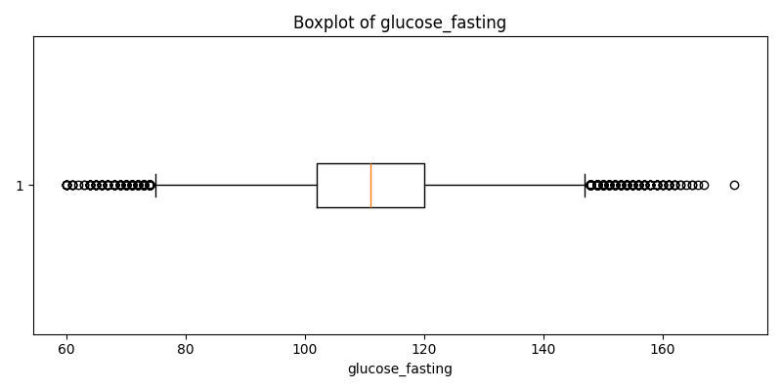

Boxplot: hba1c
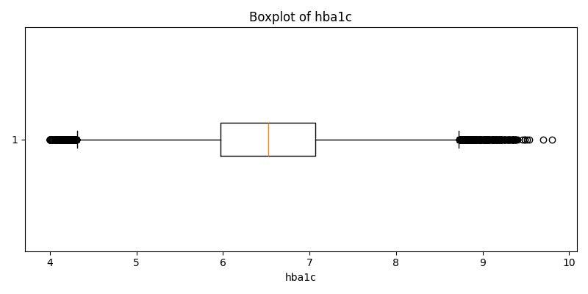

Boxplot: bmi
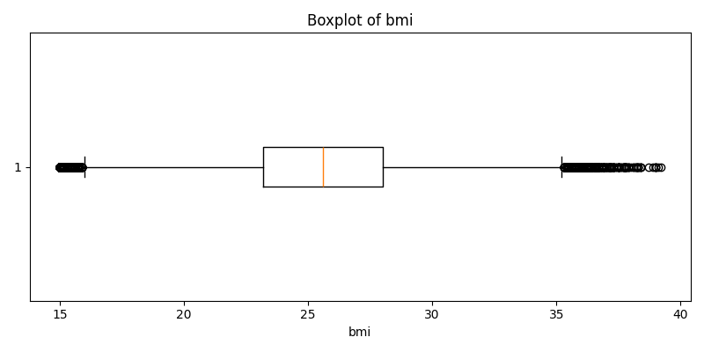

Boxplot: triglycerides
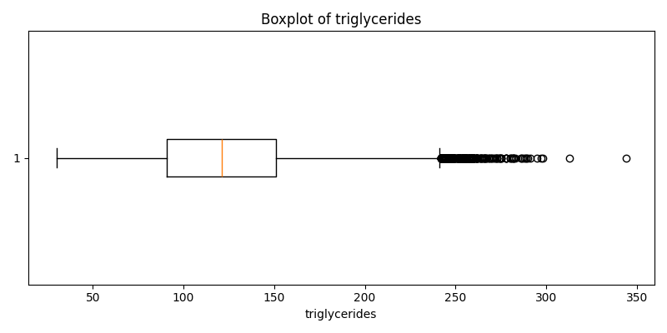

7. Leakage Checks and Handoff Notes
The following checks were performed to identify possible target leakage.
Crosstab: diagnosed_diabetes vs diabetes_stage
diagnosed_diabetes | Gestational | No Diabetes | Pre-Diabetes | Type 1 | Type 2
0 | 111 | 7737 | 31013 | 54 | 0
1 | 156 | 0 | 0 | 63 | 58163

Row percentages: diagnosed_diabetes vs diabetes_stage
diagnosed_diabetes | Gestational | No Diabetes | Pre-Diabetes | Type 1 | Type 2
0.0 | 0.29 | 19.88 | 79.69 | 0.14 | 0.0
1.0 | 0.27 | 0.0 | 0.0 | 0.11 | 99.62

diabetes_risk_score by diabetes_stage
diabetes_stage | count | mean | std | min | 25% | 50% | 75% | max
Gestational | 267.0 | 25.16 | 8.04 | 6.5 | 19.9 | 23.3 | 28.3 | 49.5
No Diabetes | 7737.0 | 24.03 | 6.67 | 2.7 | 19.5 | 23.7 | 28.1 | 53.4
Pre-Diabetes | 31013.0 | 27.93 | 7.9 | 5.0 | 22.5 | 27.2 | 32.3 | 60.3
Type 1 | 117.0 | 24.02 | 8.38 | 7.9 | 18.1 | 21.5 | 27.4 | 44.7
Type 2 | 58163.0 | 32.3 | 9.25 | 4.8 | 25.6 | 31.0 | 38.6 | 67.2

Interpretation: The feature 'diagnosed_diabetes' appears to leak the target because it is strongly aligned with diabetes_stage. The feature 'diabetes_risk_score' is also strongly target-related and should be reviewed carefully before modelling.

8. Cleaned Dataset Handoff
Full cleaned dataset shape: (97297, 31)
No-leakage modelling dataset shape: (97297, 29)
Columns removed from modelling dataset: diagnosed_diabetes, diabetes_risk_score
Dataset | Rows | Columns
cleaned_full_dataset.csv | 97297 | 31
cleaned_model_dataset.csv | 97297 | 29

Interpretation: Two datasets were saved. The full cleaned dataset preserves all columns for reference, while the modelling dataset removes the most suspicious leakage-related variables.

9. Summary
Data understanding showed that the dataset is structurally clean, with no missing values or duplicate rows. The target is highly imbalanced, and the main clinical variables contain small proportions of plausible outliers. Leakage analysis identified diagnosed_diabetes as a strong leakage feature, while diabetes_risk_score was also flagged for caution. Cleaned datasets were saved for downstream handoff.

