Credit Risk Project
Data Understanding and Preparation Report
Generated from project outputs

1. Dataset Overview
Dataset file: credit_risk_dataset.csv
Final cleaned records: 32,416
Features: 11
Target variable: loan_status (0 = No Default, 1 = Default)
The dataset contains applicant demographic, employment, loan, and credit history variables used to support binary credit risk classification.

2. Feature Summary
Feature | Description | Type
person_age | Age of the applicant | Numerical
person_income | Annual income | Numerical
person_home_ownership | Housing status | Categorical
person_emp_length | Years of employment | Numerical
loan_intent | Purpose of the loan | Categorical
loan_amnt | Loan amount requested | Numerical
loan_int_rate | Interest rate on the loan | Numerical
loan_status | Target - 0 = No Default, 1 = Default | Binary
loan_percent_income | Loan amount as a percentage of income | Numerical
cb_person_default_on_file | Previous default on file | Categorical
cb_person_cred_hist_length | Credit history length in years | Numerical

3. Class Distribution
In the cleaned dataset, there are 25,327 non-default cases (78.13%) and 7,089 default cases (21.87%). This class imbalance should be considered in the next preprocessing and modelling stages.
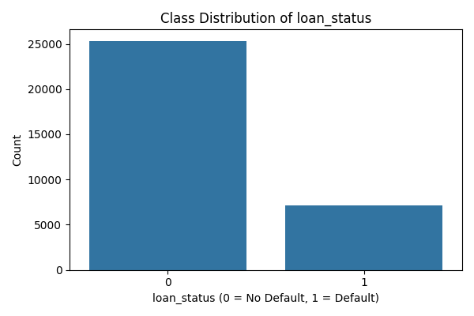

4. Data Quality Issues Identified
Before cleaning, person_emp_length contained 895 missing values and loan_int_rate contained 3,116 missing values.
The maximum value of person_age before cleaning was 144, which is unrealistic for this dataset and required correction.
The dataset was also checked for duplicate rows, and 165 duplicate records were found in the raw dataset.
Outliers were assessed using the IQR method for person_income, loan_amnt, person_age, and person_emp_length.
Column | Outlier Count
person_income | 1,484
loan_amnt | 1,689
person_age | 1,494
person_emp_length | 853

5. Data Cleaning Actions
- Removed exact duplicate rows before further analysis.
- Imputed missing values in person_emp_length using the median.
- Imputed missing values in loan_int_rate using the median within each loan_intent group.
- Applied a fallback overall median for loan_int_rate in case grouped imputation left any missing values.
- Capped person_age at 70 to handle unrealistic age values.
- Generated distribution plots, categorical count plots, boxplots, and a correlation heatmap for data understanding.
Outliers in person_income, loan_amnt, person_age, and person_emp_length were identified using the IQR method. Only unrealistic age values were corrected by capping person_age at 70, while other extreme financial values were retained and documented because they may represent valid applicant records.
After cleaning, the dataset contained 0 missing values in total, the maximum value of person_age was reduced to 70, and the cleaned dataset contained 0 duplicate rows.

6. Key Visualisations

Correlation Heatmap
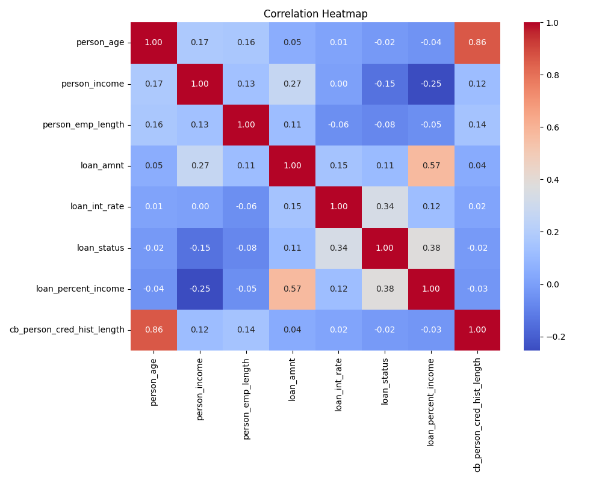

Distribution of person_income
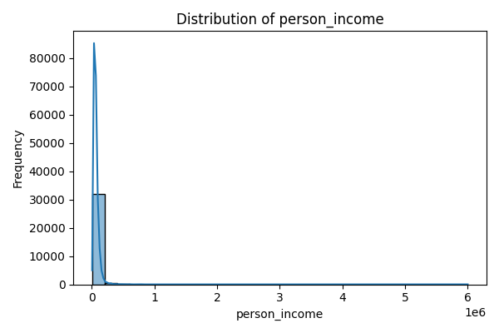

Distribution of loan_amnt
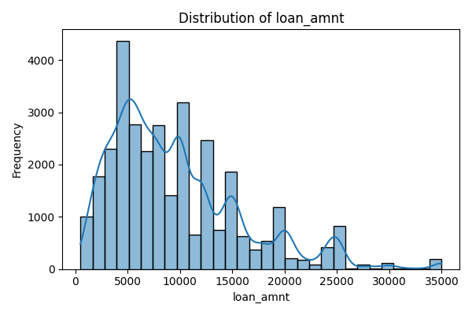

Distribution of loan_int_rate
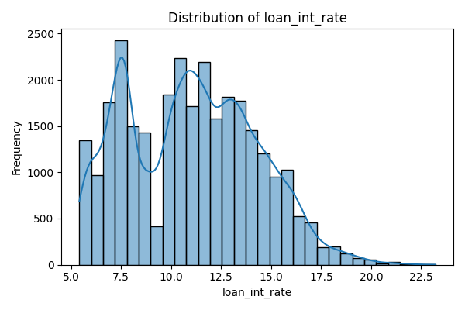

7. Final Output
The cleaned dataset was saved as data/processed/cleaned_dataset.csv and is ready for the next project stage, which includes encoding, scaling, splitting, and model preparation.
All original columns were retained in the cleaned dataset for handoff to the next preprocessing stage.

