Introduction to Sales Data Analysis

This project involves the analysis of a retail sales dataset to uncover meaningful insights. The dataset consists of various transactional attributes, including sales metrics, customer demographics, and product performance. By running SQL queries and visualizing the data, this analysis provides a comprehensive understanding of sales trends, customer behavior, and business performance.

**Analysis Objectives**

The goal of this analysis is to extract actionable insights using SQL queries and visualizations. Below is an overview of the queries and questions that will be addressed:

Overview of the Table

SELECT * FROM evolve.supermarket_sales;

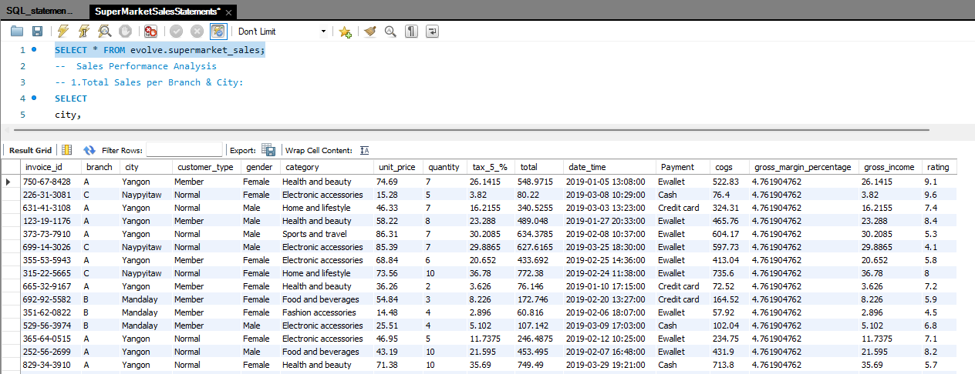

**Sales Performance Analysis**

1.Total Sales per City:

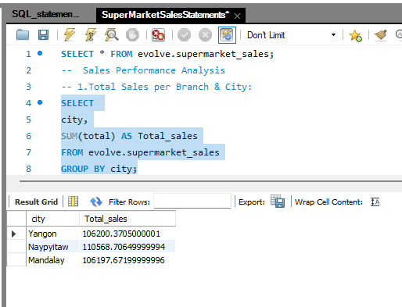

2. Average Sales per Transaction: What is the average sale amount per transaction across different cities

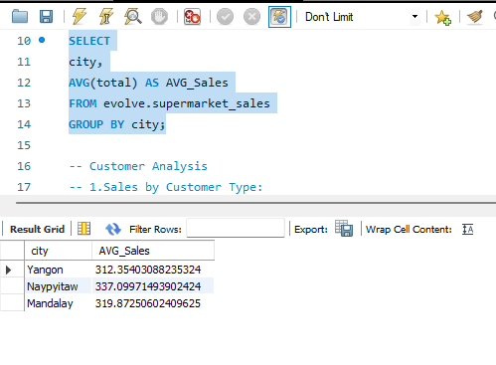

**Customer Analysis**

1.Sales by Customer Type

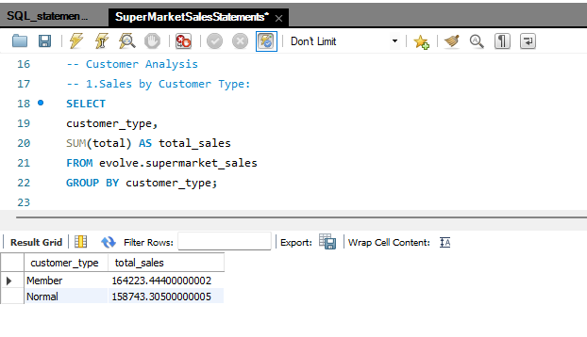

2.Gender Distribution of Customers and Their Spending

3. Top Products Purchased by Customer Type

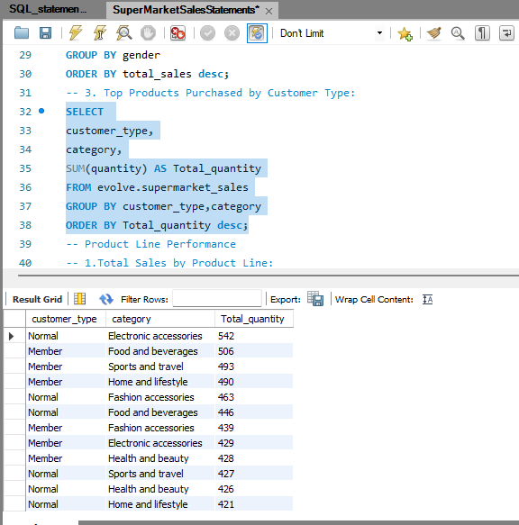

**Product Line Performance**

1.Total Sales by Product Line(category):

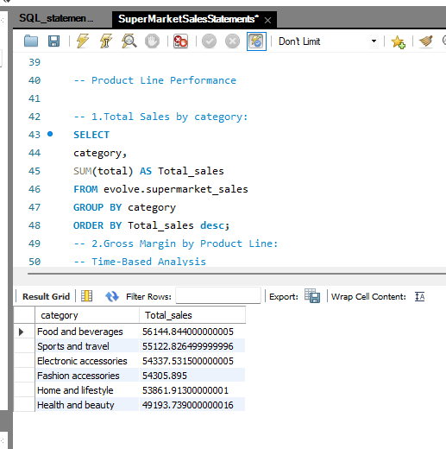

2.Gross Margin by category:

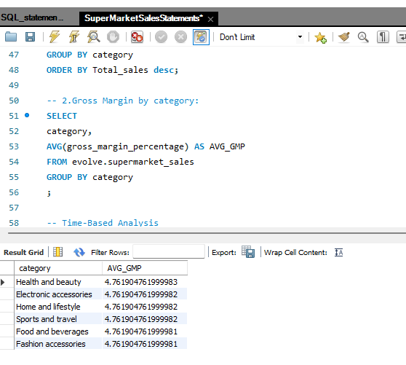

**Time-Based Analysis**

1.Sales Trends Over Time

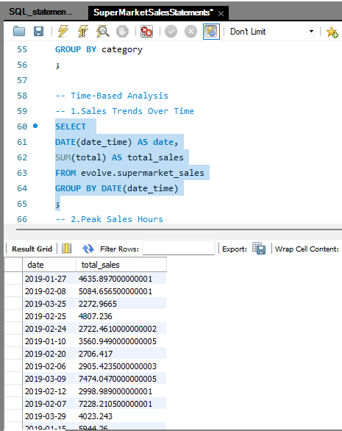

2.Peak Sales Hours

