INTRODUCTION TO DATA SCIENCE | GROUP PROJECT
Data Science for Better Service Delivery in South Africa
Predicting Municipal Audit Outcomes
Technical report: from a real public problem to a statistically validated machine-learning solution
Central challenge: how can responsible data science help a South African public-service stakeholder identify need, prioritise limited resources, or improve the reliability and reach of a service?
Student name | Student number
T Chaba | 216089898
R Tabohane | 217033101
T Mabena | 221641221
T Tshinavhe | 219537948
P Khosa | 221335970
Group: Auditors
Lecturer: Dr Dan Masethe
Submission date: 20/10/2026
IDA117V · Technical report · S2 2026
Contents
Question 1: Problem definition, success measures and data justification 1
1.1 Service-delivery problem and classification task 1
1.2 Success measures and the cost of errors 1
1.3 Dataset justification, risks and safeguards 1
Question 2: Data audit, visualisation, splitting and preparation pipeline 2
2.1 Data dictionary and data audit 2
2.2 Visualisations 4
2.3 Train, validation and test split 5
2.4 Preparation pipeline 6
Question 3: Baseline and models 6
3.1 Baseline 6
3.2 Models trained on identical data 7
3.3 Model families 7
3.4 Architecture, hyper-parameters and reproducibility 7
3.5 Rationale for each model family 7
Question 4: Evaluation, comparison and overfitting 7
4.1 Held-out metrics for every model 7
4.2 Classification reports, confusion matrices and ROC curves 8
4.3 Model comparison and provisional champion 8
4.4 Overfitting diagnosis and controls 9
Question 5: Champion optimisation 9
5.1 Search method, search space and scoring rule 9
5.2 Validation protocol and before/after comparison 10
5.3 Final locked pipeline: one-time test evaluation 10
Question 6: Ablation study and statistical validation 10
6.1 Controlled ablations 10
6.2 McNemar's test: champion vs strongest comparator 11
Question 7: User-interface deployment 12
7.1 Working user interface 12
7.2 Input, prediction pipeline and output 12
7.3 Input validation and safeguards 12
7.4 Deployment instructions and demonstration 13
Question 8: Recommendation, reproducibility and team defence 13
8.1 Recommendation for National Treasury 13
8.2 Reproducible package 14
8.3 Presentation and contribution statement 15
References 16
Appendices 17
Appendix A: Additional evaluation figures (Question 4) 17
Appendix B: Optimisation and test-year figures (Question 5) 18
Appendix C: Fairness detail and calibration (Question 8) 18
Appendix D: Dashboard (Question 7) 19
Appendix E: Execution order 22
Declaration and academic-integrity statement
This report was prepared by the group named on the cover. Every dataset, library and external source is listed in the References. Questions 1 and 2 were written by team members; their text is reproduced here with minor corrections that bring it in line with the final results (listed in docs/report_merge_notes.md). The project contains no personal data, and no personal, confidential or access-controlled records were uploaded to public repositories or external tools.
AI assistance. AI tools (Claude, by Anthropic) were used to assist with research, coding and drafting. The team reviewed, ran and verified all code and results and takes responsibility for the content; individual contributions are set out in the signed contribution statement.

Question 1: Problem definition, success measures and data justification

1.1 Service-delivery problem and classification task
Every year the Auditor-General of South Africa (AGSA) audits all 257 municipalities (AGSA, n.d.). Some pass and many fail, for various reasons or because they do not submit their financial statements. The audit outcome matters for residents because poor financial management leads to unpaid municipal bills, neglected infrastructure and failing services. The problem is that audit results arrive long after the financial year has ended, so Treasury usually responds only once the damage has been done.
Affected population. Residents of poorly governed municipalities, who bear the service failures, and the creditors and suppliers who go unpaid. Decision-maker. National Treasury's local government support function and the provincial treasuries, who decide each year where to send financial-management support, secondments and oversight. Intended benefit. Earlier, evidence-based and more consistent targeting of limited support, so that struggling municipalities are reached before service delivery collapses. The model supports human judgement; it does not replace the audit or decide funding.
Element | Definition
Unit of prediction | One municipality in one financial year t (a municipality-year), identified by its Municipal Demarcation Board code.
Inputs | Nine financial indicators for year t (total revenue, total expenditure, operating surplus, cash coverage, collection rate, debtor days, repairs and maintenance ratio, irregular expenditure ratio, grant dependency) plus the audit outcome for year t (at_risk or not_at_risk).
Target classes | The AGSA outcome for year t+1. at_risk = qualified, adverse, disclaimer or outstanding. not_at_risk = unqualified, with or without findings.
Prediction horizon | One audit cycle: the flag can be issued as soon as the year t results are known, about a year before the year t+1 outcome is published.
Intended decision | Rank municipalities by risk so that Treasury can prioritise its limited support budget and staff.
Table 1.1: The classification task.

1.2 Success measures and the cost of errors
Primary technical metric: macro-F1, the average of the at_risk and not_at_risk F1 scores, so both classes count equally. It is used instead of accuracy because the classes are unevenly sized (about 55/45): a model that always predicts not_at_risk reaches 57.8% accuracy on the 2022 validation year but a macro-F1 of only 0.366. Recall, precision, ROC-AUC and PR-AUC for the at_risk class are reported alongside it.
Service-delivery success indicators. Coverage: the share of municipalities that go on to receive a poor audit that had been flagged one cycle earlier (recall for at_risk), i.e. the proportion of failing municipalities Treasury could have reached before the failure. Targeting efficiency: the share of flagged municipalities that do receive a poor audit (precision for at_risk), which shows how much of Treasury's scarce support capacity goes to municipalities in genuine need. Whether the support that follows improves services can only be judged in later audit cycles and is outside the scope of this project.
Error | What happens | Cost
False negative | A municipality that will fail is not flagged. | Support arrives late or not at all. Unpaid creditors, service breakdowns and irregular spending continue for another year, and residents bear the cost.
False positive | A municipality that will pass is flagged. | An unnecessary visit or secondment uses scarce Treasury capacity that another municipality needed, and the flag may be read as a verdict.
Table 1.2: Cost of the two error types.
A false negative is the more costly error: a flag is only a request to look closer and offer support, which is cheap and reversible, whereas a missed failure is not, so recall matters most. Support capacity is limited, however, so precision cannot be ignored. This is why a balanced metric (macro-F1) is the primary measure and both indicators are monitored.

1.3 Dataset justification, risks and safeguards
The data is Municipal Money, Municipal Finance Data, published by National Treasury (National Treasury, n.d.-a).
Aspect | Entry
Relevance | An official, municipality-level source of audited financial statements and AGSA audit opinions. The target is published directly, so no hand-labelling is needed, and the indicators are the kind Treasury and AGSA use to judge financial health. No personal data is needed.
Provenance | Owner: National Treasury (platform run with OpenUp). Financial data are MFMA section 71 submissions signed off by each municipal manager and CFO ("audited actual" amounts; Republic of South Africa, 2003); audit opinions come from AGSA reports. The extracts were downloaded through the public API and are committed to the repository (data/raw).
Licence | Terms of Use (National Treasury, n.d.-c): use for commercial and non-commercial purposes at no cost, including copying, publishing and distributing. Conditions: acknowledge National Treasury and the date of publication; do not mislead; do not imply Treasury endorses our analysis; do not use personal data. No warranty of accuracy. The extracts may therefore be redistributed in the repository with attribution.
Coverage | 257 municipalities today (292 including disestablished ones). Audit opinions 2011–2024; financial datasets 2018–2025 (debtors from 2020, repairs and maintenance from 2019, grants from 2020 for 182 municipalities). Modelling set: 1,434 labelled municipality-years (feature years 2018–2023, target years 2019–2024), 54.5% not_at_risk and 45.5% at_risk, plus 245 rows for 2024 used to forecast the 2025 audit.
Limitations | (1) Figures are only as reliable as each municipality's submission; some are implausible (e.g. cash coverage of −23.7 months) and are kept as reported. (2) Missing items are recorded as 0 (debtor days before 2020, repairs and maintenance before 2019). (3) The grants extract appears truncated (100,000 rows, 182 municipalities). (4) The 2019-20 chart-of-accounts change (mSCOA) and boundary changes alter line items over time. (5) Municipalities that do not submit statements are the highest-risk group but have the least data. (6) Only six feature years are available, so the sample is small.
Table 1.3: Dataset card summary (full card: docs/dataset_card.md).
The table below lists the POPIA, privacy, fairness and misuse risks that apply and the proposed safeguards (Republic of South Africa, 2013).
Risk | Why it matters here | Safeguard
POPIA and privacy | POPIA protects personal information. The Municipal Officials dataset lists named staff with emails and phone numbers. Municipal finances are public records but describe identifiable public bodies. | Officials and all contact fields were excluded at download; the nine raw extracts contain no staff names, emails or phone numbers; no linking to other sources; the app needs no credentials and stores nothing; uploads are limited to 500 rows of the financial columns.
Fairness | Province and municipality type are proxies for rurality and poverty, and audit history carries past failure forward, so some groups may be flagged wrongly more often. | Province and type are not model inputs. Recall and false-positive rate are reported by province and type (Q8.1 found, for example, a 28.6% false-alarm rate in the Northern Cape and 70.0% recall in Limpopo). Flagged lists are reviewed by province before support is allocated.
Misuse: punishment | A flag could be used to cut funding, publish league tables or judge officials. | Decision support only: a flag means "look closer and offer support". No automatic allocation of funds. The app carries a responsible-use notice and a list of when not to use the model.
Misuse: false reassurance | On the 2023 test year the model's yes/no predictions are identical to "repeat last year's outcome" (Q5.3), so it adds little for a municipality that deteriorates after a clean audit. | State this limitation wherever results are shown; do not treat "not at risk" as safe; re-check the model against the published AGSA outcomes every year.
Misuse: gaming and reuse | Once the indicators are known to matter, reported figures could be adjusted, and others (e.g. lenders) could reuse the scores for credit decisions. | Access limited to Treasury support staff; documented purpose and limitations; scores not published as rankings; re-validation after accounting or boundary changes.
Table 1.4: Risks and safeguards.

Question 2: Data audit, visualisation, splitting and preparation pipeline
The analysis file (modeling_dataset.csv) holds 1,434 municipality-year records. Each record describes one municipality in financial year t (2018 to 2023) through financial indicators built from Municipal Money (audited actual figures) and carries the AGSA result for year t+1 (2019 to 2024) as the target. This follows the concept note: the flag is issued once the year t results are known, one audit cycle before the year t+1 outcome is published.

2.1 Data dictionary and data audit
Column | Role | Unit | Meaning and source | Null %
demarcation.code | Identifier | text | Municipal Demarcation Board code (e.g. BUF); join key across all Treasury cubes and the audit file | 0
financial_year_end.year | Identifier (time) | year | Financial year t; orders and splits the records, not a model input | 0
Name | Reference | text | Municipality name; reporting only | 0
total_revenue | Feature | rand | Sum of income lines (mSCOA item codes below 2900), Income and Expenditure cube, audited actual | 0
total_expenditure | Feature | rand | Sum of expenditure lines (item codes 3000 to 4399), same cube | 0
operating_surplus | Feature | rand | total_revenue minus total_expenditure (negative = deficit) | 0
cash_coverage_ratio | Feature | months | Cash and equivalents (Financial Position cube) ÷ (total_expenditure ÷ 12) | 0.1
collection_rate | Feature | proportion | (Property rates + service charges − debt impairment) ÷ (property rates + service charges) | 8.4
debtor_days | Feature | days | Total owed by customers (Aged Debtor cube) ÷ (total_revenue ÷ 365) | 0
repairs_maintenance_ratio | Feature | proportion | Repairs and maintenance spending (Repairs and Maintenance cube) ÷ total_expenditure | 0.1
irregular_expenditure_ratio | Feature | proportion | Irregular expenditure (Unauthorised, Irregular, Fruitless and Wasteful Expenditure cube) ÷ total_expenditure | 0.1
grant_dependency | Feature | proportion | All grants received (Grants cube) ÷ total_revenue | 0
prior_audit_outcome | Feature | category | Year t AGSA result grouped as not_at_risk / at_risk; past information, not leakage (2.4.4) | 0
prior_audit_opinion_raw | Reference | category | Original AGSA opinion for year t; traceability only | 0
target_next_year | Target | category | AGSA risk class for year t+1; encoded 0/1 in the pipeline | 0
target_opinion_raw | Reference | category | Original AGSA opinion for year t+1; never a model input | 0
Table 2.1: Data dictionary (docs/data_dictionary.md and reports/data_dictionary.csv). Identifier and reference columns are never given to a model.
The audit (script audit_q21_v2.py, output audit_report.txt) covered all 1,434 records:
Check | Finding | Action taken
Class balance | 781 Not at risk (54.5%) and 653 At risk (45.5%): only mildly imbalanced. | No resampling; class weights at training time (2.4.2).
Duplicates | 0 duplicate municipality-year keys and 0 fully duplicate rows. | None needed.
Missing values | Average 0.9% across features. collection_rate 8.4% (undefined when billed revenue is zero); cash_coverage_ratio, repairs_maintenance_ratio and irregular_expenditure_ratio 0.1% each; all others complete. | Median imputation, learned on training data only (2.4.2).
Invalid or implausible values | No column is entirely zero. 18 records have negative total_revenue and 11 negative total_expenditure, which is not economically plausible and is treated as a likely reporting or aggregation error. Other negatives can be valid: operating_surplus 1,032 records (a deficit), cash_coverage_ratio 167 (negative cash balance). | Retained and flagged for checking against the source; robust scaling was tested in Q5.1.
Zeros that may mean "no data" | For Buffalo City, debtor_days is 0 in 2018–2020, grant_dependency is 0 in 2018–2019 and collection_rate is exactly 1 in 2018–2021. The extracts confirm that the debtor cube starts in 2020, repairs in 2019 and grants in 2020 (182 municipalities), so earlier zeros are absent data recorded as 0. | Kept as reported and disclosed as a limitation (2.5); recoding to missing with an indicator is a recommended improvement.
Outliers | Outside 3 × IQR: total_revenue 94, total_expenditure 96, operating_surplus 111, cash_coverage_ratio 59, collection_rate 136, debtor_days 40, repairs_maintenance_ratio 32, irregular_expenditure_ratio 90, grant_dependency 6. The revenue and expenditure outliers most likely reflect the large metropolitan municipalities, which are genuinely larger. | Not deleted (they are real municipalities); capped for plotting only.
Leakage | Five possible sources examined; none found (below). | Design rules in 2.1 and 2.4.3.
Table 2.2: Data audit.
Possible leakage. Leakage means the model sees at training time something that would not exist at prediction time. Five sources were checked. (1) Target-year information in the inputs: all inputs describe year t and the target is the AGSA result for year t+1. (2) Audited figures: audited actual figures for year t are safe, because the year t audit is finished and public before year t+1 is predicted; they would be leakage only if the target were year t's own opinion. The irregular-expenditure figures are audit-derived and used under the same rule. (3) Identifiers and answer-like columns: municipality code, name, year and the raw opinion of year t+1 are excluded. (4) Last year's outcome: prior_audit_outcome is past information and so not leakage, but it is a strong "repeat last year" signal and is treated as an explicit team decision (2.4.4). (5) Preprocessing leakage: medians, scaling factors and category lists are learned from training data only.

2.2 Visualisations
Five figures were produced from the analysis file (script visualize_q22_v2.py, n = 1,434): the target distribution, missingness, two feature–target relationships and one temporal view.
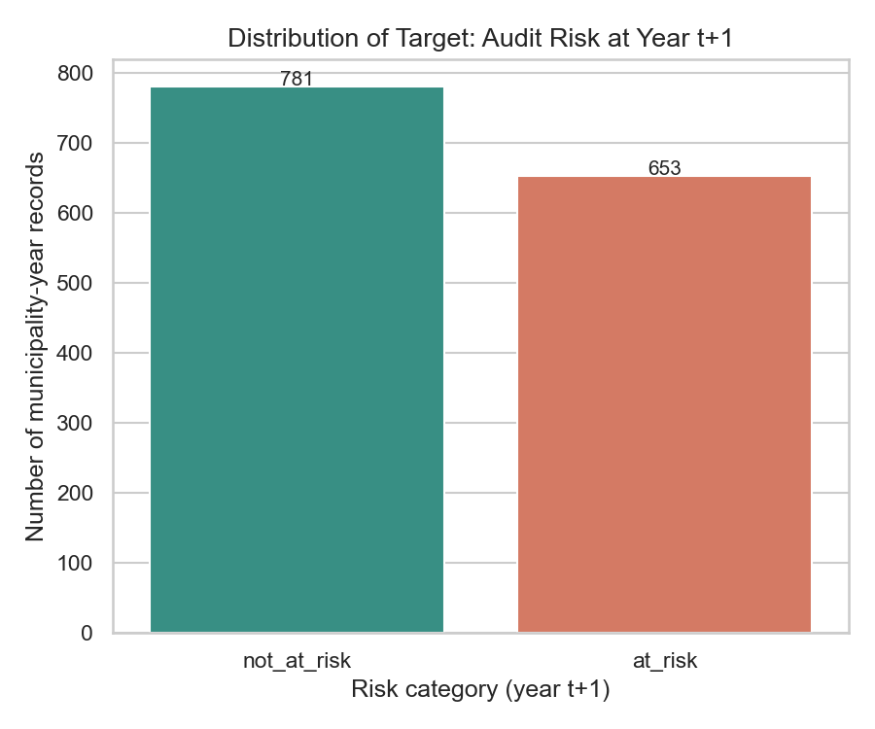  Figure 1: Distribution of the target (audit risk at year t+1). Units: number of municipality-year records. | Interpretation. 781 records are Not at risk and 653 At risk (about 54.5% and 45.5%). The classes are close to balanced, so accuracy is not dominated by one class, but macro-F1 is still reported because missing an at-risk municipality (a false negative) costs more than flagging a healthy one.
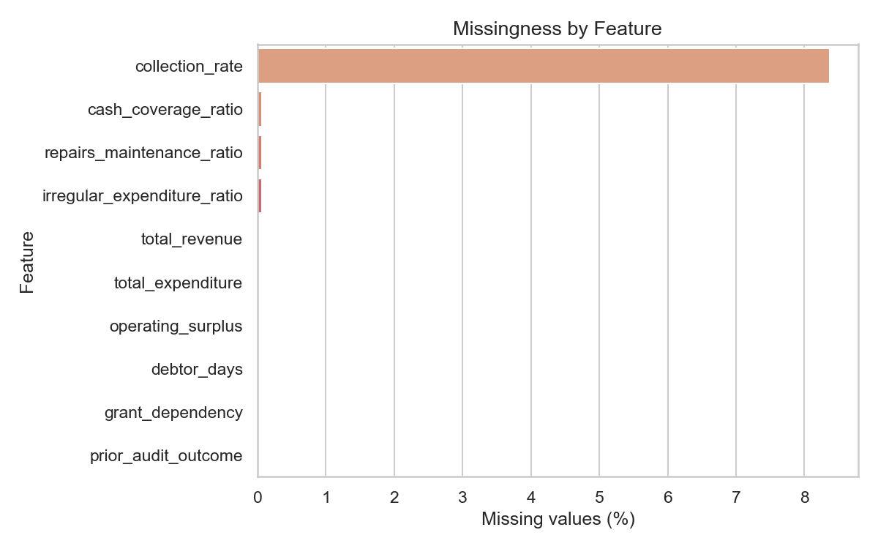  Figure 2: Missing values by feature. Units: % of the 1,434 records. | Interpretation. collection_rate is the only feature with notable missingness (about 8.4%); it is undefined when billed revenue is zero. Three other features are about 0.1% missing and the rest are complete, so median imputation is adequate. The chart cannot show the zero-versus-missing issue in Table 2.2, because zeros count as present values.
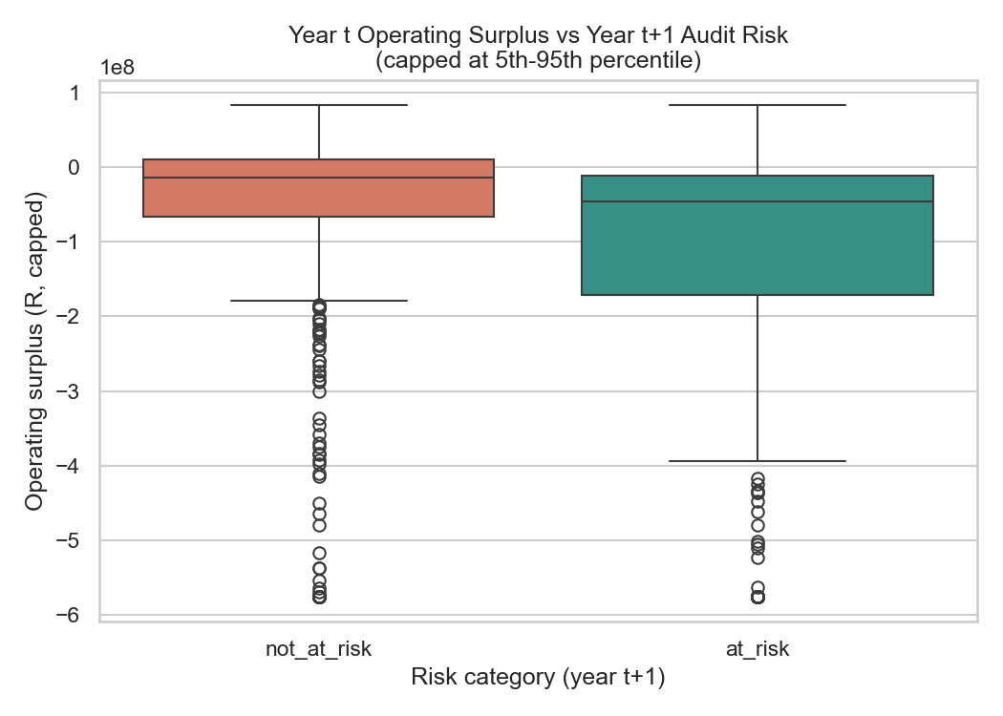  Figure 3: Year t operating surplus vs year t+1 audit risk. Units: rand, capped at the 5th and 95th percentile for display only; the axis is ×10⁸. | Interpretation. Most municipalities run an operating deficit in both groups, partly because revenue here excludes capital transfers while expenditure includes non-cash items such as depreciation. Municipalities at risk a year later had a lower median surplus (about −R45.8 million against −R13.4 million) and a longer lower tail (middle half from about −R171 million to −R11 million, against −R67 million to +R10 million). Weaker finances in year t go with worse audit outcomes in year t+1, but the boxes overlap heavily, so surplus alone separates the groups only weakly.
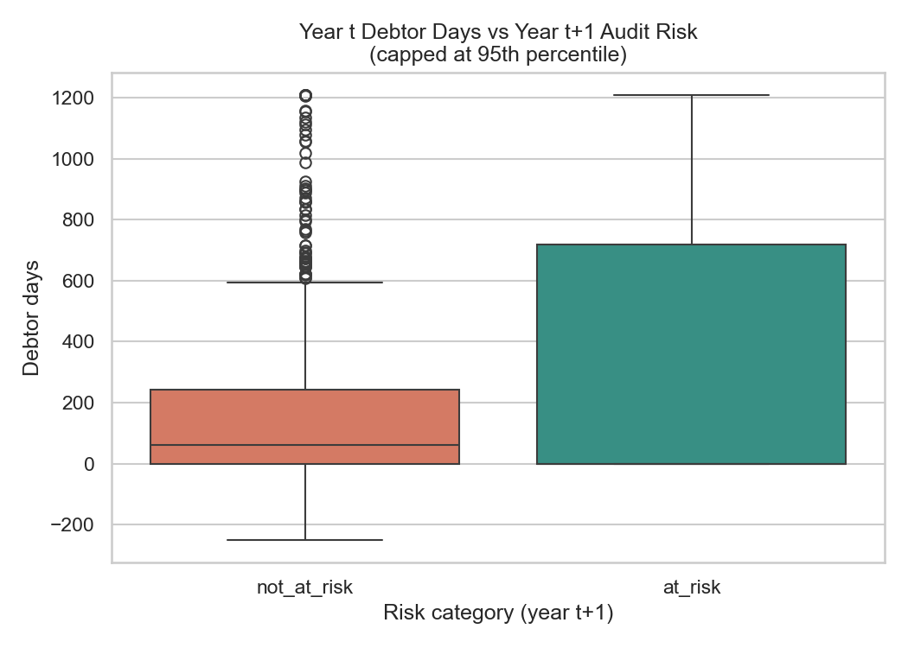  Figure 4: Year t debtor days vs year t+1 audit risk. Units: days of revenue owed, capped at the 95th percentile. | Interpretation. At-risk municipalities have a much higher upper quartile (about 718 days) than not-at-risk municipalities (about 243 days, median 62). Municipalities that struggle to collect what they bill are more likely to fail the next audit, which makes debtor days a promising feature. Caution: the lower end of both boxes is zero, and many of these zeros are missing data in the early years (Table 2.2), which compresses the lower quartile.
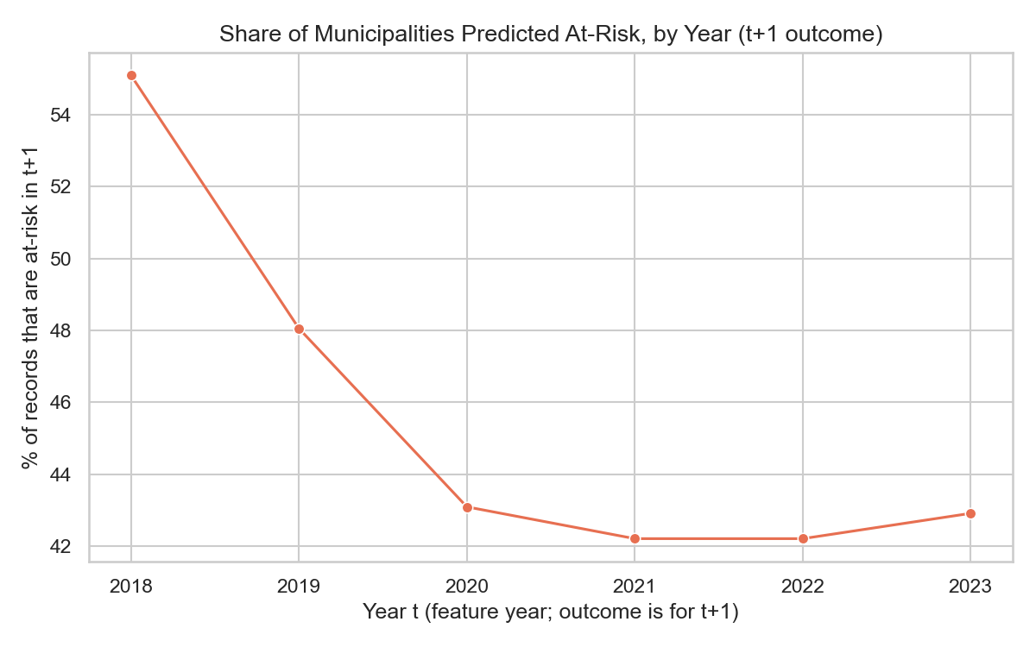  Figure 5: Share of at-risk outcomes by feature year (observed outcomes, not predictions). Units: % of that year's records. | Interpretation. The at-risk share fell from about 55% (t = 2018) to about 48% (2019) and then levelled at roughly 42–43% from 2020 to 2023. The base rate is therefore not constant: municipalities were somewhat less likely to be at risk in later years. This matters for the split in 2.3, because a model trained on the earlier, higher-risk years meets a lower base rate in validation and test. Records per year are stable (231 to 244), so the trend is not an artefact of sample size.

2.3 Train, validation and test split
Records are split by feature year t in time order: the oldest years train the model, the next year validates it and the most recent year tests it. The split is made before any transformation is learned (script split_q23_v2.py).
Split | Feature years (t) | Outcome years (t+1) | Records | At risk
Training | 2018–2021 | 2019–2022 | 950 | 447 (47.1%)
Validation | 2022 | 2023 | 244 | 103 (42.2%)
Test | 2023 | 2024 | 240 | 103 (42.9%)
Table 2.3: Time-based split (exact class counts from modeling_dataset.csv).
- It mirrors deployment. In real use Treasury issues a flag using only years already finished; training on the past and testing on the most recent year reproduces that and avoids look-ahead bias.
- The test set is reserved. It is used once, for the final locked model (Q5.3). Model selection and tuning use the validation year, or walk-forward cross-validation inside the training years only.
- Stratification and groups. Time order takes priority over stratified sampling, so the class balance of each split is reported instead (all close to balanced). The same municipality appears in several years, so training and test contain the same municipalities in different years; this is realistic but means some performance reflects municipality history (a recorded limitation).
- Alternatives rejected. A random stratified split (later years would train a model tested on earlier years, optimistic results) and grouped k-fold by municipality (ignores time order). Walk-forward cross-validation is used for tuning inside the training years (Q5): train on 2018, validate on 2019; train on 2018–2019, validate on 2020; and so on.
- Limitation. Validation and test each contain about 240 records from a single year, so single-year estimates are noisy; Q4 therefore reports cross-validation means and Q8 bootstrap confidence intervals.

2.4 Preparation pipeline
Feature engineering. The raw Treasury tables list one row per line item. They were aggregated into nine municipality-year indicators from the audited actual figures of year t (Table 2.1; script build_modeling_dataset.py, which downloads the data through the Municipal Money API). Totals were built by summing the individual line items rather than reading Treasury's own subtotal rows (codes 2900 and 4400), which were only present for 2023 onward; summing the components recovered 2018–2022 and raised the usable records from 240 to 1,434. The subtotal rows are excluded so that nothing is counted twice.
All steps are inside one scikit-learn ColumnTransformer (script pipeline_q24.py; Pedregosa et al., 2011), so the same preparation is applied identically in training, evaluation and the user interface:
Step | What is done | Why
1. Select inputs | The nine numeric features and prior_audit_outcome. Identifiers, names, year and raw opinion text are dropped. Target mapped not_at_risk = 0, at_risk = 1. | Keeps answer-like and identifying columns out of the model.
2. Imputation | Median for numeric features; most frequent value for the categorical feature. | The median is robust to the extreme values in Table 2.2; learned from training data only.
3. Encoding | One-hot encoding of prior_audit_outcome; unseen categories ignored. | Models need numbers; unseen categories must not crash the interface.
4. Scaling | StandardScaler (mean 0, SD 1), learned on training data. Robust scaling was tested as a hyper-parameter in Q5.1. | Needed by logistic regression and neural networks so that rand-sized features do not swamp ratios.
5. Class imbalance | No resampling. Class weights (class_weight = balanced, or weighted loss for the neural networks). | The imbalance is mild (about 55/45), so weighting is simpler and avoids creating synthetic municipalities.
6. Persistence | The fitted pipeline is saved (preprocessor.joblib; the final model is saved with it as final_pipeline.joblib). | Every model and the interface in Q7 use the identical preparation.
Table 2.4: Preparation pipeline.
How leakage is prevented. The pipeline is fitted on the training split only; validation and test are only transformed, using the training medians, scales and categories. Tuning uses the validation year or cross-validation inside the training years, and the test year is touched once, at the end. Inputs come only from year t and the target from year t+1. Records are split before any statistic is calculated, and the split is by time, never random.
2.4.4 Decision on prior_audit_outcome. Using the year t audit result as an input is not leakage, because it is known before year t+1 is predicted, and the concept note allows "audit outcome history up to t". It is, however, a strong "repeat last year" signal. The final model includes it, because Treasury's decision can legitimately use it and because leaving it out would hide the persistence effect rather than remove it. Its influence is made visible in three ways: the "repeat last year's outcome" baseline in Q3.1 and Q4.1, the ablation that removes it in Q6.1 (validation macro-F1 falls from 0.887 to 0.692, so a financial-ratios-only model is clearly weaker), and the discussion of limitations in Q8.1.
2.5 Limitations carried forward. (1) Zeros versus missing data (Table 2.2). (2) The revenue (below 2900) and expenditure (3000 to 4399) item-code ranges follow the mSCOA layout in Treasury's published table and should be cross-checked against its chart-of-accounts documentation. (3) Validation and test sets of about 240 records from one year are noisy. (4) The at-risk share fell over time (Figure 5) and the same municipalities appear in training and test.

Question 3: Baseline and models
Note on protocol. Question 3 was first run on a random 70/15/15 split (archived in notebooks/archive). It was re-run on the time-based split of Q2.3 so that every later comparison uses one leakage-safe protocol; all results in this report use the time split (training 2018–2021, validation 2022). The 2023 test year is not used in Questions 3 and 4.

3.1 Baseline
The naïve baseline is a scikit-learn DummyClassifier with the most_frequent strategy: it predicts not_at_risk for every municipality. On the validation year it reaches accuracy 0.578 but macro-F1 only 0.366, ROC-AUC 0.500 and an at_risk recall of zero. It establishes the floor: a model must identify failing municipalities, not just exploit the class sizes. A second, non-learning baseline, "repeat last year's outcome" (predict that year t+1 repeats the year t outcome), reaches macro-F1 0.887. It shows how much of any model's skill comes from audit persistence alone. Neither baseline counts among the four substantive models.

3.2 Models trained on identical data
Four substantive models were trained on the same training rows and the same preprocessing pipeline (Q2.4) and evaluated on the same validation rows, all with seed 42: two traditional models (Logistic Regression, Random Forest) and two neural-learning models (a multi-layer perceptron and a residual tabular network). Their validation results are in Table 4.1.

3.3 Model families
- Logistic Regression (traditional): a regularised linear model for the log-odds of at_risk (Tibshirani, 1996, for the L1 penalty used after tuning).
- Random Forest (traditional): 200 decision trees with bootstrap sampling and feature subsampling (Breiman, 2001).
- Multi-layer perceptron (neural): two hidden layers of 64 and 32 units with ReLU activation and dropout 0.2 (Srivastava et al., 2014).
- Residual tabular network (neural, second architecture): a tabular network with a 64-unit input layer followed by a residual block h + F(h), where F is a 64-unit layer with ReLU and dropout. The skip connection (He et al., 2016) lets the block learn a correction to its input and keeps training stable on small data.

3.4 Architecture, hyper-parameters and reproducibility
Setting | Logistic Regression | Random Forest | MLP | Residual tabular network
Architecture | Linear; L2 penalty (L1 after Q5 tuning) | 200 trees, max_features = sqrt, no depth limit | 9+2 inputs → 64 → 32 → 2 | inputs → 64 → residual block (64) → 2
Loss | Log-loss | Gini impurity | Class-weighted cross-entropy | Class-weighted cross-entropy
Optimiser | lbfgs (C = 1.0, 2,000 iterations) | n/a | Adam (Kingma & Ba, 2015), lr 0.001 | Adam, lr 0.001
Batch size / epochs | n/a | n/a | 32 / max 100 | 32 / max 100
Regularisation | L2 (C = 1) | Bootstrap, feature subsampling | Dropout 0.2 | Dropout 0.2; weight decay 0.0001
Early stopping | n/a | n/a | Patience 10 on a 15% stratified slice of the training years; best epoch 13, stopped at 23 | Same rule; best epoch 8, stopped at 18
Class imbalance | class_weight = balanced | class_weight = balanced | Loss weights n / (2 × n_class) | Loss weights n / (2 × n_class)
Seed | 42 | 42 | 42 (NumPy and PyTorch) | 42 (NumPy and PyTorch)
Table 3.1: Model configurations (full log: docs/experiment_log.md).
Compute environment and procedure. Windows 11 laptop CPU, Python 3.12, scikit-learn 1.9.1 and PyTorch 2.14.1 (CPU build; Paszke et al., 2019); training all models takes under a minute. Other libraries: pandas (McKinney, 2010), NumPy (Harris et al., 2020), SciPy (Virtanen et al., 2020), statsmodels (Seabold & Perktold, 2010), Optuna, Matplotlib (Hunter, 2007), Plotly (Plotly Technologies Inc., n.d.) and Streamlit. The early-stopping slice comes from the training years only, so the validation year stays untouched for model selection. The whole procedure runs from the documented command python src/train_q3.py (or python run_all.py), with fixed seeds and no manual steps.

3.5 Rationale for each model family
Logistic Regression suits the data because there are fewer than 1,000 training rows and nine ratios: a regularised linear model is stable and every coefficient can be explained to an official. Random Forest captures non-linear effects and interactions between ratios and is robust to the heavy-tailed financial values found in Q2.1, but it can memorise (Q4.4). The MLP tests whether a flexible non-linear model extracts more from the same nine ratios, and the residual network tests whether extra depth with a skip connection adds anything. With about 950 rows of tabular data, the expectation, confirmed in Q4, is that the neural models do not beat the simpler ones.

Question 4: Evaluation, comparison and overfitting

4.1 Held-out metrics for every model
Every model was fit on 2018–2021 and evaluated on the same 244 municipalities of the 2022 validation year (positive class: at_risk). Macro-F1 is the primary metric. Because the classes are moderately imbalanced (42.2% at risk), PR-AUC is reported alongside ROC-AUC, as it concentrates on the minority class (Saito & Rehmsmeier, 2015).
Model | Accuracy | Macro-F1 | Weighted-F1 | Precision (at risk) | Recall (at risk) | ROC-AUC | PR-AUC
Baseline (Dummy) | 0.578 | 0.366 | 0.423 | 0.000 | 0.000 | 0.500 | 0.422
Baseline (Repeat last year) | 0.889 | 0.887 | 0.889 | 0.865 | 0.874 | 0.887 | 0.809
Logistic Regression | 0.889 | 0.887 | 0.889 | 0.865 | 0.874 | 0.928 | 0.922
Random Forest | 0.881 | 0.878 | 0.881 | 0.856 | 0.864 | 0.913 | 0.894
MLP | 0.881 | 0.879 | 0.881 | 0.843 | 0.883 | 0.929 | 0.917
Residual Tabular NN | 0.881 | 0.879 | 0.881 | 0.843 | 0.883 | 0.927 | 0.920
Table 4.1: Validation-year (2022) metrics for both baselines and the four substantive models (n = 244).
All four substantive models clearly beat the majority-class baseline (macro-F1 0.366). However, the "repeat last year" rule already reaches macro-F1 0.887, the same as the best model, and Logistic Regression agrees with it on 100% of validation municipalities (the other models on 97–98%). The models therefore mainly learn that audit outcomes persist. Where they differ from the rule is in ranking: Logistic Regression and the neural networks reach ROC-AUC 0.927–0.929 against 0.887 for the rule, because the financial ratios separate stronger and weaker municipalities within each outcome group.

4.2 Classification reports, confusion matrices and ROC curves
Model | TN | FP | FN | TP | At risk: P / R / F1 | Not at risk: P / R / F1
Baseline (Dummy) | 141 | 0 | 103 | 0 | 0.000 / 0.000 / 0.000 | 0.578 / 1.000 / 0.732
Baseline (Repeat last year) | 127 | 14 | 13 | 90 | 0.865 / 0.874 / 0.870 | 0.907 / 0.901 / 0.904
Logistic Regression | 127 | 14 | 13 | 90 | 0.865 / 0.874 / 0.870 | 0.907 / 0.901 / 0.904
Random Forest | 126 | 15 | 14 | 89 | 0.856 / 0.864 / 0.860 | 0.900 / 0.894 / 0.897
MLP | 124 | 17 | 12 | 91 | 0.843 / 0.883 / 0.863 | 0.912 / 0.879 / 0.895
Residual Tabular NN | 124 | 17 | 12 | 91 | 0.843 / 0.883 / 0.863 | 0.912 / 0.879 / 0.895
Table 4.2: Confusion counts and per-class precision (P), recall (R) and F1 on the validation year; support 103 at risk and 141 not at risk. Confusion-matrix plots: Figure A.1.
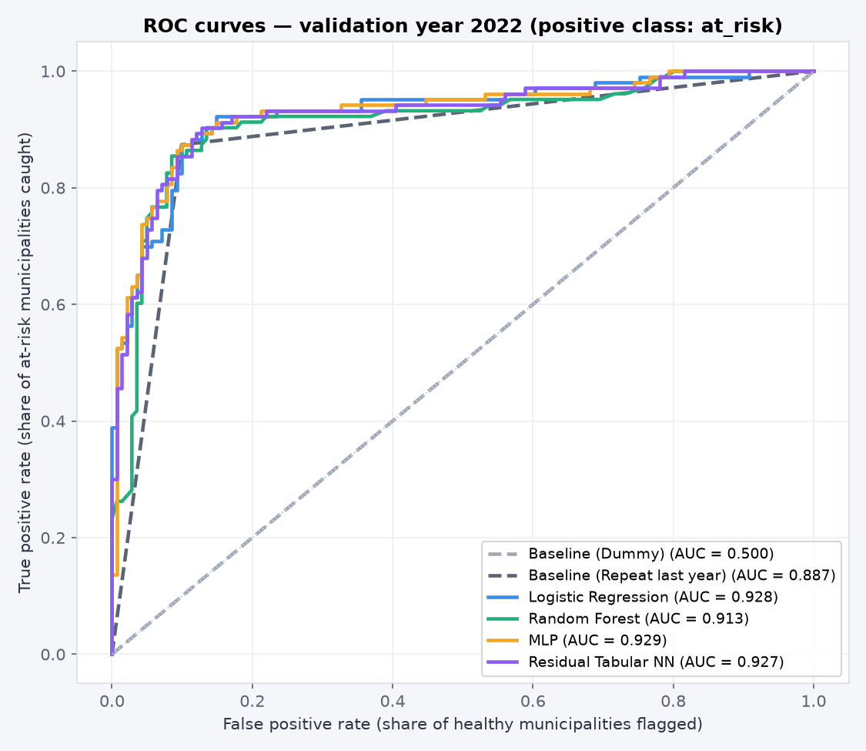  Figure 4.1: ROC curves of all models on one figure (validation 2022, positive class at_risk). | All four substantive models lie close together (AUC 0.913–0.929) and well above the dummy baseline (0.500). The "repeat last year" rule has a single operating point, so its curve is a two-segment line (AUC 0.887). Precision–recall curves are in Figure A.2.

4.3 Model comparison and provisional champion
Variability was estimated with walk-forward (expanding-window) cross-validation inside the training years: train on 2018 and score 2019, train on 2018–2019 and score 2020, train on 2018–2020 and score 2021. This respects time order, so a model is never scored on a year earlier than its training data.
Model | Val macro-F1 | Val ROC-AUC | CV macro-F1 (mean ± SD) | Fold 2019 | Fold 2020 | Fold 2021
Baseline (Dummy) | 0.366 | 0.500 | 0.331 ± 0.033 | 0.325 | 0.301 | 0.366
Baseline (Repeat last year) | 0.887 | 0.887 | 0.873 ± 0.025 | 0.870 | 0.899 | 0.850
Logistic Regression | 0.887 | 0.928 | 0.870 ± 0.023 | 0.866 | 0.895 | 0.850
Random Forest | 0.878 | 0.913 | 0.866 ± 0.020 | 0.866 | 0.886 | 0.845
MLP | 0.879 | 0.929 | 0.752 ± 0.182 | 0.866 | 0.542 | 0.850
Residual Tabular NN | 0.879 | 0.927 | 0.742 ± 0.196 | 0.861 | 0.516 | 0.850
Table 4.3: Validation scores and walk-forward cross-validation (macro-F1) for every model.
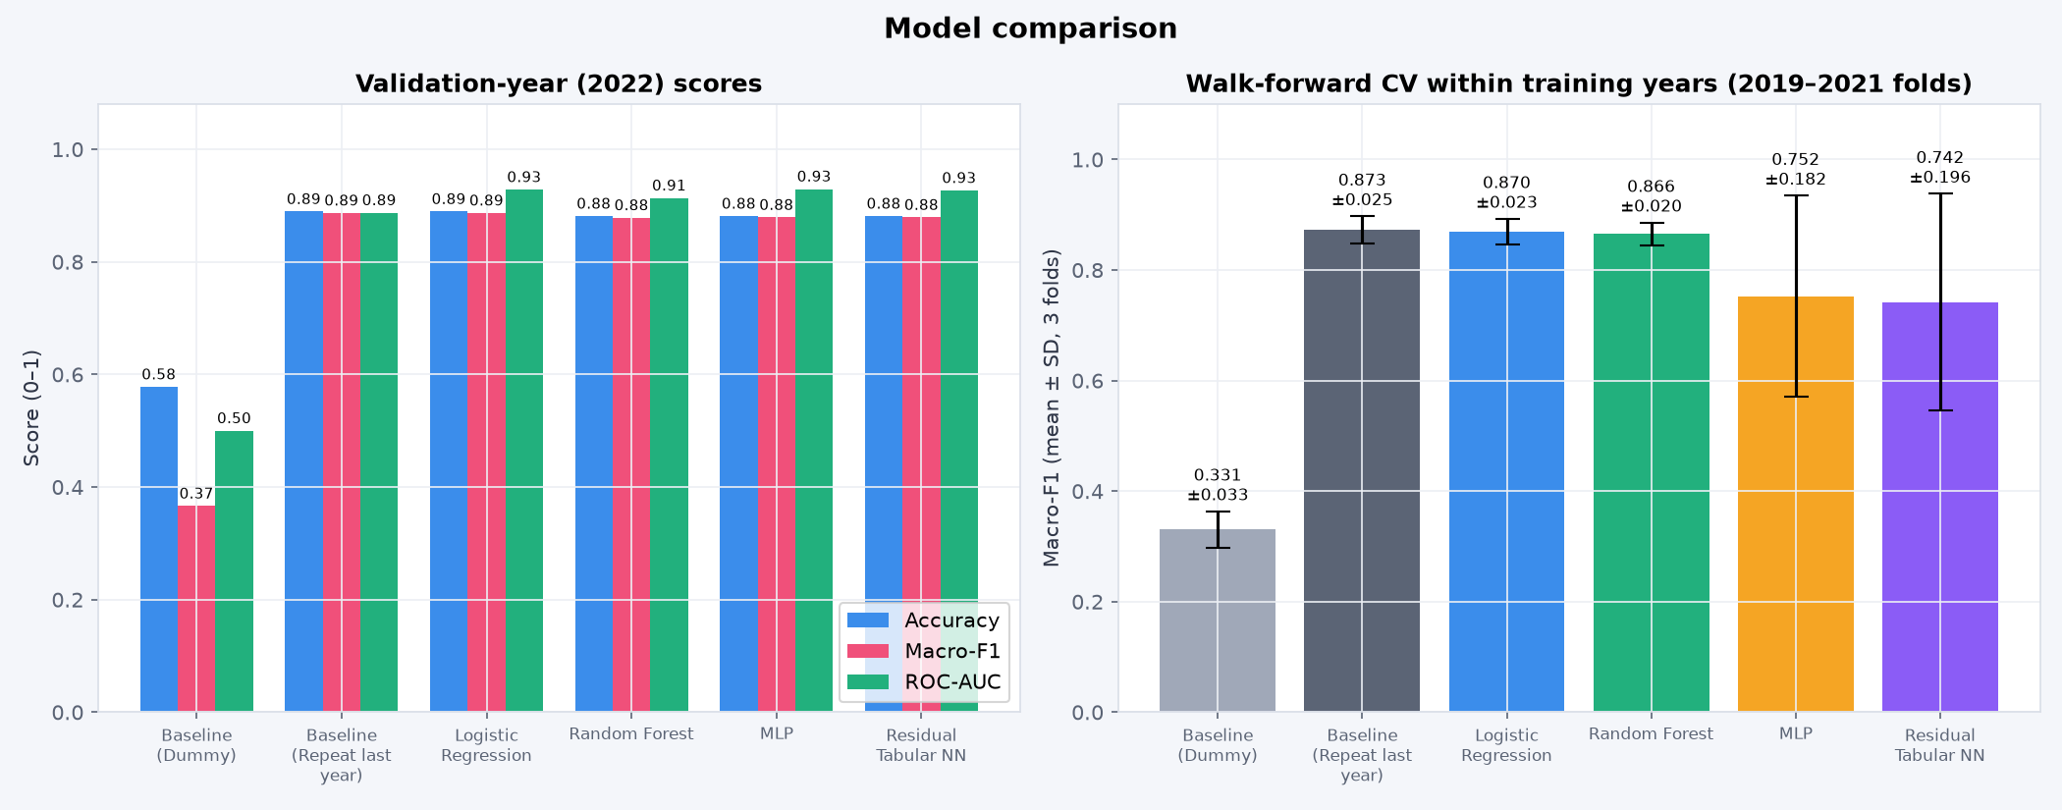
Figure 4.2: Model comparison: validation scores (left) and cross-validation mean ± SD (right).
Provisional champion: Logistic Regression, selected on validation performance only (the test year was not used): the highest validation macro-F1 of the four models (0.887), the highest PR-AUC (0.922) and stable cross-validation (0.870 ± 0.023). The MLP and residual network tie for second on macro-F1 (0.879) but are unstable (SD about 0.18–0.20): in the fold trained only on 2018–2019 their macro-F1 collapsed to 0.54 and 0.52. With fewer than 1,000 rows, the simpler model is the more reliable choice. The baselines are shown for context and are not eligible.

4.4 Overfitting diagnosis and controls
Model | Train macro-F1 | Validation macro-F1 | Gap (train − validation)
Baseline (Dummy) | 0.346 | 0.366 | −0.020
Baseline (Repeat last year) | 0.865 | 0.887 | −0.022
Logistic Regression | 0.865 | 0.887 | −0.022
Random Forest | 1.000 | 0.878 | +0.122
MLP | 0.869 | 0.879 | −0.010
Residual Tabular NN | 0.868 | 0.879 | −0.011
Table 4.4: Train-versus-validation macro-F1 gap. Learning curves and neural loss/accuracy curves: Figures A.3 and A.4.
Random Forest overfits: it scores 1.000 on the training years but 0.878 on validation (gap 0.122), and its learning curve stays at 1.0 for every training size. Fully grown trees memorise the training rows; limiting depth or raising min_samples_leaf would reduce this, but the model was not selected, so it was not tuned further. Logistic Regression and both networks show no meaningful overfitting. Their gaps are slightly negative (−0.010 to −0.022) because the 2022 validation year is slightly easier (the repeat-last-year rule scores 0.887 in 2022 against 0.865 over 2018–2021), and their learning curves flatten after about 400 rows.
Controls used: regularisation in Logistic Regression; dropout 0.2, class-weighted loss, weight decay 0.0001 (residual network) and early stopping (patience 10) in the networks. Early stopping monitors a 15% slice of the training years, not the validation year. The MLP's best epoch was 13 (stopped at 23) and the residual network's 8 (stopped at 18); training and early-stopping losses level off together without diverging (Figure A.4).

Question 5: Champion optimisation

5.1 Search method, search space and scoring rule
Only the validation champion, Logistic Regression, was optimised, with Optuna (Akiba et al., 2019) using the Tree-structured Parzen Estimator sampler (seed 42) for 60 trials. Trial 0 was fixed to the untuned configuration so the default appears in the search history (Figure A.5).
Hyper-parameter | Search range | Why it was searched
C (inverse regularisation) | 0.001 – 100, log scale | Strength of coefficient shrinkage
Penalty | L2, L1, elastic-net (l1_ratio 0.05 – 0.95) | L1 can switch off weak features
Class weight | balanced, none | Imbalance treatment
Scaler | standard, robust | Robust scaling is less sensitive to the outliers of Q2.1
Table 5.1: Optuna search space.
Scoring rule: the mean macro-F1 over the three walk-forward folds inside the training years (2019, 2020, 2021).

5.2 Validation protocol and before/after comparison
Every trial was scored only on folds drawn from 2018–2021; neither the 2022 validation year nor the 2023 test year was used for tuning. The validation year was used afterwards only to report the comparison.
Configuration | CV macro-F1 | Val accuracy | Val macro-F1 | Val recall (at risk) | Val ROC-AUC | Val PR-AUC
Default (C = 1, L2, balanced) | 0.870 ± 0.023 | 0.889 | 0.887 | 0.874 | 0.928 | 0.922
Tuned (C = 0.074, L1, balanced, standard scaler) | 0.874 ± 0.025 | 0.889 | 0.887 | 0.874 | 0.919 | 0.910
Table 5.2: Logistic Regression before and after optimisation.
Tuning improved the cross-validation macro-F1 by only +0.004, smaller than the fold-to-fold standard deviation (about 0.025), so it is not a meaningful improvement; validation macro-F1 did not change and validation ROC-AUC fell slightly (0.928 → 0.919) because the search optimised macro-F1, not ranking. The tuned configuration was kept because the scoring rule was fixed before the search. Its practical effect is a simpler model: the L1 penalty set five of the nine ratios to exactly zero. The final coefficients (standardised inputs) are: last year at_risk +1.688 and not_at_risk −1.710; cash coverage −0.145; repairs and maintenance −0.115; operating surplus −0.100; total revenue −0.029; the other five ratios 0.000.

5.3 Final locked pipeline: one-time test evaluation
The tuned pipeline (preprocessing and model together) was locked, refit on 2018–2022 and evaluated once on the 240 municipalities of the 2023 test year (predicting their 2024 audit). It is saved as models/final_pipeline.joblib, the exact object used by the interface (Q7).
Model | Accuracy | Macro-F1 | Precision (at risk) | Recall (at risk) | ROC-AUC | PR-AUC
Tuned Logistic Regression (locked) | 0.908 | 0.906 | 0.909 | 0.874 | 0.896 | 0.862
Repeat-last-year rule (reference) | 0.908 | 0.906 | 0.909 | 0.874 | 0.904 | 0.849
Table 5.3: The single test-set evaluation (2023 → 2024, n = 240). Confusion matrix: Figure A.6.
On unseen data the model is accurate (90.8%) and generalises without loss: test macro-F1 (0.906) is at least as high as validation (0.887). It caught 90 of the 103 municipalities whose next audit was poor and raised 9 false alarms among 137 healthy ones.
Is the improvement practically meaningful? Against the baselines, only partly. The tuning gain is negligible. The locked model's yes/no predictions on the test year are identical to the repeat-last-year rule, and its test ROC-AUC (0.896) is slightly lower than the rule's (0.904), while PR-AUC is slightly higher (0.862 vs 0.849). All 22 test errors are municipalities whose status changed: the 13 missed municipalities were not at risk in 2023 but failed in 2024, and the 9 false alarms improved. The practical value is a consistent, explainable and documented risk score for prioritising support, not better detection of sudden deterioration.

Question 6: Ablation study and statistical validation

6.1 Controlled ablations
Five ablations were run on the tuned champion. Each changes exactly one component while the split (fit 2018–2021), seed (42) and evaluation protocol (2022 validation year plus walk-forward cross-validation) stay fixed; the 2023 test year was not reused.
Experiment | Val macro-F1 | Δ macro-F1 | Val ROC-AUC | Δ ROC-AUC | Val recall | CV macro-F1
Full tuned champion (reference) | 0.887 | +0.000 | 0.919 | +0.000 | 0.874 | 0.874
A1: remove audit-history feature | 0.692 | −0.195 | 0.748 | −0.171 | 0.680 | 0.647
A2: remove the nine financial ratios | 0.887 | +0.000 | 0.887 | −0.032 | 0.874 | 0.873
A3: remove imbalance treatment | 0.887 | +0.000 | 0.919 | +0.000 | 0.874 | 0.874
A4: remove the scaling step | 0.627 | −0.260 | 0.682 | −0.237 | 0.709 | 0.648
A5: swap L1 regulariser for L2 | 0.887 | +0.000 | 0.927 | +0.008 | 0.874 | 0.871
Table 6.1: Ablation results (Δ = change relative to the full tuned champion).
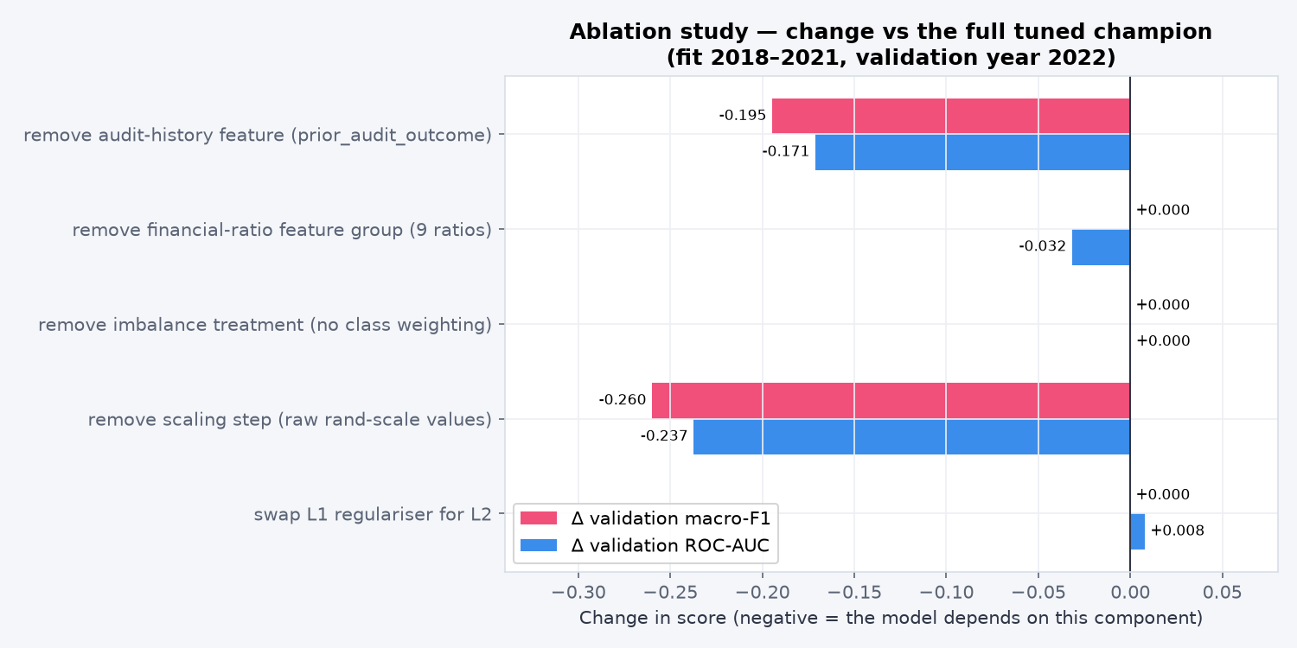
Figure 6.1: Change in validation macro-F1 and ROC-AUC for each ablation.
- A1, remove audit history: macro-F1 falls by 0.195 and ROC-AUC by 0.171, the model's main dependency. The ratios alone still reach macro-F1 0.692, well above the dummy baseline (0.366), so they carry real but weaker signal.
- A2, remove all nine ratios: macro-F1 is unchanged but ROC-AUC falls by 0.032: the ratios change no yes/no decision; they only refine the ordering of municipalities within each outcome group.
- A3, remove class weighting: no change; the 58/42 split is mild enough that imbalance treatment is unnecessary here.
- A4, remove scaling: the largest drop (macro-F1 −0.260, ROC-AUC −0.237). Revenue and expenditure are in billions of rand, so without standardisation the L1 penalty shrinks the useful features unevenly.
- A5, L2 instead of L1: macro-F1 unchanged and ROC-AUC +0.008; L1 was kept because it produces a smaller model that is easier to explain.
What the system depends on: first, last year's audit outcome; second, correct scaling of the inputs. The financial ratios add only ranking information; imbalance treatment and the regulariser type matter little.

6.2 McNemar's test: champion vs strongest comparator
The optimised champion was compared with the strongest comparator, the MLP (tied with the residual network for the best non-champion validation macro-F1, and with the higher ROC-AUC). Both were fit on 2018–2022 and predicted the same 240 test municipalities (paired predictions: results/q6_paired_test_predictions.csv).
 | MLP correct | MLP wrong | Total
Champion correct | 217 | 1 | 218
Champion wrong | 0 | 22 | 22
Total | 217 | 23 | 240
Table 6.2: McNemar 2 × 2 correctness table on the test year (b = champion only correct, c = MLP only correct).
H₀: the two models have the same error rate on these municipalities (P(b) = P(c)). H₁: the error rates differ (two-sided). α = 0.05. There is only 1 discordant pair (b = 1, c = 0), far below the usual threshold of 25, so the exact binomial version of the test (McNemar, 1947) is used instead of the chi-square approximation: statistic = min(b, c) = 0, exact p = 1.0000, so H₀ is not rejected.
Statistical vs practical significance. There is no evidence that the tuned champion is more accurate than the MLP; they disagree on a single municipality. The practical difference is also negligible: accuracy 90.8% vs 90.4% and macro-F1 0.906 vs 0.902. Logistic Regression is justified by simplicity, explainability and stability (CV SD 0.025 vs 0.18), not by superior accuracy. A McNemar test against the repeat-last-year rule would be uninformative, because the two give identical predictions (b = c = 0).

Question 7: User-interface deployment

7.1 Working user interface
The final optimised model is deployed as an interactive Streamlit web application (app/app.py; Streamlit Inc., n.d.) styled as a KPI dashboard. Its pages are: Overview (test-year KPIs, the forecast for the next audit, trend, highest-risk municipalities, leaderboard), Explorer (filter all municipalities by audit year, province, type, last opinion and risk band), Municipality profile (one page per municipality), Risk check (the prediction tool), Model evidence and About & responsible use. Every ring, gauge and chart on the overview opens a more detailed view (Table A.1); screenshots are in Appendix D. A notebook cell is not used anywhere.

7.2 Input, prediction pipeline and output
Every prediction runs the saved end-to-end pipeline (models/final_pipeline.joblib), so imputation, scaling, encoding and the tuned model behave exactly as in Q5; nothing is retrained in the app. Users can pick a municipality (its latest audited figures, 2024, forecast the 2025 audit), enter figures in a form with units and help text, or upload a CSV of up to 500 municipalities with a downloadable result. Each prediction shows the predicted class, the probability of a poor audit on a gauge, a confidence band (high, moderate or close call around the 50% threshold) and a plain-language explanation of the two or three features that pushed it most (coefficient × standardised value), for example "Operating surplus / deficit of −R1.43 bn (typical: −R26.3 m) raises the risk" (Figure A.13).
Forecasting the next audit. The raw extracts already contain audited 2024 statements and 2024 audit opinions, so src/forecast_next.py rebuilds the features for 2018–2024 with the same feature-engineering code, checks that the rebuilt 2018–2023 features equal modeling_dataset.csv exactly (1,434 of 1,434 rows) and that the 2023 scores equal the Q5 test predictions, then scores every municipality-year with the locked pipeline. The 245 rows for 2024 are a genuine forecast of the 2025 audit: 106 municipalities are forecast at risk, 102 of them at 80% or more.
  Figure 7.1: Profile of Emfuleni (GT421): 85.4% forecast risk for 2025, ranked #17 of 245 nationally. | Municipality profile. Clicking any municipality opens a profile (shareable as /municipality?code=GT421) with the forecast, its gauge, explanation and national and province rank; the risk history for 2019–2025 coloured by what actually happened (training years shaded, so in-sample points are not mistaken for forecasts); the audit opinion for every year; six financial-health trends against the national median; and a peer table against the province, municipality-type and national medians and the MFMA Circular 71 norms (National Treasury, 2014).  The forecast also shows the main limitation openly: no municipalities are forecast to change status between 2024 and 2025.

7.3 Input validation and safeguards
Check | Response
Text where a number is expected; revenue or expenditure missing, zero or negative; unrecognised audit outcome | Error naming the row and field (and the accepted values); the row is not scored
Required columns missing, empty file, or more than 500 rows | Error explaining the expected format
Ratio left blank; value outside the 1st–99th percentile of training data; surplus inconsistent with revenue − expenditure | Warning (training median used; extra caution; recalculated)
Table 7.1: Input validation rules (Figure A.7 shows an invalid entry being rejected).
A column guide and help tooltips explain every feature, its unit and the relevant Treasury norm. Every prediction carries a notice that a flag means "look closer and offer support", not "this municipality has failed", the profile warns that raw Municipal Money figures can contain errors, and the About page lists limitations and when not to use the model. The app needs no credentials, stores nothing and holds no personal data.

7.4 Deployment instructions and demonstration
The app is launched locally with streamlit run app/app.py after python -m venv .venv, activating it and pip install -r requirements.txt (README.md; a slimmer app/requirements.txt without PyTorch is used for hosting). It can be hosted on Streamlit Community Cloud from the repository (README, section "Live demo and deployment"). A smoke test (python app/test_app.py) opens every page and dialog; all 19 checks pass. The demonstration files are in app/samples:
Case | Input | Output
Valid 1: Masilonyana (FS181) | Prior opinion disclaimer, cash coverage −23.7 months, irregular expenditure 1,271% | At risk, 89.9%, high confidence (warnings for unusual values)
Valid 2: eThekwini (ETH) | Prior opinion unqualified with findings, revenue R48.9 bn, cash coverage 0.9 months | Not at risk, 9.2%, high confidence
Valid 3: Tsantsabane (NC085) | Prior opinion qualified, cash coverage 0.4 months, repairs and maintenance 30.6% | At risk, 77.2%, moderate confidence
Invalid: invalid_case.csv | Revenue "four hundred million", expenditure 0, prior outcome "maybe" | Rejected with three specific error messages; nothing scored
Table 7.2: Demonstration cases: three valid and one invalid (the sample CSV holds 2023 figures, i.e. predictions for the 2024 audit).

Question 8: Recommendation, reproducibility and team defence

8.1 Recommendation for National Treasury
Recommendation. Treasury's local government support function should use the model as a consistent, explainable triage list for municipalities that are already in difficulty, not as an early-warning system. For the 2025 audit it flags 106 of 245 municipalities, 102 of them at 80% or more: the municipalities where support (finance secondments, closer oversight, Financial Management Grant conditions) is most likely to be needed. The dashboard profiles give officials the history, indicators and peer comparison to decide what kind of support each needs. The model's decisions are the same as "repeat last year's outcome" and McNemar's test found no difference from the next-best model, so its value is that it is documented, calibrated, explainable and reproducible, and brings each municipality's data into one place.
Finding | Evidence | What it means for Treasury
Accuracy with uncertainty | Bootstrap (Efron, 1979): macro-F1 0.906 (95% CI 0.866–0.941); recall 0.874 (95% CI 0.802–0.934); precision 0.909 (95% CI 0.851–0.963) | Roughly 8 to 9 in 10 failing municipalities are flagged; about 1 flag in 10 is a false alarm.
Calibration | Brier score 0.088; predicted about 84–85% in the high-risk bins against 90–92% observed (Figure A.8) | Probabilities can be read roughly at face value; high-risk scores slightly understate the risk.
Status changes are missed | Test year: 22 municipalities changed status; accuracy 0% on them vs 100% on the rest | About 22 municipalities can be expected to change status in 2025; each will be misclassified.
Ranking is no early warning | Of 141 clean municipalities in 2023, the top 10% by risk (14) held 2 of the 13 that deteriorated (base rate 9%) | A model-based watch list of clean municipalities is not supported by the evidence.
Table 8.1: Evidence behind the recommendation (test year: 2023 figures → 2024 audit).
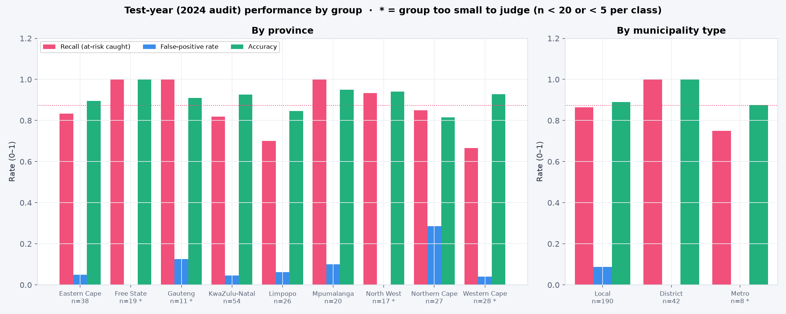  Figure 8.1: Recall, false-positive rate and accuracy by province and municipality type (test year). | Fairness. Province and type are not model inputs, but performance differs. Northern Cape has the highest false-alarm rate (28.6% of its healthy municipalities flagged, against 4.7%–10.0% in the other provinces large enough to judge), because several improved after a poor audit. Limpopo has the lowest recall (70.0%): 3 of its 10 failing municipalities were missed. Districts were classified perfectly (n = 42). Western Cape, Free State, North West, Gauteng and the metros are too small to judge (marked *). Provinces where outcomes are volatile therefore get more false alarms and missed cases, so flagged lists should be reviewed by province before support is allocated. Full table: Table A.2.
Limitations. The model depends on last year's outcome (Q6.1), so it cannot anticipate change. The financial data is self-reported and sometimes implausible; missing debtor and repairs data before 2020/2019 is recorded as zero; the grants extract appears truncated, so grant dependency is unreliable; and municipalities that fail to submit statements, the highest-risk group, have the least data. Results cover 2018–2024 only.
Monitoring. Each year, when the Auditor-General publishes outcomes: compare the 2025 forecast with them and recompute macro-F1, recall and the false-positive rate overall and by province; retrain on the newest year if macro-F1 falls below 0.866 or recall below 0.802 (the lower confidence bounds); check calibration and the share of municipalities that changed status; and run data-quality checks on each new extract.
Do not use the model to allocate funding or impose interventions automatically; to judge or penalise a municipality or its officials; to predict deterioration in municipalities with a clean audit; for municipalities without audited figures, or after boundary or accounting-standard changes (as with mSCOA) without re-validation; for years after 2025 without retraining; or when the app warns that inputs are outside the range seen in training. To become an early-warning tool it needs in-year quarterly (section 71) data, audit findings, senior-management vacancies and debt-collection trends, and should model the probability of a change in status directly.

8.2 Reproducible package
Requirement | Where it is
README, environment, seeds | README.md; requirements.txt (pinned versions, Python 3.12, PyTorch CPU build); seed 42 for every split, model, search and bootstrap
Execution order | python run_all.py runs all 11 steps in order (Appendix E); each script is named after the question it answers
Source links and data dictionary | README.md and docs/dataset_card.md (Municipal Money site, API documentation, terms of use); docs/data_dictionary.md and reports/data_dictionary.csv
Saved model and interface | models/final_pipeline.joblib (preprocessing and tuned model as one object); app/ (Streamlit code, samples, smoke test)
Evidence bundle | results/ (metric tables, paired McNemar predictions, forecasts), reports/figures/, docs/experiment_log.md, docs/dataset_card.md
Data licence | Municipal Money terms allow reuse, so data/raw is included with attribution; no personal data is included
Table 8.2: Reproducibility checklist.
Reproduction test. The repository was cloned into an empty folder and python run_all.py was run end to end: all 11 steps completed in 4.1 minutes on a laptop CPU without manual intervention, and every regenerated result file (validation and cross-validation metrics, the Optuna result and test evaluation, ablations, McNemar's test, all 1,679 municipality scores and the uncertainty and fairness tables) was identical to the committed version. Only saved model objects, figure images and the dtype label of one column in the data audit differed (serialisation details and a pandas version change).

8.3 Presentation and contribution statement
The 10–12 minute presentation follows this report: problem and stakeholder, data and the leakage-safe split, models and evaluation, optimisation, ablation and McNemar's test, a live dashboard demonstration (three valid municipalities, the invalid file, and a drill-down from the overview to a municipality profile), and the recommendation and limitations. Every member presents the part they led and answers questions on the whole pipeline. A second, plain-language deck (why we chose the project, what it solves, how it works) is provided for non-technical audiences. A one-page contribution statement lists each member's role and specific outputs with evidence from the repository's commit history and is signed by all members.

References
Akiba, T., Sano, S., Yanase, T., Ohta, T. and Koyama, M. (2019) Optuna: A next-generation hyperparameter optimization framework. Proceedings of the 25th ACM SIGKDD International Conference on Knowledge Discovery and Data Mining, pp. 2623–2631.
Auditor-General of South Africa (AGSA) (n.d.) MFMA general reports on local government audit outcomes. Available at: https://www.agsa.co.za
Breiman, L. (2001) Random forests. Machine Learning, 45(1), pp. 5–32.
Efron, B. (1979) Bootstrap methods: another look at the jackknife. The Annals of Statistics, 7(1), pp. 1–26.
Harris, C.R. et al. (2020) Array programming with NumPy. Nature, 585, pp. 357–362.
He, K., Zhang, X., Ren, S. and Sun, J. (2016) Deep residual learning for image recognition. Proceedings of the IEEE Conference on Computer Vision and Pattern Recognition, pp. 770–778.
Hunter, J.D. (2007) Matplotlib: a 2D graphics environment. Computing in Science & Engineering, 9(3), pp. 90–95.
Kingma, D.P. and Ba, J. (2015) Adam: a method for stochastic optimization. 3rd International Conference on Learning Representations (ICLR).
McKinney, W. (2010) Data structures for statistical computing in Python. Proceedings of the 9th Python in Science Conference, pp. 56–61.
McNemar, Q. (1947) Note on the sampling error of the difference between correlated proportions or percentages. Psychometrika, 12(2), pp. 153–157.
National Treasury (2014) MFMA Circular No. 71: Uniform financial ratios and norms. Pretoria: National Treasury.
National Treasury (n.d.-a) Municipal Money: Municipal Finance Data. Available at: https://municipaldata.treasury.gov.za (now https://municipalmoney.gov.za).
National Treasury (n.d.-b) Municipal Finance Data API documentation. Available at: https://municipaldata.treasury.gov.za/docs
National Treasury (n.d.-c) Municipal Money Terms of Use. Available at: https://municipaldata.treasury.gov.za/terms
Paszke, A. et al. (2019) PyTorch: an imperative style, high-performance deep learning library. Advances in Neural Information Processing Systems, 32.
Pedregosa, F. et al. (2011) Scikit-learn: machine learning in Python. Journal of Machine Learning Research, 12, pp. 2825–2830.
Plotly Technologies Inc. (n.d.) Plotly Python graphing library. Available at: https://plotly.com/python/
Republic of South Africa (2003) Local Government: Municipal Finance Management Act 56 of 2003. Pretoria: Government Printer.
Republic of South Africa (2013) Protection of Personal Information Act 4 of 2013. Pretoria: Government Printer.
Saito, T. and Rehmsmeier, M. (2015) The precision-recall plot is more informative than the ROC plot when evaluating binary classifiers on imbalanced datasets. PLOS ONE, 10(3), e0118432.
Seabold, S. and Perktold, J. (2010) statsmodels: econometric and statistical modeling with Python. Proceedings of the 9th Python in Science Conference.
Srivastava, N., Hinton, G., Krizhevsky, A., Sutskever, I. and Salakhutdinov, R. (2014) Dropout: a simple way to prevent neural networks from overfitting. Journal of Machine Learning Research, 15, pp. 1929–1958.
Streamlit Inc. (n.d.) Streamlit. Available at: https://streamlit.io
Tibshirani, R. (1996) Regression shrinkage and selection via the lasso. Journal of the Royal Statistical Society: Series B, 58(1), pp. 267–288.
Virtanen, P. et al. (2020) SciPy 1.0: fundamental algorithms for scientific computing in Python. Nature Methods, 17, pp. 261–272.

Appendices

Appendix A: Additional evaluation figures (Question 4)
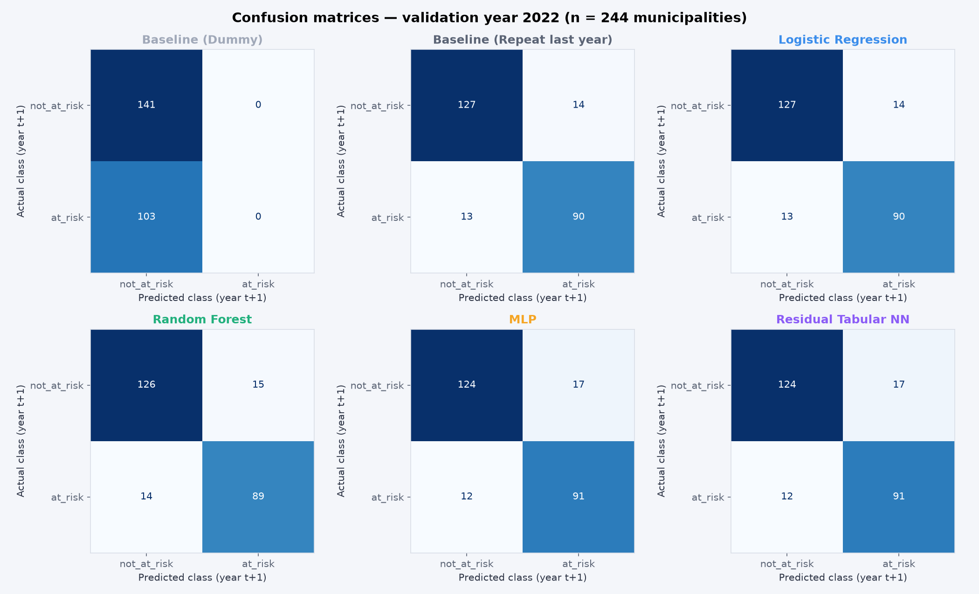
Figure A.1: Confusion matrices for both baselines and all four models, validation year 2022 (n = 244).
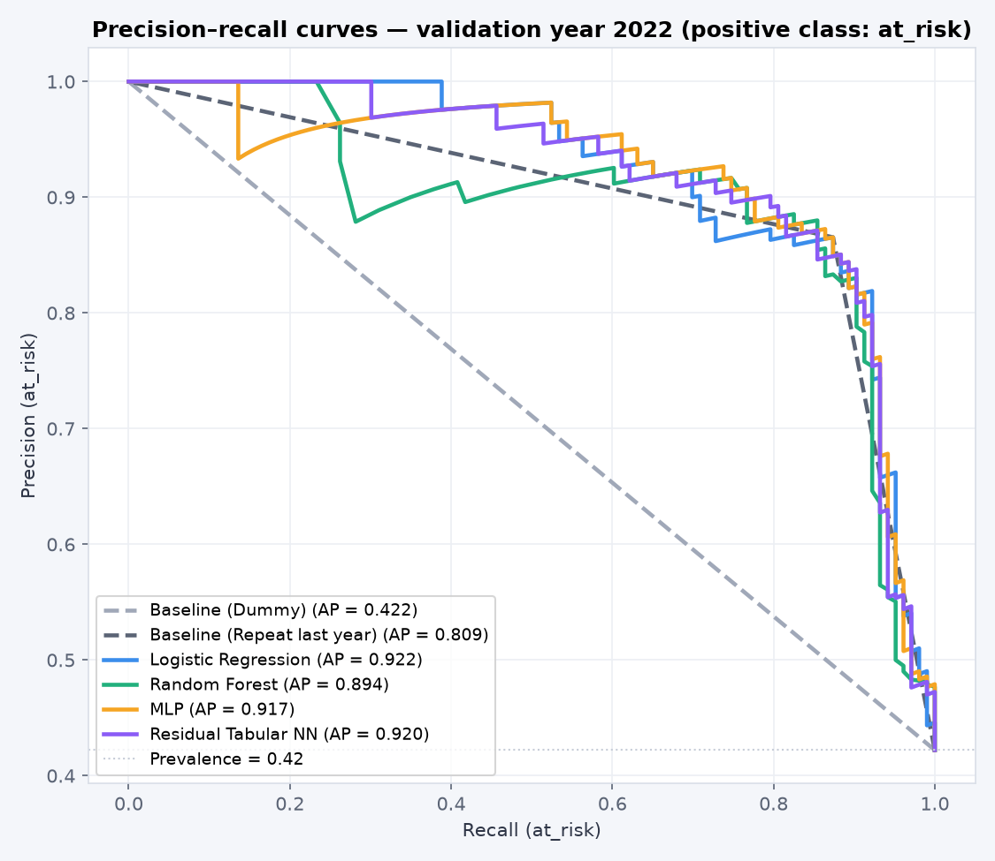
Figure A.2: Precision–recall curves, validation 2022 (positive class at_risk).
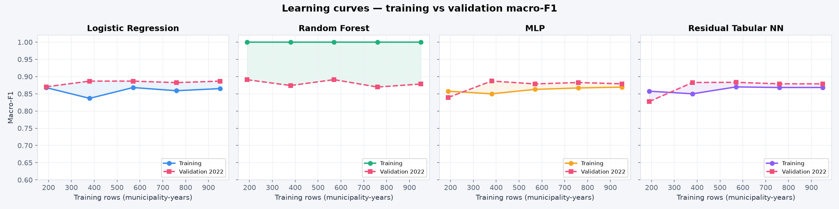
Figure A.3: Learning curves: training vs validation macro-F1 as the training set grows.
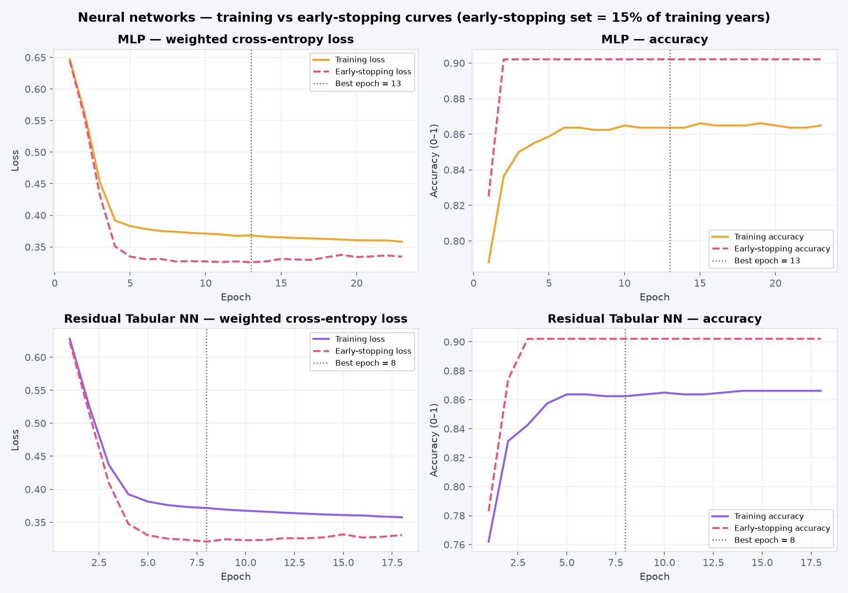
Figure A.4: Neural networks: training vs early-stopping loss and accuracy per epoch (early-stopping slice = 15% of the training years).

Appendix B: Optimisation and test-year figures (Question 5)
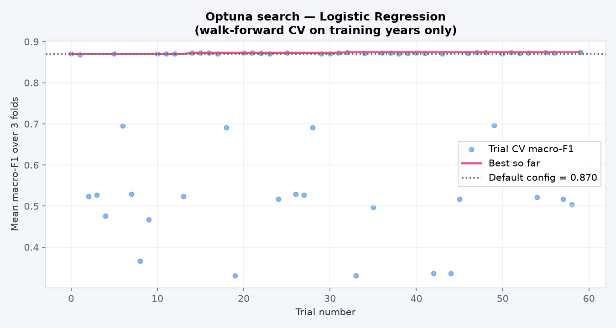  Figure A.5: Optuna optimisation history (each dot is a trial; the line is the best so far). | 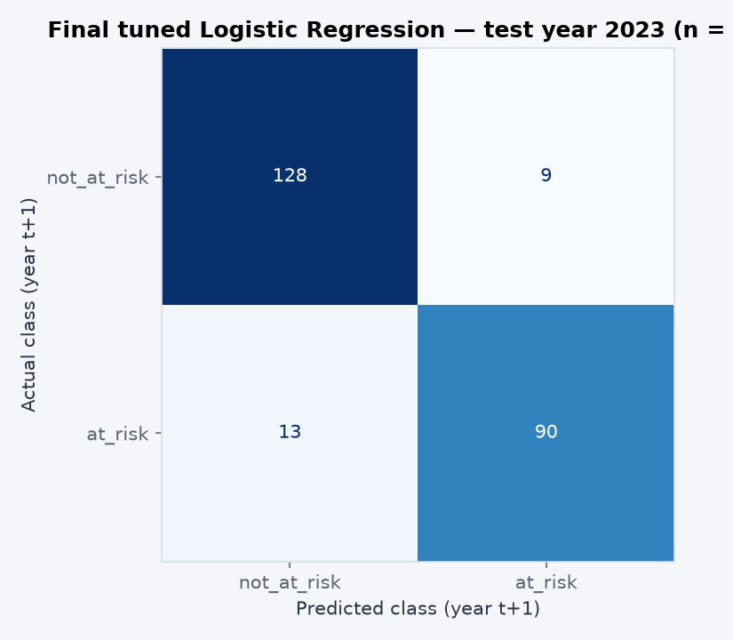  Figure A.6: Confusion matrix of the locked model on the 2023 test year.

Appendix C: Fairness detail and calibration (Question 8)
Group | n | Actually at risk | Flagged | Accuracy | Recall | False-positive rate | Judge?
KwaZulu-Natal | 54 | 11 | 20.4% | 92.6% | 81.8% | 4.7% | yes
Eastern Cape | 38 | 18 | 42.1% | 89.5% | 83.3% | 5.0% | yes
Western Cape | 28 | 3 | 10.7% | 92.9% | 66.7% | 4.0% | too small
Northern Cape | 27 | 20 | 70.4% | 81.5% | 85.0% | 28.6% | yes
Limpopo | 26 | 10 | 30.8% | 84.6% | 70.0% | 6.3% | yes
Mpumalanga | 20 | 10 | 55.0% | 95.0% | 100.0% | 10.0% | yes
Free State | 19 | 13 | 68.4% | 100.0% | 100.0% | 0.0% | too small
North West | 17 | 15 | 82.4% | 94.1% | 93.3% | 0.0% | too small
Gauteng | 11 | 3 | 36.4% | 90.9% | 100.0% | 12.5% | too small
Local (type) | 190 | 88 | 44.7% | 88.9% | 86.4% | 8.8% | yes
District (type) | 42 | 11 | 26.2% | 100.0% | 100.0% | 0.0% | yes
Metro (type) | 8 | 4 | 37.5% | 87.5% | 75.0% | 0.0% | too small
Table A.2: Test-year performance by province and municipality type (groups under 20 municipalities, or under 5 per class, are too small to judge).
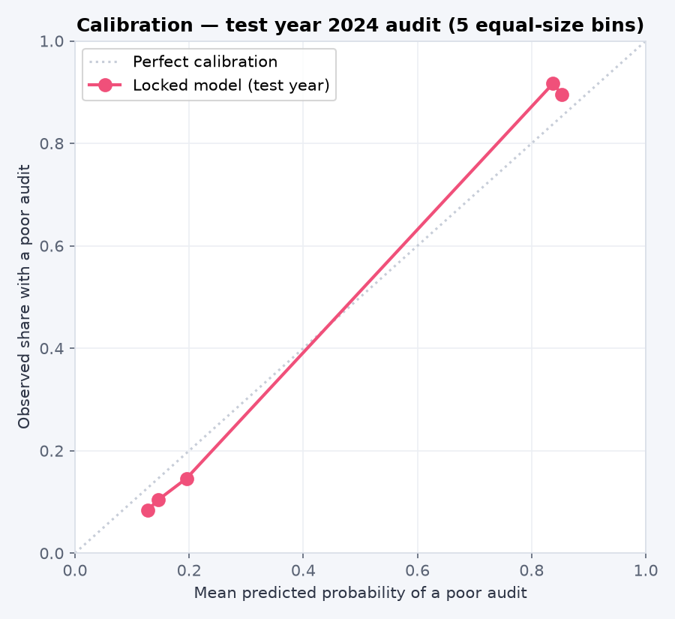
Figure A.8: Calibration of the locked model on the test year (5 equal-size bins).

Appendix D: Dashboard (Question 7)
Click on | Opens
Macro-F1 ring → Details | Precision, recall and F1 for each class in the 2024 test year
Recall ring → Details | The at-risk municipalities that were caught and the 13 that were missed, with their before-and-after opinions
Precision ring → Details | The correct flags and the false alarms
ROC-AUC ring → Details | How predicted risk is spread for municipalities that did and did not fail
Forecast gauges → See list | The municipalities flagged for 2025, those at 80% or more, and those forecast to change status
A point on the trend chart | That audit year's opinion breakdown and at-risk share by province
A top-10 bar or a table row | That municipality's profile
A province or category bar | The Explorer, filtered accordingly
A leaderboard bar | That model's confusion matrix and cross-validation folds
Table A.1: Drill-down interactions in the dashboard.

Figure A.9: Overview page with test-year KPIs, the 2025 forecast, trend, highest-risk list and leaderboard.

Figure A.10: Explorer with filters, clickable category charts, the municipality table and the biggest risk increases.
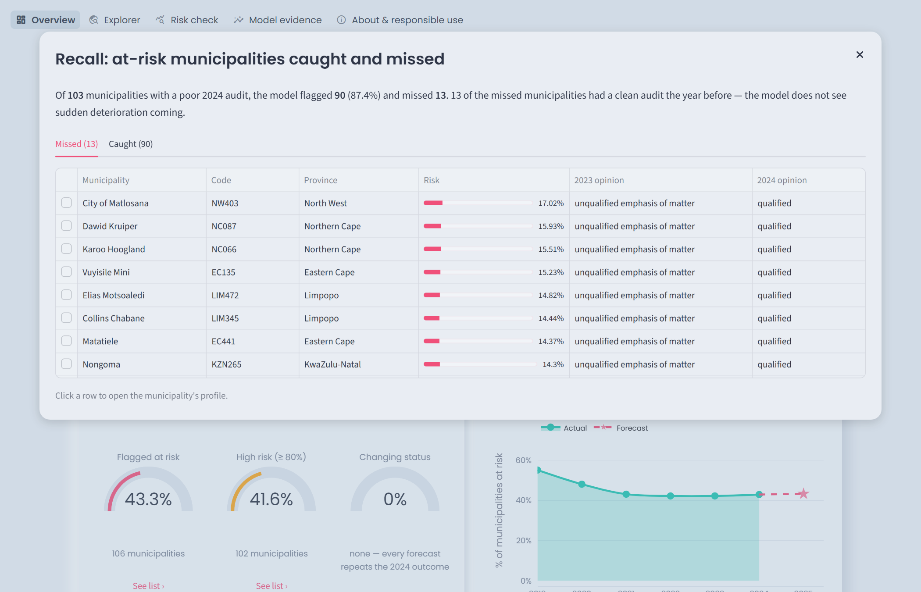
Figure A.11: Recall details: the 13 at-risk municipalities missed in the test year (every one had a clean audit the year before).
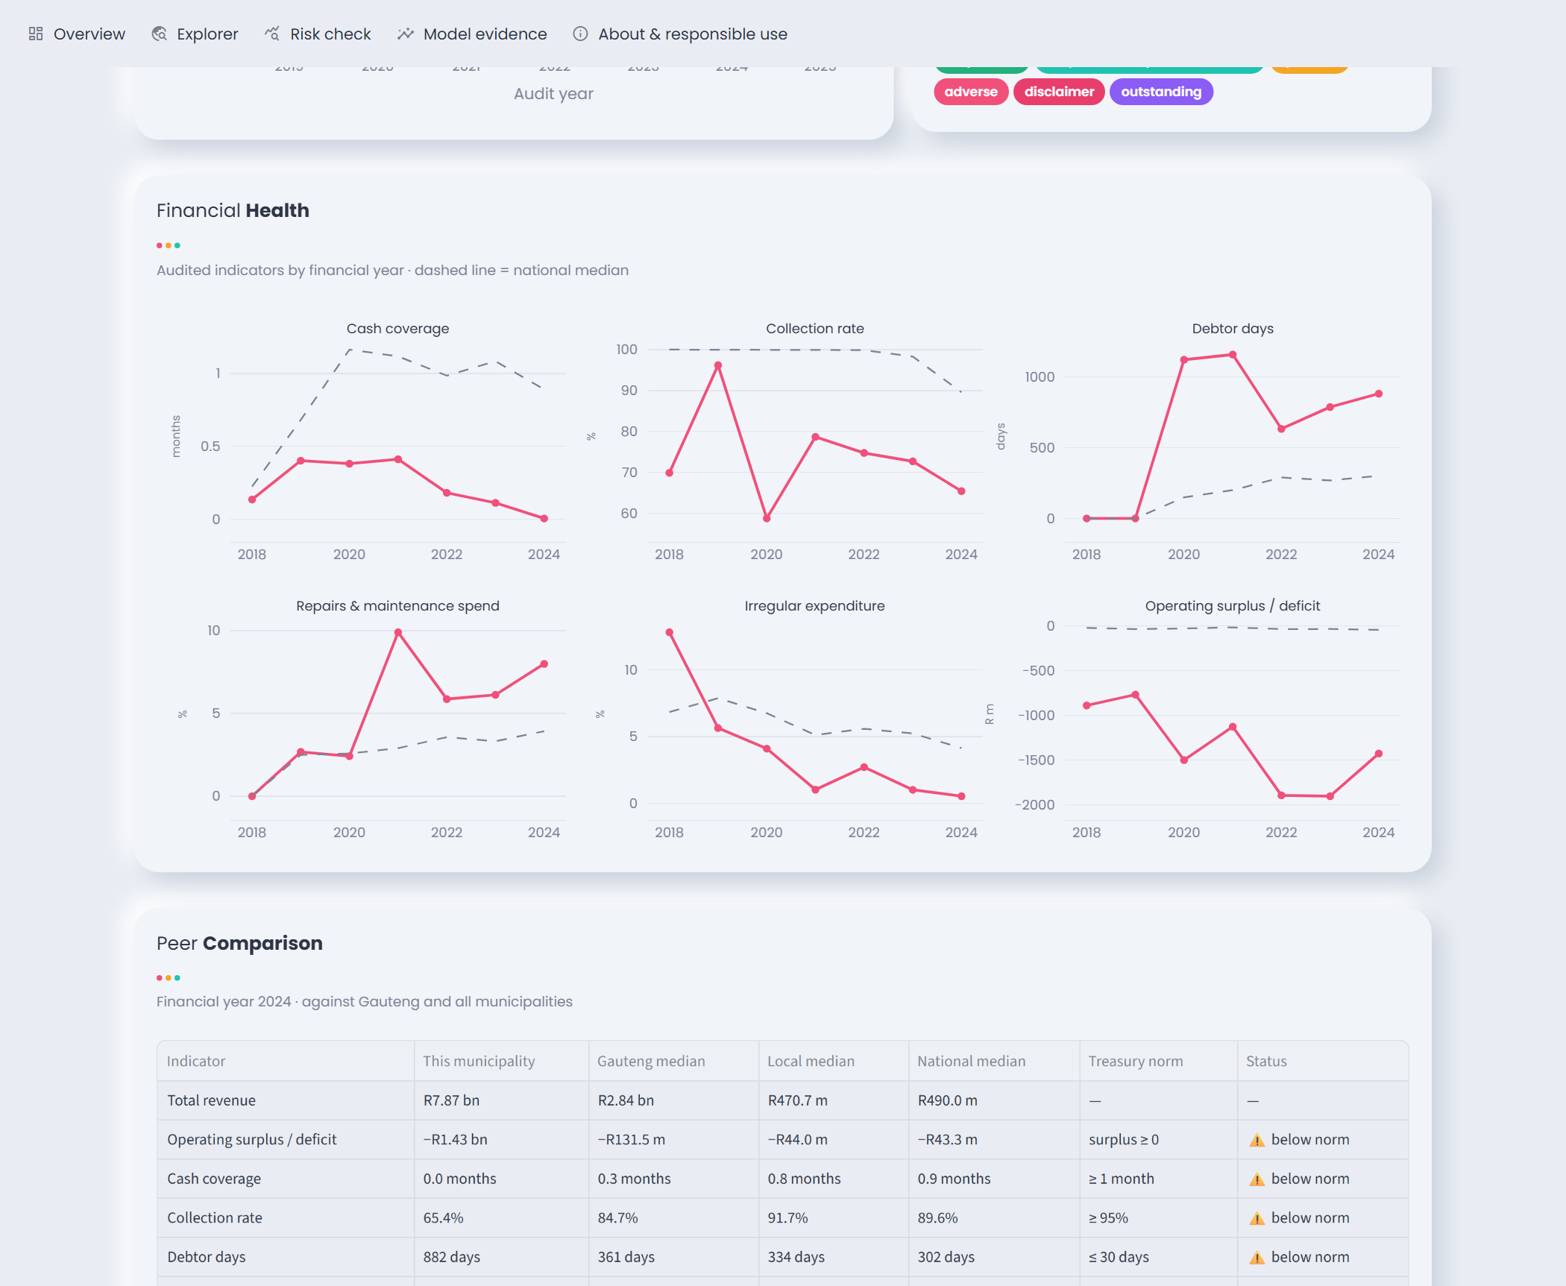
Figure A.12: Profile of Emfuleni: financial-health trends against the national median and the peer comparison against Treasury norms.

Figure A.13: Risk check: forecast for Emfuleni with the predicted class, probability gauge, confidence, plain-language reasons and feature contributions.
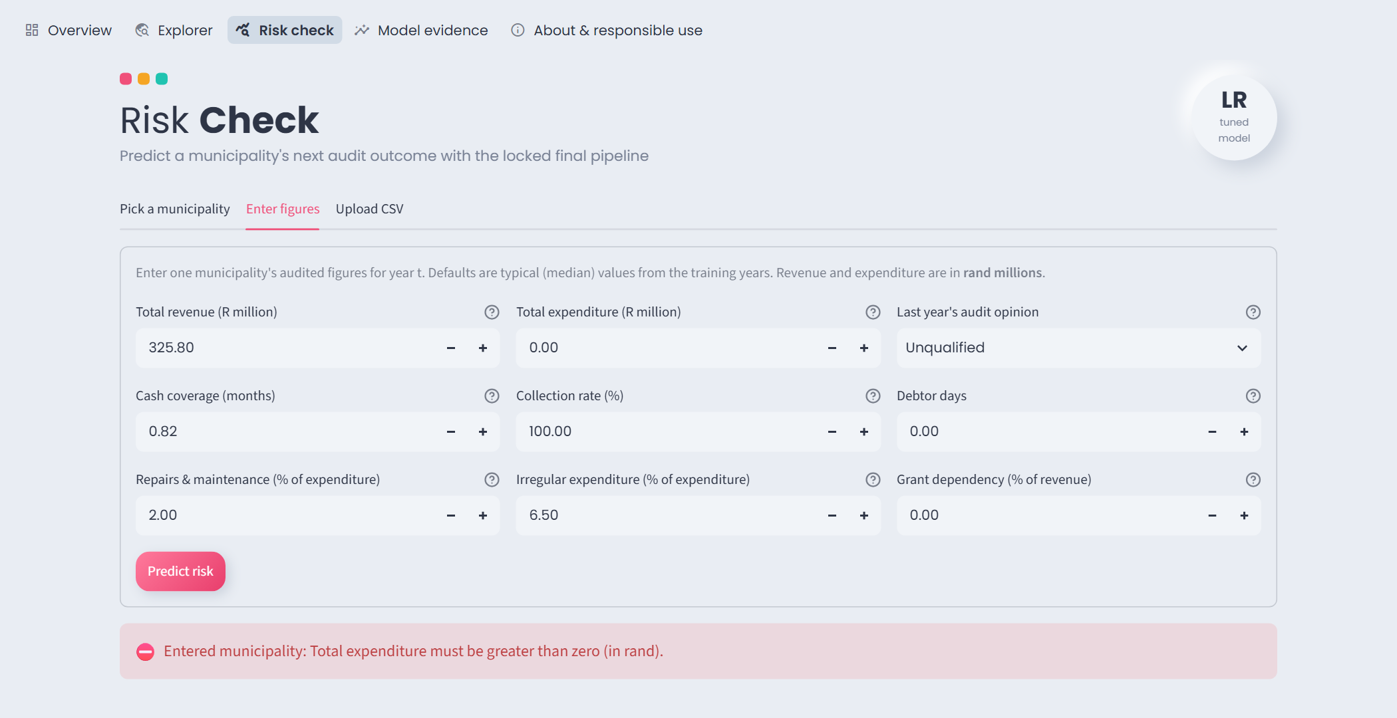
Figure A.7: Invalid manual input (total expenditure = 0) rejected with a clear error message.

Appendix E: Execution order
python run_all.py runs these steps in order from the project root (about 4 minutes on a laptop CPU); seed 42 throughout.
Step | Script | Question
(optional) | src/build_modeling_dataset.py: download the cubes and build the modelling dataset (needs internet) | Q2
1 | src/audit_q21_v2.py: data audit → reports/data_dictionary.csv, reports/audit_report.txt | Q2.1
2 | src/visualize_q22_v2.py: five EDA figures | Q2.2
3 | src/split_q23_v2.py: time split (train 2018–2021, validation 2022, test 2023) | Q2.3
4 | src/pipeline_q24.py: preprocessing fit on training rows only | Q2.4
5 | src/train_q3.py: baselines and the four models | Q3
6 | src/evaluate_q4.py: metrics, ROC/PR, cross-validation, overfitting | Q4
7 | src/optimise_q5.py: Optuna tuning and the only use of the 2023 test year | Q5
8 | src/ablation_mcnemar_q6.py: ablations and McNemar's test | Q6
9 | src/forecast_next.py: score every municipality-year and forecast the 2025 audit | Q7
10 | src/fairness_q8.py: bootstrap intervals, calibration, fairness by province and type | Q8
11 | src/experiment_log.py: regenerate docs/experiment_log.md | Q8
Table A.3: Execution order.

