Question 2
Data audit, visualisation, data splitting and preparation pipeline
IDA117V Group Project · Predicting municipal audit risk one audit cycle ahead · 18 marks
Dataset used in this question. The analysis file (modeling_dataset.csv) holds 1,434 municipality-year records. Each record describes one municipality in financial year t (2018 to 2023) through financial indicators built from National Treasury’s Municipal Money data (audited actual figures), and carries the Auditor-General (AGSA) result for year t+1 (2019 to 2024) as the target: At risk (qualified, adverse, disclaimer or outstanding) versus Not at risk (unqualified, with or without findings). This follows the group concept note: the flag is issued once the year t results are known, one audit cycle before the year t+1 outcome is published.

2.1 Data dictionary and data audit

2.1.1 Data dictionary
Every column of the analysis file is described below. Identifier and reference columns are kept for traceability and plotting but are never given to a model.
Column | Role | Type / unit | Meaning and source | Null %
demarcation.code | Identifier | Text | Municipal Demarcation Board code (e.g. BUF = Buffalo City). Join key across all Treasury cubes and the audit file. | 0%
financial_year_end.year | Identifier (time) | Year | Calendar year in which financial year t ends. Used to order records in time and to split the data; not a model input. | 0%
Name | Reference | Text | Municipality name from the audit file. Reporting only. | 0%
total_revenue | Feature | Rand | Sum of all income lines (mSCOA item codes below 2900) for year t. Income and Expenditure cube (incexp_v2), audited actual. | 0%
total_expenditure | Feature | Rand | Sum of all expenditure lines (item codes 3000 to 4399) for year t. incexp_v2, audited actual. | 0%
operating_surplus | Feature | Rand | total_revenue minus total_expenditure. Negative means an operating deficit. | 0%
cash_coverage_ratio | Feature | Months | Cash and cash equivalents (Financial Position cube) divided by one month of expenditure (total_expenditure ÷ 12). | 0.1%
collection_rate | Feature | Proportion | (Property rates + service charges − debt impairment) ÷ (property rates + service charges). Share of billed revenue actually collected. | 8.4%
debtor_days | Feature | Days | Total owed by customers (Aged Debtor cube) divided by daily revenue (total_revenue ÷ 365). Days of revenue tied up in unpaid bills. | 0%
repairs_maintenance_ratio | Feature | Proportion | All repairs-and-maintenance spending (Repairs and Maintenance cube) ÷ total_expenditure. | 0.1%
irregular_expenditure_ratio | Feature | Proportion | Irregular expenditure (Unauthorised, Irregular, Fruitless and Wasteful Expenditure cube) ÷ total_expenditure. | 0.1%
grant_dependency | Feature | Proportion | All grants received (Grants cube) ÷ total_revenue. Reliance on national and provincial transfers. | 0%
prior_audit_outcome | Feature (team decision) | Category | Year t audit result, not_at_risk or at_risk, grouped like the target. Past information, not leakage; see 2.4.4. | 0%
prior_audit_opinion_raw | Reference | Category | Original AGSA opinion for year t (e.g. qualified). Traceability only. | 0%
target_next_year | Target | Category | Audit risk for year t+1: at_risk (qualified, adverse, disclaimer, outstanding) or not_at_risk (unqualified, with or without findings). Encoded 0/1 in the pipeline. | 0%
target_opinion_raw | Reference | Category | Original AGSA opinion for year t+1. Traceability only; never a model input. | 0%

2.1.2 Audit of the data
The audit was run on all 1,434 records (script audit_q21_v2.py, output audit_report.txt). Results:
Check | Finding | Action taken
Class balance | 781 records Not at risk (54.5%) and 653 At risk (45.5%). Only mildly imbalanced. | No resampling; class weights at training time (2.4.2).
Duplicates | 0 duplicate municipality-year keys and 0 fully duplicate rows. | None needed.
Missing values | Average 0.9% across features. collection_rate 8.4% (undefined when billed revenue is zero). cash_coverage_ratio, repairs_maintenance_ratio and irregular_expenditure_ratio 0.1% each. All other features complete. | Median imputation, learned on training data only (2.4.2).
Invalid or implausible values | No column is entirely zero. 18 records have negative total_revenue and 11 negative total_expenditure, which is not economically plausible and is treated as a likely reporting or aggregation error. Other negatives can be valid: operating_surplus 1,032 records (a deficit), cash_coverage_ratio 167 (negative cash balance). | Retained and flagged. The 29 revenue/expenditure records are to be checked against the source; capping or robust scaling is tested in the ablation study.
Zeros that may mean “no data” | Some zeros look like absent data rather than true zeros. For Buffalo City, debtor_days is 0 in 2018–2020 and grant_dependency is 0 in 2018–2019, and collection_rate is exactly 1 in 2018–2021 (implying a debt-impairment line of zero). Treasury describes the aged-debtor, grants and repairs cubes as starting in 2019/20. | Reported as a limitation (2.5). If confirmed, recode to missing and add a missing-value indicator.
Outliers | Records outside 3 × the interquartile range: total_revenue 94, total_expenditure 96, operating_surplus 111, cash_coverage_ratio 59, collection_rate 136, debtor_days 40, repairs_maintenance_ratio 32, irregular_expenditure_ratio 90, grant_dependency 6. The revenue and expenditure outliers most likely reflect the large metropolitan municipalities, which are genuinely larger. | Not deleted (they are real municipalities). Capped for plotting only; scaling choice discussed in 2.4.2.
Leakage | Four possible sources examined; none found (2.1.3). | Design rules in 2.1.3 and 2.4.3.

2.1.3 Possible leakage
Leakage means the model sees at training time something that would not exist at prediction time, which makes results look better than they will be in use. Five possible sources were checked:
- Target-year information in the inputs. All inputs describe year t; the target is the AGSA result for year t+1. No year t+1 figure is used as an input.
- Audited figures. Audited actual figures for year t are safe to use, because the year t audit is finished and public before year t+1 is predicted. They would be leakage only if the target were year t’s own opinion, since those figures are produced by that same audit. The irregular-expenditure figures are audit-derived by nature and are used under the same rule (year t only).
- Identifiers and answer-like columns. Municipality code, name, year and the raw opinion text of year t+1 are excluded from the inputs.
- Last year’s outcome. prior_audit_outcome is past information and therefore not leakage, but it is a strong “repeat last year” signal; it is treated as an explicit team decision (2.4.4).
- Preprocessing leakage. Medians, scaling factors and category lists are learned from training data only (2.3 and 2.4).

2.2 Visualisations
Five figures were produced from the analysis file (script visualize_q22_v2.py, n = 1,434): the target distribution, missingness, two feature–target relationships and one temporal view.

Figure 1: Distribution of the target (audit risk at year t+1)
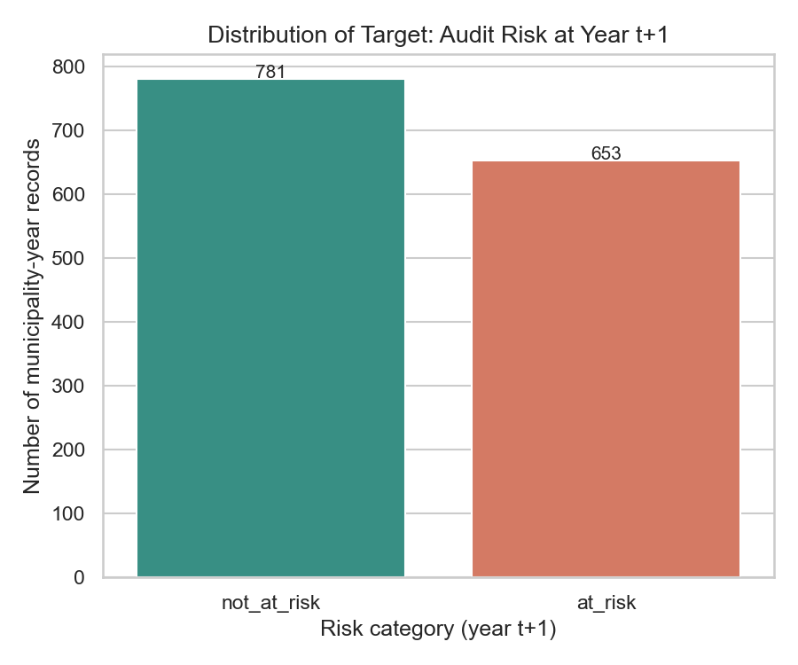
Units: number of municipality-year records. 781 Not at risk, 653 At risk.
Interpretation. The two classes are close to balanced (about 54.5% Not at risk and 45.5% At risk). Accuracy is therefore not dominated by one class, but macro-F1 is still reported because missing an at-risk municipality (a false negative) costs more than flagging a healthy one.

Figure 2: Missing values by feature
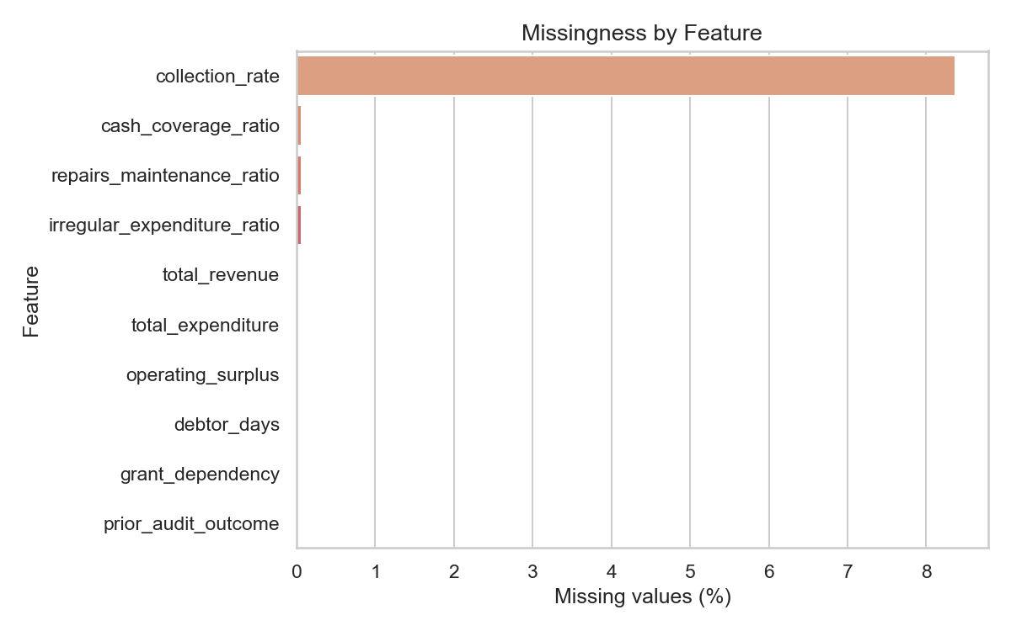
Units: percentage of the 1,434 records with a missing value.
Interpretation. collection_rate is the only feature with notable missingness (about 8.4%); it is undefined when billed revenue is zero. cash_coverage_ratio, repairs_maintenance_ratio and irregular_expenditure_ratio are about 0.1% missing and the rest are complete. Missingness is low, so median imputation is adequate. This chart cannot show the zero-versus-missing issue described in 2.1.2, because zeros count as present values.

Figure 3: Year t operating surplus versus year t+1 audit risk
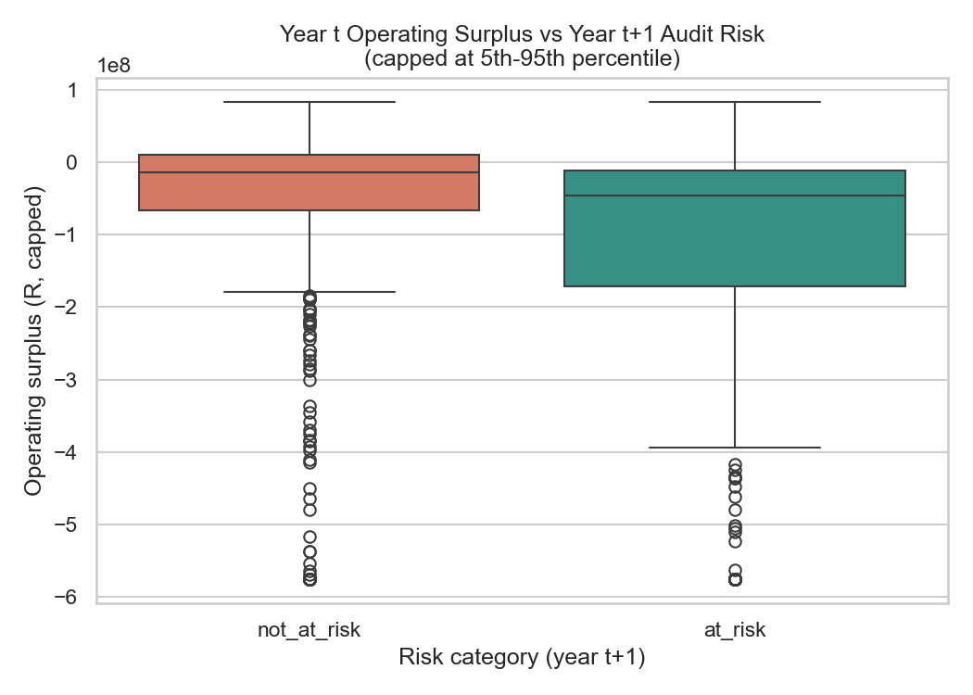
Units: rand (R). Values capped at the 5th and 95th percentile so that a few very large metros do not flatten the plot; capping affects the display only. The vertical scale is ×10⁸ (−1 means −R100 million).
Interpretation. Most municipalities run an operating deficit in both groups (median below zero), partly because revenue here excludes capital transfers while expenditure includes non-cash items such as depreciation. Municipalities that were at risk a year later had a lower median surplus (roughly −R45 million against −R15 million) and a longer lower tail (middle half from roughly −R170 million to −R10 million, against roughly −R65 million to +R10 million). Weaker finances in year t go with worse audit outcomes in year t+1, but the boxes overlap heavily, so surplus alone separates the groups only weakly.

Figure 4: Year t debtor days versus year t+1 audit risk
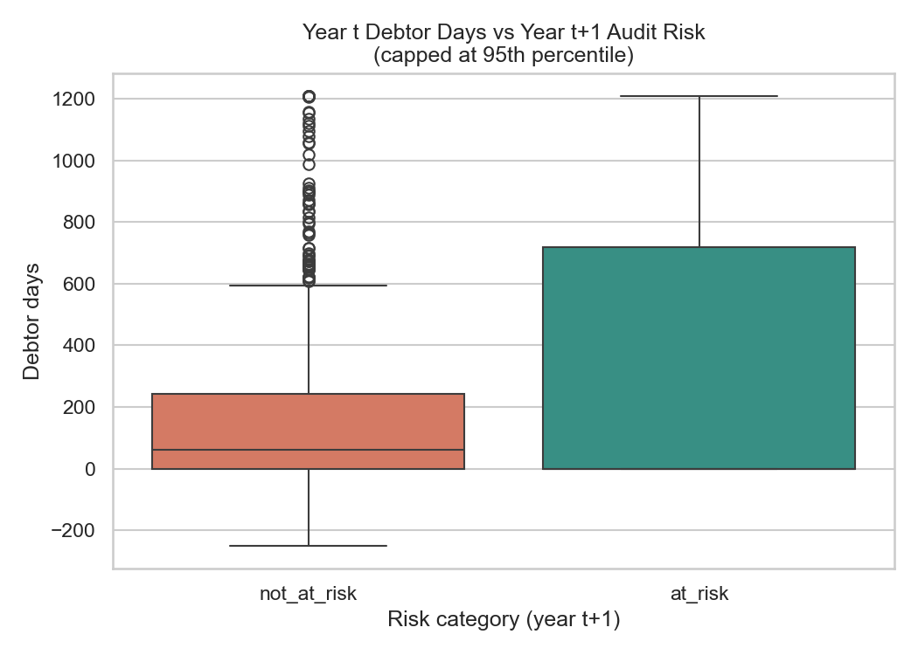
Units: days of revenue owed by customers. Values capped at the 95th percentile.
Interpretation. At-risk municipalities have a much higher upper quartile (about 720 days) than not-at-risk municipalities (about 240 days, median about 60 days). Municipalities that struggle to collect what they bill are more likely to fail the next audit, which makes debtor days a promising feature. Caution: the lower end of both boxes is zero, and many of these zeros are probably missing data in the early years (2.1.2), which compresses the lower quartile; a few negative values (about −250 days) are also visible.

Figure 5: Share of at-risk outcomes by feature year (temporal view)
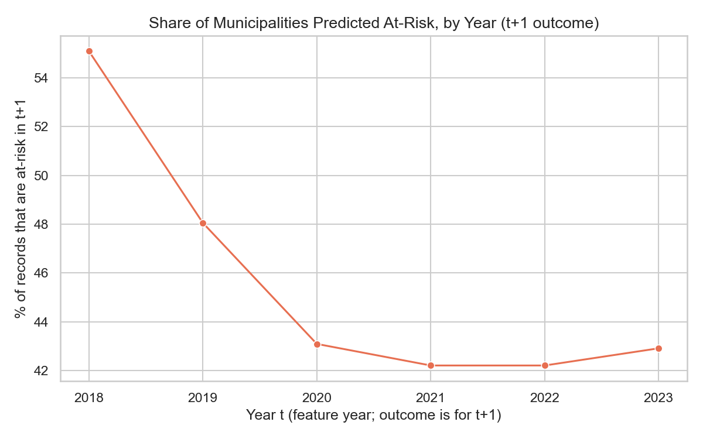
Units: percentage of that year’s records whose year t+1 outcome is At risk. The values are observed outcomes, not model predictions.
Interpretation. The at-risk share fell from about 55% (t = 2018) to about 48% (2019) and then levelled at roughly 42–43% from 2020 to 2023. The audit-risk base rate is therefore not constant over time: municipalities are somewhat less likely to be at risk in later years. This matters for the split in 2.3, because a model trained on the earlier, higher-risk years meets a lower base rate in validation and test. Records per year are stable (231 to 244), so the trend is not an artefact of sample size.

2.3 Train, validation and test split

2.3.1 Design
Records are split by feature year t, in time order: the oldest years train the model, the next year validates it, and the most recent year tests it. The split is made before any transformation is learned (script split_q23_v2.py).
Split | Feature years (t) | Outcome years (t+1) | Records | Approximate at-risk share*
Training | 2018–2021 | 2019–2022 | 950 | about 47%
Validation | 2022 | 2023 | 244 | about 42%
Test | 2023 | 2024 | 240 | about 43%
*Read from Figure 5; the exact class counts per split are printed by split_q23_v2.py.

2.3.2 Justification
- It mirrors deployment. In real use Treasury issues a flag using only the years already finished. Training on the past and testing on the most recent year reproduces that, and avoids look-ahead bias.
- The test set is reserved. It is used once, for the final locked model (Question 5.3). Model selection and tuning use the validation year, or cross-validation inside the training years only.
- Split before fit. No median, scaling factor or category list is learned before the split (2.4).
- Stratification. Time order takes priority over stratifying by class, so stratified sampling is not used. Instead the class balance of each split is reported, and all three are close to balanced (about 42–47% At risk).
- Group constraint. The same municipality appears in several years, so training and test contain the same municipalities in different years. This is realistic (Treasury monitors the same municipalities over time) but means some performance reflects municipality history. It is recorded as a limitation.

2.3.3 Alternatives considered
- Random stratified split: rejected. Rows from later years would train a model that is tested on earlier years, and the same municipality would appear on both sides, giving optimistic results.
- Grouped k-fold by municipality: rejected as the main design because it ignores time order.
- Walk-forward (expanding-window) cross-validation: adopted for tuning inside the training years in Question 5, for example train on 2018–2019 and validate on 2020, then train on 2018–2020 and validate on 2021. It gives several validation estimates instead of one.
Limitation. Validation and test each contain about 240 records from a single year, so their estimates are noisy. Question 4 therefore reports cross-validation means and variability alongside the single test result.

2.4 Preparation pipeline

2.4.1 Feature engineering
The raw Treasury tables list one row per financial line item, which cannot be fed to a model directly. They were aggregated into nine municipality-year indicators using the audited actual figures of year t (script build_modeling_dataset.py, which downloads the data through the Municipal Money API):
Feature | Calculation | Source cube
total_revenue | Sum of all income items with item code below 2900 | Income and Expenditure
total_expenditure | Sum of all expenditure items with item code 3000 to 4399 | Income and Expenditure
operating_surplus | total_revenue − total_expenditure | Income and Expenditure
cash_coverage_ratio | Cash and cash equivalents ÷ (total_expenditure ÷ 12) | Financial Position; Income and Expenditure
collection_rate | (Property rates + service charges − debt impairment) ÷ (property rates + service charges) | Income and Expenditure
debtor_days | Total by income source ÷ (total_revenue ÷ 365) | Aged Debtor; Income and Expenditure
repairs_maintenance_ratio | Sum of all repairs-and-maintenance rows ÷ total_expenditure | Repairs and Maintenance
irregular_expenditure_ratio | Irregular expenditure ÷ total_expenditure | Unauthorised, Irregular, Fruitless and Wasteful Expenditure
grant_dependency | Sum of all grants received ÷ total_revenue | Grants
Totals were built by summing the individual line items rather than reading Treasury’s own subtotal rows (codes 2900 and 4400). The subtotal rows were only present in the audited data for 2023 onward; summing the components recovered 2018–2022 and raised the usable records from 240 to 1,434. The subtotal rows themselves are excluded so that nothing is counted twice.

2.4.2 Pipeline steps
All steps are inside one scikit-learn ColumnTransformer (script pipeline_q24.py), so the same preparation is applied identically in training, evaluation and the user interface:
Step | What is done | Why
1. Select inputs | The nine numeric features. Identifiers, names, year and raw opinion text are dropped. The target is mapped not_at_risk = 0, at_risk = 1. | Keeps answer-like and identifying columns out of the model.
2. Imputation | Median for numeric features; most frequent value for any categorical feature. | The median is robust to the extreme values found in 2.1.2. The medians are learned from training data only.
3. Encoding | One-hot encoding for prior_audit_outcome when it is enabled, with unseen categories ignored. | Models need numbers; unseen categories must not crash the interface.
4. Scaling | StandardScaler (mean 0, standard deviation 1), learned on training data. | Needed by logistic regression, SVM and neural networks so that rand-sized features do not swamp ratios. Heavy tails (2.1.2) mean log or robust scaling will be tested in the ablation study.
5. Class imbalance | No resampling. Class weights (class_weight = balanced, or weighted loss for neural networks). | The imbalance is mild (about 55/45), so weighting is simpler and avoids creating synthetic municipalities.
6. Persistence | The fitted pipeline is saved as preprocessor.joblib; prepared X and y files are saved for each split. | Every modelling lead, and the interface in Question 7, uses the identical preparation.

2.4.3 How leakage is prevented
- The pipeline is fitted (fit_transform) on the training split only; validation and test are only transformed, using the training medians, scales and categories.
- Tuning uses the validation year or cross-validation inside the training years. The test year is touched once, at the end.
- Inputs come only from year t; the target comes from year t+1; identifiers and raw opinion text are excluded.
- Records are split before any statistic is calculated, and the split is by time, never random.

2.4.4 Decision on prior_audit_outcome
Using the year t audit result as an input is not leakage, because it is known before year t+1 is predicted, and the concept note allows “audit outcome history up to t”. It is, however, a strong “repeat last year” signal that could dominate the financial indicators, and it adds little for Treasury, which already knows last year’s result. The current build therefore excludes it (switch USE_PRIOR_AUDIT_OUTCOME = False in pipeline_q24.py), so the model must learn from financial health alone. The version that includes it is run as an ablation in Question 6.1, which measures how much the model depends on it.

2.4.5 Reproducibility and execution order
Script (run in this order) | Purpose | Output
build_modeling_dataset.py | Downloads the Treasury data, builds the nine indicators and the lagged target | data/processed/modeling_dataset.csv; raw extracts in data/raw
audit_q21_v2.py | Data dictionary and data audit (2.1) | data_dictionary.csv, audit_report.txt
visualize_q22_v2.py | Five figures (2.2) | figures/01 to 05
split_q23_v2.py | Time-based split (2.3) | train.csv, val.csv, test.csv
pipeline_q24.py | Fitted preprocessing pipeline (2.4) | preprocessor.joblib, X_*.csv, y_*.csv
The first script needs an internet connection; the packages are listed in requirements.txt. Question 2 uses no random numbers, because the split is deterministic by year; random seeds are disclosed in the modelling questions.

2.5 Limitations carried forward
- Zeros versus missing data. Some zeros in debtor_days, grant_dependency and repairs_maintenance_ratio, and collection_rate values of exactly 1, probably mean “no data submitted” in the early years. To be confirmed against each cube’s first available year, and recoded to missing if so.
- Item-code convention. The revenue (below 2900) and expenditure (3000 to 4399) ranges follow the mSCOA layout shown in Treasury’s published table and should be cross-checked against Treasury’s chart-of-accounts documentation.
- Small validation and test sets. About 240 records each, from one year, so estimates are noisy.
- Shifting base rate and repeated municipalities. The at-risk share fell over time (Figure 5) and the same municipalities appear in training and test.

