PHY4000W

Computational Physics

Tutorial 2

Transmission Cables

Boitshoko Moetaesi

**Introduction**

Transmission cables can be modelled by set of cells distributed along the x direction. Each of these cells containing its resistance and inductance connected in series and capacitor and conductance in parallel as shown I fig 1. Solving the equations to get the time dependent voltages and currents gives two coupled differential equation’s which can be simplified to be linier equations with complex numbers. This report with study the behaviour of voltages and currents in the transmission line.

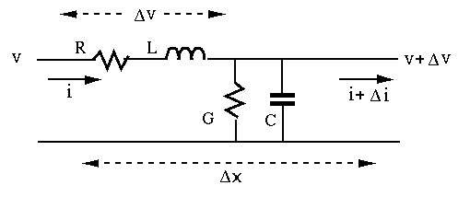

Figure 1: A cell in the transmission line. It’s made up of resistance

and inductance connected in series and capacitor and conductance in parallel

**Results**

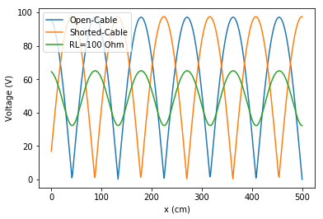

Figure 2: Voltage along the cable. Amplitudes of circuits with terminal resistance RL open and closed are larger than the on with 100 Ohm resistor. This might be because the sinusoidal signal interferes with itself thus behaving like a standing wave. Voltage at the RL is zero for the open circuit and maximum for the closed on. This is what is expected.

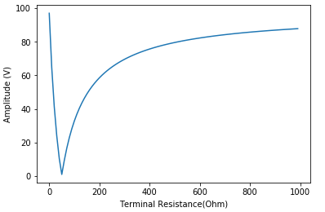

Figure 3: Plot show the terminal resistor affects the difference between the minimum and maximum amplitude of the voltage along the transmission line. The value of the termination resistor which gives the smallest difference was found to be about 50 Ohm.

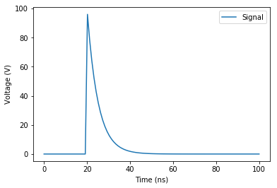

Fig 4: Detector signal.

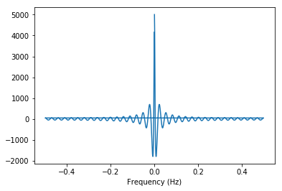

Figure 4: Fourer transform of detector signal.