# Computational Tut3

# Boitshoko Moetaesi

**Question 1**

**a.**The following tables and plots give the numerical integration of the normal distribution considered on the interval [-1,1] which comes from the standard deviation being 1, with the mean being zero. We expect to get 0.682689492137086 this value has an uncertainty of about 7.579375928402476e-15 .

Table1:Numerical integration for different types of numerical methods.

|  |  |  |  |  |
| --- | --- | --- | --- | --- |
|  |  |  |  |  |
| Sample size | Trapezoid rule | Simpsons rule | Richardson Extrapolation for Trapezoid rule | Richardson Extrapolation for Simpsons rule |
| 2 | 0.640913004920576 | 0.6932368568813392 | 0.6830581039925915 | 0.6823795204666748 |
| 4 | 0.6725218292245876 | 0.6830581039925914 | 0.6839249862010572 | 0.6826742279209552 |
| 10 | 0.6810741969569398 | 0.6826982201754325 | 0.6826900317769405 | 0.6826894858837076 |
| 20 | 0.6822860730719403 | 0.6826900317769404 | 0.6826895257741635 | 0.6826894920406451 |
| 40 | 0.6825886625986077 | 0.6826895257741635 | 0.6826894942379951 | 0.6826894921355838 |
| 80 | 0.6826642863281482 | 0.6826894942379951 | 0.6826894922683707 | 0.6826894921370624 |
| 160 | 0.6826831907833151 | 0.6826894922683707 | 0.682689492145291 | 0.6826894921370855 |
|  |  |  |  |  |

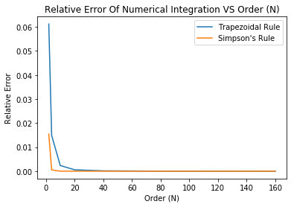

FIG 1:Relative error of numerical integration vs order of approximation for Trapezoidal rule and Simpsons rule

To get more precision you can take higher and higher orders of n .but this doesn’t hold for rough functions.

B, As can be seen in table 1,Richardson extrapolation converges faster than both Simpson and trapezoid. Yes, the next leading order terms can of the Richardson extrapolation can be used to appro

c.

Table 2 numerical integration using the Gaussion quadrature method or N =2,34 and relative errors.

|  |  |  |
| --- | --- | --- |
| n | Gaussion quadrature estimates | Relative error |
| 2 | 0.6829972607142692 | 0.00045081780330300794 |
| 3 | 0.6826798061437325 | 1.418799244026902e-05 |
| 4 | 0.6826897353882191 | 3.563129884476557e-07 |

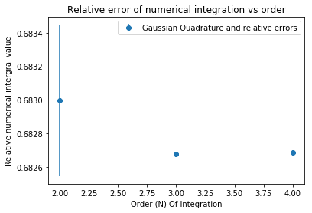

Fig3: Plot showing how relative error of numerical integration using Gaussian Quadrature method as it approaches the exact value. As can be seen in the plot the error decrease fast. Using table, we can see that the errors become smaller by an order of magnitude of about 10^-2.

Question 2

a.The likelihood for S = 20, µ = 5, σ = 2 and B = 1 is 1.850274791990269e-14

b, µ = 3.80000038, σ = 2.57681976 S=19.99999964, B=-0.19999998.

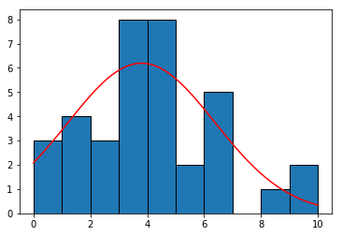

Fig4:Fit for the parameters given in b.

c.

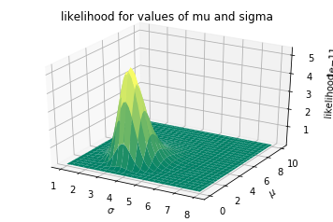

Fig5:plot showing the likelihood as the mean and standard deviation is varied background and S used here are the ones found in 2.b.we can see that sigma and mu are around the points predicted. The vertical axis represents the Likelihood and its of order 1e-11.