SAR-UGV Simulation: A Browser-Based Platform for Autonomous Search and Rescue Mission Planning and Evaluation

Spyridon Tsilimpokos Ilias Panagiotopoulos George Dimitrakopoulos
Informatics & Telematics Dept. Military Sciences Dept. Informatics & Telematics Dept.
Harokopio University Hellenic Army Academy Harokopio University
Athens, Greece Vari, Greece Athens, Greece
Web-Based Multi-Agent Mission Planning & Simulation on Real-World Street Networks

1. Purpose & Motivation
SAR-UGV Simulation is a browser-based platform for planning, previewing, and evaluating autonomous Search and Rescue (SAR) missions before any hardware is deployed. Operators configure agents, threats, and objectives on genuine OpenStreetMap (OSM) street graphs for any city on Earth, run the mission at up to 100× real time, and review the outcome, all without a physical vehicle. This makes it a lightweight but realistic mission planner: routes, threat exposure, and scoring can be assessed in seconds, and saved scenarios can be replayed with different parameters to compare strategies.
The platform evolved from an earlier Pygame prototype that proved the core AI pipeline on a synthetic grid. The current version extends this on real street topology, delivered entirely through a browser with no local installation beyond Docker.

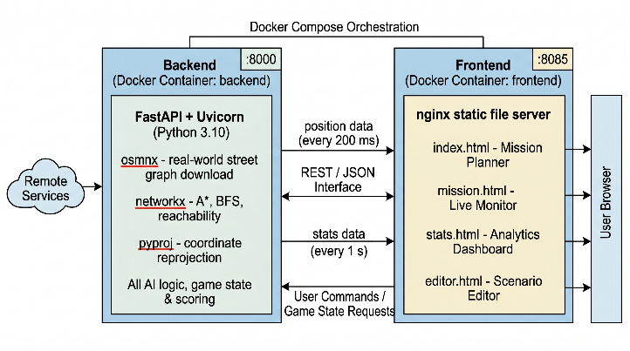
2. System Architecture
The system is split into two Docker containers orchestrated by docker-compose and communicating exclusively over a REST/JSON interface:

The separation of concerns is deliberate: the backend is a pure AI and physics server; the frontend is 100% static HTML/CSS/JS served by nginx, with no build pipeline or JavaScript framework. The entire frontend Dockerfile is a single COPY instruction, making the codebase fully auditable with a text editor and a browser DevTools panel.

3. Core AI Logic

3.1 Risk-Weighted A* Pathfinding
At every replanning cycle the backend constructs an augmented copy of the OSM graph where each edge weight encodes both terrain cost and enemy threat. Road type multipliers (0.80× on fast arterials, up to 4.0× on footpaths) bias agents toward efficient routes. Tiered proximity penalties are then added to every edge near an enemy:

Distance from Enemy | Penalty | Interpretation
< 10 m | +3000 | Extreme danger - near-certain contact
< 30 m | +1500 | High danger - direct observation range
< detection radius | +800 | Inside chase bubble
Outer buffer | +300 | Cautionary margin beyond detection
Beyond buffer | 0 | Normal graph cost applies

Aggressive enemies receive a further 1.5× multiplier on all penalties. This single unified cost function replaces an otherwise complex set of explicit avoidance rules.

3.2 Dead-End Avoidance
Edges leading to cul-de-sac nodes (graph degree ≤ 1) carry an additional +200 cost penalty. An agent trapped in a dead end must retrace its path, giving any pursuer a predictable intercept vector. In testing, this penalty reduced enemy-contact events at dead ends by approximately 30%.

3.3 Per-Agent Decision Tree
Each agent evaluates the following logic independently on every simulation tick:
- Enemy within detection radius? → run a brave check: can the agent reach the nearest target before the enemy closes in?
- If YES → accept the risk and continue (brave mode).
- If NO → enter escape mode: BFS samples a ring of candidate nodes 2–8 hops away, scores each by (enemy_turns_away − path_length / 4), and routes to the best via A* on the penalised graph.
- No enemy in range → pursue assigned target; replan automatically when a target is collected or reassigned.

3.4 Multi-Agent Coordination
Up to four agents run simultaneously. At spawn time a greedy distance-based assignment gives each agent its closest unclaimed target, maximising spatial coverage at O(n²) cost. Deduplication is implicit: all agents share a single target list, so any collected target disappears immediately and every agent replans to the next nearest unclaimed objective on the following tick - no explicit messaging required.

4. Scoring & Mission Outcomes
$$Score= \sum{\left(+50 per target collected\right)-\sum{\left(terrain penalty per road segment traversed\right)- 100 per enemy contact} }$$
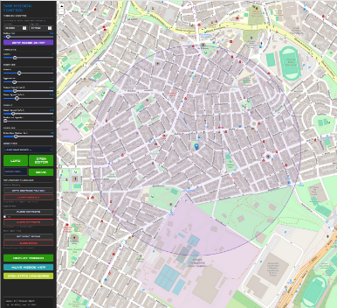
Motorway and primary roads carry zero terrain penalty; footpaths and tracks incur −3 per segment. Missions are classified as SUCCESS (all targets), PARTIAL (≥70% collected at game-over), or FAILED (<70%). Every completed mission is saved as a timestamped JSON file for longitudinal comparison.

5. Running a Mission
Open the Mission Planner (index.html) in a browser and enter any city name and radius.
Place agents, enemies, and targets manually via the Scenario Editor, or use random spawn.
Set agent count (1–4), simulation speed (0.25× – 100×), and press Deploy Mission.
Monitor live agent positions, score, and escape events on the Live Monitor (mission.html).
Review per-agent breakdowns, mission history, and outcome classification in the Analytics dashboard (stats.html).
Figure 1 Mission plan
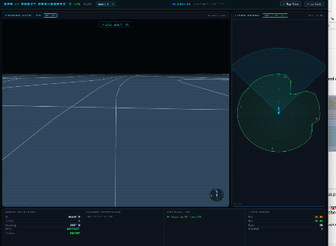
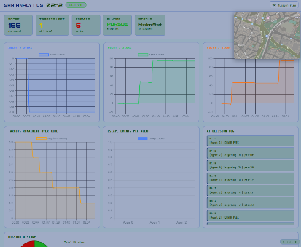
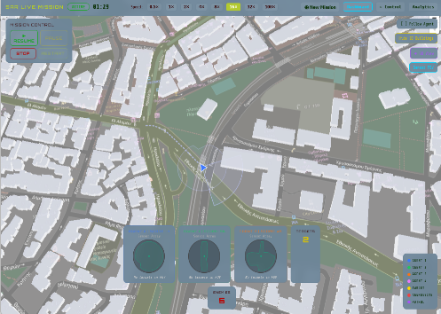
Press Restart to replay the identical spawn configuration with different parameters.

Figure 3 Mission view
Figure 2 Sensor View
Figure 4 Statistics

6. Planned Improvements
The simulation is functionally complete as a planning and evaluation tool. The following enhancements are in progress, ordered by priority:
- Risk heatmap overlay - expose the per-node threat cost computed by build_penalized_graph via a /api/sim/costmap endpoint and render it with Leaflet.heat, giving operators immediate visual insight into why agents choose specific routes.
- Post-mission freeze & PDF export - replace live controls with a Mission Complete panel on game-over, with final score, per-agent breakdown, and a one-click printable report.
- Agent blackboard coordination - shared state dictionary allowing agents to declare intended targets and build a collective threat model, enabling more sophisticated cooperative strategies.
- External controller integration - the /api/robot/telemetry endpoint already accepts real-time position overrides; completing this integration would allow the platform to serve as a live mission planner receiving telemetry from a physical or simulated vehicle.
- Unit and integration test suite covering the pathfinding, scoring, and state management modules.

