Factors Report 20080102-20161230

**1. genticT37_19**

**截面指标累计曲线:**

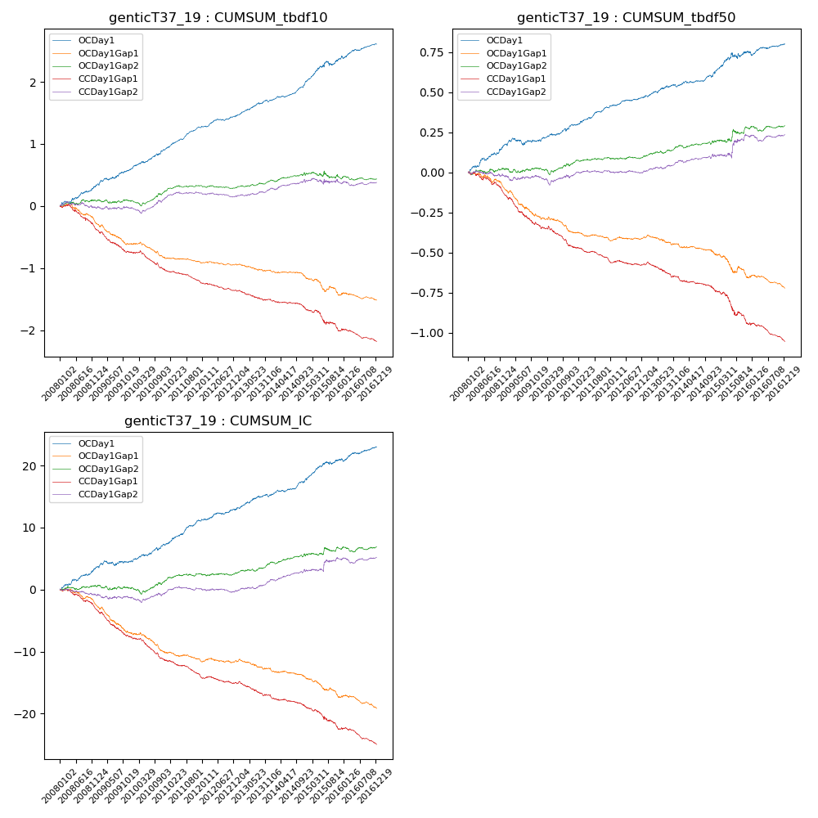

**因子换手率:** 112.32%

**截面指标_OCDay1:**

|  |  |  |  |  |  |  |  |  |
| --- | --- | --- | --- | --- | --- | --- | --- | --- |
| year | annret_tbdf10 | sharpe_tbdf10 | maxdd_tbdf10 | annret_tbdf50 | sharpe_tbdf50 | maxdd_tbdf50 | mean_IC | tstat_IC |
| 2008 | 0.31 | 3.36 | -0.03 | 0.16 | 3.68 | -0.02 | 0.01 | 3.76 |
| 2009 | 0.28 | 3.2 | -0.03 | 0.03 | 0.8 | -0.04 | 0.0 | 1.13 |
| 2010 | 0.34 | 4.35 | -0.03 | 0.1 | 2.86 | -0.02 | 0.01 | 3.18 |
| 2011 | 0.34 | 6.51 | -0.01 | 0.1 | 3.89 | -0.01 | 0.02 | 4.93 |
| 2012 | 0.18 | 3.23 | -0.03 | 0.07 | 2.77 | -0.01 | 0.01 | 2.5 |
| 2013 | 0.26 | 4.25 | -0.03 | 0.07 | 2.32 | -0.02 | 0.01 | 2.88 |
| 2014 | 0.32 | 5.43 | -0.02 | 0.09 | 3.03 | -0.01 | 0.01 | 3.92 |
| 2015 | 0.38 | 3.1 | -0.07 | 0.12 | 1.93 | -0.04 | 0.01 | 2.91 |
| 2016 | 0.21 | 3.17 | -0.04 | 0.05 | 1.74 | -0.03 | 0.01 | 2.62 |

**截面指标_CCDay1Gap1:**

|  |  |  |  |  |  |  |  |  |
| --- | --- | --- | --- | --- | --- | --- | --- | --- |
| year | annret_tbdf10 | sharpe_tbdf10 | maxdd_tbdf10 | annret_tbdf50 | sharpe_tbdf50 | maxdd_tbdf50 | mean_IC | tstat_IC |
| 2008 | -0.37 | -3.73 | -0.32 | -0.13 | -3.33 | -0.13 | -0.01 | -4.04 |
| 2009 | -0.38 | -4.67 | -0.32 | -0.2 | -5.1 | -0.18 | -0.02 | -5.6 |
| 2010 | -0.31 | -4.15 | -0.28 | -0.14 | -3.85 | -0.13 | -0.02 | -5.12 |
| 2011 | -0.2 | -4.34 | -0.19 | -0.09 | -3.84 | -0.09 | -0.01 | -4.72 |
| 2012 | -0.12 | -2.59 | -0.12 | -0.02 | -0.78 | -0.03 | -0.0 | -1.54 |
| 2013 | -0.16 | -2.75 | -0.15 | -0.09 | -3.14 | -0.1 | -0.01 | -3.29 |
| 2014 | -0.16 | -2.9 | -0.15 | -0.07 | -2.76 | -0.07 | -0.01 | -3.11 |
| 2015 | -0.32 | -2.94 | -0.3 | -0.21 | -3.22 | -0.2 | -0.01 | -3.21 |
| 2016 | -0.19 | -3.15 | -0.19 | -0.11 | -4.38 | -0.11 | -0.01 | -4.28 |

**风格暴露:**

|  |  |  |  |  |
| --- | --- | --- | --- | --- |
|  | long | short | corr_OCDay1 | corr_CCDay1Gap1 |
| liquidity10 | -0.01 | 0.01 | -0.07 | -0.02 |
| liquidity20 | -0.01 | 0.01 | -0.07 | -0.02 |
| liquidity5 | -0.0 | 0.0 | -0.05 | -0.0 |
| logmktcap | -0.02 | 0.03 | 0.15 | 0.07 |
| momentum15 | 0.0 | 0.0 | 0.06 | -0.02 |
| momentum30 | -0.01 | 0.01 | 0.04 | 0.01 |
| momentum5 | 0.02 | -0.01 | 0.07 | 0.04 |
| retvolatility30 | -0.02 | 0.02 | -0.11 | -0.02 |