Factors Report 20080102-20161230

**1. genticT4_1**

**截面指标累计曲线:**

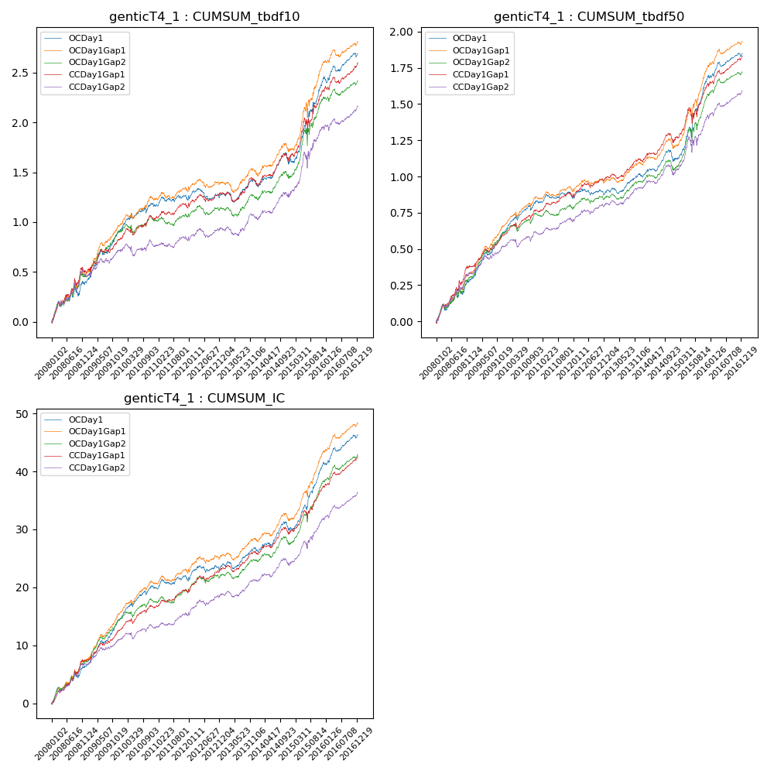

**因子换手率:** 27.66%

**截面指标_OCDay1:**

|  |  |  |  |  |  |  |  |  |
| --- | --- | --- | --- | --- | --- | --- | --- | --- |
| year | annret_tbdf10 | sharpe_tbdf10 | maxdd_tbdf10 | annret_tbdf50 | sharpe_tbdf50 | maxdd_tbdf50 | mean_IC | tstat_IC |
| 2008 | 0.4 | 2.94 | -0.09 | 0.29 | 3.77 | -0.05 | 0.03 | 4.2 |
| 2009 | 0.52 | 5.72 | -0.04 | 0.33 | 6.56 | -0.02 | 0.03 | 7.06 |
| 2010 | 0.25 | 2.7 | -0.05 | 0.2 | 4.35 | -0.03 | 0.02 | 4.73 |
| 2011 | 0.06 | 0.88 | -0.05 | 0.04 | 0.98 | -0.04 | 0.01 | 1.24 |
| 2012 | 0.06 | 0.75 | -0.11 | 0.04 | 0.96 | -0.04 | 0.01 | 2.08 |
| 2013 | 0.14 | 1.68 | -0.1 | 0.13 | 3.06 | -0.04 | 0.01 | 3.01 |
| 2014 | 0.18 | 1.85 | -0.11 | 0.09 | 1.74 | -0.08 | 0.01 | 2.39 |
| 2015 | 0.84 | 4.9 | -0.09 | 0.58 | 5.88 | -0.07 | 0.05 | 7.34 |
| 2016 | 0.26 | 3.08 | -0.06 | 0.16 | 3.46 | -0.03 | 0.02 | 4.57 |

**截面指标_CCDay1Gap1:**

|  |  |  |  |  |  |  |  |  |
| --- | --- | --- | --- | --- | --- | --- | --- | --- |
| year | annret_tbdf10 | sharpe_tbdf10 | maxdd_tbdf10 | annret_tbdf50 | sharpe_tbdf50 | maxdd_tbdf50 | mean_IC | tstat_IC |
| 2008 | 0.5 | 3.89 | -0.07 | 0.38 | 5.12 | -0.03 | 0.03 | 5.34 |
| 2009 | 0.33 | 3.6 | -0.05 | 0.22 | 4.29 | -0.02 | 0.02 | 5.08 |
| 2010 | 0.2 | 2.21 | -0.07 | 0.16 | 3.42 | -0.04 | 0.02 | 3.74 |
| 2011 | 0.12 | 1.8 | -0.05 | 0.1 | 2.79 | -0.03 | 0.01 | 2.85 |
| 2012 | 0.15 | 2.08 | -0.08 | 0.14 | 3.26 | -0.03 | 0.02 | 3.8 |
| 2013 | 0.13 | 1.53 | -0.1 | 0.13 | 3.31 | -0.03 | 0.01 | 3.0 |
| 2014 | 0.23 | 2.4 | -0.08 | 0.13 | 2.44 | -0.07 | 0.01 | 2.81 |
| 2015 | 0.67 | 3.69 | -0.13 | 0.38 | 3.64 | -0.11 | 0.03 | 4.98 |
| 2016 | 0.28 | 3.47 | -0.06 | 0.2 | 4.53 | -0.03 | 0.02 | 5.58 |

**风格暴露:**

|  |  |  |  |  |
| --- | --- | --- | --- | --- |
|  | long | short | corr_OCDay1 | corr_CCDay1Gap1 |
| liquidity10 | 0.05 | -0.05 | 0.19 | 0.28 |
| liquidity20 | -0.11 | 0.12 | 0.25 | 0.31 |
| liquidity5 | 0.08 | -0.07 | 0.17 | 0.26 |
| logmktcap | 1.49 | -1.48 | -0.77 | -0.77 |
| momentum15 | 0.42 | -0.41 | -0.28 | -0.22 |
| momentum30 | 0.37 | -0.36 | -0.28 | -0.23 |
| momentum5 | 0.16 | -0.16 | -0.22 | -0.13 |
| retvolatility30 | -0.07 | 0.07 | 0.29 | 0.34 |