Factors Report 20080102-20161230

**1. maqiuhao49**

**截面指标累计曲线:**

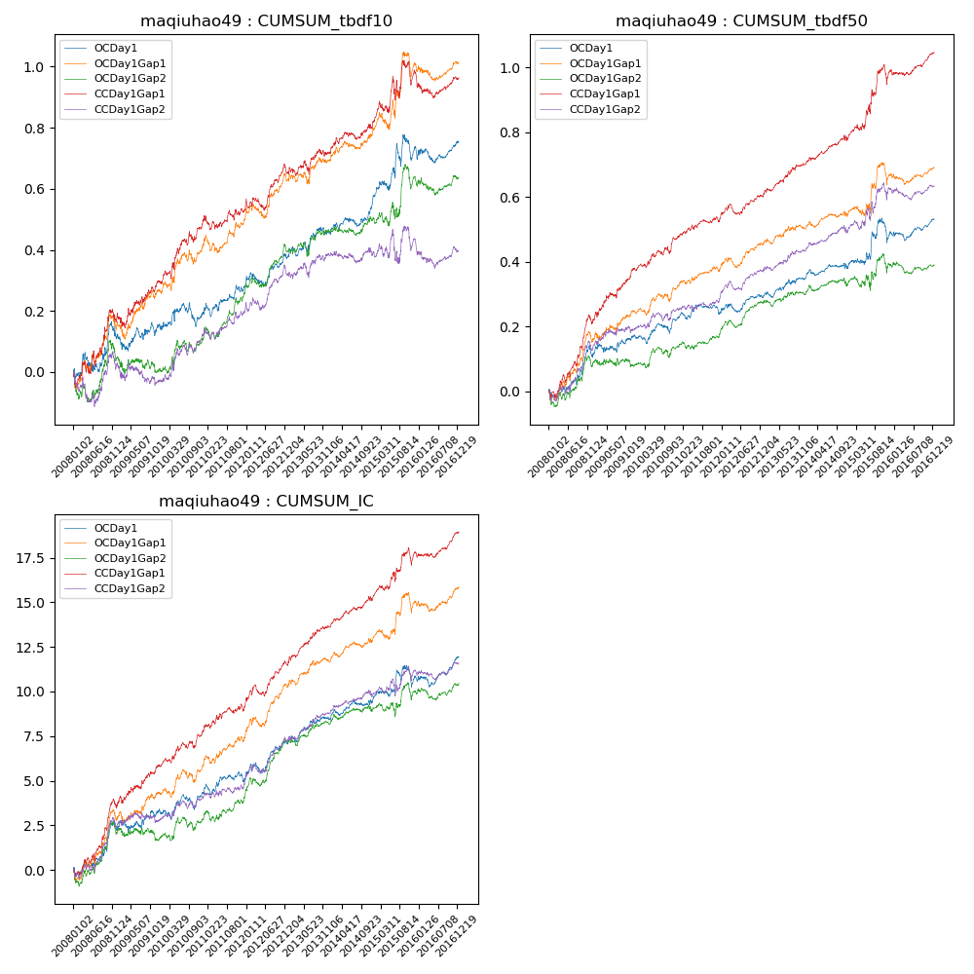

**因子换手率:** 36.55%

**截面指标_OCDay1:**

|  |  |  |  |  |  |  |  |  |
| --- | --- | --- | --- | --- | --- | --- | --- | --- |
| year | annret_tbdf10 | sharpe_tbdf10 | maxdd_tbdf10 | annret_tbdf50 | sharpe_tbdf50 | maxdd_tbdf50 | mean_IC | tstat_IC |
| 2008 | 0.11 | 1.1 | -0.07 | 0.11 | 2.0 | -0.03 | 0.01 | 2.14 |
| 2009 | 0.04 | 0.55 | -0.06 | 0.06 | 1.41 | -0.03 | 0.0 | 1.19 |
| 2010 | 0.04 | 0.59 | -0.08 | 0.06 | 1.52 | -0.03 | 0.0 | 1.27 |
| 2011 | 0.09 | 1.55 | -0.04 | 0.02 | 0.69 | -0.03 | 0.0 | 1.19 |
| 2012 | 0.1 | 1.94 | -0.04 | 0.04 | 1.45 | -0.03 | 0.01 | 2.58 |
| 2013 | 0.08 | 1.33 | -0.03 | 0.06 | 1.98 | -0.02 | 0.01 | 2.26 |
| 2014 | 0.11 | 2.48 | -0.03 | 0.04 | 1.28 | -0.02 | 0.0 | 1.88 |
| 2015 | 0.17 | 1.66 | -0.08 | 0.11 | 1.57 | -0.07 | 0.01 | 1.25 |
| 2016 | 0.02 | 0.38 | -0.05 | 0.04 | 1.61 | -0.03 | 0.0 | 1.94 |

**截面指标_CCDay1Gap1:**

|  |  |  |  |  |  |  |  |  |
| --- | --- | --- | --- | --- | --- | --- | --- | --- |
| year | annret_tbdf10 | sharpe_tbdf10 | maxdd_tbdf10 | annret_tbdf50 | sharpe_tbdf50 | maxdd_tbdf50 | mean_IC | tstat_IC |
| 2008 | 0.17 | 1.75 | -0.05 | 0.21 | 3.64 | -0.03 | 0.01 | 3.61 |
| 2009 | 0.13 | 1.73 | -0.05 | 0.17 | 3.65 | -0.02 | 0.01 | 2.67 |
| 2010 | 0.19 | 2.69 | -0.04 | 0.1 | 2.57 | -0.02 | 0.01 | 2.58 |
| 2011 | 0.05 | 0.87 | -0.05 | 0.06 | 2.13 | -0.02 | 0.01 | 2.19 |
| 2012 | 0.13 | 2.4 | -0.04 | 0.06 | 2.2 | -0.03 | 0.01 | 3.37 |
| 2013 | 0.07 | 1.13 | -0.05 | 0.1 | 3.12 | -0.01 | 0.01 | 3.53 |
| 2014 | 0.1 | 1.98 | -0.02 | 0.08 | 2.76 | -0.02 | 0.01 | 3.18 |
| 2015 | 0.16 | 1.56 | -0.08 | 0.21 | 2.93 | -0.06 | 0.01 | 2.55 |
| 2016 | -0.01 | -0.32 | -0.08 | 0.05 | 2.17 | -0.02 | 0.0 | 2.34 |

**风格暴露:**

|  |  |  |  |  |
| --- | --- | --- | --- | --- |
|  | long | short | corr_OCDay1 | corr_CCDay1Gap1 |
| liquidity10 | 0.03 | -0.19 | -0.14 | -0.14 |
| liquidity20 | 0.02 | -0.19 | -0.13 | -0.14 |
| liquidity5 | 0.04 | -0.18 | -0.14 | -0.15 |
| logmktcap | -0.04 | 0.02 | -0.03 | -0.04 |
| momentum15 | 0.31 | -0.3 | -0.29 | -0.3 |
| momentum30 | 0.36 | -0.4 | -0.34 | -0.38 |
| momentum5 | 0.15 | -0.12 | -0.14 | -0.21 |
| retvolatility30 | -0.06 | -0.25 | -0.1 | -0.11 |