Factors Report 20080102-20161230

**1. RSI**

**截面指标累计曲线:**

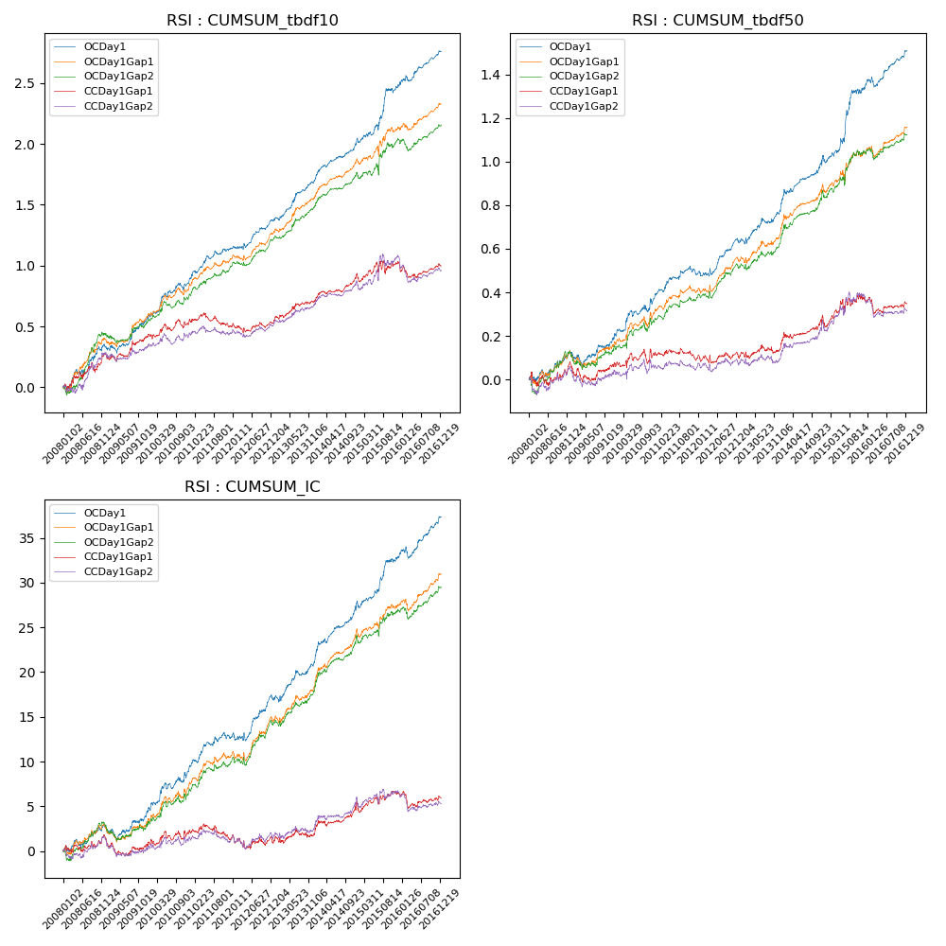

**因子换手率:** 31.92%

**截面指标_OCDay1:**

|  |  |  |  |  |  |  |  |  |
| --- | --- | --- | --- | --- | --- | --- | --- | --- |
| year | annret_tbdf10 | sharpe_tbdf10 | maxdd_tbdf10 | annret_tbdf50 | sharpe_tbdf50 | maxdd_tbdf50 | mean_IC | tstat_IC |
| 2008 | 0.33 | 2.83 | -0.05 | 0.12 | 1.82 | -0.04 | 0.01 | 1.97 |
| 2009 | 0.24 | 2.63 | -0.06 | 0.06 | 1.09 | -0.06 | 0.01 | 1.31 |
| 2010 | 0.33 | 3.69 | -0.06 | 0.21 | 2.73 | -0.03 | 0.02 | 3.0 |
| 2011 | 0.25 | 3.42 | -0.03 | 0.09 | 1.98 | -0.04 | 0.01 | 2.56 |
| 2012 | 0.22 | 3.31 | -0.03 | 0.14 | 2.93 | -0.03 | 0.02 | 2.91 |
| 2013 | 0.35 | 4.33 | -0.03 | 0.16 | 2.72 | -0.03 | 0.02 | 3.15 |
| 2014 | 0.34 | 5.32 | -0.02 | 0.25 | 4.07 | -0.03 | 0.03 | 4.81 |
| 2015 | 0.43 | 3.35 | -0.05 | 0.31 | 3.29 | -0.03 | 0.02 | 3.18 |
| 2016 | 0.29 | 3.78 | -0.05 | 0.17 | 3.37 | -0.05 | 0.02 | 3.58 |

**截面指标_CCDay1Gap1:**

|  |  |  |  |  |  |  |  |  |
| --- | --- | --- | --- | --- | --- | --- | --- | --- |
| year | annret_tbdf10 | sharpe_tbdf10 | maxdd_tbdf10 | annret_tbdf50 | sharpe_tbdf50 | maxdd_tbdf50 | mean_IC | tstat_IC |
| 2008 | 0.27 | 2.27 | -0.08 | 0.06 | 0.76 | -0.06 | 0.01 | 1.01 |
| 2009 | 0.15 | 1.64 | -0.06 | 0.01 | 0.22 | -0.07 | -0.0 | -0.43 |
| 2010 | 0.14 | 1.59 | -0.07 | 0.06 | 0.77 | -0.07 | 0.01 | 1.07 |
| 2011 | -0.06 | -0.81 | -0.11 | -0.03 | -0.58 | -0.06 | -0.0 | -0.78 |
| 2012 | 0.04 | 0.54 | -0.07 | 0.0 | 0.07 | -0.04 | -0.0 | -0.37 |
| 2013 | 0.18 | 2.27 | -0.03 | 0.04 | 0.77 | -0.04 | 0.0 | 0.79 |
| 2014 | 0.22 | 3.47 | -0.02 | 0.14 | 2.38 | -0.03 | 0.01 | 2.58 |
| 2015 | 0.09 | 0.6 | -0.1 | 0.08 | 0.9 | -0.05 | 0.0 | 0.76 |
| 2016 | -0.02 | -0.24 | -0.11 | -0.02 | -0.38 | -0.08 | -0.0 | -0.46 |

**风格暴露:**

|  |  |  |  |  |
| --- | --- | --- | --- | --- |
|  | long | short | corr_OCDay1 | corr_CCDay1Gap1 |
| liquidity10 | -0.4 | 0.26 | 0.29 | 0.27 |
| liquidity20 | -0.31 | 0.17 | 0.23 | 0.22 |
| liquidity5 | -0.41 | 0.29 | 0.31 | 0.28 |
| logmktcap | 0.01 | -0.03 | -0.07 | -0.1 |
| momentum15 | -0.47 | 0.47 | 0.28 | 0.24 |
| momentum30 | -0.54 | 0.5 | 0.26 | 0.23 |
| momentum5 | -0.12 | 0.15 | 0.23 | 0.15 |
| retvolatility30 | -0.23 | 0.01 | 0.16 | 0.15 |