Factors Report 20080102-20161230

**1. genticT5_4**

**截面指标累计曲线:**

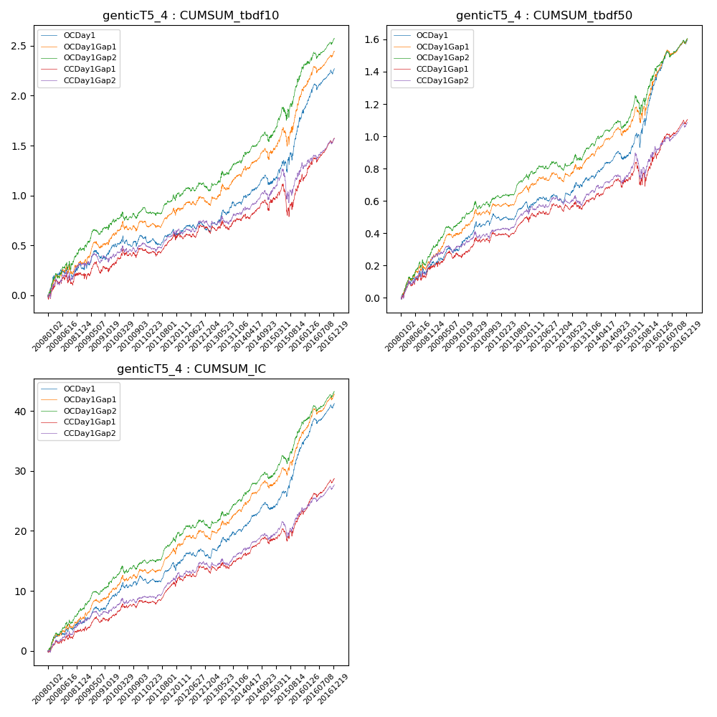

**因子换手率:** 34.75%

**截面指标_OCDay1:**

|  |  |  |  |  |  |  |  |  |
| --- | --- | --- | --- | --- | --- | --- | --- | --- |
| year | annret_tbdf10 | sharpe_tbdf10 | maxdd_tbdf10 | annret_tbdf50 | sharpe_tbdf50 | maxdd_tbdf50 | mean_IC | tstat_IC |
| 2008 | 0.3 | 2.04 | -0.13 | 0.22 | 2.77 | -0.05 | 0.02 | 3.06 |
| 2009 | 0.19 | 1.63 | -0.09 | 0.14 | 2.55 | -0.03 | 0.02 | 3.04 |
| 2010 | 0.08 | 0.8 | -0.1 | 0.13 | 2.41 | -0.03 | 0.01 | 2.07 |
| 2011 | 0.02 | 0.23 | -0.09 | 0.05 | 1.3 | -0.05 | 0.01 | 1.65 |
| 2012 | 0.09 | 1.01 | -0.08 | 0.07 | 1.49 | -0.04 | 0.01 | 1.86 |
| 2013 | 0.26 | 2.52 | -0.05 | 0.14 | 2.5 | -0.03 | 0.02 | 2.89 |
| 2014 | 0.19 | 2.2 | -0.09 | 0.11 | 2.45 | -0.05 | 0.01 | 3.13 |
| 2015 | 0.71 | 3.76 | -0.12 | 0.49 | 4.44 | -0.09 | 0.04 | 5.89 |
| 2016 | 0.45 | 4.51 | -0.06 | 0.25 | 4.38 | -0.03 | 0.03 | 5.17 |

**截面指标_CCDay1Gap1:**

|  |  |  |  |  |  |  |  |  |
| --- | --- | --- | --- | --- | --- | --- | --- | --- |
| year | annret_tbdf10 | sharpe_tbdf10 | maxdd_tbdf10 | annret_tbdf50 | sharpe_tbdf50 | maxdd_tbdf50 | mean_IC | tstat_IC |
| 2008 | 0.21 | 1.39 | -0.12 | 0.19 | 2.52 | -0.04 | 0.01 | 2.32 |
| 2009 | 0.09 | 0.76 | -0.11 | 0.09 | 1.46 | -0.05 | 0.01 | 1.94 |
| 2010 | 0.15 | 1.53 | -0.09 | 0.11 | 2.02 | -0.03 | 0.01 | 2.04 |
| 2011 | 0.1 | 1.38 | -0.07 | 0.08 | 2.06 | -0.04 | 0.01 | 2.6 |
| 2012 | 0.13 | 1.41 | -0.06 | 0.1 | 2.03 | -0.02 | 0.01 | 2.25 |
| 2013 | 0.08 | 0.82 | -0.09 | 0.05 | 0.85 | -0.05 | 0.01 | 1.31 |
| 2014 | 0.19 | 1.98 | -0.1 | 0.11 | 2.11 | -0.05 | 0.01 | 2.83 |
| 2015 | 0.23 | 1.18 | -0.29 | 0.17 | 1.43 | -0.14 | 0.02 | 2.59 |
| 2016 | 0.39 | 4.01 | -0.05 | 0.22 | 3.9 | -0.03 | 0.02 | 4.59 |

**风格暴露:**

|  |  |  |  |  |
| --- | --- | --- | --- | --- |
|  | long | short | corr_OCDay1 | corr_CCDay1Gap1 |
| liquidity10 | -0.1 | 0.07 | 0.29 | 0.37 |
| liquidity20 | -0.1 | 0.06 | 0.3 | 0.36 |
| liquidity5 | -0.14 | 0.11 | 0.3 | 0.38 |
| logmktcap | 1.09 | -1.07 | -0.59 | -0.6 |
| momentum15 | 0.04 | -0.03 | -0.02 | 0.06 |
| momentum30 | 0.05 | -0.05 | -0.05 | 0.02 |
| momentum5 | -0.07 | 0.08 | -0.03 | 0.04 |
| retvolatility30 | -0.31 | 0.25 | 0.36 | 0.39 |