Factors Report 20080102-20161230

**1. genticT7_2**

**截面指标累计曲线:**

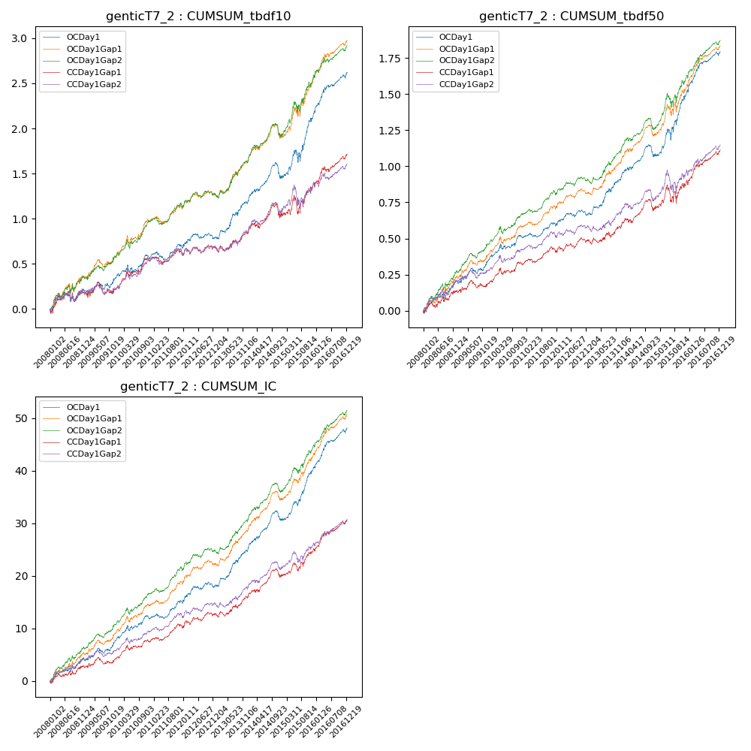

**因子换手率:** 34.29%

**截面指标_OCDay1:**

|  |  |  |  |  |  |  |  |  |
| --- | --- | --- | --- | --- | --- | --- | --- | --- |
| year | annret_tbdf10 | sharpe_tbdf10 | maxdd_tbdf10 | annret_tbdf50 | sharpe_tbdf50 | maxdd_tbdf50 | mean_IC | tstat_IC |
| 2008 | 0.2 | 1.35 | -0.1 | 0.2 | 2.66 | -0.04 | 0.02 | 2.63 |
| 2009 | 0.15 | 1.33 | -0.08 | 0.16 | 2.74 | -0.04 | 0.02 | 2.75 |
| 2010 | 0.21 | 2.04 | -0.08 | 0.15 | 2.63 | -0.04 | 0.02 | 2.89 |
| 2011 | 0.12 | 1.71 | -0.09 | 0.09 | 2.44 | -0.03 | 0.01 | 2.88 |
| 2012 | 0.1 | 1.24 | -0.06 | 0.07 | 1.62 | -0.04 | 0.01 | 2.36 |
| 2013 | 0.4 | 3.54 | -0.04 | 0.25 | 4.09 | -0.03 | 0.03 | 4.62 |
| 2014 | 0.27 | 2.49 | -0.16 | 0.16 | 2.65 | -0.08 | 0.02 | 3.88 |
| 2015 | 0.72 | 3.48 | -0.14 | 0.45 | 4.11 | -0.08 | 0.04 | 5.39 |
| 2016 | 0.46 | 4.22 | -0.04 | 0.28 | 4.75 | -0.03 | 0.03 | 5.51 |

**截面指标_CCDay1Gap1:**

|  |  |  |  |  |  |  |  |  |
| --- | --- | --- | --- | --- | --- | --- | --- | --- |
| year | annret_tbdf10 | sharpe_tbdf10 | maxdd_tbdf10 | annret_tbdf50 | sharpe_tbdf50 | maxdd_tbdf50 | mean_IC | tstat_IC |
| 2008 | 0.17 | 1.12 | -0.12 | 0.13 | 1.76 | -0.04 | 0.01 | 1.89 |
| 2009 | 0.05 | 0.4 | -0.13 | 0.06 | 1.09 | -0.05 | 0.01 | 1.26 |
| 2010 | 0.32 | 2.96 | -0.08 | 0.13 | 2.28 | -0.04 | 0.01 | 2.56 |
| 2011 | 0.06 | 0.78 | -0.07 | 0.08 | 2.18 | -0.04 | 0.01 | 2.52 |
| 2012 | 0.08 | 0.94 | -0.07 | 0.08 | 1.63 | -0.03 | 0.01 | 2.0 |
| 2013 | 0.17 | 1.48 | -0.06 | 0.1 | 1.59 | -0.04 | 0.01 | 2.36 |
| 2014 | 0.21 | 1.81 | -0.14 | 0.13 | 2.1 | -0.08 | 0.02 | 2.92 |
| 2015 | 0.34 | 1.74 | -0.19 | 0.18 | 1.57 | -0.12 | 0.02 | 2.77 |
| 2016 | 0.33 | 3.12 | -0.06 | 0.23 | 3.95 | -0.03 | 0.02 | 4.48 |

**风格暴露:**

|  |  |  |  |  |
| --- | --- | --- | --- | --- |
|  | long | short | corr_OCDay1 | corr_CCDay1Gap1 |
| liquidity10 | -0.34 | 0.33 | 0.4 | 0.47 |
| liquidity20 | -0.31 | 0.3 | 0.41 | 0.47 |
| liquidity5 | -0.39 | 0.38 | 0.4 | 0.47 |
| logmktcap | 1.23 | -1.22 | -0.63 | -0.67 |
| momentum15 | 0.06 | -0.05 | -0.01 | 0.06 |
| momentum30 | 0.16 | -0.15 | -0.04 | 0.02 |
| momentum5 | -0.08 | 0.09 | -0.06 | -0.0 |
| retvolatility30 | -0.47 | 0.45 | 0.46 | 0.49 |