Factors Report 20080102-20161230

**1. genticT8_19**

**截面指标累计曲线:**

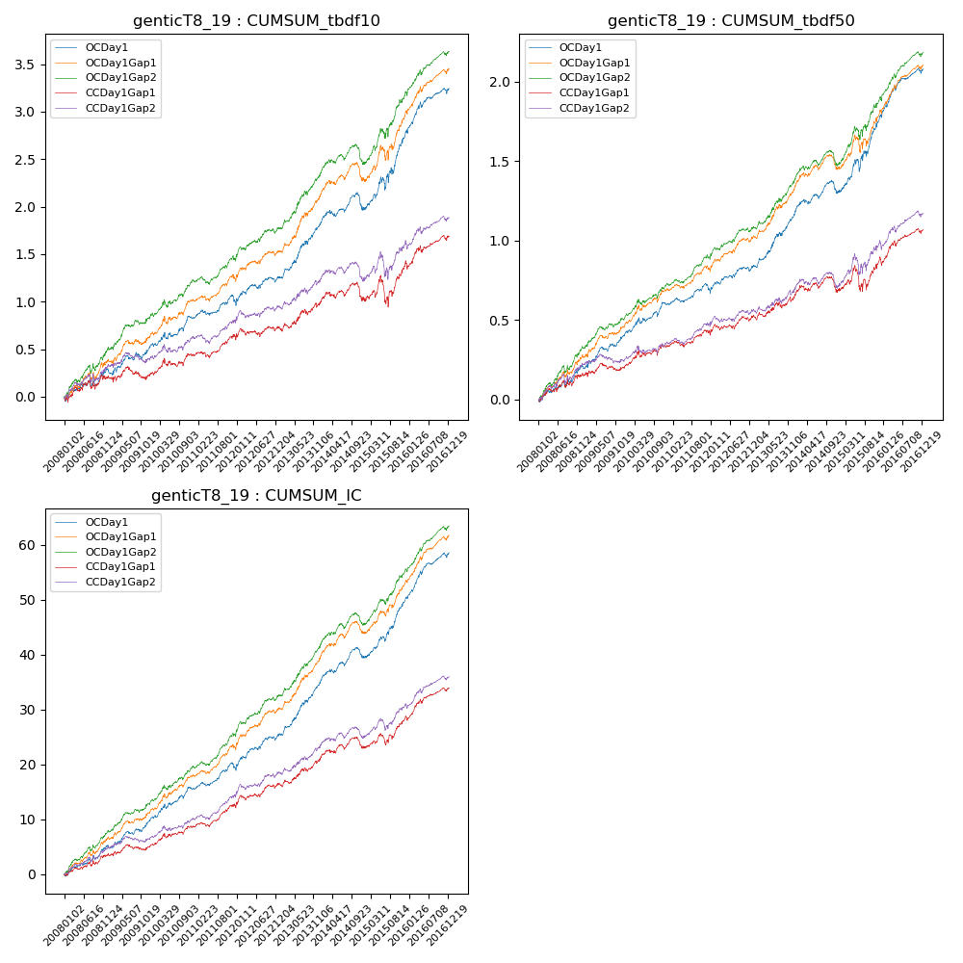

**因子换手率:** 32.3%

**截面指标_OCDay1:**

|  |  |  |  |  |  |  |  |  |
| --- | --- | --- | --- | --- | --- | --- | --- | --- |
| year | annret_tbdf10 | sharpe_tbdf10 | maxdd_tbdf10 | annret_tbdf50 | sharpe_tbdf50 | maxdd_tbdf50 | mean_IC | tstat_IC |
| 2008 | 0.29 | 1.88 | -0.08 | 0.21 | 2.6 | -0.04 | 0.02 | 3.11 |
| 2009 | 0.25 | 2.16 | -0.07 | 0.2 | 3.44 | -0.03 | 0.02 | 3.49 |
| 2010 | 0.3 | 2.72 | -0.07 | 0.19 | 3.09 | -0.04 | 0.02 | 3.71 |
| 2011 | 0.15 | 1.66 | -0.08 | 0.08 | 1.74 | -0.05 | 0.01 | 2.71 |
| 2012 | 0.27 | 2.51 | -0.05 | 0.15 | 2.76 | -0.03 | 0.03 | 3.86 |
| 2013 | 0.59 | 4.7 | -0.04 | 0.35 | 4.99 | -0.02 | 0.04 | 5.83 |
| 2014 | 0.15 | 1.2 | -0.18 | 0.13 | 2.0 | -0.08 | 0.02 | 2.73 |
| 2015 | 0.82 | 3.87 | -0.13 | 0.49 | 4.24 | -0.08 | 0.04 | 5.65 |
| 2016 | 0.46 | 3.8 | -0.06 | 0.3 | 4.62 | -0.03 | 0.03 | 5.34 |

**截面指标_CCDay1Gap1:**

|  |  |  |  |  |  |  |  |  |
| --- | --- | --- | --- | --- | --- | --- | --- | --- |
| year | annret_tbdf10 | sharpe_tbdf10 | maxdd_tbdf10 | annret_tbdf50 | sharpe_tbdf50 | maxdd_tbdf50 | mean_IC | tstat_IC |
| 2008 | 0.2 | 1.23 | -0.1 | 0.15 | 1.88 | -0.04 | 0.01 | 2.22 |
| 2009 | 0.04 | 0.3 | -0.13 | 0.06 | 0.95 | -0.05 | 0.01 | 1.38 |
| 2010 | 0.21 | 1.84 | -0.09 | 0.13 | 2.1 | -0.04 | 0.01 | 2.61 |
| 2011 | 0.15 | 1.65 | -0.07 | 0.06 | 1.29 | -0.04 | 0.01 | 2.61 |
| 2012 | 0.13 | 1.25 | -0.09 | 0.12 | 2.12 | -0.04 | 0.02 | 2.83 |
| 2013 | 0.28 | 2.07 | -0.06 | 0.13 | 1.78 | -0.04 | 0.02 | 2.84 |
| 2014 | 0.05 | 0.36 | -0.18 | 0.04 | 0.52 | -0.09 | 0.01 | 1.29 |
| 2015 | 0.36 | 1.6 | -0.29 | 0.19 | 1.57 | -0.16 | 0.02 | 2.8 |
| 2016 | 0.29 | 2.49 | -0.07 | 0.19 | 2.93 | -0.04 | 0.02 | 3.87 |

**风格暴露:**

|  |  |  |  |  |
| --- | --- | --- | --- | --- |
|  | long | short | corr_OCDay1 | corr_CCDay1Gap1 |
| liquidity10 | -0.62 | 0.6 | 0.51 | 0.57 |
| liquidity20 | -0.63 | 0.6 | 0.51 | 0.57 |
| liquidity5 | -0.64 | 0.62 | 0.5 | 0.58 |
| logmktcap | 1.23 | -1.21 | -0.62 | -0.65 |
| momentum15 | -0.04 | 0.05 | 0.06 | 0.11 |
| momentum30 | -0.02 | 0.03 | 0.04 | 0.09 |
| momentum5 | -0.09 | 0.1 | -0.02 | 0.05 |
| retvolatility30 | -0.82 | 0.79 | 0.56 | 0.59 |