Factors Report 20080102-20161230

**1. genticT12_19**

**截面指标累计曲线:**

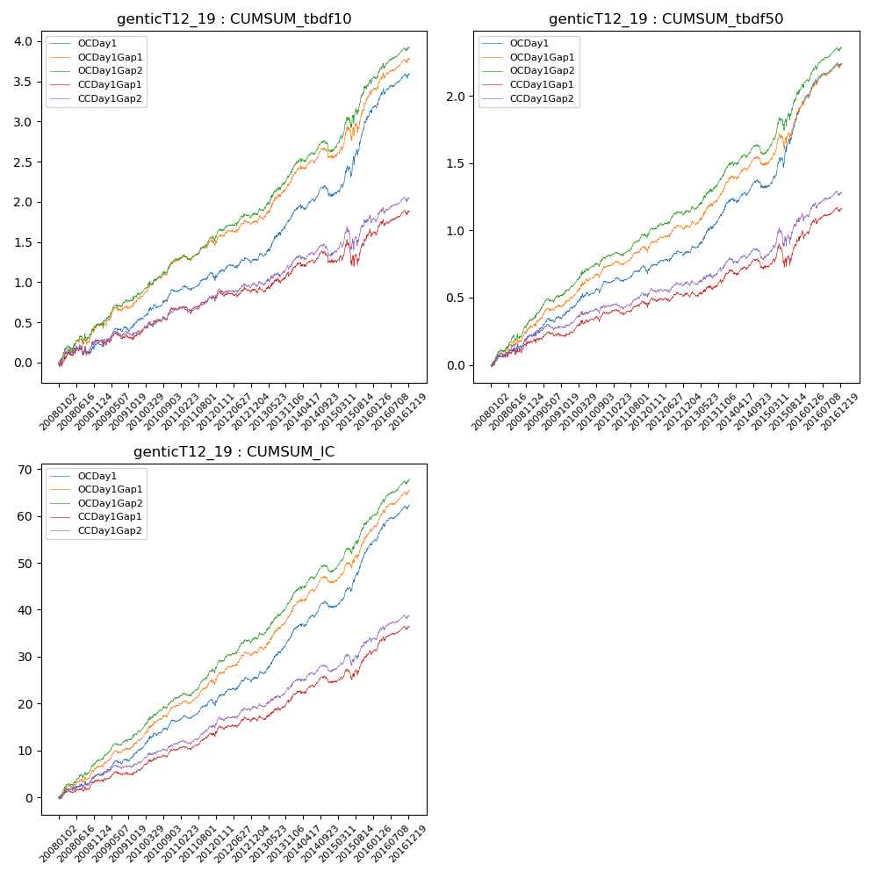

**因子换手率:** 31.3%

**截面指标_OCDay1:**

|  |  |  |  |  |  |  |  |  |
| --- | --- | --- | --- | --- | --- | --- | --- | --- |
| year | annret_tbdf10 | sharpe_tbdf10 | maxdd_tbdf10 | annret_tbdf50 | sharpe_tbdf50 | maxdd_tbdf50 | mean_IC | tstat_IC |
| 2008 | 0.23 | 1.51 | -0.1 | 0.22 | 2.84 | -0.03 | 0.02 | 2.96 |
| 2009 | 0.28 | 2.49 | -0.06 | 0.19 | 3.28 | -0.03 | 0.02 | 3.63 |
| 2010 | 0.38 | 3.63 | -0.05 | 0.21 | 3.41 | -0.03 | 0.03 | 4.44 |
| 2011 | 0.15 | 1.72 | -0.08 | 0.08 | 1.7 | -0.05 | 0.01 | 2.78 |
| 2012 | 0.23 | 2.3 | -0.07 | 0.15 | 2.73 | -0.04 | 0.02 | 3.57 |
| 2013 | 0.57 | 4.48 | -0.05 | 0.33 | 4.82 | -0.02 | 0.04 | 5.65 |
| 2014 | 0.24 | 2.14 | -0.13 | 0.16 | 2.44 | -0.06 | 0.02 | 3.57 |
| 2015 | 1.05 | 4.71 | -0.14 | 0.64 | 5.28 | -0.07 | 0.05 | 6.55 |
| 2016 | 0.48 | 3.88 | -0.07 | 0.3 | 4.49 | -0.03 | 0.03 | 5.23 |

**截面指标_CCDay1Gap1:**

|  |  |  |  |  |  |  |  |  |
| --- | --- | --- | --- | --- | --- | --- | --- | --- |
| year | annret_tbdf10 | sharpe_tbdf10 | maxdd_tbdf10 | annret_tbdf50 | sharpe_tbdf50 | maxdd_tbdf50 | mean_IC | tstat_IC |
| 2008 | 0.27 | 1.64 | -0.1 | 0.17 | 2.13 | -0.04 | 0.01 | 2.31 |
| 2009 | 0.08 | 0.64 | -0.09 | 0.07 | 1.12 | -0.04 | 0.01 | 1.62 |
| 2010 | 0.33 | 3.09 | -0.05 | 0.15 | 2.56 | -0.04 | 0.02 | 3.63 |
| 2011 | 0.09 | 0.98 | -0.07 | 0.04 | 0.87 | -0.04 | 0.01 | 2.19 |
| 2012 | 0.14 | 1.45 | -0.08 | 0.1 | 1.84 | -0.04 | 0.02 | 2.6 |
| 2013 | 0.25 | 1.83 | -0.07 | 0.13 | 1.71 | -0.04 | 0.02 | 2.74 |
| 2014 | 0.13 | 1.13 | -0.13 | 0.07 | 1.16 | -0.07 | 0.01 | 2.22 |
| 2015 | 0.35 | 1.36 | -0.3 | 0.25 | 1.85 | -0.16 | 0.03 | 2.97 |
| 2016 | 0.26 | 2.13 | -0.08 | 0.19 | 2.79 | -0.04 | 0.02 | 3.67 |

**风格暴露:**

|  |  |  |  |  |
| --- | --- | --- | --- | --- |
|  | long | short | corr_OCDay1 | corr_CCDay1Gap1 |
| liquidity10 | -0.65 | 0.62 | 0.56 | 0.61 |
| liquidity20 | -0.67 | 0.63 | 0.57 | 0.61 |
| liquidity5 | -0.67 | 0.65 | 0.56 | 0.62 |
| logmktcap | 1.3 | -1.28 | -0.66 | -0.7 |
| momentum15 | -0.01 | 0.02 | 0.06 | 0.08 |
| momentum30 | -0.01 | 0.01 | 0.06 | 0.07 |
| momentum5 | -0.07 | 0.08 | -0.01 | 0.03 |
| retvolatility30 | -0.86 | 0.79 | 0.61 | 0.64 |