Factors Report 20080102-20161230

**1. genticT14_1**

**截面指标累计曲线:**

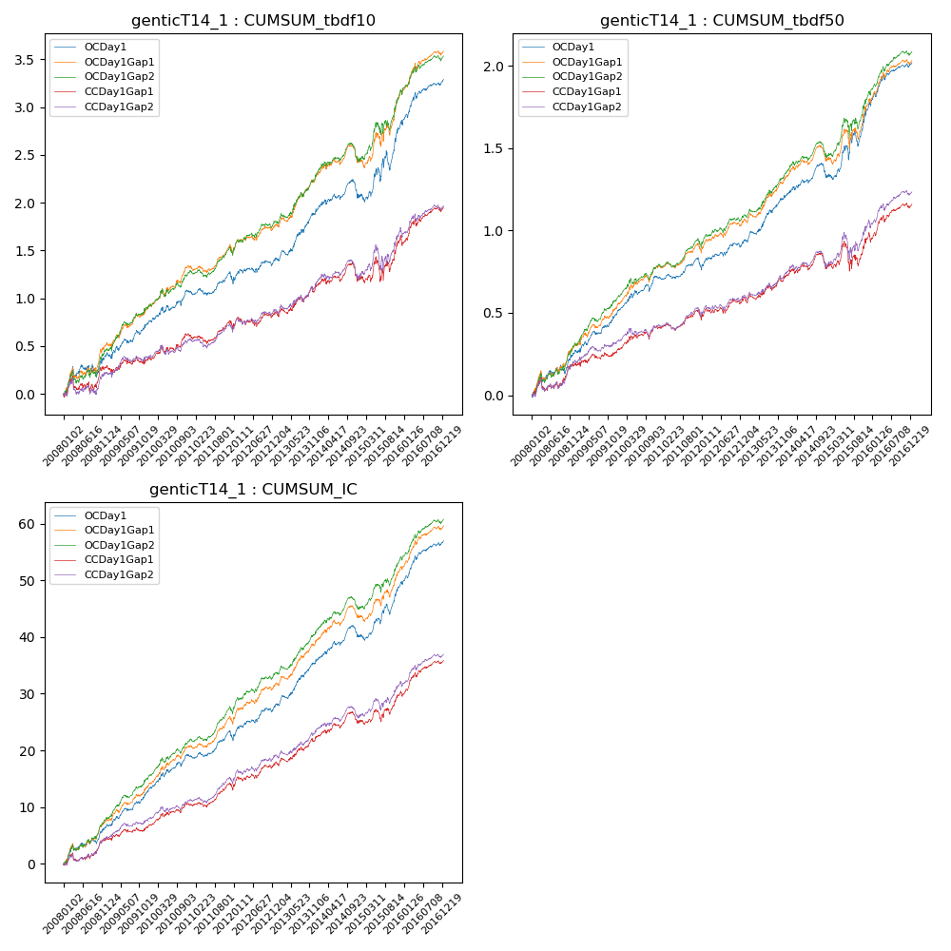

**因子换手率:** 31.39%

**截面指标_OCDay1:**

|  |  |  |  |  |  |  |  |  |
| --- | --- | --- | --- | --- | --- | --- | --- | --- |
| year | annret_tbdf10 | sharpe_tbdf10 | maxdd_tbdf10 | annret_tbdf50 | sharpe_tbdf50 | maxdd_tbdf50 | mean_IC | tstat_IC |
| 2008 | 0.39 | 2.24 | -0.13 | 0.25 | 2.99 | -0.05 | 0.03 | 3.57 |
| 2009 | 0.36 | 2.82 | -0.06 | 0.24 | 3.97 | -0.02 | 0.03 | 4.5 |
| 2010 | 0.32 | 2.82 | -0.06 | 0.22 | 3.52 | -0.04 | 0.02 | 3.92 |
| 2011 | 0.11 | 1.16 | -0.1 | 0.06 | 1.27 | -0.06 | 0.01 | 2.31 |
| 2012 | 0.22 | 2.07 | -0.05 | 0.16 | 2.85 | -0.03 | 0.02 | 3.61 |
| 2013 | 0.53 | 3.96 | -0.05 | 0.28 | 4.45 | -0.02 | 0.03 | 4.99 |
| 2014 | 0.15 | 1.14 | -0.18 | 0.12 | 1.88 | -0.09 | 0.02 | 2.6 |
| 2015 | 0.78 | 3.16 | -0.19 | 0.45 | 3.56 | -0.1 | 0.04 | 4.36 |
| 2016 | 0.46 | 3.78 | -0.06 | 0.26 | 3.98 | -0.03 | 0.03 | 4.83 |

**截面指标_CCDay1Gap1:**

|  |  |  |  |  |  |  |  |  |
| --- | --- | --- | --- | --- | --- | --- | --- | --- |
| year | annret_tbdf10 | sharpe_tbdf10 | maxdd_tbdf10 | annret_tbdf50 | sharpe_tbdf50 | maxdd_tbdf50 | mean_IC | tstat_IC |
| 2008 | 0.27 | 1.52 | -0.15 | 0.18 | 2.15 | -0.08 | 0.02 | 2.53 |
| 2009 | 0.09 | 0.69 | -0.11 | 0.09 | 1.37 | -0.03 | 0.01 | 1.76 |
| 2010 | 0.25 | 2.19 | -0.06 | 0.14 | 2.37 | -0.04 | 0.02 | 2.89 |
| 2011 | 0.06 | 0.67 | -0.09 | 0.04 | 0.9 | -0.06 | 0.01 | 1.98 |
| 2012 | 0.17 | 1.55 | -0.1 | 0.13 | 2.25 | -0.03 | 0.02 | 3.01 |
| 2013 | 0.29 | 2.09 | -0.06 | 0.13 | 1.94 | -0.04 | 0.02 | 2.91 |
| 2014 | 0.08 | 0.64 | -0.19 | 0.07 | 1.05 | -0.1 | 0.01 | 1.81 |
| 2015 | 0.41 | 1.57 | -0.24 | 0.18 | 1.32 | -0.17 | 0.02 | 2.36 |
| 2016 | 0.34 | 2.76 | -0.07 | 0.2 | 2.92 | -0.04 | 0.02 | 3.92 |

**风格暴露:**

|  |  |  |  |  |
| --- | --- | --- | --- | --- |
|  | long | short | corr_OCDay1 | corr_CCDay1Gap1 |
| liquidity10 | -0.51 | 0.51 | 0.44 | 0.53 |
| liquidity20 | -0.55 | 0.56 | 0.47 | 0.54 |
| liquidity5 | -0.52 | 0.53 | 0.43 | 0.53 |
| logmktcap | 1.47 | -1.47 | -0.69 | -0.73 |
| momentum15 | 0.07 | -0.06 | -0.0 | 0.06 |
| momentum30 | 0.07 | -0.06 | 0.01 | 0.03 |
| momentum5 | -0.05 | 0.05 | -0.05 | 0.02 |
| retvolatility30 | -0.63 | 0.64 | 0.48 | 0.53 |