Factors Report 20080102-20161230

**1. genticT14_19**

**截面指标累计曲线:**

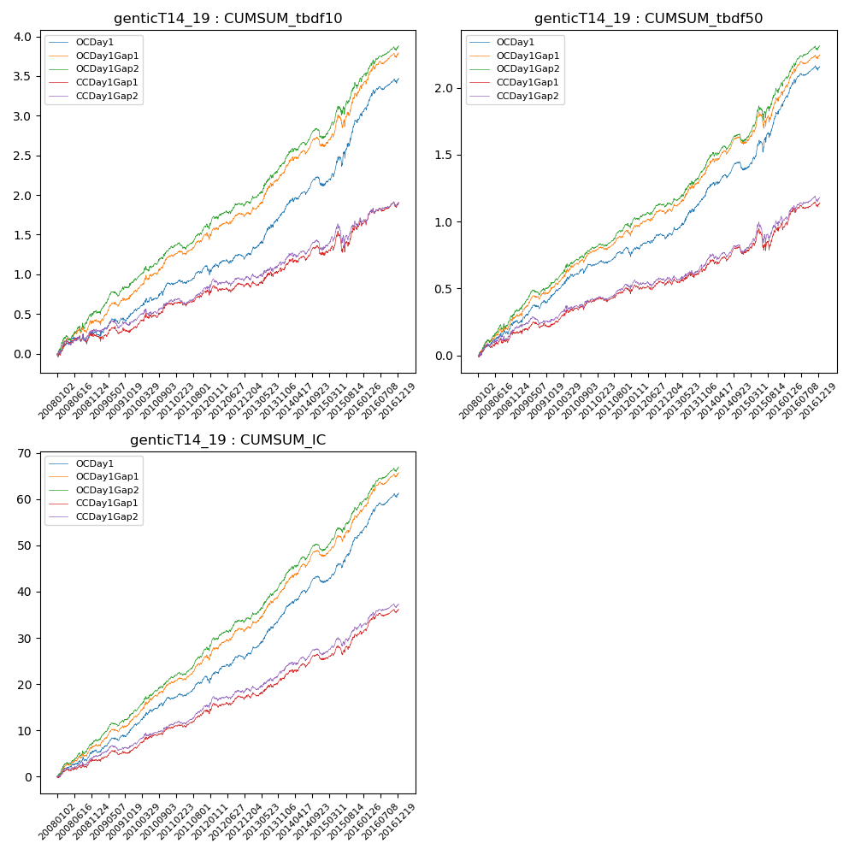

**因子换手率:** 30.97%

**截面指标_OCDay1:**

|  |  |  |  |  |  |  |  |  |
| --- | --- | --- | --- | --- | --- | --- | --- | --- |
| year | annret_tbdf10 | sharpe_tbdf10 | maxdd_tbdf10 | annret_tbdf50 | sharpe_tbdf50 | maxdd_tbdf50 | mean_IC | tstat_IC |
| 2008 | 0.27 | 1.73 | -0.12 | 0.25 | 3.33 | -0.04 | 0.02 | 3.48 |
| 2009 | 0.26 | 2.29 | -0.07 | 0.21 | 3.64 | -0.03 | 0.02 | 3.85 |
| 2010 | 0.37 | 3.3 | -0.05 | 0.21 | 3.45 | -0.04 | 0.03 | 4.12 |
| 2011 | 0.13 | 1.41 | -0.09 | 0.08 | 1.6 | -0.06 | 0.01 | 2.62 |
| 2012 | 0.22 | 2.09 | -0.06 | 0.14 | 2.64 | -0.04 | 0.02 | 3.6 |
| 2013 | 0.57 | 4.46 | -0.04 | 0.32 | 4.49 | -0.02 | 0.04 | 5.54 |
| 2014 | 0.32 | 2.79 | -0.11 | 0.18 | 2.97 | -0.06 | 0.03 | 4.12 |
| 2015 | 0.9 | 4.25 | -0.12 | 0.48 | 4.25 | -0.09 | 0.04 | 5.65 |
| 2016 | 0.46 | 3.8 | -0.05 | 0.3 | 4.54 | -0.03 | 0.04 | 5.42 |

**截面指标_CCDay1Gap1:**

|  |  |  |  |  |  |  |  |  |
| --- | --- | --- | --- | --- | --- | --- | --- | --- |
| year | annret_tbdf10 | sharpe_tbdf10 | maxdd_tbdf10 | annret_tbdf50 | sharpe_tbdf50 | maxdd_tbdf50 | mean_IC | tstat_IC |
| 2008 | 0.22 | 1.45 | -0.11 | 0.17 | 2.17 | -0.04 | 0.01 | 2.35 |
| 2009 | 0.1 | 0.82 | -0.09 | 0.07 | 1.21 | -0.04 | 0.01 | 1.91 |
| 2010 | 0.32 | 2.9 | -0.06 | 0.17 | 2.73 | -0.03 | 0.02 | 3.63 |
| 2011 | 0.1 | 1.07 | -0.07 | 0.05 | 1.02 | -0.05 | 0.01 | 2.26 |
| 2012 | 0.14 | 1.33 | -0.08 | 0.09 | 1.53 | -0.04 | 0.02 | 2.45 |
| 2013 | 0.21 | 1.53 | -0.06 | 0.11 | 1.45 | -0.04 | 0.02 | 2.51 |
| 2014 | 0.2 | 1.66 | -0.11 | 0.12 | 1.9 | -0.06 | 0.02 | 2.67 |
| 2015 | 0.38 | 1.8 | -0.24 | 0.21 | 1.63 | -0.16 | 0.02 | 3.02 |
| 2016 | 0.24 | 1.96 | -0.07 | 0.17 | 2.42 | -0.04 | 0.02 | 3.33 |

**风格暴露:**

|  |  |  |  |  |
| --- | --- | --- | --- | --- |
|  | long | short | corr_OCDay1 | corr_CCDay1Gap1 |
| liquidity10 | -0.66 | 0.64 | 0.53 | 0.59 |
| liquidity20 | -0.67 | 0.66 | 0.54 | 0.59 |
| liquidity5 | -0.67 | 0.66 | 0.53 | 0.58 |
| logmktcap | 1.28 | -1.27 | -0.64 | -0.69 |
| momentum15 | -0.03 | 0.03 | 0.04 | 0.09 |
| momentum30 | -0.02 | 0.03 | 0.03 | 0.07 |
| momentum5 | -0.07 | 0.08 | -0.02 | 0.04 |
| retvolatility30 | -0.86 | 0.84 | 0.58 | 0.61 |