Factors Report 20080102-20161230

**1. genticT16_12**

**截面指标累计曲线:**

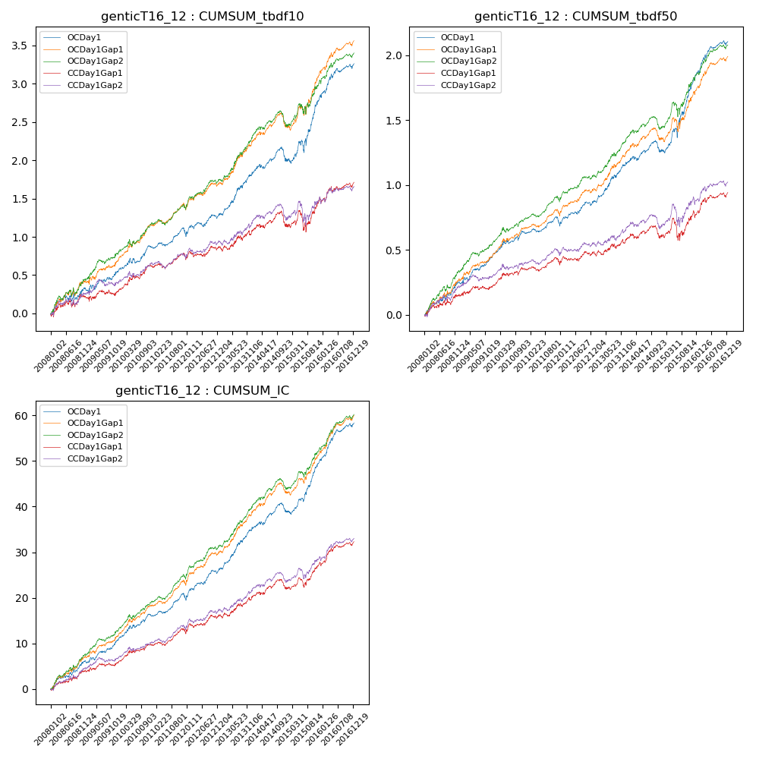

**因子换手率:** 32.56%

**截面指标_OCDay1:**

|  |  |  |  |  |  |  |  |  |
| --- | --- | --- | --- | --- | --- | --- | --- | --- |
| year | annret_tbdf10 | sharpe_tbdf10 | maxdd_tbdf10 | annret_tbdf50 | sharpe_tbdf50 | maxdd_tbdf50 | mean_IC | tstat_IC |
| 2008 | 0.32 | 1.99 | -0.08 | 0.25 | 3.12 | -0.03 | 0.02 | 3.55 |
| 2009 | 0.24 | 1.9 | -0.06 | 0.2 | 3.41 | -0.03 | 0.02 | 3.45 |
| 2010 | 0.31 | 2.88 | -0.07 | 0.18 | 3.01 | -0.03 | 0.02 | 3.5 |
| 2011 | 0.16 | 1.86 | -0.09 | 0.06 | 1.43 | -0.06 | 0.01 | 2.93 |
| 2012 | 0.27 | 2.55 | -0.06 | 0.17 | 3.15 | -0.03 | 0.03 | 4.06 |
| 2013 | 0.55 | 4.16 | -0.04 | 0.31 | 4.33 | -0.02 | 0.04 | 5.16 |
| 2014 | 0.17 | 1.31 | -0.17 | 0.09 | 1.37 | -0.09 | 0.01 | 2.21 |
| 2015 | 0.85 | 3.81 | -0.15 | 0.56 | 4.75 | -0.07 | 0.05 | 5.69 |
| 2016 | 0.43 | 3.39 | -0.06 | 0.3 | 4.29 | -0.03 | 0.03 | 4.94 |

**截面指标_CCDay1Gap1:**

|  |  |  |  |  |  |  |  |  |
| --- | --- | --- | --- | --- | --- | --- | --- | --- |
| year | annret_tbdf10 | sharpe_tbdf10 | maxdd_tbdf10 | annret_tbdf50 | sharpe_tbdf50 | maxdd_tbdf50 | mean_IC | tstat_IC |
| 2008 | 0.21 | 1.27 | -0.09 | 0.15 | 1.84 | -0.04 | 0.02 | 2.49 |
| 2009 | 0.08 | 0.64 | -0.08 | 0.07 | 1.17 | -0.03 | 0.01 | 1.54 |
| 2010 | 0.33 | 3.08 | -0.05 | 0.13 | 2.24 | -0.03 | 0.02 | 2.96 |
| 2011 | 0.08 | 0.91 | -0.08 | 0.03 | 0.62 | -0.06 | 0.01 | 1.9 |
| 2012 | 0.16 | 1.56 | -0.07 | 0.1 | 1.72 | -0.04 | 0.02 | 2.61 |
| 2013 | 0.22 | 1.54 | -0.06 | 0.1 | 1.34 | -0.04 | 0.02 | 2.37 |
| 2014 | 0.08 | 0.62 | -0.19 | 0.02 | 0.36 | -0.09 | 0.01 | 1.23 |
| 2015 | 0.33 | 1.47 | -0.26 | 0.18 | 1.43 | -0.16 | 0.02 | 2.77 |
| 2016 | 0.23 | 1.85 | -0.07 | 0.16 | 2.32 | -0.04 | 0.02 | 3.14 |

**风格暴露:**

|  |  |  |  |  |
| --- | --- | --- | --- | --- |
|  | long | short | corr_OCDay1 | corr_CCDay1Gap1 |
| liquidity10 | -0.62 | 0.59 | 0.52 | 0.59 |
| liquidity20 | -0.62 | 0.59 | 0.53 | 0.59 |
| liquidity5 | -0.63 | 0.61 | 0.52 | 0.59 |
| logmktcap | 1.19 | -1.17 | -0.64 | -0.67 |
| momentum15 | -0.02 | 0.03 | 0.01 | 0.08 |
| momentum30 | -0.02 | 0.02 | 0.02 | 0.06 |
| momentum5 | -0.07 | 0.08 | -0.03 | 0.02 |
| retvolatility30 | -0.84 | 0.78 | 0.58 | 0.61 |