Factors Report 20080102-20161230

**1. genticT17_11**

**截面指标累计曲线:**

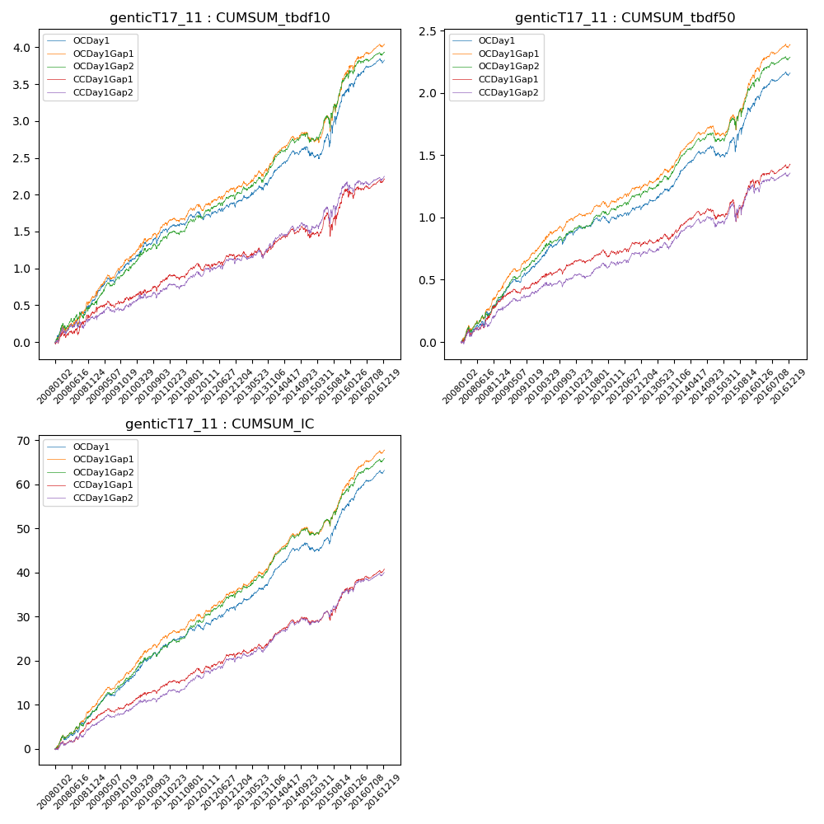

**因子换手率:** 31.35%

**截面指标_OCDay1:**

|  |  |  |  |  |  |  |  |  |
| --- | --- | --- | --- | --- | --- | --- | --- | --- |
| year | annret_tbdf10 | sharpe_tbdf10 | maxdd_tbdf10 | annret_tbdf50 | sharpe_tbdf50 | maxdd_tbdf50 | mean_IC | tstat_IC |
| 2008 | 0.54 | 3.04 | -0.11 | 0.32 | 3.82 | -0.05 | 0.03 | 4.48 |
| 2009 | 0.51 | 4.37 | -0.06 | 0.28 | 4.79 | -0.02 | 0.03 | 5.35 |
| 2010 | 0.48 | 3.8 | -0.08 | 0.28 | 4.4 | -0.04 | 0.03 | 5.15 |
| 2011 | 0.17 | 1.83 | -0.07 | 0.09 | 1.92 | -0.04 | 0.02 | 2.76 |
| 2012 | 0.21 | 1.97 | -0.06 | 0.13 | 2.29 | -0.03 | 0.02 | 3.42 |
| 2013 | 0.41 | 3.24 | -0.06 | 0.27 | 4.25 | -0.02 | 0.03 | 4.79 |
| 2014 | 0.22 | 1.84 | -0.12 | 0.14 | 2.46 | -0.08 | 0.02 | 3.31 |
| 2015 | 0.89 | 3.39 | -0.17 | 0.41 | 3.19 | -0.11 | 0.04 | 4.65 |
| 2016 | 0.41 | 3.08 | -0.06 | 0.25 | 3.74 | -0.03 | 0.03 | 4.96 |

**截面指标_CCDay1Gap1:**

|  |  |  |  |  |  |  |  |  |
| --- | --- | --- | --- | --- | --- | --- | --- | --- |
| year | annret_tbdf10 | sharpe_tbdf10 | maxdd_tbdf10 | annret_tbdf50 | sharpe_tbdf50 | maxdd_tbdf50 | mean_IC | tstat_IC |
| 2008 | 0.4 | 2.31 | -0.09 | 0.32 | 3.74 | -0.05 | 0.03 | 3.88 |
| 2009 | 0.18 | 1.43 | -0.09 | 0.15 | 2.53 | -0.03 | 0.01 | 2.73 |
| 2010 | 0.28 | 2.21 | -0.07 | 0.16 | 2.54 | -0.05 | 0.02 | 3.19 |
| 2011 | 0.12 | 1.21 | -0.09 | 0.05 | 1.1 | -0.06 | 0.01 | 1.96 |
| 2012 | 0.21 | 1.84 | -0.07 | 0.12 | 2.01 | -0.04 | 0.02 | 2.94 |
| 2013 | 0.17 | 1.2 | -0.12 | 0.13 | 1.94 | -0.05 | 0.02 | 2.53 |
| 2014 | 0.11 | 0.87 | -0.15 | 0.08 | 1.29 | -0.08 | 0.01 | 2.12 |
| 2015 | 0.59 | 2.22 | -0.28 | 0.28 | 2.03 | -0.17 | 0.03 | 3.39 |
| 2016 | 0.18 | 1.32 | -0.1 | 0.14 | 2.06 | -0.04 | 0.02 | 3.07 |

**风格暴露:**

|  |  |  |  |  |
| --- | --- | --- | --- | --- |
|  | long | short | corr_OCDay1 | corr_CCDay1Gap1 |
| liquidity10 | -0.6 | 0.59 | 0.51 | 0.56 |
| liquidity20 | -0.61 | 0.6 | 0.53 | 0.57 |
| liquidity5 | -0.59 | 0.58 | 0.49 | 0.55 |
| logmktcap | 1.51 | -1.5 | -0.75 | -0.78 |
| momentum15 | -0.1 | 0.11 | -0.05 | -0.03 |
| momentum30 | -0.07 | 0.08 | -0.03 | -0.03 |
| momentum5 | -0.07 | 0.07 | -0.11 | -0.03 |
| retvolatility30 | -0.63 | 0.62 | 0.55 | 0.57 |