Factors Report 20080102-20161230

**1. genticT17_12**

**截面指标累计曲线:**

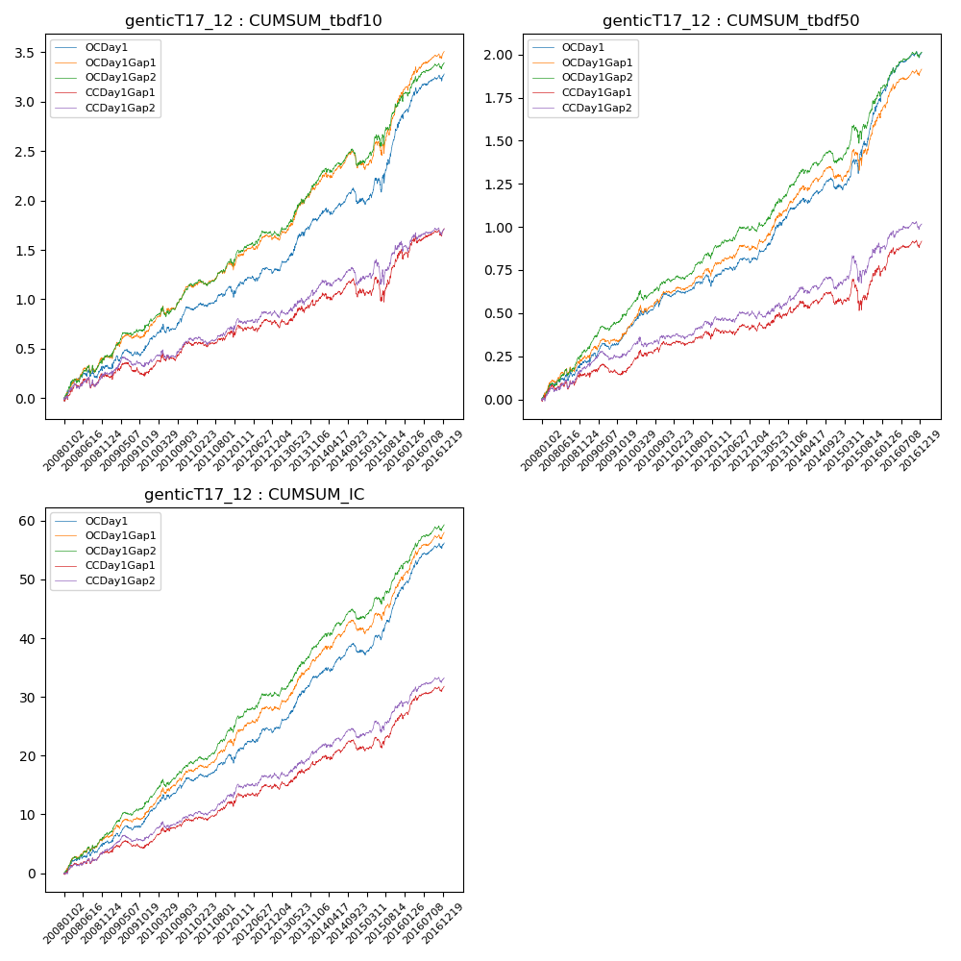

**因子换手率:** 32.86%

**截面指标_OCDay1:**

|  |  |  |  |  |  |  |  |  |
| --- | --- | --- | --- | --- | --- | --- | --- | --- |
| year | annret_tbdf10 | sharpe_tbdf10 | maxdd_tbdf10 | annret_tbdf50 | sharpe_tbdf50 | maxdd_tbdf50 | mean_IC | tstat_IC |
| 2008 | 0.32 | 2.01 | -0.1 | 0.21 | 2.79 | -0.04 | 0.02 | 3.24 |
| 2009 | 0.25 | 2.16 | -0.07 | 0.18 | 3.11 | -0.04 | 0.02 | 3.59 |
| 2010 | 0.34 | 3.04 | -0.09 | 0.21 | 3.45 | -0.03 | 0.02 | 3.84 |
| 2011 | 0.14 | 1.57 | -0.08 | 0.06 | 1.34 | -0.06 | 0.01 | 2.34 |
| 2012 | 0.25 | 2.38 | -0.06 | 0.14 | 2.64 | -0.03 | 0.02 | 3.48 |
| 2013 | 0.52 | 3.79 | -0.04 | 0.3 | 4.23 | -0.02 | 0.04 | 5.09 |
| 2014 | 0.19 | 1.59 | -0.15 | 0.12 | 1.93 | -0.06 | 0.02 | 2.75 |
| 2015 | 0.86 | 3.91 | -0.14 | 0.51 | 4.32 | -0.08 | 0.04 | 5.5 |
| 2016 | 0.44 | 3.45 | -0.06 | 0.28 | 4.1 | -0.04 | 0.03 | 4.71 |

**截面指标_CCDay1Gap1:**

|  |  |  |  |  |  |  |  |  |
| --- | --- | --- | --- | --- | --- | --- | --- | --- |
| year | annret_tbdf10 | sharpe_tbdf10 | maxdd_tbdf10 | annret_tbdf50 | sharpe_tbdf50 | maxdd_tbdf50 | mean_IC | tstat_IC |
| 2008 | 0.22 | 1.35 | -0.11 | 0.14 | 1.82 | -0.05 | 0.01 | 2.36 |
| 2009 | 0.05 | 0.42 | -0.13 | 0.03 | 0.41 | -0.06 | 0.01 | 1.17 |
| 2010 | 0.28 | 2.52 | -0.08 | 0.15 | 2.49 | -0.04 | 0.02 | 3.01 |
| 2011 | 0.07 | 0.71 | -0.07 | 0.03 | 0.57 | -0.05 | 0.01 | 1.78 |
| 2012 | 0.14 | 1.39 | -0.07 | 0.07 | 1.22 | -0.04 | 0.01 | 2.24 |
| 2013 | 0.23 | 1.56 | -0.07 | 0.11 | 1.39 | -0.04 | 0.02 | 2.4 |
| 2014 | 0.12 | 0.92 | -0.17 | 0.05 | 0.79 | -0.07 | 0.01 | 1.66 |
| 2015 | 0.37 | 1.69 | -0.23 | 0.19 | 1.47 | -0.17 | 0.02 | 2.89 |
| 2016 | 0.25 | 1.95 | -0.07 | 0.16 | 2.37 | -0.04 | 0.02 | 3.3 |

**风格暴露:**

|  |  |  |  |  |
| --- | --- | --- | --- | --- |
|  | long | short | corr_OCDay1 | corr_CCDay1Gap1 |
| liquidity10 | -0.6 | 0.57 | 0.5 | 0.57 |
| liquidity20 | -0.6 | 0.57 | 0.51 | 0.56 |
| liquidity5 | -0.62 | 0.6 | 0.5 | 0.57 |
| logmktcap | 1.2 | -1.18 | -0.6 | -0.63 |
| momentum15 | -0.03 | 0.03 | 0.05 | 0.12 |
| momentum30 | -0.02 | 0.02 | 0.03 | 0.08 |
| momentum5 | -0.08 | 0.08 | -0.0 | 0.08 |
| retvolatility30 | -0.82 | 0.77 | 0.57 | 0.58 |