Factors Report 20080102-20161230

**1. genticT18_6**

**截面指标累计曲线:**

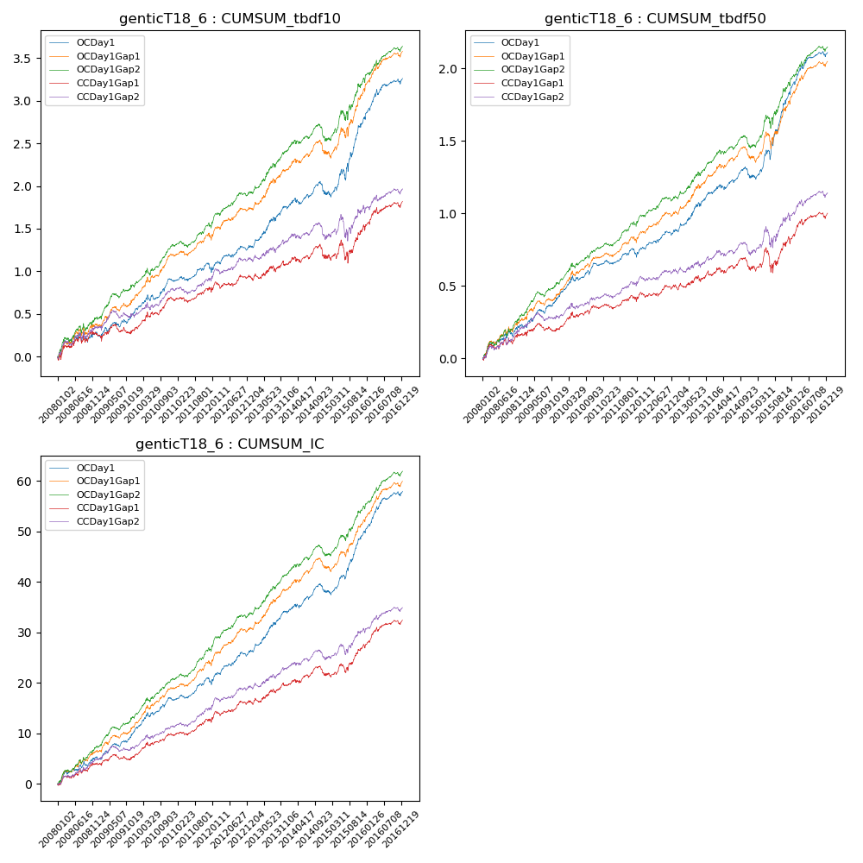

**因子换手率:** 33.29%

**截面指标_OCDay1:**

|  |  |  |  |  |  |  |  |  |
| --- | --- | --- | --- | --- | --- | --- | --- | --- |
| year | annret_tbdf10 | sharpe_tbdf10 | maxdd_tbdf10 | annret_tbdf50 | sharpe_tbdf50 | maxdd_tbdf50 | mean_IC | tstat_IC |
| 2008 | 0.27 | 1.7 | -0.11 | 0.23 | 2.81 | -0.05 | 0.02 | 3.07 |
| 2009 | 0.26 | 2.12 | -0.08 | 0.21 | 3.53 | -0.03 | 0.02 | 3.84 |
| 2010 | 0.36 | 3.39 | -0.07 | 0.21 | 3.47 | -0.04 | 0.02 | 4.12 |
| 2011 | 0.12 | 1.33 | -0.08 | 0.07 | 1.47 | -0.05 | 0.01 | 2.54 |
| 2012 | 0.28 | 2.7 | -0.05 | 0.17 | 3.21 | -0.03 | 0.03 | 4.03 |
| 2013 | 0.46 | 3.59 | -0.05 | 0.27 | 3.85 | -0.03 | 0.03 | 4.65 |
| 2014 | 0.16 | 1.33 | -0.15 | 0.11 | 1.69 | -0.07 | 0.02 | 2.49 |
| 2015 | 0.89 | 4.11 | -0.12 | 0.58 | 5.05 | -0.07 | 0.05 | 5.95 |
| 2016 | 0.48 | 3.66 | -0.06 | 0.29 | 4.09 | -0.04 | 0.03 | 4.93 |

**截面指标_CCDay1Gap1:**

|  |  |  |  |  |  |  |  |  |
| --- | --- | --- | --- | --- | --- | --- | --- | --- |
| year | annret_tbdf10 | sharpe_tbdf10 | maxdd_tbdf10 | annret_tbdf50 | sharpe_tbdf50 | maxdd_tbdf50 | mean_IC | tstat_IC |
| 2008 | 0.26 | 1.58 | -0.08 | 0.16 | 2.0 | -0.04 | 0.02 | 2.52 |
| 2009 | 0.07 | 0.52 | -0.11 | 0.05 | 0.76 | -0.05 | 0.01 | 1.27 |
| 2010 | 0.35 | 3.21 | -0.06 | 0.14 | 2.34 | -0.04 | 0.02 | 3.26 |
| 2011 | 0.08 | 0.87 | -0.06 | 0.04 | 0.82 | -0.04 | 0.01 | 1.92 |
| 2012 | 0.19 | 1.84 | -0.08 | 0.11 | 2.04 | -0.04 | 0.02 | 2.85 |
| 2013 | 0.14 | 1.02 | -0.07 | 0.07 | 0.98 | -0.04 | 0.01 | 1.88 |
| 2014 | 0.1 | 0.79 | -0.16 | 0.05 | 0.75 | -0.09 | 0.01 | 1.48 |
| 2015 | 0.34 | 1.49 | -0.25 | 0.2 | 1.54 | -0.16 | 0.02 | 2.86 |
| 2016 | 0.3 | 2.46 | -0.07 | 0.18 | 2.59 | -0.04 | 0.02 | 3.42 |

**风格暴露:**

|  |  |  |  |  |
| --- | --- | --- | --- | --- |
|  | long | short | corr_OCDay1 | corr_CCDay1Gap1 |
| liquidity10 | -0.59 | 0.55 | 0.51 | 0.57 |
| liquidity20 | -0.59 | 0.55 | 0.53 | 0.57 |
| liquidity5 | -0.61 | 0.58 | 0.52 | 0.57 |
| logmktcap | 1.17 | -1.15 | -0.64 | -0.66 |
| momentum15 | -0.04 | 0.04 | 0.06 | 0.11 |
| momentum30 | -0.03 | 0.03 | 0.05 | 0.08 |
| momentum5 | -0.09 | 0.1 | 0.0 | 0.06 |
| retvolatility30 | -0.79 | 0.72 | 0.57 | 0.58 |