Factors Report 20080102-20161230

**1. genticT18_7**

**截面指标累计曲线:**

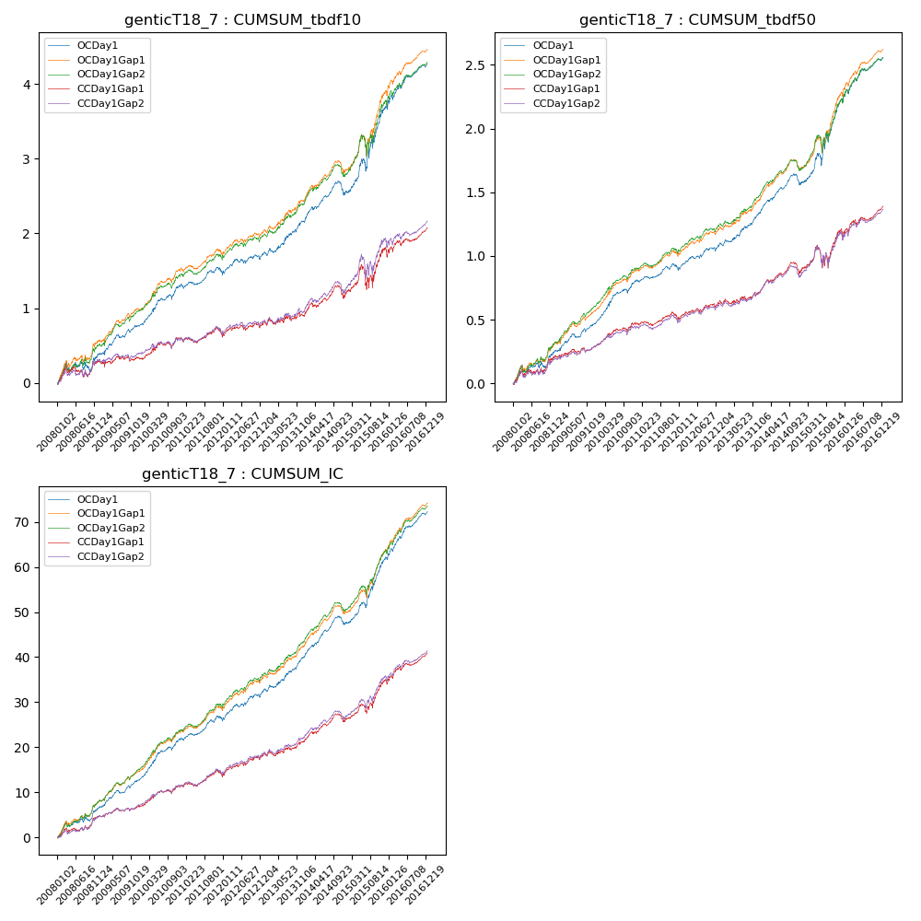

**因子换手率:** 25.64%

**截面指标_OCDay1:**

|  |  |  |  |  |  |  |  |  |
| --- | --- | --- | --- | --- | --- | --- | --- | --- |
| year | annret_tbdf10 | sharpe_tbdf10 | maxdd_tbdf10 | annret_tbdf50 | sharpe_tbdf50 | maxdd_tbdf50 | mean_IC | tstat_IC |
| 2008 | 0.38 | 2.1 | -0.13 | 0.25 | 2.91 | -0.06 | 0.03 | 3.56 |
| 2009 | 0.4 | 3.7 | -0.05 | 0.23 | 4.12 | -0.03 | 0.03 | 5.1 |
| 2010 | 0.55 | 4.65 | -0.07 | 0.34 | 5.59 | -0.03 | 0.04 | 5.88 |
| 2011 | 0.15 | 1.57 | -0.08 | 0.09 | 1.91 | -0.04 | 0.02 | 3.02 |
| 2012 | 0.25 | 2.3 | -0.07 | 0.18 | 3.34 | -0.03 | 0.03 | 4.01 |
| 2013 | 0.46 | 3.29 | -0.06 | 0.26 | 3.97 | -0.02 | 0.03 | 4.5 |
| 2014 | 0.36 | 2.93 | -0.18 | 0.22 | 3.77 | -0.09 | 0.03 | 4.74 |
| 2015 | 1.17 | 4.01 | -0.16 | 0.67 | 4.71 | -0.09 | 0.06 | 6.06 |
| 2016 | 0.59 | 4.03 | -0.06 | 0.33 | 4.48 | -0.04 | 0.04 | 5.94 |

**截面指标_CCDay1Gap1:**

|  |  |  |  |  |  |  |  |  |
| --- | --- | --- | --- | --- | --- | --- | --- | --- |
| year | annret_tbdf10 | sharpe_tbdf10 | maxdd_tbdf10 | annret_tbdf50 | sharpe_tbdf50 | maxdd_tbdf50 | mean_IC | tstat_IC |
| 2008 | 0.28 | 1.63 | -0.15 | 0.21 | 2.45 | -0.05 | 0.02 | 2.81 |
| 2009 | 0.04 | 0.31 | -0.08 | 0.08 | 1.43 | -0.03 | 0.01 | 1.83 |
| 2010 | 0.29 | 2.44 | -0.08 | 0.19 | 3.01 | -0.04 | 0.02 | 3.44 |
| 2011 | 0.0 | 0.01 | -0.13 | 0.02 | 0.37 | -0.06 | 0.01 | 1.35 |
| 2012 | 0.18 | 1.7 | -0.07 | 0.14 | 2.53 | -0.03 | 0.02 | 3.25 |
| 2013 | 0.12 | 0.78 | -0.08 | 0.08 | 1.15 | -0.04 | 0.01 | 1.8 |
| 2014 | 0.27 | 2.07 | -0.17 | 0.16 | 2.68 | -0.09 | 0.02 | 3.18 |
| 2015 | 0.6 | 1.89 | -0.29 | 0.31 | 1.93 | -0.17 | 0.04 | 3.53 |
| 2016 | 0.31 | 2.11 | -0.09 | 0.2 | 2.68 | -0.05 | 0.03 | 3.82 |

**风格暴露:**

|  |  |  |  |  |
| --- | --- | --- | --- | --- |
|  | long | short | corr_OCDay1 | corr_CCDay1Gap1 |
| liquidity10 | -0.8 | 0.77 | 0.62 | 0.66 |
| liquidity20 | -0.78 | 0.75 | 0.64 | 0.67 |
| liquidity5 | -0.79 | 0.77 | 0.61 | 0.65 |
| logmktcap | 1.71 | -1.69 | -0.8 | -0.83 |
| momentum15 | -0.11 | 0.12 | 0.01 | 0.04 |
| momentum30 | -0.03 | 0.03 | 0.03 | 0.03 |
| momentum5 | -0.08 | 0.09 | -0.06 | -0.0 |
| retvolatility30 | -0.74 | 0.7 | 0.67 | 0.69 |