Factors Report 20080102-20161230

**1. genticT18_11**

**截面指标累计曲线:**

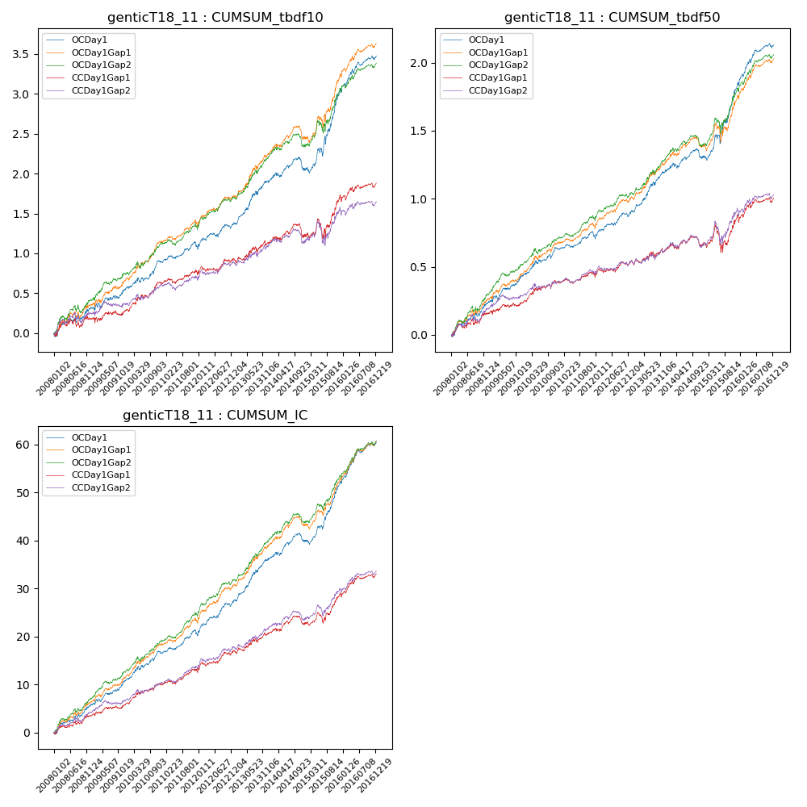

**因子换手率:** 32.97%

**截面指标_OCDay1:**

|  |  |  |  |  |  |  |  |  |
| --- | --- | --- | --- | --- | --- | --- | --- | --- |
| year | annret_tbdf10 | sharpe_tbdf10 | maxdd_tbdf10 | annret_tbdf50 | sharpe_tbdf50 | maxdd_tbdf50 | mean_IC | tstat_IC |
| 2008 | 0.3 | 1.95 | -0.07 | 0.23 | 3.01 | -0.03 | 0.02 | 3.36 |
| 2009 | 0.26 | 2.16 | -0.05 | 0.21 | 3.58 | -0.03 | 0.02 | 3.93 |
| 2010 | 0.34 | 3.06 | -0.06 | 0.2 | 3.22 | -0.03 | 0.02 | 3.78 |
| 2011 | 0.18 | 2.04 | -0.08 | 0.08 | 1.94 | -0.04 | 0.02 | 3.02 |
| 2012 | 0.29 | 2.82 | -0.05 | 0.18 | 3.34 | -0.03 | 0.03 | 4.33 |
| 2013 | 0.54 | 4.02 | -0.04 | 0.31 | 4.36 | -0.03 | 0.04 | 5.06 |
| 2014 | 0.15 | 1.27 | -0.16 | 0.1 | 1.57 | -0.07 | 0.02 | 2.36 |
| 2015 | 1.0 | 4.55 | -0.1 | 0.55 | 4.63 | -0.07 | 0.05 | 5.88 |
| 2016 | 0.44 | 3.56 | -0.05 | 0.29 | 4.22 | -0.03 | 0.03 | 5.09 |

**截面指标_CCDay1Gap1:**

|  |  |  |  |  |  |  |  |  |
| --- | --- | --- | --- | --- | --- | --- | --- | --- |
| year | annret_tbdf10 | sharpe_tbdf10 | maxdd_tbdf10 | annret_tbdf50 | sharpe_tbdf50 | maxdd_tbdf50 | mean_IC | tstat_IC |
| 2008 | 0.17 | 1.1 | -0.11 | 0.16 | 2.02 | -0.05 | 0.01 | 2.29 |
| 2009 | 0.12 | 0.91 | -0.07 | 0.09 | 1.41 | -0.03 | 0.01 | 1.96 |
| 2010 | 0.35 | 3.26 | -0.04 | 0.15 | 2.39 | -0.03 | 0.02 | 3.14 |
| 2011 | 0.09 | 1.03 | -0.06 | 0.03 | 0.74 | -0.04 | 0.01 | 1.94 |
| 2012 | 0.19 | 1.86 | -0.07 | 0.11 | 2.07 | -0.03 | 0.02 | 2.87 |
| 2013 | 0.21 | 1.48 | -0.07 | 0.09 | 1.16 | -0.04 | 0.02 | 2.15 |
| 2014 | 0.11 | 0.86 | -0.17 | 0.04 | 0.6 | -0.07 | 0.01 | 1.43 |
| 2015 | 0.47 | 2.03 | -0.23 | 0.2 | 1.55 | -0.19 | 0.02 | 2.93 |
| 2016 | 0.19 | 1.51 | -0.07 | 0.14 | 2.01 | -0.04 | 0.02 | 2.8 |

**风格暴露:**

|  |  |  |  |  |
| --- | --- | --- | --- | --- |
|  | long | short | corr_OCDay1 | corr_CCDay1Gap1 |
| liquidity10 | -0.6 | 0.58 | 0.52 | 0.58 |
| liquidity20 | -0.61 | 0.59 | 0.53 | 0.58 |
| liquidity5 | -0.62 | 0.6 | 0.52 | 0.59 |
| logmktcap | 1.17 | -1.16 | -0.6 | -0.64 |
| momentum15 | -0.02 | 0.03 | 0.05 | 0.11 |
| momentum30 | -0.02 | 0.02 | 0.04 | 0.07 |
| momentum5 | -0.08 | 0.08 | -0.01 | 0.05 |
| retvolatility30 | -0.82 | 0.79 | 0.58 | 0.61 |