Factors Report 20080102-20161230

**1. genticT18_15**

**截面指标累计曲线:**

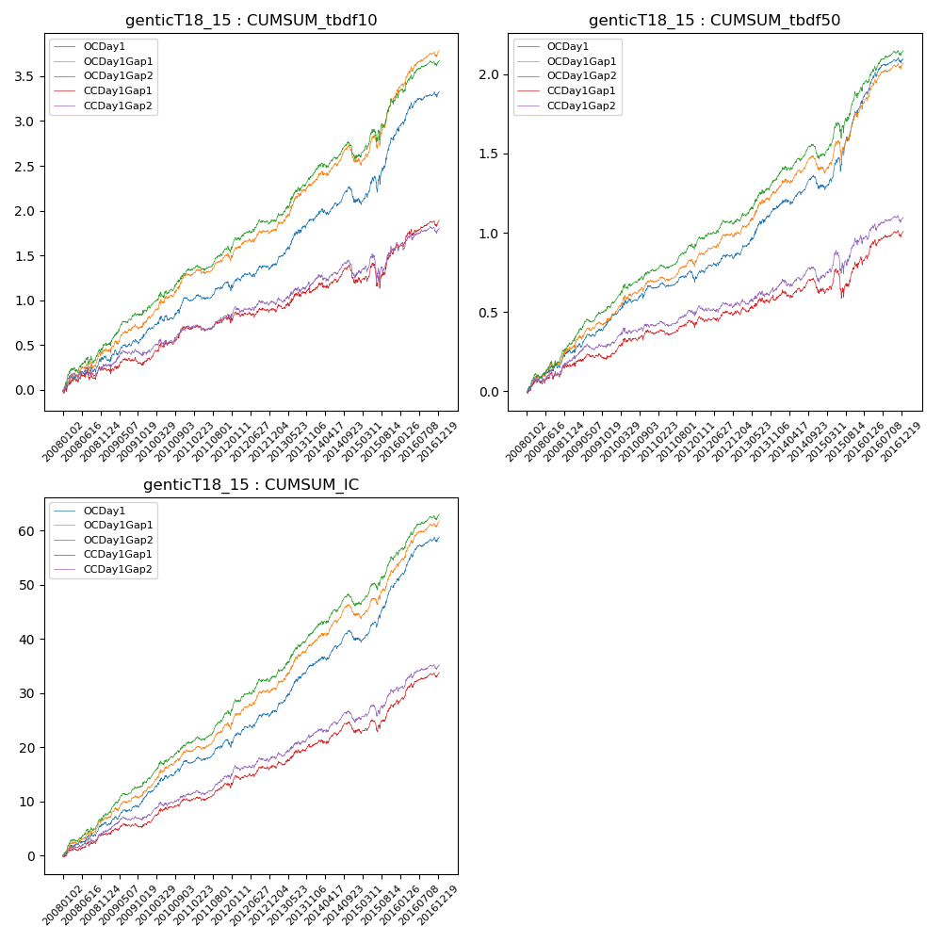

**因子换手率:** 32.47%

**截面指标_OCDay1:**

|  |  |  |  |  |  |  |  |  |
| --- | --- | --- | --- | --- | --- | --- | --- | --- |
| year | annret_tbdf10 | sharpe_tbdf10 | maxdd_tbdf10 | annret_tbdf50 | sharpe_tbdf50 | maxdd_tbdf50 | mean_IC | tstat_IC |
| 2008 | 0.37 | 2.3 | -0.08 | 0.25 | 3.17 | -0.04 | 0.02 | 3.5 |
| 2009 | 0.3 | 2.51 | -0.07 | 0.21 | 3.47 | -0.02 | 0.02 | 3.85 |
| 2010 | 0.35 | 3.07 | -0.06 | 0.2 | 3.12 | -0.03 | 0.02 | 3.86 |
| 2011 | 0.12 | 1.42 | -0.08 | 0.05 | 1.08 | -0.06 | 0.01 | 2.4 |
| 2012 | 0.25 | 2.38 | -0.05 | 0.16 | 2.87 | -0.03 | 0.03 | 3.81 |
| 2013 | 0.52 | 4.03 | -0.04 | 0.31 | 4.32 | -0.02 | 0.04 | 5.08 |
| 2014 | 0.2 | 1.62 | -0.17 | 0.12 | 1.84 | -0.08 | 0.02 | 2.82 |
| 2015 | 0.81 | 3.7 | -0.17 | 0.54 | 4.56 | -0.08 | 0.05 | 5.6 |
| 2016 | 0.43 | 3.38 | -0.06 | 0.28 | 4.12 | -0.03 | 0.03 | 4.79 |

**截面指标_CCDay1Gap1:**

|  |  |  |  |  |  |  |  |  |
| --- | --- | --- | --- | --- | --- | --- | --- | --- |
| year | annret_tbdf10 | sharpe_tbdf10 | maxdd_tbdf10 | annret_tbdf50 | sharpe_tbdf50 | maxdd_tbdf50 | mean_IC | tstat_IC |
| 2008 | 0.23 | 1.45 | -0.1 | 0.16 | 2.01 | -0.05 | 0.02 | 2.54 |
| 2009 | 0.11 | 0.84 | -0.09 | 0.07 | 1.12 | -0.04 | 0.01 | 1.59 |
| 2010 | 0.36 | 3.15 | -0.04 | 0.14 | 2.34 | -0.03 | 0.02 | 3.21 |
| 2011 | 0.06 | 0.67 | -0.07 | 0.03 | 0.64 | -0.05 | 0.01 | 1.77 |
| 2012 | 0.15 | 1.44 | -0.06 | 0.1 | 1.72 | -0.03 | 0.02 | 2.59 |
| 2013 | 0.22 | 1.58 | -0.06 | 0.09 | 1.21 | -0.03 | 0.02 | 2.3 |
| 2014 | 0.11 | 0.86 | -0.19 | 0.04 | 0.65 | -0.09 | 0.01 | 1.69 |
| 2015 | 0.39 | 1.71 | -0.26 | 0.2 | 1.57 | -0.17 | 0.02 | 2.74 |
| 2016 | 0.28 | 2.28 | -0.07 | 0.18 | 2.63 | -0.04 | 0.02 | 3.49 |

**风格暴露:**

|  |  |  |  |  |
| --- | --- | --- | --- | --- |
|  | long | short | corr_OCDay1 | corr_CCDay1Gap1 |
| liquidity10 | -0.63 | 0.61 | 0.52 | 0.57 |
| liquidity20 | -0.64 | 0.61 | 0.53 | 0.57 |
| liquidity5 | -0.65 | 0.62 | 0.52 | 0.58 |
| logmktcap | 1.22 | -1.2 | -0.65 | -0.66 |
| momentum15 | -0.01 | 0.02 | 0.02 | 0.07 |
| momentum30 | 0.0 | 0.0 | 0.01 | 0.04 |
| momentum5 | -0.06 | 0.07 | -0.02 | 0.04 |
| retvolatility30 | -0.84 | 0.78 | 0.58 | 0.59 |