Factors Report 20080102-20161230

**1. genticT18_16**

**截面指标累计曲线:**

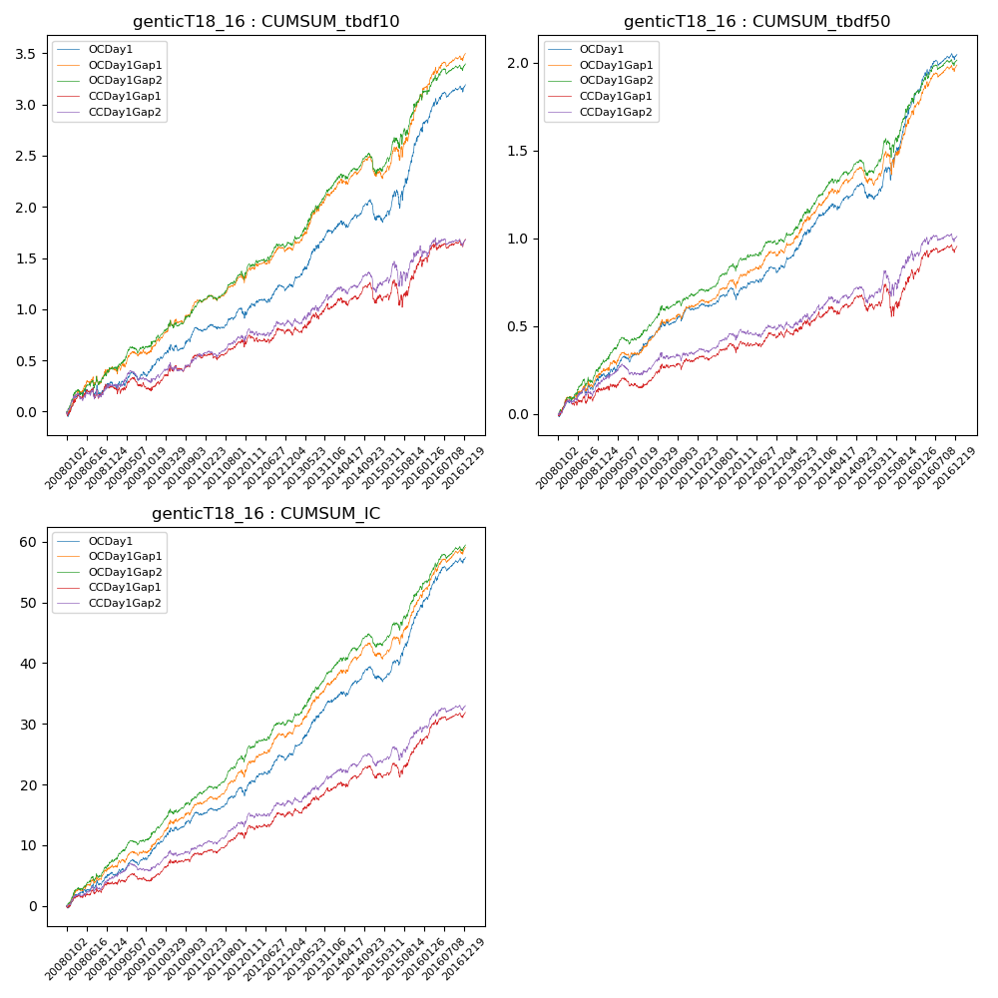

**因子换手率:** 32.43%

**截面指标_OCDay1:**

|  |  |  |  |  |  |  |  |  |
| --- | --- | --- | --- | --- | --- | --- | --- | --- |
| year | annret_tbdf10 | sharpe_tbdf10 | maxdd_tbdf10 | annret_tbdf50 | sharpe_tbdf50 | maxdd_tbdf50 | mean_IC | tstat_IC |
| 2008 | 0.28 | 1.76 | -0.1 | 0.22 | 2.8 | -0.04 | 0.02 | 3.21 |
| 2009 | 0.2 | 1.66 | -0.08 | 0.18 | 3.09 | -0.03 | 0.02 | 3.15 |
| 2010 | 0.33 | 3.07 | -0.06 | 0.19 | 3.21 | -0.03 | 0.02 | 3.73 |
| 2011 | 0.14 | 1.57 | -0.07 | 0.07 | 1.48 | -0.05 | 0.01 | 2.63 |
| 2012 | 0.28 | 2.62 | -0.06 | 0.16 | 3.01 | -0.04 | 0.03 | 3.89 |
| 2013 | 0.54 | 4.25 | -0.03 | 0.32 | 4.55 | -0.02 | 0.04 | 5.31 |
| 2014 | 0.13 | 1.07 | -0.19 | 0.09 | 1.48 | -0.09 | 0.02 | 2.38 |
| 2015 | 0.88 | 3.9 | -0.17 | 0.55 | 4.65 | -0.07 | 0.05 | 5.81 |
| 2016 | 0.45 | 3.27 | -0.06 | 0.27 | 3.66 | -0.03 | 0.03 | 4.62 |

**截面指标_CCDay1Gap1:**

|  |  |  |  |  |  |  |  |  |
| --- | --- | --- | --- | --- | --- | --- | --- | --- |
| year | annret_tbdf10 | sharpe_tbdf10 | maxdd_tbdf10 | annret_tbdf50 | sharpe_tbdf50 | maxdd_tbdf50 | mean_IC | tstat_IC |
| 2008 | 0.24 | 1.52 | -0.11 | 0.14 | 1.76 | -0.04 | 0.01 | 2.42 |
| 2009 | 0.02 | 0.16 | -0.13 | 0.04 | 0.6 | -0.06 | 0.01 | 0.97 |
| 2010 | 0.28 | 2.55 | -0.06 | 0.13 | 2.17 | -0.04 | 0.02 | 2.84 |
| 2011 | 0.09 | 1.03 | -0.07 | 0.04 | 0.92 | -0.05 | 0.01 | 2.05 |
| 2012 | 0.16 | 1.49 | -0.08 | 0.11 | 1.84 | -0.03 | 0.02 | 2.65 |
| 2013 | 0.23 | 1.7 | -0.06 | 0.11 | 1.46 | -0.04 | 0.02 | 2.34 |
| 2014 | 0.08 | 0.59 | -0.19 | 0.04 | 0.61 | -0.09 | 0.01 | 1.41 |
| 2015 | 0.38 | 1.61 | -0.25 | 0.2 | 1.52 | -0.17 | 0.02 | 2.8 |
| 2016 | 0.21 | 1.55 | -0.07 | 0.15 | 2.08 | -0.05 | 0.02 | 2.92 |

**风格暴露:**

|  |  |  |  |  |
| --- | --- | --- | --- | --- |
|  | long | short | corr_OCDay1 | corr_CCDay1Gap1 |
| liquidity10 | -0.59 | 0.57 | 0.52 | 0.57 |
| liquidity20 | -0.6 | 0.56 | 0.53 | 0.57 |
| liquidity5 | -0.62 | 0.59 | 0.52 | 0.58 |
| logmktcap | 1.2 | -1.18 | -0.64 | -0.66 |
| momentum15 | -0.02 | 0.02 | 0.04 | 0.09 |
| momentum30 | 0.0 | 0.0 | 0.04 | 0.06 |
| momentum5 | -0.07 | 0.08 | -0.01 | 0.05 |
| retvolatility30 | -0.81 | 0.75 | 0.58 | 0.6 |